1. **Introduction**

This project is aimed at developing a student management system which supports for the organization/expert to build up & manage the lessons and student. This system support for the below types of users

* Admin: Full authority, focusing on the configuration system, managing the list of subjects, and decentralizing subject management
* Manager: follow, configures, and deploys the subjects he is in charge of, and plays the role of Expert / Trainer
* Expert: prepares training content for subjects, while acting as Trainer
* Trainer: manage students, student assignment project implementation
* Supporter: prepare news articles, answer questions/web contact, track orders,…
* Student: update, track the status of their assignment projects + view detailed evaluation scores

1. Overall Description

User List

Setting Details

Web Contact List

Setting List

Class Setting List

Subject Details

Subject List

User Details

Team List

Class List

Class Detail

Team Details

Class Setting Details

Web Contact Details

Web Contact List

Web Contact Details

User Profile

Change Password

PostLogin

User Login

Homepage

Reset Password

Demo Dashboard

User Register

Subject Details

Subject List

Student List

Student Import

Lesson Details

Lesson List

Class Lesson Details

Class Lesson List

b. Screen Details

|  |  |  |  |
| --- | --- | --- | --- |
| # | Feature | Screen | Description |
| 1 | Common | Home Page | Show the static contents and include the web header & footer as in the Mockups sheet  Allow the guest to submit the contact information in a chosen category |
| 2 | Common | Demo Dashboard | Show the sample dashboard information |
| 3 | Common | User Login | Fields: Email, Password, Capcha; Links: Reset Password, Register  User can choose Google Login using the FPT @fpt.edu.vn account |
| 4 | Common | Password Reset | Expiable new password link would be sent to the email for resetting  Email -> Reset Link (Expirable) -> New Password, Verifying Password |
| 5 | Common | User Register | Just input limited fields (full name, email, capcha), random access password sent via email; the user can by-pass registering with Google log-in |
| 6 | Common | User profile | o Allow the user to change the avatar, full name and view others (email, role)  o The client can input/change his/her mobile, address, company, position  o He/she can link to the Password Change screen below |
| 7 | Common | Password Change | Fields: Current Password, New Password, Verifying Password |
| **8** | Admin | Setting Details | Fields: Type (L), Title, Value, Display Order, Status, Description |
| 9 | Admin | Setting List | Filters: Type, Status  Column: Id, Type, Title, Value, Display Order, Status  Row Actions: View/Edit, Activate/Deactivate  Global Actions: Filter, Search (by Title), Sort (columns), Paginate  Roles: admin ~ full access  Status: Active, Inactive |
| 10 | Admin | User List | Filters: Role, Status  Column: Id, Full Name, Email, Mobile, Role, Status  Row Actions: View/Edit, Activate/Deactivate (activating for Unverified status)  Global Actions: Filter, Search (by Full Name, Email, or Mobile)), Sort (columns), Paginate  Roles: admin ~ full access  Status: Active, Inactive, Unverified |
| 11 | Admin | User Details | Fields: Id, Full Name, Email, Mobile, Role, Status, Note |
| 12 | Manager | Subject List | Filters: Manager, Expert, Status  Column: Id, Code, Name, Manager, Expert, Status  Row Actions: View/Edit, Activate/Deactivate  Global Actions: Filter, Search (by Code, Name), Sort (columns), Paginate  Roles: admin ~ full access, manager ~ change the expert & status  Status: Active, Inactive |
| 13 | Manager | Subject Details | Fields: Code, Name, Manager (L), Expert (L), Status, Description |
| 14 | Supporter | Web Contact List | Show the list of assigned web contacts |
| 15 | Supporter | Web Contact Details | View/Edit an assigned web contact |

c. Non-Screen Functions

|  |  |  |  |
| --- | --- | --- | --- |
| # | Feature | System Function | Description |
| 0 | Common | Reliability | The system are reliable to users anytime, anywhere, just need a PC and Internet Connection. Also the system work in multiple web browsers like (Chrome, Mozilla, Opera, and Internet Explorer). |
| 1 | Common | Security | Only authorized users can access the system with username and password |
| 2 | Common | User Friendly | The system has a friendly user interface and the system very interactive. |
| 3 | Common | Performance | Easy tracking of records and updating can be done. |
| 4 | Common | Maintainability | Backups for database is available |

1. **System Functions**

1. User Authorization

a. Common Feature

The common functions/screens used for all types of users, as listed below

* Home Page: the starting page of the system
* User Login: authenticate the user to give him/her to access authorized features later on
* User Register: register new user into the system, verified by the registered email
* Reset Password: use in case the user forgot his/her password
* Change Password: change user’s login password
* User Profile: view & edit/update user profile
* User Authorization: authorize user into the system functions based on his/her role

b. Admin Feature

The Admin feature includes the screens used for the organization manager and system administrator, as listed below

* Admin Dashboard: view general statistics & fluctuation about the management-related data
* Users List: list, filter, search, show, hide, view, add new or edit existing user(s)
* User Details: view & edit the details of a specific user
* Settings List: list, filter, search, show, hide, view, add new or edit existing system setting(s)
* Setting Details: view & edit the details of a specific system setting

c. Manager Feature

* Subjects List: list, filter, search, show, hide, view, add new or edit existing subjects
* Subjects Details: view & edit the details of a specific subject
* Class List: list, filter, search, show, hide, view, add new or edit existing classes
* Class Details: view & edit the details of a specific classes

d. Expert Feature

* Lesson List: list, filter, search, show, hide, view, add new or edit existing lesson
* Lesson Details: view & edit the details of a specific lesson

e. Trainer Feature

* Team List: list, filter, search, show, hide, view, add new or edit existing team
* Team Details: view & edit the details of a specific team
* Class Setting List: list, filter, search, show, hide, view, add new or edit existing classes’ settings
* Class Setting Details: view & edit the details of a specific classes’ settings
* Student List: list, filter, search, show, hide, view, add new or edit existing students
* Student Details: view & edit the details of a specific students
* Class Lesson List: list, filter, search, show, hide, view, add new or edit existing lesson of class
* Class Lesson Details: view & edit the details of a specific lesson of class

f. Supporter Feature

* Web Contact List: list, filter, search, show, hide, view existing web contact
* Web Contact Details: view & edit the details of a specific web contact

1. ERD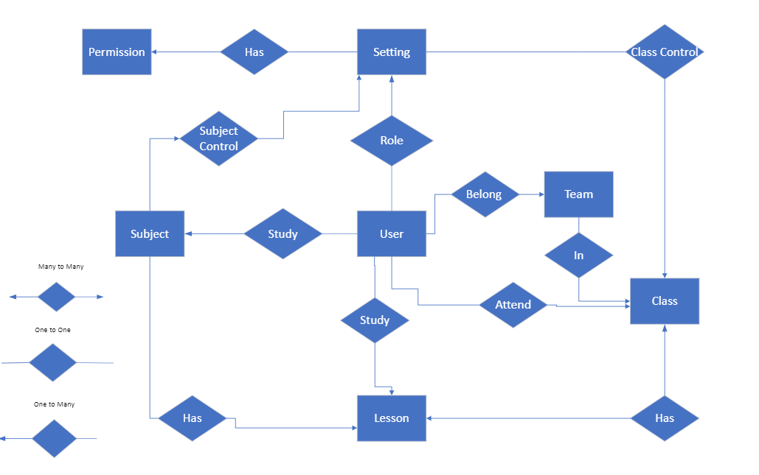

|  |  |  |
| --- | --- | --- |
| **#** | **Entity** | **Description** |
| 1 | User | Admin, Manager, Trainer, Expert, Supporter, Client, Guest |
| 2 | Subject | Subject information |
| 3 | Lesson | Lesson in a subject |
| 4 | Class |  |
| 5 | Team | User is assigned to a team which belong to one class |
| 6 | Setting | Filters, Action(Edit, View, Update) |
| 7 | Permission | Admin, Manager, Trainer, Supporter, Public |