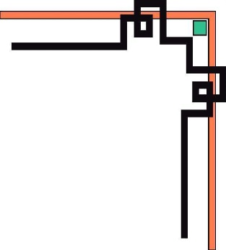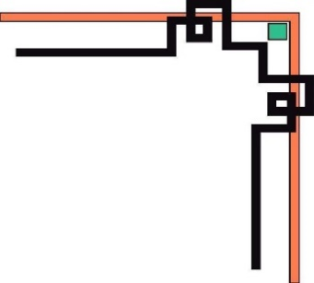

**MINISTRY OF EDUCATION AND TRAINING**

**HCMC UNIVERSITY OF TECHNOLOGY AND EDUCATION**

**FACULTY FOR HIGH-QUALITY TRAINING**

 **🕯✡🕮🕮✡🕯**

IT PROJECT

**FINAL PROJECT**

COFFEE SHOP MANAGER

Lecturer: Lê Văn Vinh

1. Nguyen Hoang Nhan 20110010

2. Le Hoang Lam 20110030

**PROJ215879E_22_1_03CLC**

Ho Chi Minh, February 2022

**SCORE**

|  |  |  |  |
| --- | --- | --- | --- |
| Criteria | Content | Presentation | Total |
| Point |  |  |  |

**REMARKS OF TEACHERS**

………………………………………………………………………………………………………………………………………………………………….……………….……………….……………….…………

………………………………………………………………………………………………………………………………………………………………………………………………………………………………

………………………………………………………………………………………………………………………………………………………………………………………………………………………………

………………………………………………………………………………………………………………………………………………………………………………………………………………………………

………………………………………………………………………………………………………………………………………………………………………………………………………………………………………………………………………………………………………………………………………………

Ho Chi Minh City, December 17th, 2022

Teacher’s score

(Signature and full name)

**Le Van Vinh**

**i. General**

## **1.1. REASONS FOR CHOOSING THE PROJECT**

One of the urgent requirements today is to put information technology into management to reduce human labor, save time, increase accuracy, narrow storage space, and avoid loss. exit and ensure data safety. Therefore, it is necessary to have a simple and effective Coffee Shop Management software.

The software helps users have the most intuitive view of data information. With the manager will be able to manage employees and revenue easily without spending too much effort and time. With employees, they will see the most accurate information about what customers request and process invoices

## **1.2. DESCRIPTION OF COFFEE STORE MANAGEMENT SOFTWARE**

The coffee shop needs to manage the number of employees of each type, the menu of drinks and food, the quantity in the menu requested by the guests, the invoice, and the revenue calculation.

The following is a description of the operation of the management software:

In terms of personnel, The Coffee Shop will have a main manager at the top, grasping the situation of the cafe. The manager will have personal information such as full name, management code, phone number, home address and salary information. The manager has full rights to affect the data in the software, such as editing personnel, editing menus, checking sales of the restaurant.

The shop has many employees with different roles: cashier, waiter, bartender. Each employee also has an employee code, full name, address, contact phone number, and salary coefficient corresponding to each position. Staff can add items, delete items in the Order table, print out invoices for customers.

For the menu of the coffee shop, the shop has two types of drinks and snacks, with a rich variety, so for easy management, each dish has its own code, name and price of each type.

Every time a customer places an order, the staff will make a list on the software, to know the number of items purchased by the customer, as well as record additional requests for the item according to the customer's wishes.

From the Order list, the employee will be allowed by the system to calculate the amount that the customer needs to pay, and output the payment time along with the invoice code. For invoices over 1 million VND, the store will automatically give customers a 10% discount.

For customers, the system will record some information such as customer code, name, phone number, address and amount paid by the customer. Saving customer information will make it easy to do some store incentives for long-term loyal customers, such as more discounts, or buy 1 get 1 free, .. . by lookup, add, delete. The coffee shop needs to manage the number of employees of each type, the menu of drinks and food, the quantity in the menu requested by the guests, the invoice, and the revenue calculation.

**iI. Database design**

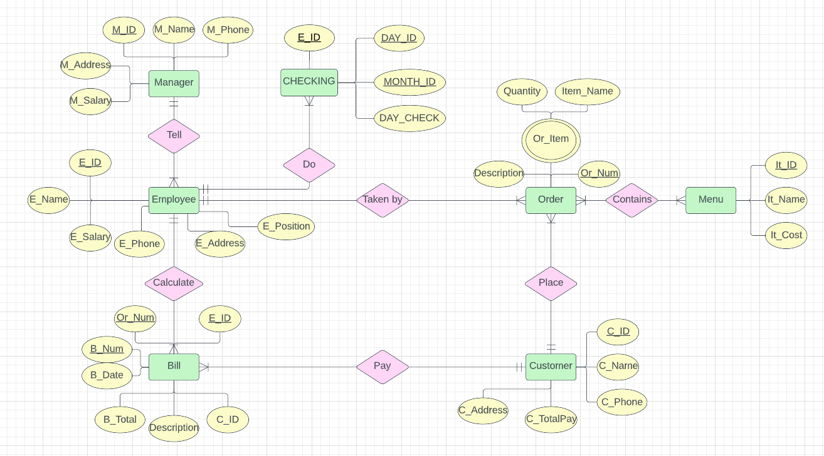

**iII. Class Diagram**

