

Capstone Project Report
Report 1 – Project Introduction

– Hanoi, August 2019 –
Table of Contents
I. Record of Changes 3
II. Project Introduction 4
1. Overview 4
1.1 Project Information 4
1.2 Project Team 4
2. Product Background 4
3. Existing Systems 4
3.1 System name1 4
3.2 System name2 4
4. Business Opportunity 4
5. Software Product Vision 5
6. Project Scope & Limitations 5
6.1 Major Features 5
6.2 Limitations & Exclusions 6

I. Record of Changes
Date | A*  M, D | In charge | Change Description
*A - Added M - Modified D - Deleted

II. Project Introduction

1. Overview

1.1 Project Information

1.2 Project Team
Full Name | Role | Email | Mobile

2. Product Background

3. Existing Systems

3.1 System name1

3.2 System name2

4. Business Opportunity

5. Software Product Vision

6. Project Scope & Limitations

6.1 Major Features

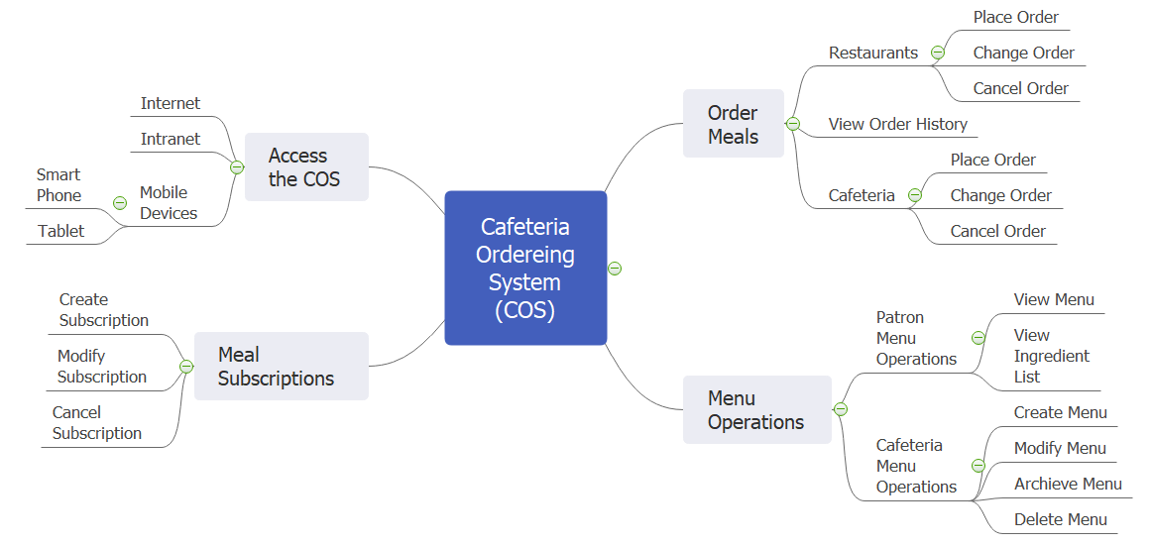

6.2 Limitations & Exclusions

