

Capstone Project Report
Report 4 – Software Design Document

– Ho Chi Minh City, May 2026 –

Table of Contents
I. Record of Changes 3
II. Software Design Document 4
1. System Design 4
1.1 System Architecture 4
1.2 Package Diagram 4
2. Database Design 4
3. Detailed Design 5
3.1 <Feature/Function Name1> 5
3.2 <Feature/Function Name2> 6

I. Record of Changes
Date | A/M/D | In charge | Change Description
31/05/2026 | A |  | Initial Software Design Document with system architecture, package diagram, and database design references
31/05/2026 | M |  | Added rendered system architecture and database relationship diagrams; aligned terminology with Assessment Engine implementation

*A - Added M - Modified D - Deleted

II. Software Design Document

1. System Design

1.1 System Architecture
The VSTEP Platform is designed as a multi-client learning system consisting of learner-facing web and mobile applications, an admin application, a Laravel backend API, relational database storage, media storage, and external services for identity verification, payment processing, grammar checking, speech processing, and AI-supported assessment.
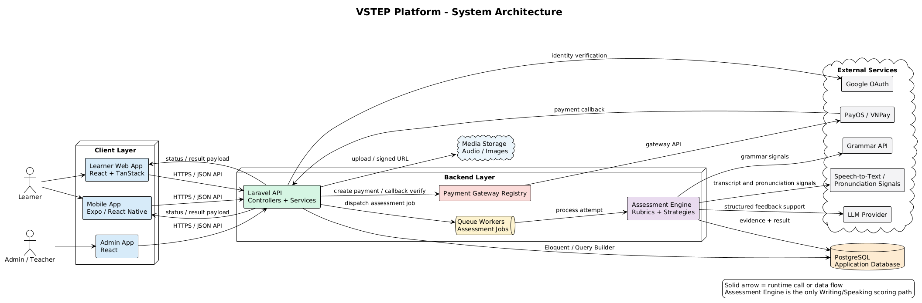
Figure 4.1. System Architecture Diagram
Main components:
No | Component | Description
01 | Learner Web App | Browser-based application for learners to practice skills, take mock exams, view feedback, manage course bookings, and track progress.
02 | Mobile App | Mobile learning application that provides practice, exam, vocabulary review, speaking, and profile features for learners.
03 | Admin App | Administration interface for managing users, learning content, exams, rubrics, courses, bookings, payments, notifications, and analytics.
04 | Backend API | Central Laravel API that implements authentication, business rules, validation, persistence, background processing, and integration orchestration.
05 | Database | Stores users, profiles, learning content, practice attempts, exam sessions, assessment results, course data, wallet transactions, and notifications.
06 | External Services | Third-party or infrastructure services used for Google identity verification, payment callbacks, media storage, grammar checking, speech-to-text, pronunciation signals, and AI feedback support.

1.2 Package Diagram
The package diagrams below describe the main packages and namespace-level dependencies inside each software sub-system. A package represents a source-code module or namespace. A dashed dependency arrow means that one package imports, calls, or uses types/services from another package.

Backend API Package Diagram
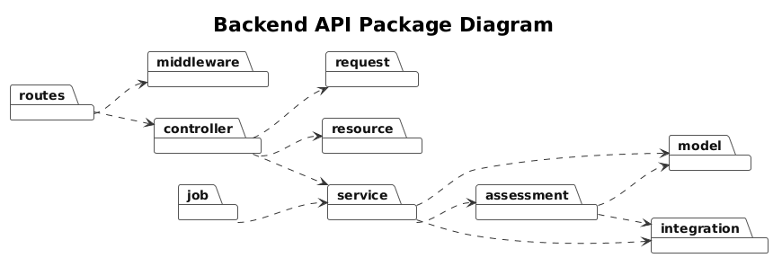
Figure 4.2. Backend API Package Diagram

Learner Web App Package Diagram
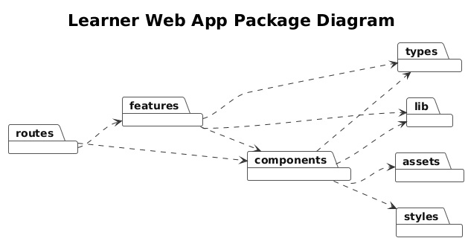
Figure 4.3. Learner Web App Package Diagram

Admin App Package Diagram
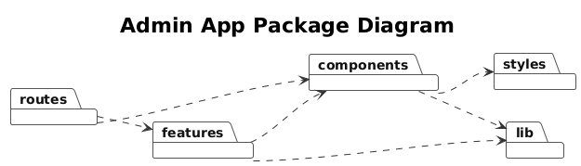
Figure 4.4. Admin App Package Diagram

Mobile App Package Diagram
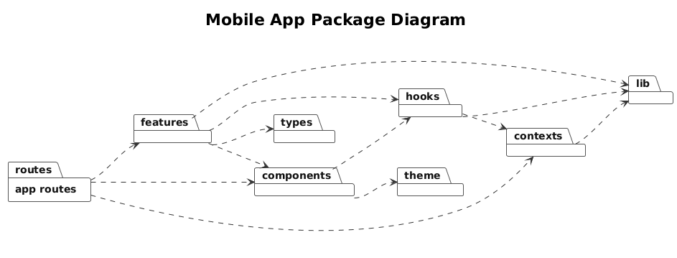
Figure 4.5. Mobile App Package Diagram

Package Descriptions
No | Package | Description
01 | Backend API — routes | Defines API endpoints and maps HTTP routes to middleware and controllers.
02 | Backend API — middleware | Handles HTTP pipeline concerns such as authentication, authorization checks, and request preprocessing.
03 | Backend API — controller | Receives validated API requests and delegates business workflows to service packages.
04 | Backend API — request | Validates request input and authorization rules before controller logic executes.
05 | Backend API — resource | Formats model and service results into consistent API response payloads.
06 | Backend API — service | Contains application service workflows for authentication, practice, exams, course booking, wallet, progress, and notifications.
07 | Backend API — assessment | Contains rubric-based assessment logic, scoring strategies, evidence extraction support, and feedback processing.
08 | Backend API — job | Contains asynchronous background tasks such as assessment processing and notification-related work.
09 | Backend API — model | Contains Eloquent models and relationships for persistent domain entities.
10 | Backend API — integration | Encapsulates communication with external providers such as AI, speech, grammar, payment, identity, and media storage services.
11 | Learner Web — routes | Defines browser routes and connects learner pages to feature modules.
12 | Learner Web — features | Contains learner-facing modules such as authentication, onboarding, profile, practice, exam, assessment result display, vocabulary, grammar, dashboard, course, booking, wallet, and notifications.
13 | Learner Web — components | Contains reusable UI components used by learner pages and feature modules.
14 | Learner Web — lib | Contains API clients, authentication helpers, query configuration, utility functions, and shared frontend helpers.
15 | Learner Web — types | Contains shared TypeScript types used by learner features and components.
16 | Learner Web — assets and styles | Contains static assets and styling resources for the learner web application.
17 | Admin App — routes | Defines admin routes and maps administration screens to feature modules.
18 | Admin App — features | Contains administration modules for users, courses, exams, practice content, assessment operations, grammar, vocabulary, promos, top-up, and teacher workflows.
19 | Admin App — components | Contains reusable UI components for admin pages.
20 | Admin App — lib | Contains admin API client, authentication helper, and utility functions.
21 | Admin App — styles | Contains styling resources for the admin interface.
22 | Mobile App — app routes | Defines Expo Router screens and navigation groups for the mobile learner application.
23 | Mobile App — features | Contains mobile feature modules for profile, onboarding, practice, shadowing, vocabulary, course, wallet, coin, streak, and notifications.
24 | Mobile App — components | Contains reusable mobile UI components used by screens and feature modules.
25 | Mobile App — hooks | Contains reusable stateful logic for API calls, audio recording, playback, speech-to-text, practice, and other mobile flows.
26 | Mobile App — contexts | Contains app-wide state providers such as authentication/session context.
27 | Mobile App — lib | Contains API clients, authentication helpers, asset utilities, audio upload helpers, and shared utilities.
28 | Mobile App — theme and types | Contains mobile design tokens and shared TypeScript types.

2. Database Design
The database is designed around the main operational areas of the VSTEP Platform: identity and learner profiles, wallet and payment, course booking, practice activities, mock exam sessions, assessment processing, progress tracking, and notifications.
The table relationships are presented as five subject-area ERDs. Each ERD uses table boxes with primary keys, foreign keys, and crow's-foot relationships. The diagrams are grouped by business area so that each figure can be read independently, while the table description list provides the complete database inventory.
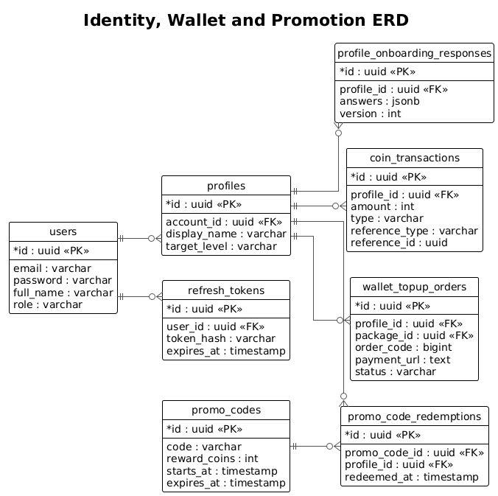
Figure 4.6. Identity, Wallet and Promotion ERD
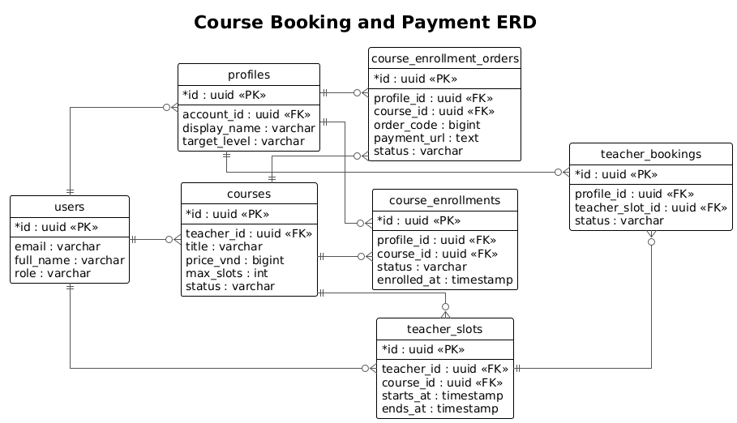
Figure 4.7. Course Booking and Payment ERD
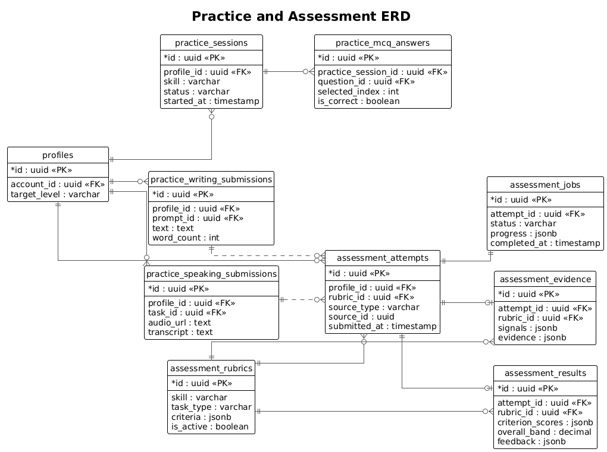
Figure 4.8. Practice and Assessment ERD
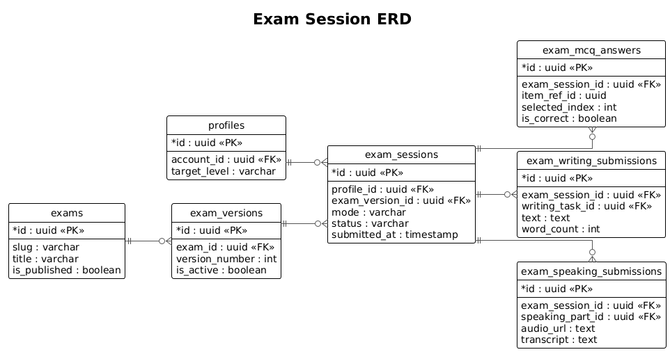
Figure 4.9. Exam Session ERD
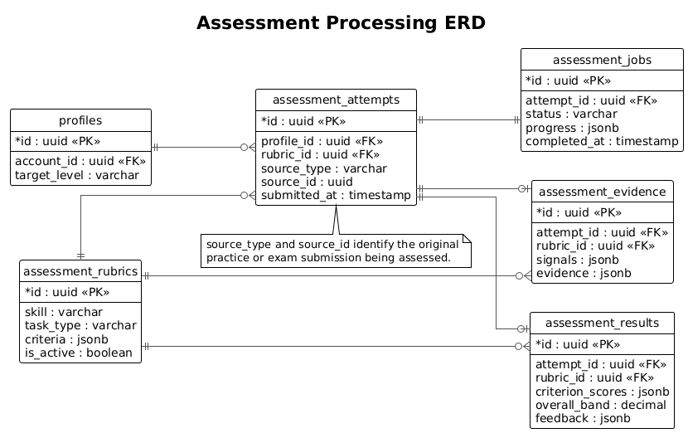
Figure 4.10. Assessment Processing ERD

Table Descriptions
No | Table | Description
01 | users | Stores accounts for learners, teachers, and administrators.  Primary keys: id  Foreign keys: none
02 | profiles | Stores learner profile and target-level information.  Primary keys: id  Foreign keys: account_id
03 | refresh_tokens | Stores refresh-token records for authenticated sessions.  Primary keys: id  Foreign keys: user_id
04 | profile_onboarding_responses | Stores learner onboarding answers and onboarding version.  Primary keys: id  Foreign keys: profile_id
05 | coin_transactions | Stores wallet credit and debit ledger entries.  Primary keys: id  Foreign keys: profile_id
06 | wallet_topup_orders | Stores wallet top-up payment orders and gateway status.  Primary keys: id  Foreign keys: profile_id, package_id
07 | promo_codes | Stores promotional code rules and reward configuration.  Primary keys: id  Foreign keys: none
08 | promo_code_redemptions | Stores promo-code redemption history by learner profile.  Primary keys: id  Foreign keys: promo_code_id, profile_id
09 | courses | Stores teacher-led course definitions, pricing, and enrollment constraints.  Primary keys: id  Foreign keys: teacher_id
10 | course_enrollment_orders | Stores course enrollment payment orders, payment URLs, and callback status.  Primary keys: id  Foreign keys: profile_id, course_id
11 | course_enrollments | Stores confirmed learner enrollments for courses.  Primary keys: id  Foreign keys: profile_id, course_id
12 | teacher_slots | Stores teacher availability slots for course booking.  Primary keys: id  Foreign keys: teacher_id, course_id
13 | teacher_bookings | Stores learner bookings against teacher slots.  Primary keys: id  Foreign keys: profile_id, teacher_slot_id
14 | practice_sessions | Stores listening and reading practice session state.  Primary keys: id  Foreign keys: profile_id
15 | practice_mcq_answers | Stores selected answers for objective practice questions.  Primary keys: id  Foreign keys: practice_session_id
16 | practice_writing_submissions | Stores learner writing practice submissions.  Primary keys: id  Foreign keys: profile_id, prompt_id
17 | practice_speaking_submissions | Stores learner speaking practice audio and transcript data.  Primary keys: id  Foreign keys: profile_id, task_id
18 | exams | Stores mock exam definitions.  Primary keys: id  Foreign keys: none
19 | exam_versions | Stores versioned content sets for mock exams.  Primary keys: id  Foreign keys: exam_id
20 | exam_sessions | Stores learner mock exam attempts, timing, and status.  Primary keys: id  Foreign keys: profile_id, exam_version_id
21 | exam_mcq_answers | Stores listening/reading answers in mock exam sessions.  Primary keys: id  Foreign keys: exam_session_id
22 | exam_writing_submissions | Stores writing responses in mock exam sessions.  Primary keys: id  Foreign keys: exam_session_id, writing_task_id
23 | exam_speaking_submissions | Stores speaking responses in mock exam sessions.  Primary keys: id  Foreign keys: exam_session_id, speaking_part_id
24 | assessment_rubrics | Stores assessment criteria, evidence schema, and scoring policy.  Primary keys: id  Foreign keys: none
25 | assessment_attempts | Stores normalized assessment attempts from practice or exam submissions.  Primary keys: id  Foreign keys: profile_id, rubric_id
26 | assessment_jobs | Stores asynchronous assessment processing state.  Primary keys: id  Foreign keys: attempt_id
27 | assessment_evidence | Stores assessment signals, source evidence, and validation details.  Primary keys: id  Foreign keys: attempt_id, rubric_id
28 | assessment_results | Stores final criterion scores, overall band, calculation trace, and feedback.  Primary keys: id  Foreign keys: attempt_id, rubric_id
29 | profile_daily_activity | Stores daily learning activity aggregates.  Primary keys: id  Foreign keys: profile_id
30 | profile_streak_state | Stores learner streak status and milestone progress.  Primary keys: id  Foreign keys: profile_id
31 | notifications | Stores learner-facing notification records.  Primary keys: id  Foreign keys: profile_id

3. Detailed Design
The following detailed designs cover representative functions of the system. Features with similar controller-service-model structure follow the same design pattern.

3.1 Authentication & Profile Management
This function handles login, Google authentication, token issuing, refresh tokens, and learner profile ownership.

3.1.1 Class Diagram
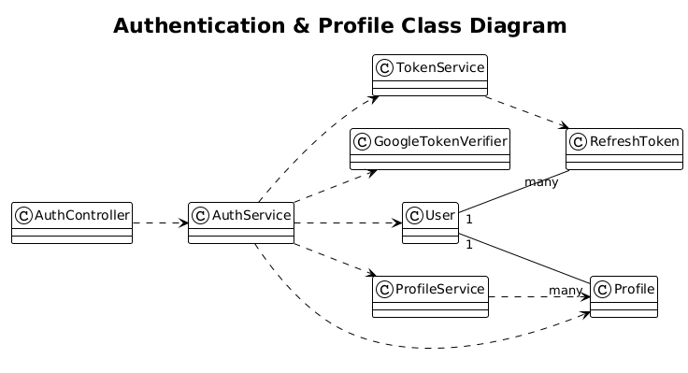
Figure 4.11. Authentication & Profile Class Diagram

3.1.2 Login Sequence
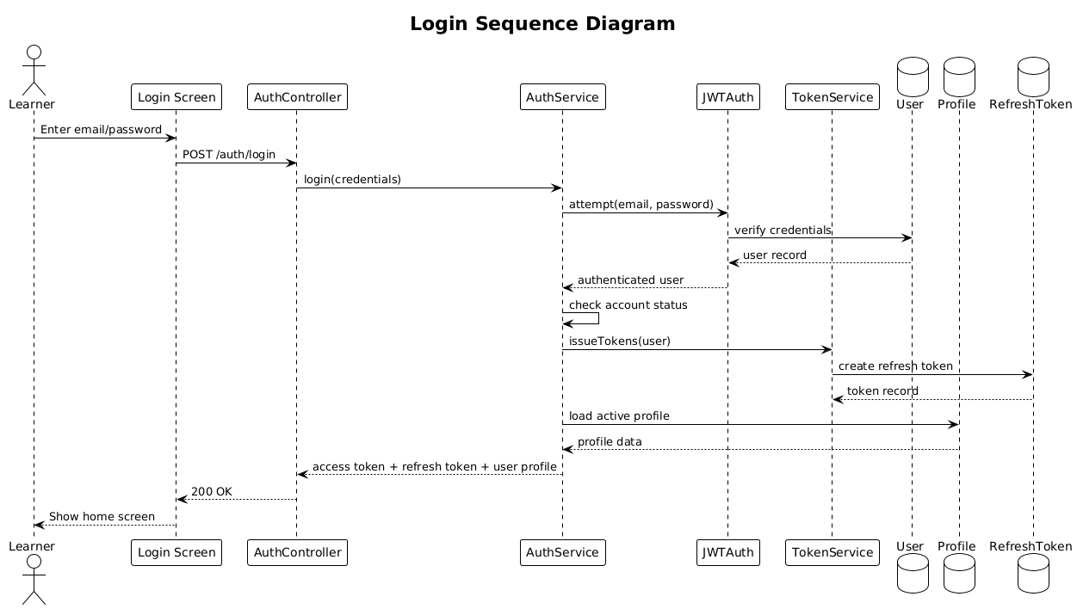
Figure 4.12. Login Sequence Diagram

3.2 Practice & Assessment Processing
This function handles learner writing/speaking practice submissions, paid feedback requests, assessment attempt creation, queued processing, and assessment result storage.

3.2.1 Class Diagram
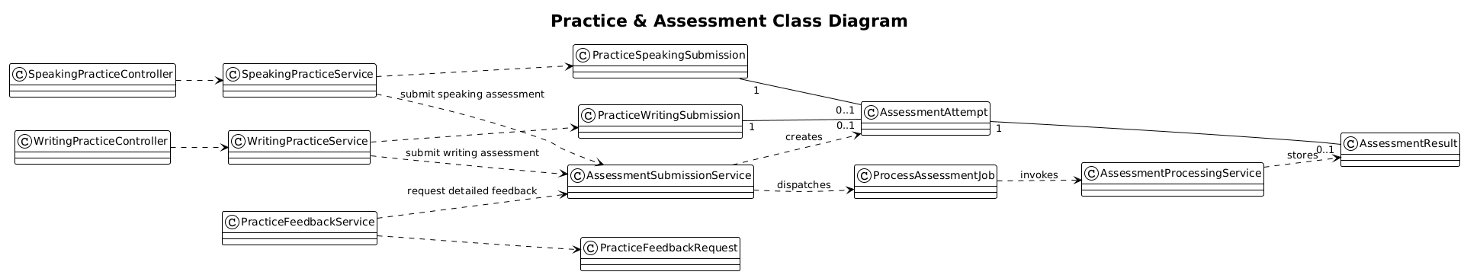
Figure 4.13. Practice & Assessment Class Diagram

3.2.2 Practice Feedback Sequence
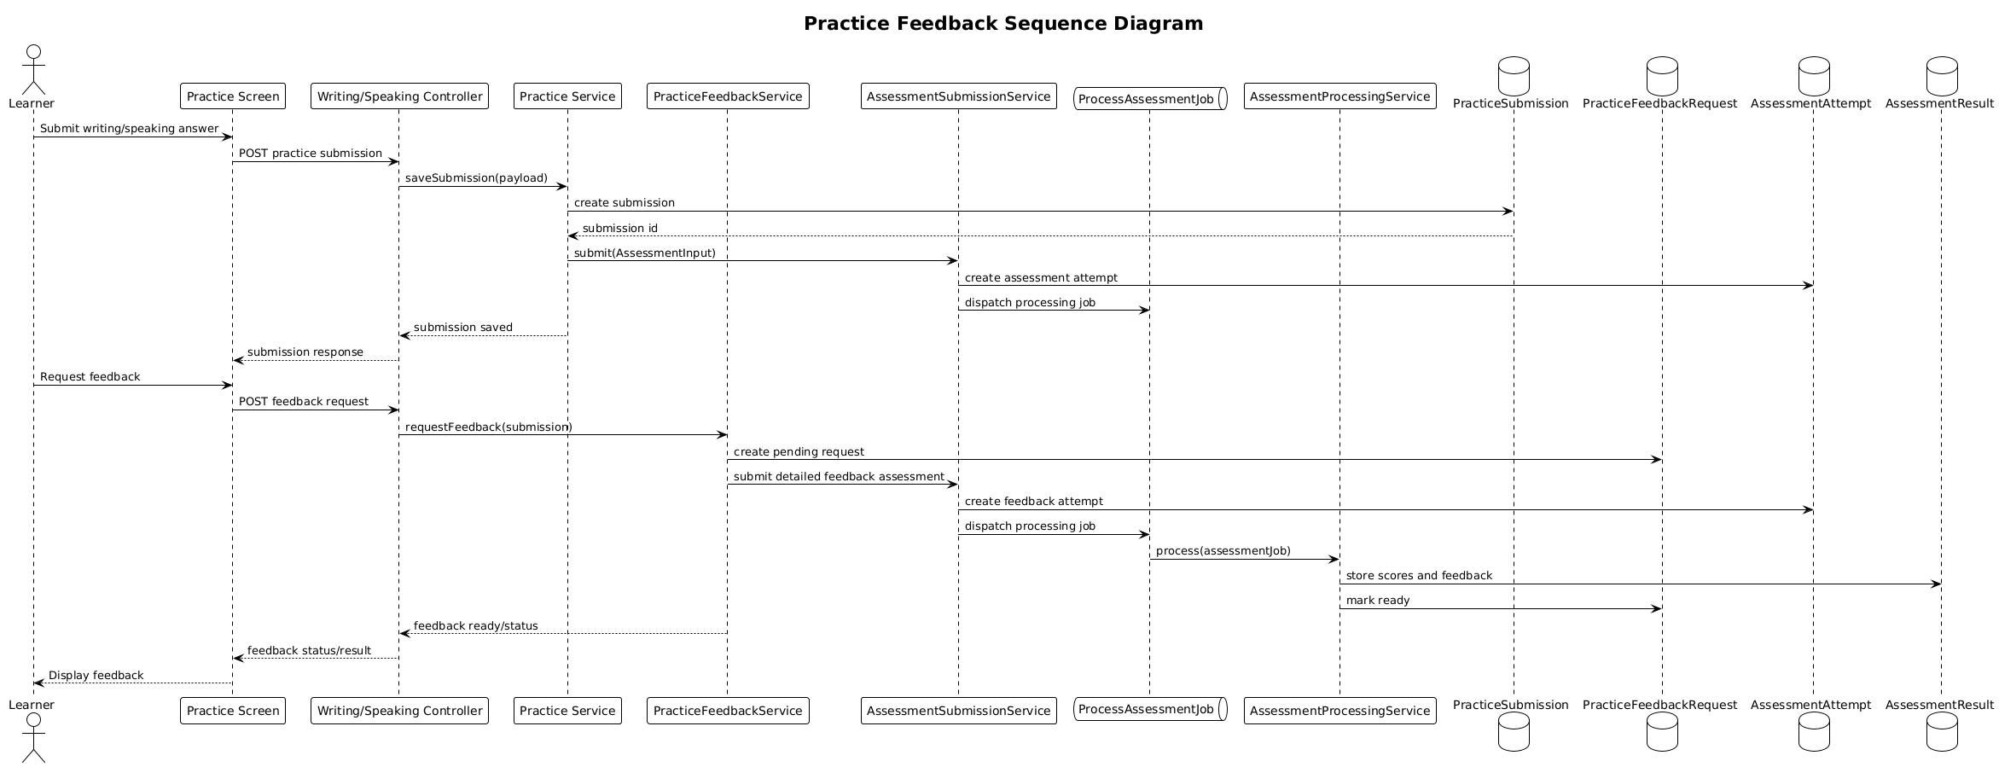
Figure 4.14. Practice Feedback Sequence Diagram

3.3 Mock Exam Session
This function handles VSTEP mock exam session creation, answer saving, draft persistence, and productive-skill assessment submission.

3.3.1 Class Diagram
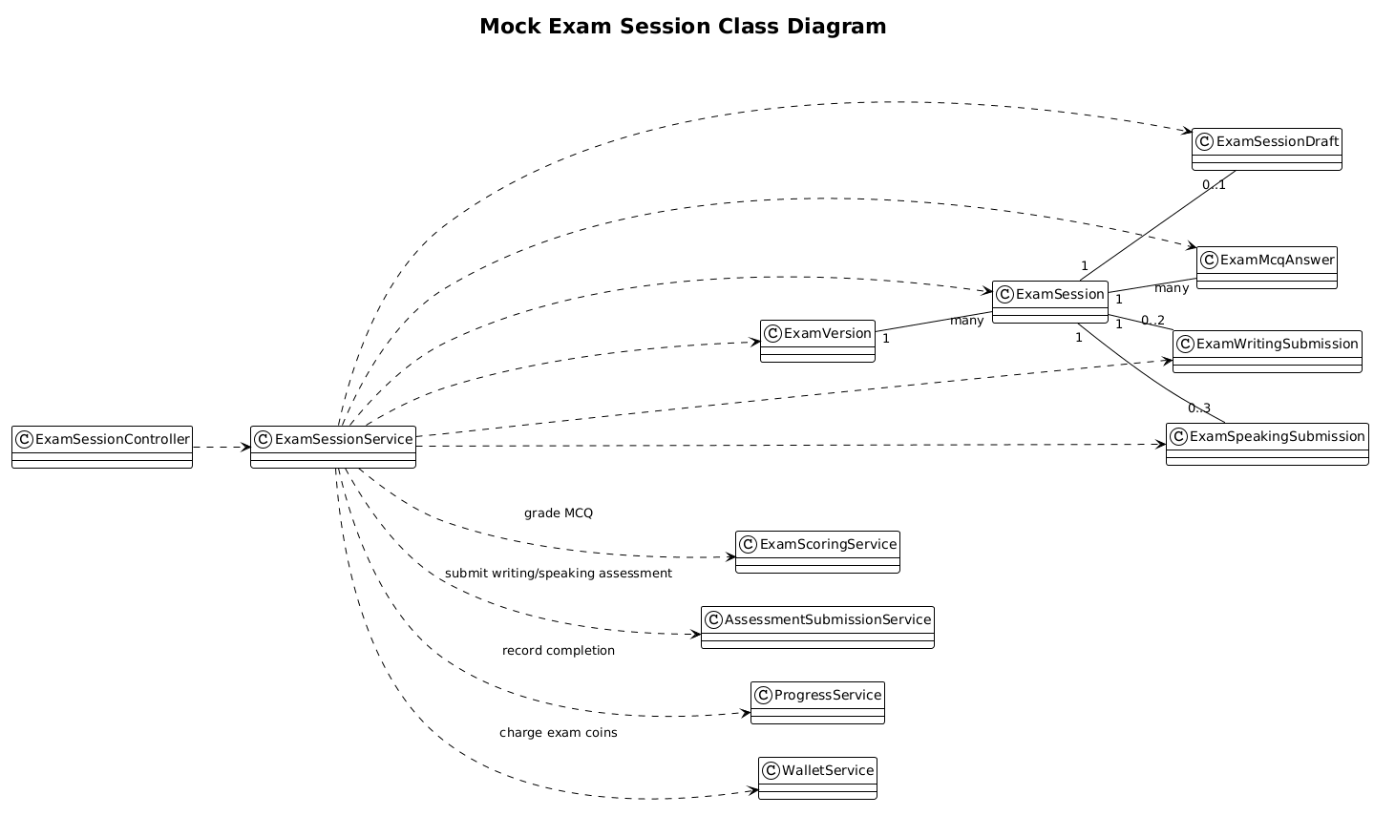
Figure 4.15. Mock Exam Session Class Diagram

3.3.2 Exam Submission Sequence
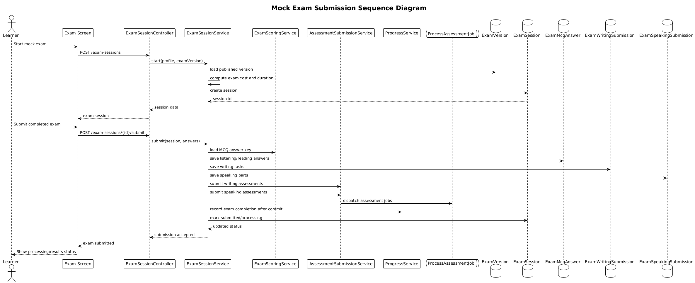
Figure 4.16. Mock Exam Submission Sequence Diagram

3.4 Course Booking & Payment
This function handles course enrollment orders, teacher slot booking, payment gateway interaction, coin transactions, and operational notifications.

3.4.1 Class Diagram
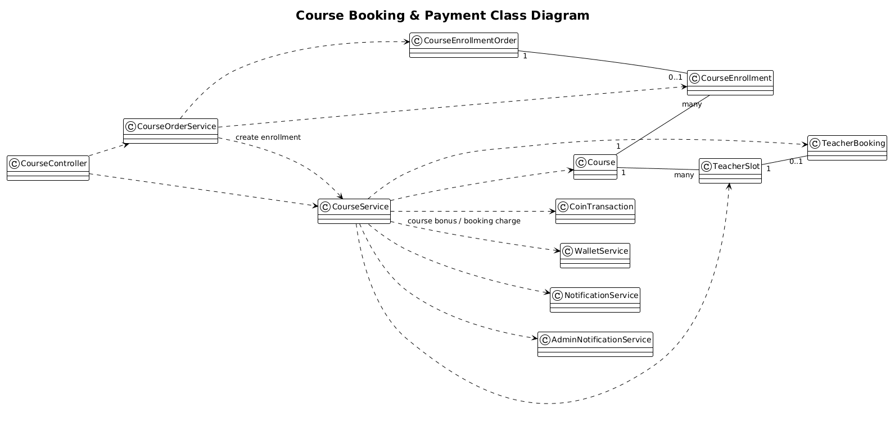
Figure 4.17. Course Booking & Payment Class Diagram

3.4.2 Course Enrollment Payment Sequence
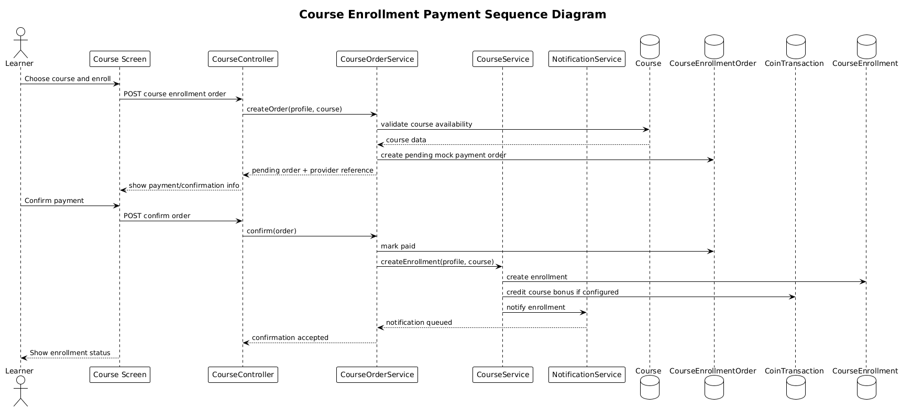
Figure 4.18. Course Enrollment Payment Sequence Diagram

