

CAPSTONE PROJECT REPORT
Report 3 – Software Requirement Specification

– Hanoi, May 2026 –
Table of Contents
I. Project Report 3
1. Status Report 3
2. Team Involvements 3
3. Issues/Suggestions 3
II. Software Requirement Specification 4
1. Overall Description 4
1.1 Product Overview 4
1.2 Business Rules 5
2. User Requirements 6
2.1 System Actors 6
2.2 Use Cases 6
3. Functional Requirements 8
3.1 System Functional Overview 8
3.2 <<Feature Name 1>> 10
3.3 <<Feature Name 2>> 10
4. Non-Functional Requirements 11
4.1 External Interfaces 11
4.2 Quality Attributes 12
5. Other Requirements 14
5.1 Appendix1 - Messages List 14
5.2 Appendix2 - … 14
5.3 … 14

I. Record of Changes
Date | A*  M, D | In charge | Change Description
2026-05-29 | A |  | Create VSTEP Software Requirement Specification from current implementation.
*A - Added M - Modified D - Deleted

II. Software Requirement Specification

1. Product Overview
VSTEP Adaptive Learning System is a capstone project for adaptive VSTEP exam preparation. The system supports learner onboarding, vocabulary and grammar learning, four-skill practice, VSTEP mock exams, AI writing/speaking grading, coin wallet, course enrollment, 1-on-1 teacher booking, teacher workspace, staff content management and admin operations.
Context diagram image placeholder: replace this template image with the VSTEP context diagram.
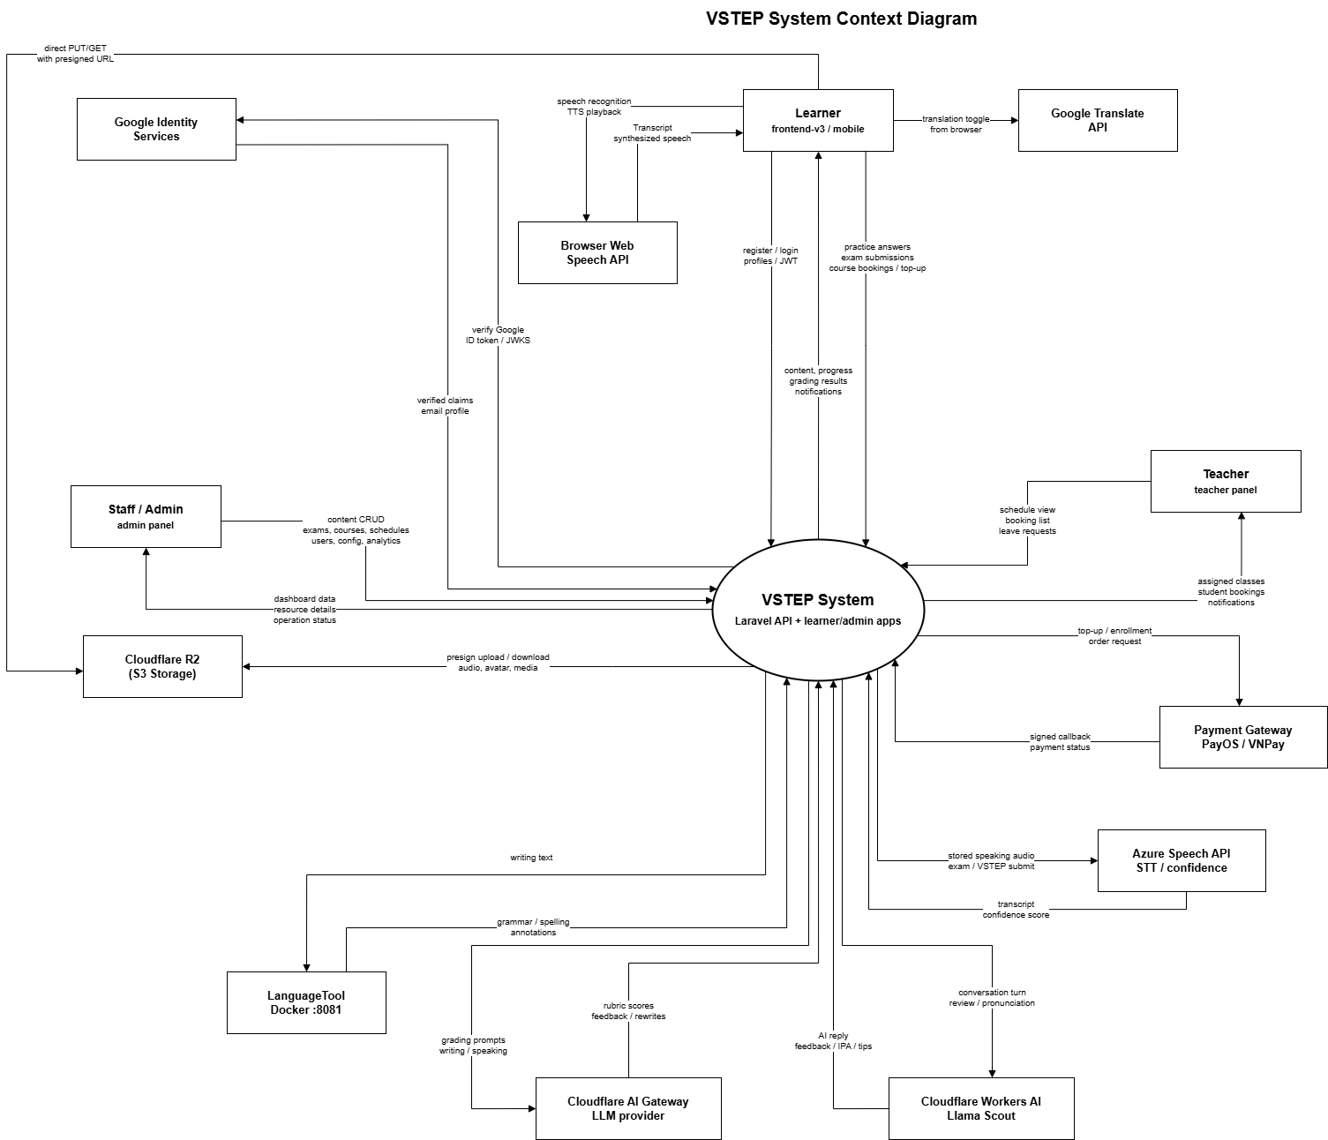

2. User Requirements

2.1 Actors

# | Actor | Description
1 | Guest | Unauthenticated visitor who can register, log in and use Google sign-in.
2 | Learner | Primary user with active learning profile for study, practice, mock exam, wallet, course, booking, notifications and progress.
3 | Teacher | Instructor role for dashboard, teaching schedule, bookings and leave requests.
4 | Staff | Operations/content role for courses, learning content, draft exams, teacher slots, enrollments, bookings and leave request review.
5 | Admin | Highest privileged role for users, system config, promo codes, top-up packages, exams and admin dashboard.
6 | AI Provider | External/system actor used by writing/speaking grading, conversation and pronunciation review.
7 | Payment Gateway | External payment system that receives top-up orders and sends callbacks.

2.2 Use Cases

2.2.1 Diagram(s)

Overview:

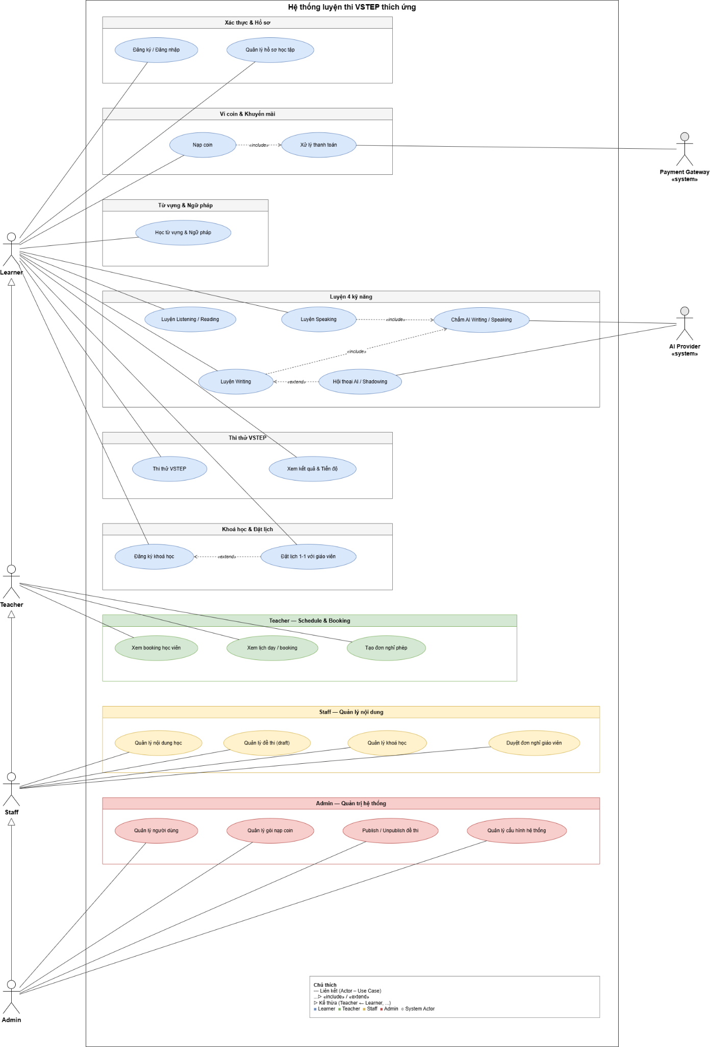

Learner:
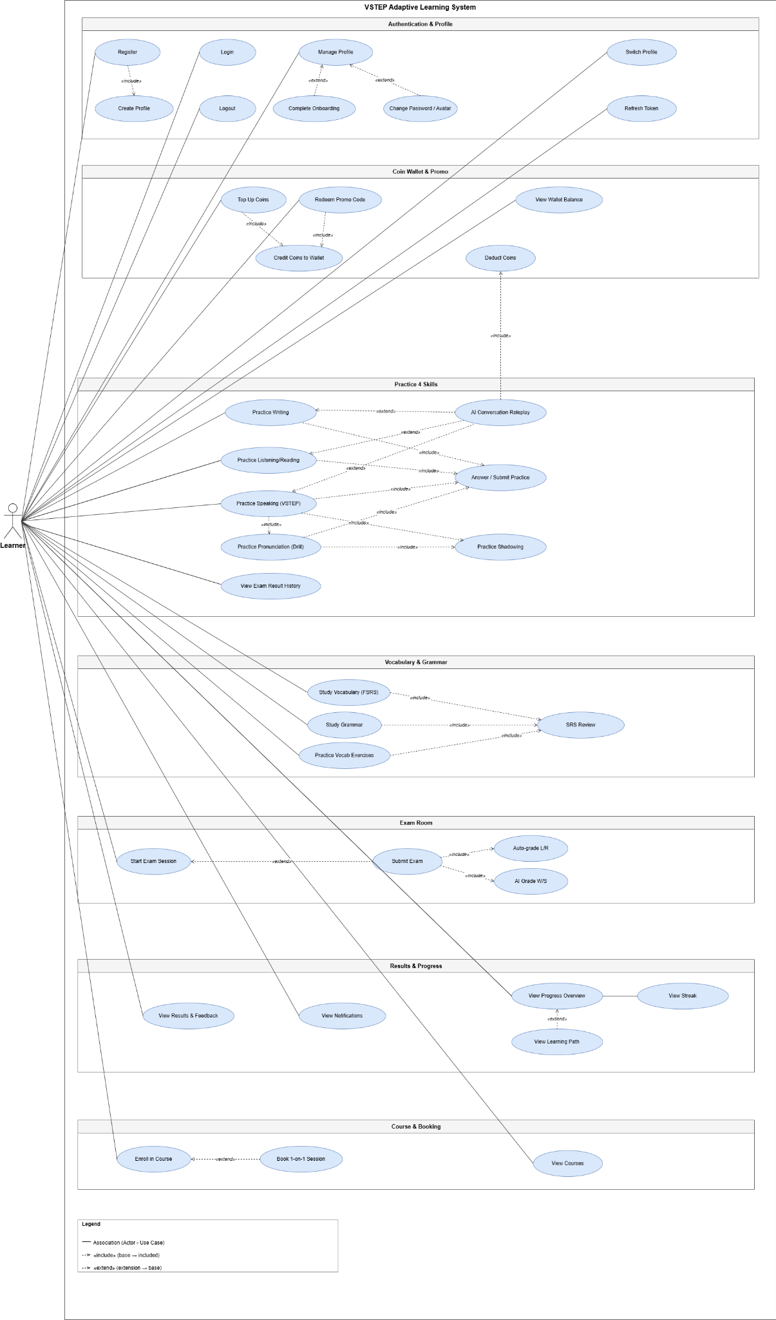
Teacher:
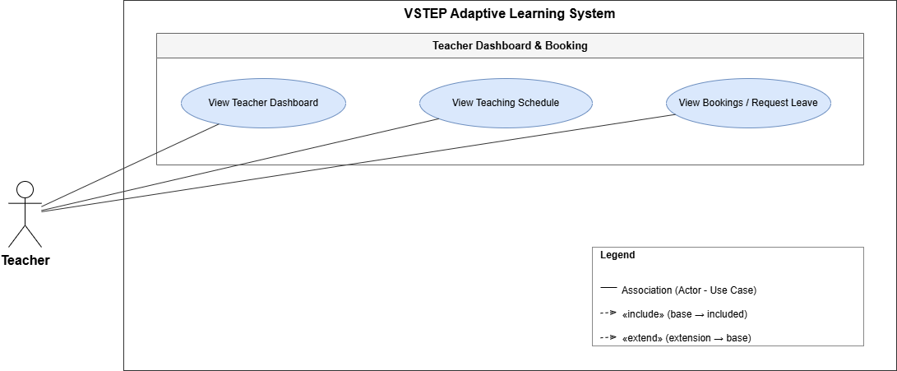

Admin:
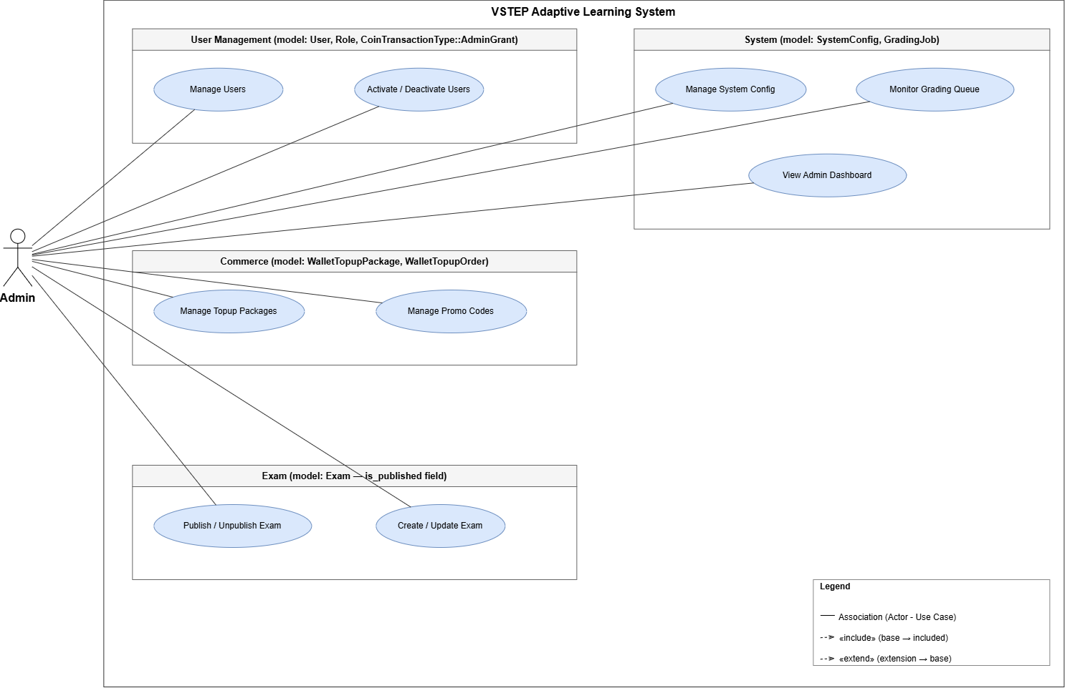

Staff:
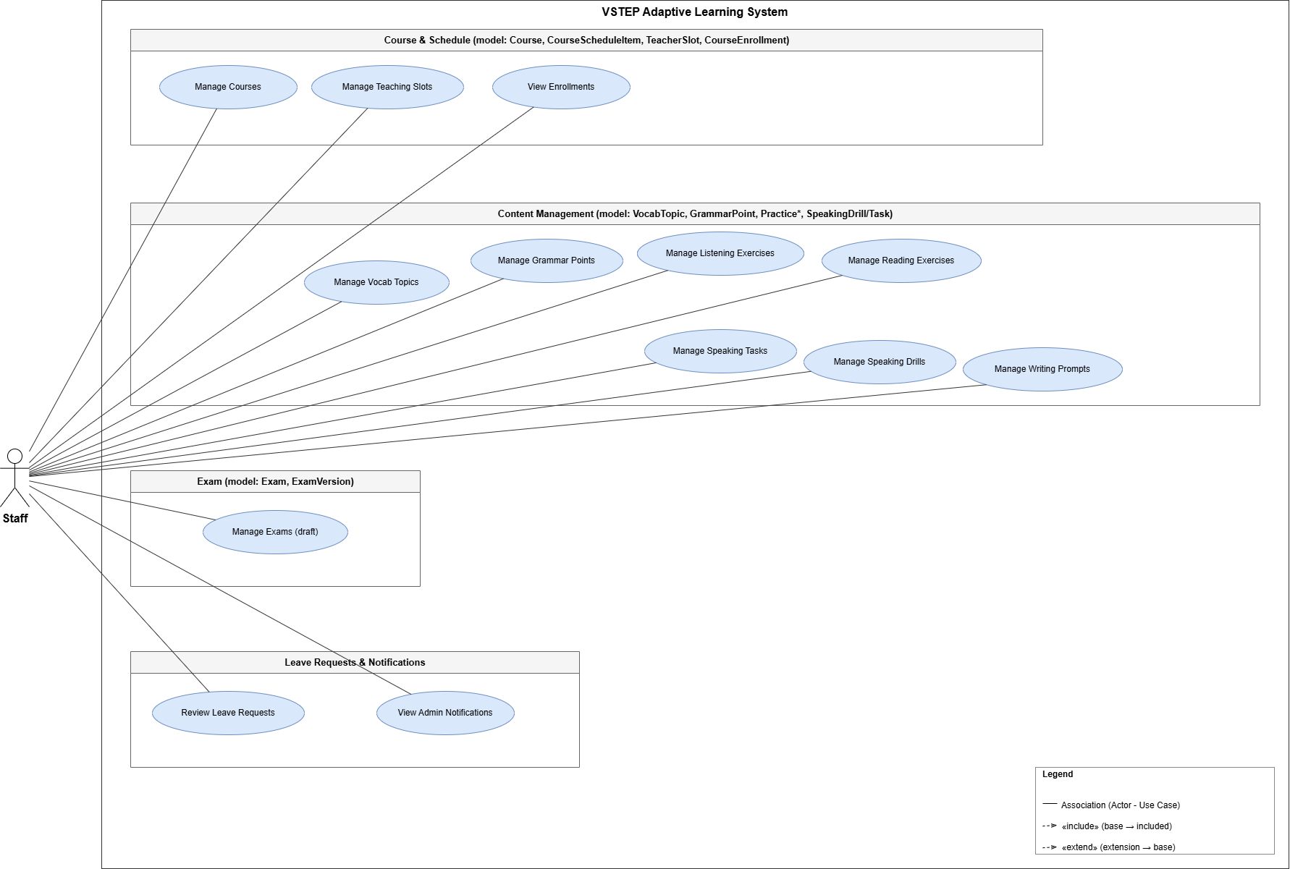

2.2.2 Descriptions

ID | Use Case | Actors | Use Case Description
UC-L01 | Register | Guest | Create a new learner account with email/password and initial onboarding data.
UC-L02 | Login | Guest, Learner, Teacher, Staff, Admin | Authenticate user credentials and return role-appropriate session data.
UC-L03 | Logout | Authenticated user | Invalidate current session tokens and clear client authentication state.
UC-L04 | Refresh Token | Authenticated user | Use refresh token to receive a new access token without re-login.
UC-L05 | Create Profile | Learner | Create a new learning profile with target level and deadline.
UC-L06 | Manage Profile | Learner | View and update learner profile information.
UC-L07 | Switch Profile | Learner | Change active profile so following APIs use the selected learning context.
UC-L08 | Complete Onboarding | Learner | Finish onboarding information and receive welcome coin bonus when applicable.
UC-L09 | Change Password / Avatar | Learner | Change account password and upload/update profile avatar.
UC-L10 | View Wallet Balance | Learner | View current coin balance in header/profile wallet UI.
UC-L11 | Top Up Coins | Learner, Payment Gateway | Select top-up package, create payment order and redirect to payment URL.
UC-L12 | Redeem Promo Code | Learner | Submit promo code and receive coins if the code is valid.
UC-L13 | Credit Coins to Wallet | Payment Gateway, System | Credit coins after validated payment callback or successful promo redemption.
UC-L14 | Deduct Coins | Learner, System | Deduct coins for exam session start or paid booking actions.
UC-L15 | Study Vocabulary (FSRS) | Learner | Browse vocabulary topics and study words with adaptive scheduling.
UC-L16 | Practice Vocab Exercises | Learner | Answer vocabulary exercises such as MCQ/fill blank and view feedback.
UC-L17 | SRS Review | Learner | Review due vocabulary cards and update FSRS intervals based on rating.
UC-L18 | Study Grammar | Learner | Browse grammar points, examples, mistakes, tips and exercises.
UC-L19 | Practice Listening/Reading | Learner | Open listening/reading MCQ exercises, answer questions and view results.
UC-L20 | Practice Writing | Learner, AI Provider | Write practice response, submit, trigger AI feedback and view result.
UC-L21 | Practice Speaking (VSTEP) | Learner, AI Provider | Record VSTEP speaking task responses and submit for AI scoring.
UC-L22 | Practice Pronunciation (Drill) | Learner, AI Provider | Complete pronunciation drill and receive audio/pronunciation feedback.
UC-L23 | AI Conversation Roleplay | Learner, AI Provider | Start conversation scenario, submit turns and receive conversation feedback.
UC-L24 | Practice Shadowing | Learner | Listen, repeat/record shadowing content and save progress.
UC-L25 | Answer / Submit Practice | Learner | Submit answers or attempts for practice sessions and receive immediate/AI results.
UC-L26 | View Exam Result History | Learner | View submitted exam/practice result history from learner screens.
UC-L27 | Start Exam Session | Learner | Start full/custom exam session after checking coin balance and selected skills.
UC-L28 | Submit Exam | Learner | Submit exam manually or through auto-submit when time expires.
UC-L29 | Auto-grade L/R | System | Automatically calculate listening/reading MCQ scores after exam submission.
UC-L30 | AI Grade W/S | AI Provider, System | Generate writing/speaking scores and feedback asynchronously.
UC-L31 | View Results & Feedback | Learner | View score summary, pending AI status, feedback and result detail.
UC-L32 | View Progress Overview | Learner | View dashboard overview cards, skill progress and recent activity.
UC-L33 | View Streak | Learner | View streak state, milestones and claim available rewards.
UC-L34 | View Learning Path | Learner | View weak-skill recommendations and suggested exercises.
UC-L35 | View Notifications | Learner | Open notification bell/list and mark notifications as read.
UC-L36 | View Courses | Learner | Browse available courses and course detail information.
UC-L37 | Enroll in Course | Learner | Create course enrollment order and confirm enrollment flow.
UC-L38 | Book 1-on-1 Session | Learner, Teacher | Book teacher slot with coin deduction and booking constraints.
UC-T01 | View Teacher Dashboard | Teacher | View teacher summary dashboard in teacher workspace.
UC-T02 | View Teaching Schedule | Teacher | View assigned course schedule and teaching calendar.
UC-T03 | View Bookings / Request Leave | Teacher | View 1-on-1 bookings and create leave requests.
UC-A01 | View Admin Dashboard | Staff, Admin | View statistics, alerts, analytics, content status and recent activity.
UC-A02 | Manage Users | Admin | Search, create, view and update users by role.
UC-A03 | Activate / Deactivate Users | Admin | Deactivate or reactivate accounts according to admin-only permission.
UC-A04 | Manage Topup Packages | Admin | Create/update/activate/deactivate wallet top-up packages.
UC-A05 | Manage Promo Codes | Admin | Create, edit and list promo codes for coin redemption.
UC-A06 | Manage System Config | Admin | View and update system configuration keys.
UC-A07 | Monitor Grading Queue | Staff, Admin | View grading alerts/throughput and failed grading jobs from admin dashboard.
UC-A08 | Publish / Unpublish Exam | Staff, Admin | Publish or unpublish an exam so learners can/cannot access it.
UC-A09 | Create / Update Exam | Staff, Admin | Create/import/update exam metadata, versions and skill content.
UC-S01 | Manage Courses | Staff, Admin | Create/update/publish courses and manage course detail tabs.
UC-S02 | Manage Teaching Slots | Staff, Admin | Create/update/delete teacher slots for 1-on-1 booking.
UC-S03 | View Enrollments | Staff, Admin | View and manage course enrollments and commitment override.
UC-S04 | Manage Vocab Topics | Staff, Admin | Create/update/publish vocabulary topics, words and exercises.
UC-S05 | Manage Grammar Points | Staff, Admin | Create/update/publish grammar points and child content.
UC-S06 | Manage Listening Exercises | Staff, Admin | Create/update/publish listening exercises and questions.
UC-S07 | Manage Reading Exercises | Staff, Admin | Create/update/publish reading exercises and questions.
UC-S08 | Manage Writing Prompts | Staff, Admin | Create/update/publish writing prompts and markers.
UC-S09 | Manage Speaking Tasks | Staff, Admin | Create/update/publish VSTEP speaking tasks.
UC-S10 | Manage Speaking Drills | Staff, Admin | Create/update/publish speaking drills and drill sentences.
UC-S11 | Manage Exams (draft) | Staff, Admin | Manage draft exams and versions before publishing.
UC-S12 | Review Leave Requests | Staff | Approve or reject teacher leave requests.
UC-S13 | View Admin Notifications | Teacher, Staff, Admin | View admin-shell notifications and unread count.

3. Functional Requirements

3.1 System Functional Overview
The functional overview covers learner-facing study and exam flows, admin/staff management screens, teacher workspace and backend integration services.

3.1.1 Screens Flow
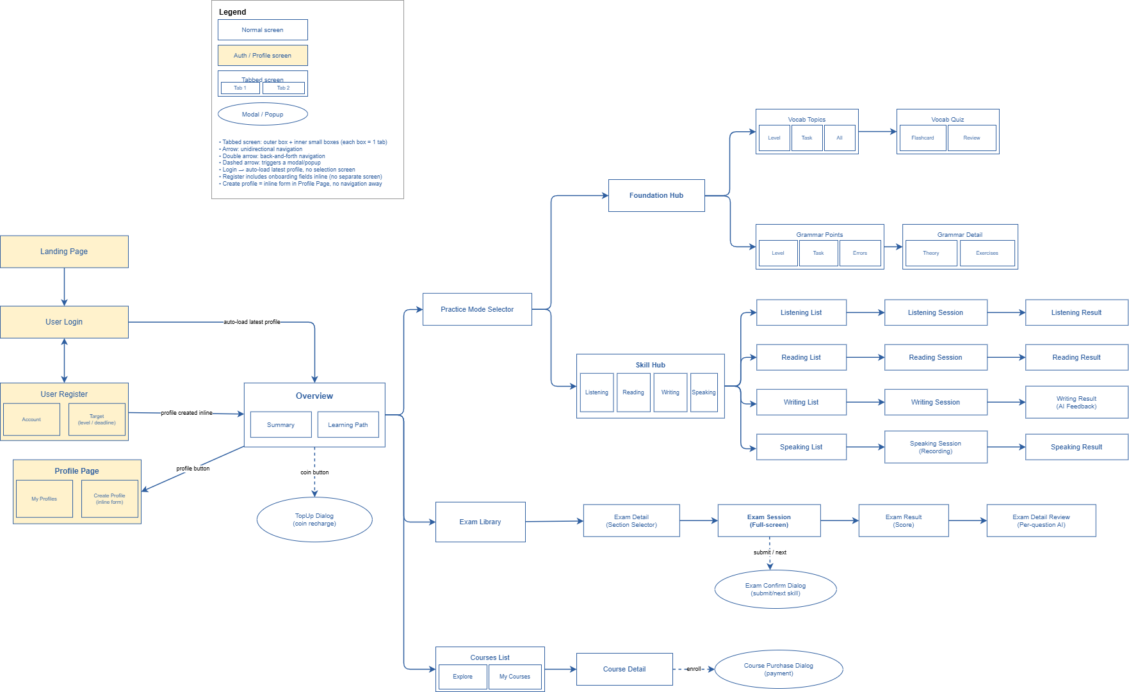

3.1.2 Screen Descriptions

# | Feature | Screen | Description
1 | Register | Register | Register learner with email, onboarding data
2 | Login | Login | Login with email/password, session, redirect
3 | Google Login | Google Auth | Google Sign-In integration
4 | Session & Refresh | Session | Token refresh, logout, lifecycle
5 | Profile CRUD | Profile | List, create, switch, update, onboarding
6 | Vocabulary & SRS | Vocabulary | Topic list, detail, exercises, SRS review
7 | Grammar Points | Grammar | Point list, detail, exercise flow
8 | Listening Practice | Listening | Exercise list, audio, answer, results
9 | Reading Practice | Reading | Exercise list, passage, questions, results
10 | Writing Practice | Writing | Prompt, editor, submit, AI feedback, SSE
11 | Speaking Drills | Speaking Drills | Pronunciation drill, recording, feedback
12 | VSTEP Speaking | VSTEP Speaking | VSTEP session, submit, grading
13 | Conversation | Conversation AI | Scenario start, turns, review, feedback
14 | Shadowing | Shadowing | Shadowing session, playback, recording
15 | Exam Library & Detail | Exam Library | List, status cards, detail, skill selector
16 | Start Exam Session | Exam Start | Full/custom start, coin, insufficient balance
17 | Draft Autosave | Exam Draft | Save, autosave debounce, resume from draft
18 | Exam Room Panels | Exam Panels | L/R/W/S panels, device check
19 | Transition & Submit | Exam Submit | Next skill, confirm, submit, auto-submit, scoring
20 | Exam Result | Exam Result | Result summary, feedback, polling, detail page
21 | Wallet Balance | Wallet Balance | Balance endpoint, header display
22 | Top-up & Payment | Top-up | Package list, order, confirm, redirect
23 | Promo Redemption | Promo Redeem | Valid/invalid redeem, frontend, error
24 | Dashboard & Progress | Dashboard | Overview, spider chart, streak, learning path
25 | Course Enrollment | Course Enroll | List, enrollment order, frontend flow
26 | Booking & Notification | Booking | Book slot, coin, limit, commitment, notifications
27 | Admin Dashboard | Admin Dashboard | Stats, alerts, role enforcement, frontend
28 | Admin Vocab & Grammar | Admin Vocab Grammar | Vocab/grammar CRUD, publish/unpublish, frontend
29 | Admin Settings | Admin Settings | System config, update, role enforcement
30 | Admin Exam Mgmt | Admin Exams | Exam CRUD, import, version, content editors
31 | Admin Practice Content | Admin Practice | L/R/W/S exercise CRUD, editors
32 | Admin User Mgmt | Admin Users | User CRUD, deactivate, role enforcement, frontend
33 | Admin Course & Promo | Admin Courses | Course CRUD, enrollments, bookings, promo, top-up
34 | Teacher | Teacher | Dashboard, schedule, bookings, leave requests
35 | Grading & AI | Grading AI | Result lookup, SSE, scoring formulas, pipeline
36 | System Integration | System | Role hierarchy, health, config, cross-module
37 | Non-functional | Non-functional | Security, performance, compatibility, usability, reliability

3.1.3 Screen Authorization

Screen | Role-Name1 | Role-Name2 | Role-Name3 | …
Landing, Register, Login | X
Dashboard, Profile, Wallet, Promo |  | X
Vocabulary, Grammar, Practice Skills |  | X
Exam Library, Exam Room, Result |  | X
Courses and 1-on-1 Booking |  | X
Teacher Dashboard, Schedule, Bookings, Leave Requests |  |  | X
Staff Content/Course/Exam Management |  |  | X
User Management |  |  |  | X
System Configuration |  |  |  | X
Promo Codes and Top-up Packages |  |  |  | X

3.1.4 Non-Screen Functions

# | Feature | System Function | Description
1 | Authentication | JWT refresh and role middleware | Issue/refresh/revoke tokens and enforce role hierarchy plus active profile context.
2 | Wallet | Payment callback and transaction | Validate callback, credit coins and create wallet transactions.
3 | Vocabulary | FSRS scheduler | Compute due cards, review intervals and vocabulary memory states.
4 | Writing/Speaking | AI grading pipeline | Create grading jobs, call AI provider, store scores and feedback.
5 | Grading | SSE stream | Stream grading progress, score and feedback completion events.
6 | Exam | Draft autosave | Persist and restore exam answers, active skill index and speaking marks.
7 | Progress | Streak and learning path | Update streak, grant milestone coins and recommend weak skills.
8 | System | Health/config endpoints | Expose system health and configuration.

3.1.5 Entity Relationship Diagram
Auth Profile:
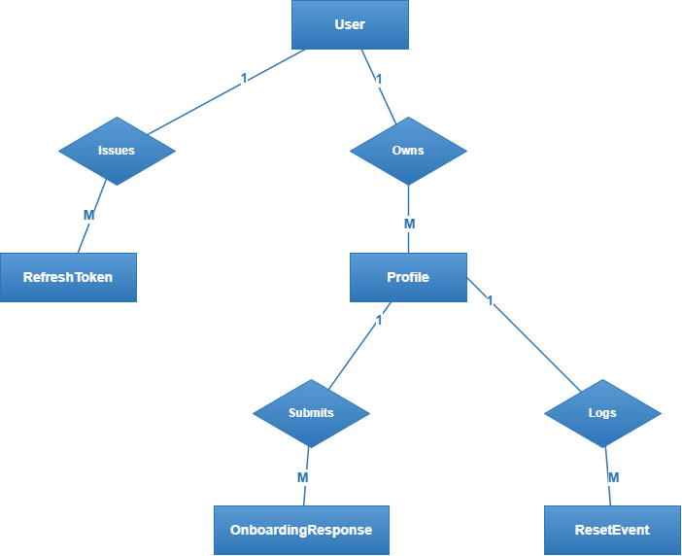
Wallet:
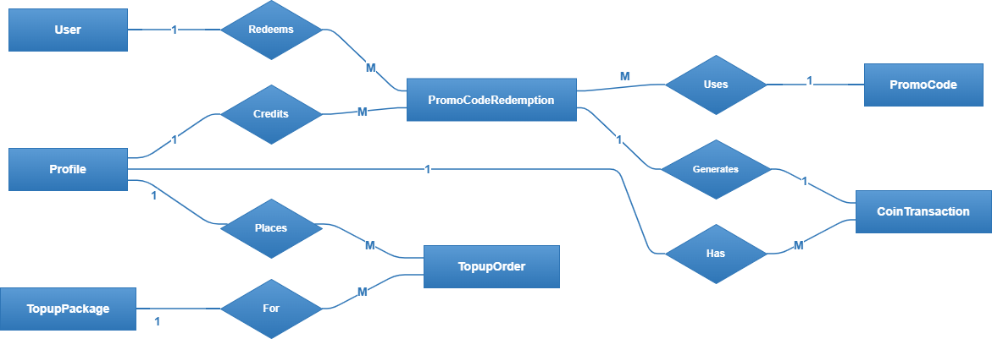
Commerce:
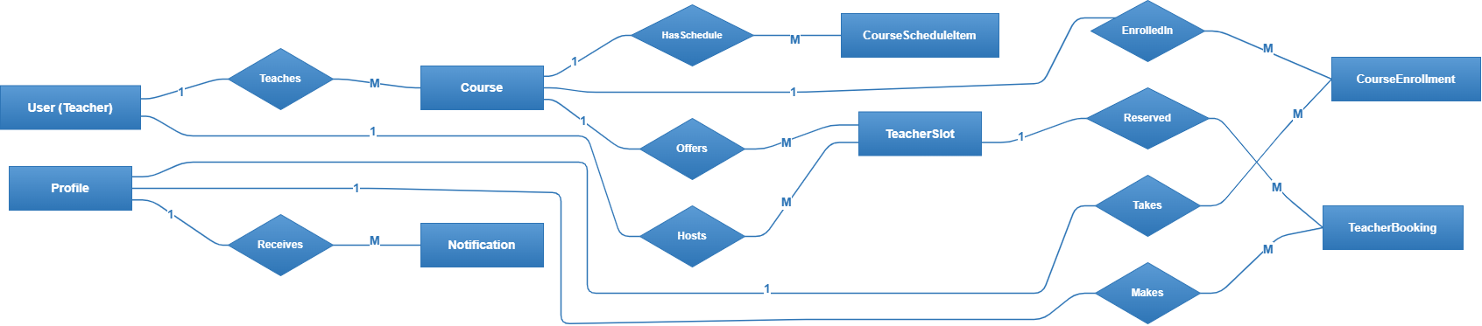
Vocab:
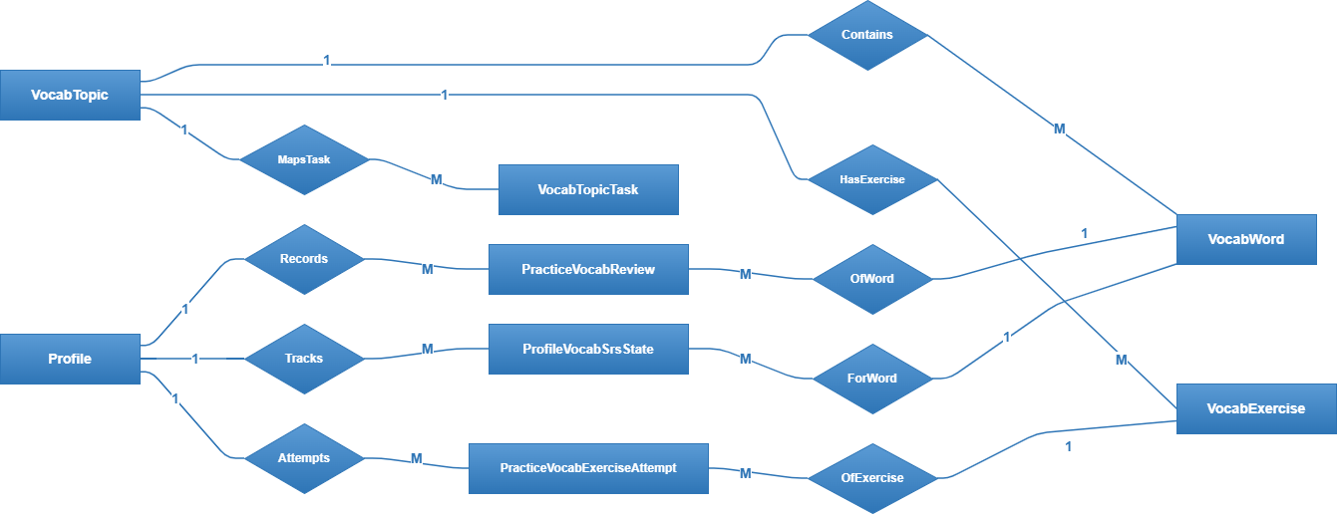

Grammar:
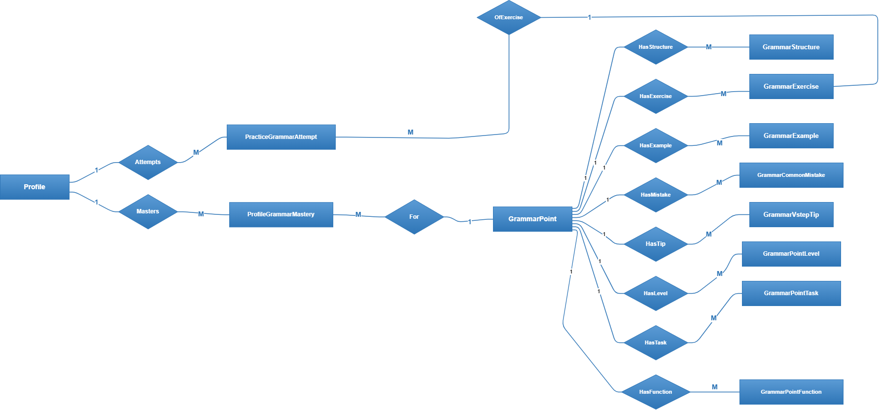

Listening & Reading:
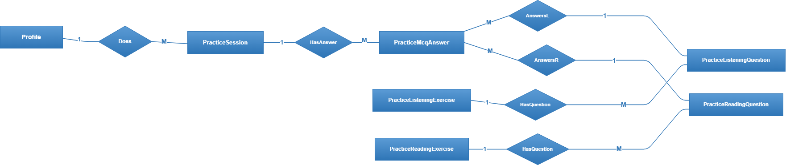
Writing:
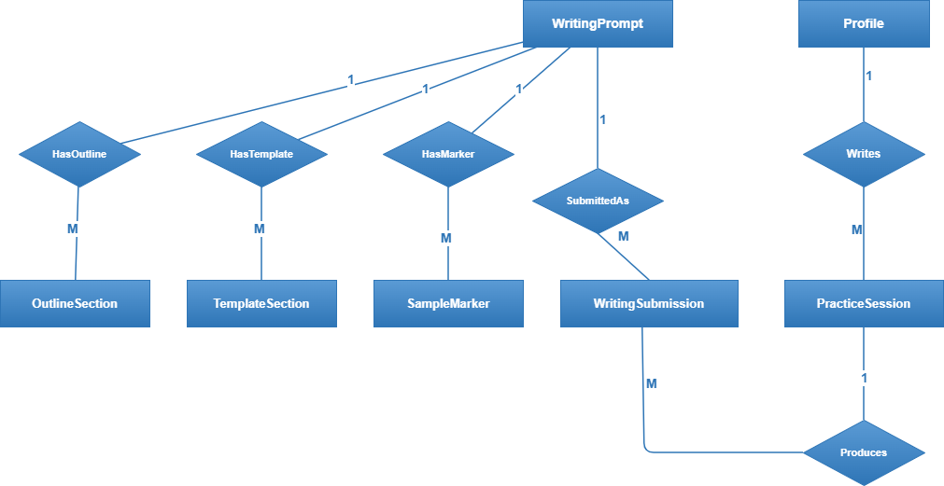

Speaking:
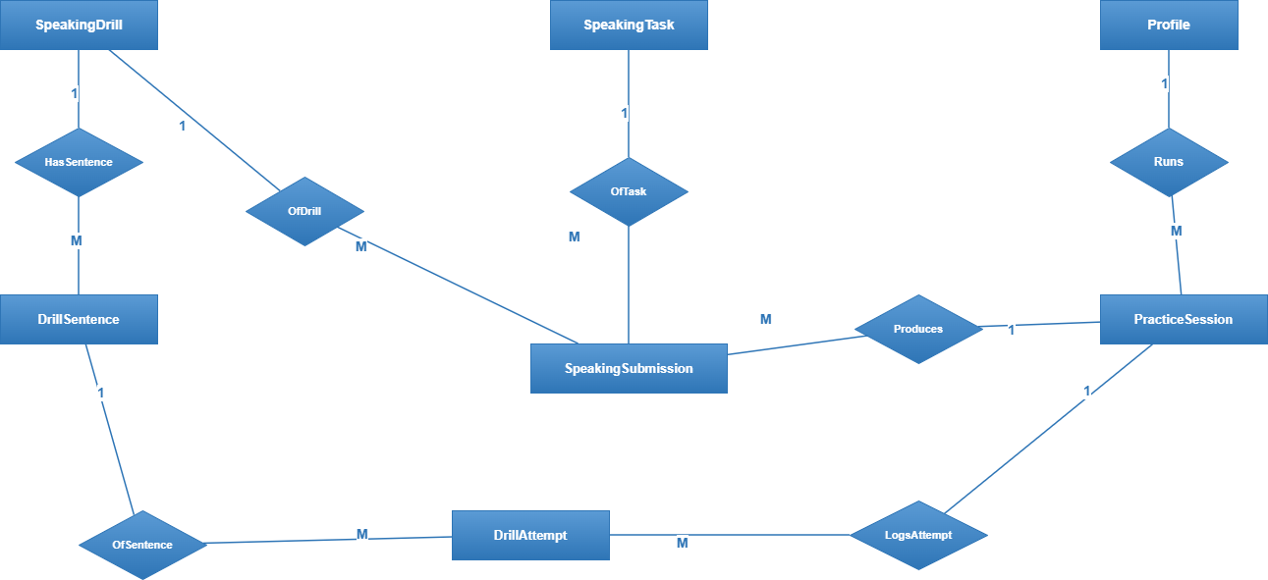
Exam Content:
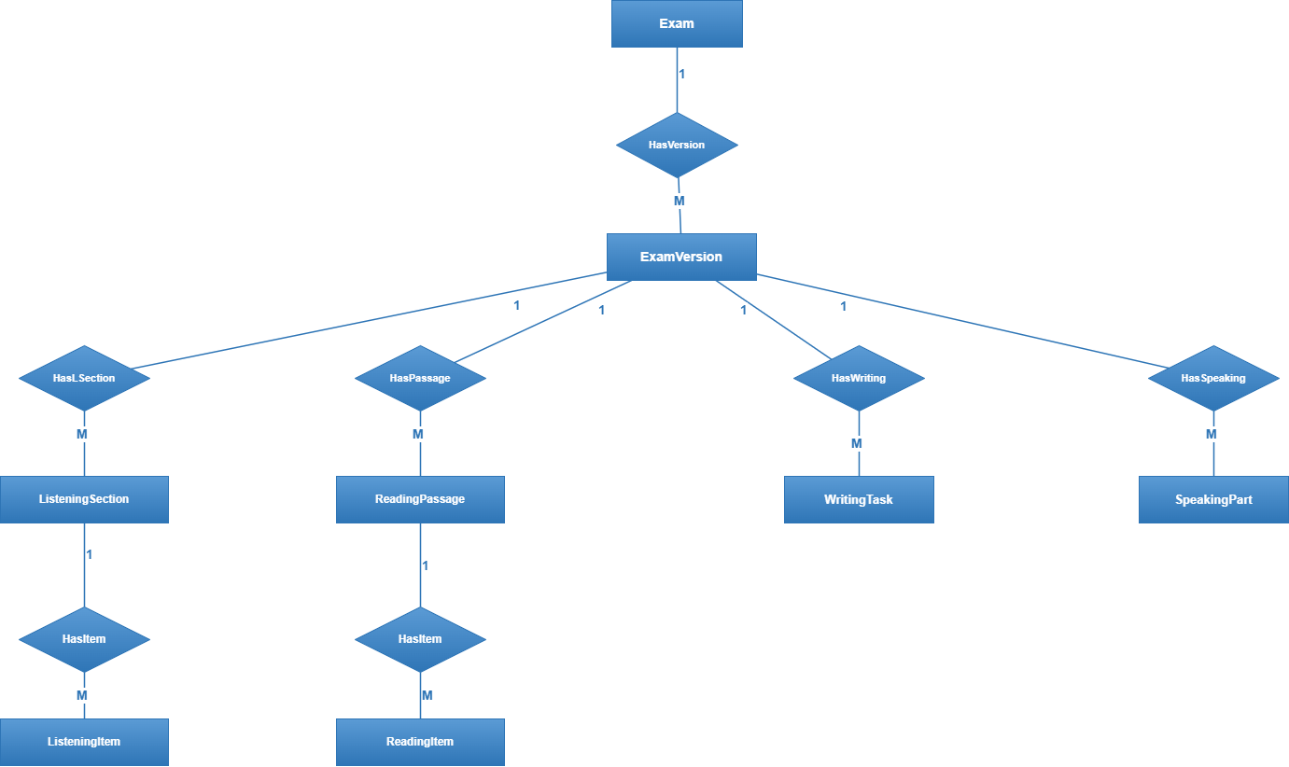

Exam Session:
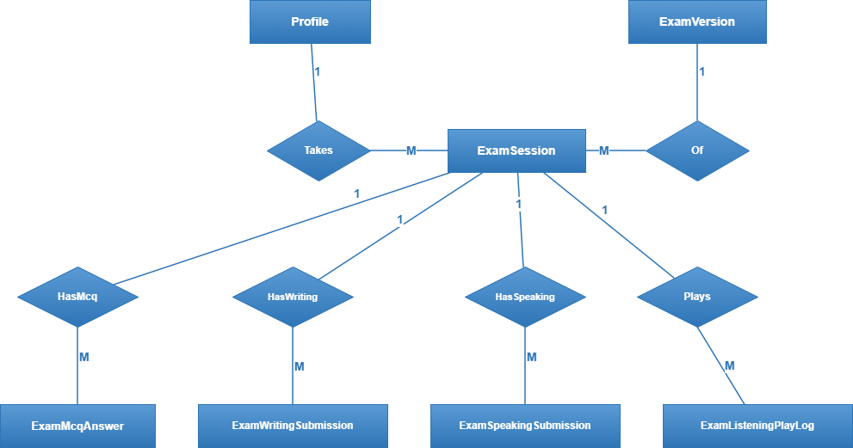

Grading + Session:
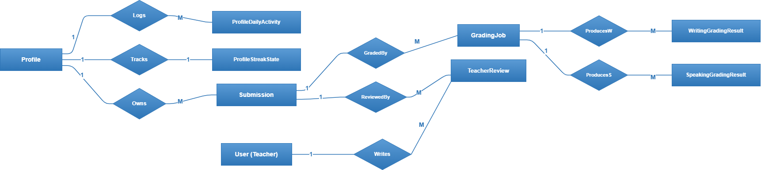
Entities Description
# | Entity | Description
1 | User | Account identity with role such as learner, teacher, staff or admin.
2 | Profile | Learning profile owned by a user and used as active study/payment context.
3 | Wallet / WalletTransaction | Coin balance and transaction ledger.
4 | VocabTopic / VocabWord / SrsReview | Vocabulary content and FSRS scheduling state.
5 | GrammarPoint | Grammar content and exercises.
6 | PracticeExercise / PracticeSession | Listening/reading MCQ exercises and sessions.
7 | WritingPrompt / WritingSubmission | Writing prompt, submitted text and feedback.
8 | SpeakingDrill / SpeakingTask / ConversationSession | Speaking drill, VSTEP speaking and AI conversation data.
9 | Exam / ExamVersion / ExamSession | VSTEP mock exam structure, session, draft and result.
10 | GradingJob | Asynchronous AI grading job.
11 | Course / Enrollment / TeacherBooking | Course catalog, enrollment and 1-on-1 booking.
12 | PromoCode / TopupPackage / TopupOrder | Commerce configuration and payment order data.
13 | Notification / SystemConfig | Notifications and runtime configuration.

3.2 Core Functional Features

3.2.1 Learner Study, Practice and Exam Flows
Learner functions are triggered from landing/login, dashboard, profile, practice tabs, exam library, course pages and focused exam/practice screens. Backend validates active profile, coin balance, word counts, permissions and submit states.
- Function trigger: learner navigation and form/action submission from frontend-v3 routes.
- Function description: authenticate, manage profile, learn content, submit practice/exam answers, receive AI feedback, manage wallet and booking.
- Screen layout: replace this template image with VSTEP learner screenshots.
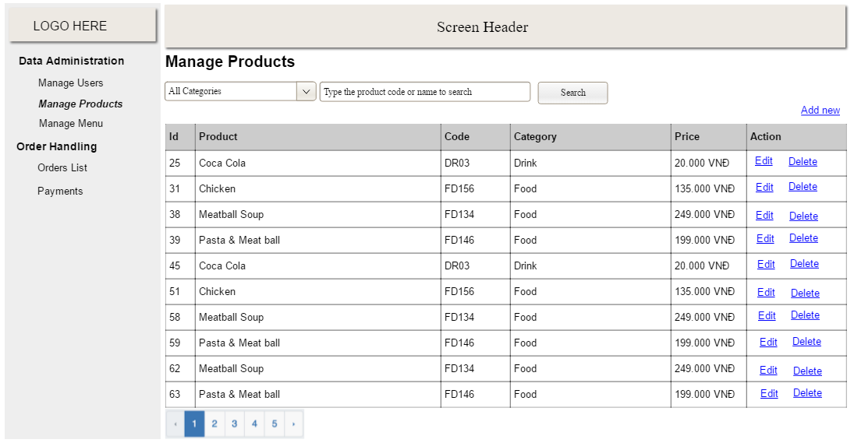
- Function details: see feature tables, business rules and use cases in this document.

3.2.2 Admin, Staff and Teacher Operations
Admin/staff functions include dashboard analytics, users, courses, exams, vocabulary, grammar, practice content, promo codes, top-up packages and system configuration. Teacher functions include dashboard, schedule, bookings and leave requests.

3.3 Backend Services and Integrations
Backend services include JWT authentication, role hierarchy, active profile context, payment callback handling, wallet transaction consistency, AI grading pipeline, SSE streaming, notification generation, health/config endpoints and FSRS scheduling.

4. Non-Functional Requirements

4.1 External Interfaces
External interfaces include learner web, admin/teacher web, backend REST API, SSE grading stream, AI provider and payment gateway callback.

4.2 Quality Attributes
Quality requirements are based on current implementation and Report 5 non-functional test scope.

4.2.1 Usability
The UI must be usable without special training, use clear Vietnamese learner-facing messages, show informative empty/error states and protect exam/practice focus mode from accidental exit.

4.2.2 Reliability
The system must preserve data consistency after exam submit, wallet top-up and draft autosave/restore. AI grading and payment callbacks must not corrupt learner results or coin balance.
Availability: local/staging environment should keep core learning and exam APIs available during normal testing.
MTBF/MTTR: critical learning/exam flows should recover by refresh/re-login without data loss when draft exists.
Accuracy: MCQ scoring, coin deduction/credit and role permission checks must match backend source of truth.
Maximum defect rate: critical bugs must not affect authentication, payment, exam submit, AI feedback result storage or authorization.
Critical defect definition: any bug causing unauthorized access, wrong wallet balance, lost exam submission or inaccessible core exam/practice flow.

4.2.3 Performance
Common API requests should respond under 2 seconds in normal local/staging usage. AI grading target is under 3 seconds for the test scope, with pending/SSE/polling states when generation is not complete.
Response time: common API < 2 seconds; grading target < 3 seconds under test conditions.
Throughput: supports concurrent learner practice/exam requests in capstone testing scope.
Capacity: supports seeded capstone data for learners, profiles, exams, content and courses.
Resource utilization: frontend runs in Chrome; backend uses Laravel API, database, queues and external AI/payment integrations.

4.2.4 Security and Compatibility
Protected APIs require bearer token authentication. Role hierarchy must prevent learner access to admin APIs and staff access to admin-only APIs. The learner web must support Chrome compatibility.

5. Requirement Appendix
Business rules, common requirements and messages are listed below.

5.1 Business Rules
Business rules are consolidated from backend routes, services and Report 5 test cases.
ID | Rule Definition
BR-01 | One user may own multiple profiles; one profile represents one target/course context.
BR-02 | Changing target creates a new profile; existing profile target is not overwritten.
BR-03 | Learner APIs requiring study context must have an active profile.
BR-04 | New learner/onboarding bonus grants 100 coins when applicable.
BR-05 | Full exam costs 25 coins; custom exam costs 8 coins per selected skill.
BR-06 | Practice exercises use attempt/answer flow; exams use submit flow.
BR-07 | Spider chart is hidden until at least five graded full-test exams.
BR-08 | FSRS adaptive scheduling applies to vocabulary review only.
BR-09 | Writing/speaking feedback displays Strengths, Improvements and Rewrites.
BR-10 | Learner cannot access admin/staff APIs; staff cannot access admin-only APIs.
BR-11 | Payment callback is public but must be validated before crediting coins.
BR-12 | Booking cannot exceed configured limits and may require commitment gate.

5.2 Common Requirements
Common requirements: responsive web UI, consistent API response envelope { data: T }, role-based authorization, no password leakage, clear Vietnamese feedback, and predictable loading/error states.

5.3 Application Messages List
# | Message code | Message Type | Context | Content
1 | MSG-AUTH-01 | Inline / Toast | Login failed | Email or password is incorrect.
2 | MSG-AUTH-02 | Toast | Session expired | Your session has expired. Please log in again.
3 | MSG-PROF-01 | Toast | Onboarding completed | Welcome gift has been added to your wallet.
4 | MSG-WAL-01 | Inline | Insufficient coins | Your coin balance is not enough for this action.
5 | MSG-WAL-02 | Popup | Promo redeemed | Promo code redeemed successfully.
6 | MSG-EXAM-01 | Dialog | Leave exam | Are you sure you want to leave the exam room?
7 | MSG-EXAM-02 | Overlay | Time expired | Time is up. Your exam will be submitted automatically.
8 | MSG-WRI-01 | Inline | Writing too short | Your answer does not meet the minimum word requirement.
9 | MSG-GRD-01 | Status | AI grading pending | Your feedback is being generated. Please wait.
10 | MSG-SEC-01 | Error | Forbidden | You do not have permission to access this resource.

5.4 Other Requirements…

