***Wavelength Routing and Assignment Project***

***Wavelength Division Multiplexing technology***

Dang Le Bao Khanh - 1148550

Electrical Engineering and Information Technology

Vietnamese - German University (VGU)

Binh Duong, Vietnam

Eeit2014_Khanh.dlb@student.vgu.edu.vn

Nguyen Minh Hieu - 1148453

Electrical Engineering and Information Technology

Vietnamese - German University (VGU)

Binh Duong, Vietnam

Eeit2014_Hieu.nm@student.vgu.edu.vn

Nguyen Gia Khanh - 1148563

Electrical Engineering and Information Technology

Vietnamese - German University (VGU)

Binh Duong, Vietnam

Eeit2014_Khanh.ng@student.vgu.edu.vn

*Abstract* — Contemporary, seventeen large cities in Germany are linked together by optical fibers in an interconnected system called “German 17-node backbone network”. Every link between two cities consisting two optical fibers with eight wavelengths each. To effectively optimize the use of this backbone network, all lightpath requests behave in a dynamic manner. In this light, if a lightpath is fully assigned a specific route and wavelength, it would only remain in the loop for a set period. After this set amount of time, the dedicated resources would be freed up and available for the next requests. From that understanding and the provided topology, this report aims to illustrate an algorithm which could reduce significantly the blocking probability, ensure a fast connection speed for all citizens in Germany and solve the problem indicated from the Digital Routing course.

Keywords — network map; wavelength division multiplexing technology; linear programming problem; wavelength routing and assignment.

# Introduction

Wavelength Division Multiplexing (WDM) is a technology that is capable of multiplexing multiple carrier signals transmitted via optical fiber using a single cable. By utilizing and adding different wavelengths of laser light, this technique can make use of the large bandwidth of the optical fiber. The scope of this project is to comprehensively understand the concept of Wavelength Routing and Assignment (WRA), and by examining the provided topology, a lightpath optimization algorithm shall be developed and tested. The main challenge for such algorithm is its ability to take in account the wavelength continuity constraint - a terminology stating that a light path must use the same wavelength on all links it passes through in the process of transmission – in order to utilize the efficiency of the wavelength resources and ultimately keep the blocking probability as low as possible. To fully implement the code, a topology of the German 17-node backbone network topology which visualizes the linking backbone system interconnecting large cities in Germany together is used as the practical mean. The code was written in Python 3.6 and Spyder was used as Integrated Development Environment (IDE) in this project.

# A Linear Programming Approach

We consider solving the RWA problems jointly for an optical network. We have [1, Fig.1] to illustrate the most general level. Initially, there are already some established lightpath requests. After that, more requests will arrive one at a time and terminated randomly. New requests need to be assigned to their routes and wavelengths without changing the existing lightpaths. A problem arises from this, however, that is some of the lightpath requests will be blocked due to limited number of wavelengths. Since blocking lightpaths comes with an associated cost, we want to minimize the sum of the expected blocking costs. This problem is involved with dynamic programming that models the randomly determined nature of future lightpath arrivals or departures and incorporates this information into the decision taken every time a route or wavelength is assigned.

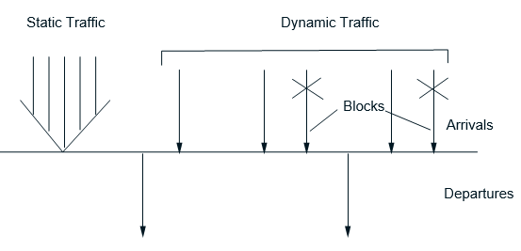

Fig. 1. Static and dynamic/stochastic traffic model [1, p.6].

Dynamic programming problems variables for optimization/decision are the decisions that the RWA need to make each time there is a new lightpath request. The set of established plus the new lightpath requests is the state of the system, and based on the RWA decision, the new state is changed. However, this dynamic programming has a significantly large state space. While approximation is a possible way to address the computational difficulty, we prefer using another method in this paper. Despite this method being more static in its characteristic, it still solves the dynamic nature of the problem by spreading the traffic in a way that links are not operated close to their limit.

We take the desired multicommodity flow formulation as our new approach which includes several flow types or “commodities” using the network at the same time and being connected through either link capacities or cost function. Generally, the form of the desired multicommodity formula is:

$min\sum_{l∈L}{D_{l}(f_{l})}$ (1)

subject to the conservation including flow constraints and special constraints, if any, in which *fl* denotes the total flow on link *l*, while the set of all links in the network is denoted by *L*. A convex and monotonically increasing function has to be the shape of the link cost function *Dl*. Moreover, being able to spread the traffic and keep the link flows away from the its limit are the desired outcomes of this formulation, which in turn gives an efficient bandwidth usage and minimizes blocking of new incoming traffic.

When we have to deal with optical networks, each commodity is bounded to every lightpath that is established between nodes in the network. First, let us handle a simple case where all routing nodes have full wavelength conversion. In this case, we do not consider the distinction between the available wavelengths, in other words, we don’t have to satisfy the wavelength continuity constraint along the lightpaths and the capacity constraint where the number of wavelengths on each link is just considered as the total number of lightpaths crossing that link. That is the reason these networks are similar to a circuit-switched network. The optimal routing-wavelength assignment problem for such networks reduces only to finding a route for each lightpath, which is done while the capacity constraints are satisfied with the resulting flows without assigning a specific wavelength. (Flow is measured in a number of lightpaths in optical networks, that is to say, ﬂow on a link correlates to the number of lightpaths crossing that link and ﬂow of a path correlates to the number of lightpaths using that path).

The problem can be now stated as follows: assuming that we have a graph *A = (N, E).* *N* would stand for a nodes set and *E* for edges set. Let us also assume that we have a set of source-destination (S,D) pairs, where each (S,D) has a form of *w = (a, b)* of different nodes *a* and node *b*. (S,D) pair *w* has an input traffic *rw*, where *w* is a non-negative integer that represents the quantity of connection requests from node *a* to *b*. This also means that lightpath requests are unidirectional, that is to say, a lightpath request from node *a* to node *b* does not imply a reversed path. Denote:

*L       =* Set of all links in network,

*W =* Set of all (S,D) pairs,

*Pw     =* Set of all paths that a (S,D) pair *w* may use,

*C =* Set of all wavelengths/colors available on each link.

The problem can be formulated in terms of a collection of path ﬂows {*xp* | *w* ∈ *W, p* ∈ *Pw*}, where *xp* represents the ﬂow of path *p* ∈ *Pw* for some *w* ∈ *W* and an integer with non-negative value is taken. *fl* is the total ﬂow on link *l* ∈ *L* which can be expressed in terms of the path ﬂows traversing link *l* as

$${ f}_{l}=\sum_{\{p∈P_{w} | l∈p\}}{\sum_{ w∈W}{x_{p}^{w},}}$$

where we write *l* ∈ *p* if link *l* belongs to path *p*. Then, the problem takes the following form:

$$min\sum_{l∈L}{D_{l}(f_{l})}$$

subject to

$f_{l}=\sum_{\left\{p∈P_{w}\right|l∈p\}}{\sum_{ w∈W}{x_{p}^{w}}},∀ l∈L,$ (2)

$f_{l}≤ \left|C\right|,∀l∈L,$ (3)

$\sum_{p∈P_{w}}{x_{p}}= r_{w},∀w∈W,$ (4)

$x_{p}∊Z_{≥0},∀w∈W and p∈P_{w},$ (5)

where |*C*| denotes the cardinality of set *C*, i.e., the number of available wavelengths. The limitation of constraint on each link given by the number of usable wavelengths is represented by the first constraint, while the requirement that the demand of each (S,D) pair has to be reflected in the resulting path ﬂows is represented by the second constraint.

Based on the above formulation, the sum of link cost function results in the overall cost function and every link cost function relies on the amount of flow on each link. Hence, the function *Dl* has to be piecewise linear as shown in [1, Fig. 2]. This cost function has two main elements that affect considerably on the nature of the desired solution:

(a) Cost function of every link must have a convex shape, monotonically and piecewise linear due to the fact that the marginal cost for routing preceding lightpaths must be at least lower than a half of the marginal cost for routing a new lightpath over a given link.

(b) Every piecewise linear link cost function has its breakpoint occurred at the integer points 0, 1... |*C*| (see [1, Fig. 2]). The cost for ﬂow larger than |*C*| is ∞, thereby satisfying the link capacity constraint.

Due to feature (a), underused links are more likely to chosen in order to have the optimal solution. And because of feature (b), the resulting optimal solution is often integer which is the reason there is no need for tedious integer programming techniques.

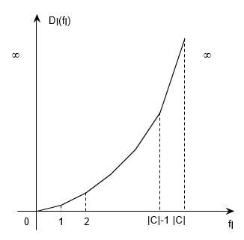

Fig. 2. Cost function *Dl* [1, p.6].

In networks without wavelength conversion, due to the existence of the wavelength continuity constraint, the calculation of flow in a link (2) needs to be modified. In these cases, each lightpath has to be separated from others by aspects such as wavelength/color. Hence, the routing wavelength assignment problem can also be formulated for optical networks without the need for wavelength converters in terms of a path-wavelength vector:

{| *p* ∈ *Pw, w* ∈ *W, c* ∈ *C*}

The variable $x_{p}^{c}$ takes a value of 0 or 1, and its meaning is

$x_{p}^{c}$ $=\left\{\begin{aligned}1, &if wavelength c is used by path p, \\ 0, &otherwise.\end{aligned}\right.$ (6)

The total ﬂow on link *l* ∈ *L, fl*, can be expressed in terms of the $x_{p}^{c}$ as

$$f_{l}=\sum_{\{p∈P_{w}|l∈p\} }{\sum_{c∈C}{\sum_{w∈W}{x_{p}^{w,c}}}}.$$

Then, the problem formulation is given by

$$min\sum_{l∈L}{D_{l}(f_{l})}$$

subject to

${ f}_{l}=\sum_{\{p∈P_{w}|l∈p\} }{\sum_{c∈C}{\sum_{w∈W}{x_{p }^{w,c}}}},∀l∈L,$ (7)

$\sum_{\{p∈P_{w}|l∈p\} }{\sum_{w∈W}{x_{p }^{w}}}≤ K,∀l∈L and c∈C,$ (8)

$\sum_{c∈C}{\sum_{p∈P_{w}}{x_{p}^{c}}= r_{w},∀w∈W, }$ (9)

$x_{p}^{c}∊\left\{0\right.$, $\left.1\right\}, ∀ w∈W, p∈P_{w} and c∈C,$

where *Dl* is a piecewise linear, monotonically increasing, convex function, with break points at 0*,* 1*…*|*C*|, as shown in [1, Fig. 2]. Here, the capacity constraint that each wavelength on each link can be used at most *K* > 0 time(s) is represented by the first constraint, while the demand constraint of (S,D) pairs is represented by the second constraint.

# Converting Algorithm To Python Code And Solving Given Problem

## Routing and Wavelength Assignment Problem

We are given a map of system called “German 17-node backbone network” as in Fig. 3. There are in total 17 nodes and 26 links in the whole network map.

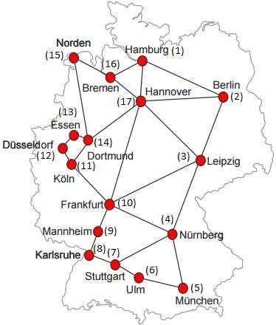

Fig. 3. German 17-node backbone network [6, p.3].

Each link consists of 2 identical optical fibers and each fiber has a capability of 8 wavelengths. This is a dynamic traffic with the mean inter-arrival time between 2 subsequent requests and the mean holding time of a lightpath are $\frac{1}{λ}$ and $\frac{1}{μ}$, respectively. Both these mean values must follow the exponential distribution. Once the holding time expires, the respective lightpath has to be removed from the network map and the using resource (wavelength) will be released which will then be processed for many future incoming requests. Each lightpath comes with a random source and destination following the uniform distribution type in the whole network.

## Brief Python Code Explanation

In our algorithm, we choose ${ D}_{l}\left(f_{l}\right)=4f_{l}^{2}$ in [1, (1)], || = 2 in [1, (8)] due to 2 identical optical fibers and handle totally 10000 random coming requests.

At first, when there is a coming request which requires to establish between nodes A and B, the algorithm will find all paths from A to B. After that, it will check for each path whether any available wavelength. If there are no free wavelength in all paths, the request would be considered to be blocked. Otherwise, it will continue to calculate the cost for every possible path using the linear programming technique in order to determine the optimal one which has the lowest cost. Then a proper wavelength would be assigned to this path and a connection is established.

Our Python code uses networkx 2.0 library to draw the network map and Depth First Traversal (DFS) algorithm to find all paths between any arbitrary 2 nodes. 10000 requests are simulated by using multithread technique with built-in random functions: *random.choice()* for sources or destinations and *random.expovariate()* for inter-arrival as well as holding time.

## Results

We ran our simulation for investigating the blocking probability for five values of $\frac{λ}{μ}$, which are 100, 200, 300, 400 and 500. For each ratio, we ran the simulation test at least 20 times to get the most reliable average results as illustrated in Table I and Fig. 4.

As we can see, in Fig. 4, the performance curve has a desired increasing parabolic shape which has an asymptote at horizontal line y = 100%. It is also worth noting out that the higher traffic intensity network has to handle, the larger number blocking probability increases to.

1. Blocking Probabilities of Network in Different Traffic Intensity Scenarios

|  |  |
| --- | --- |
| **Traffic Intensity (*λ*/*μ*)** | **Blocking Probability (*%*)** |
| 100 | 0.00 |
| 200 | 11.47 |
| 300 | 16.20 |
| 400 | 19.54 |
| 500 | 22.63 |

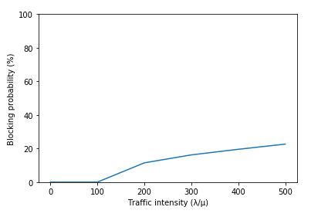Fig. 4. Network performance

# Conclusion

In this paper, networks with/without wavelength conversion capabilities were introduced with an alternative and reliable RWA formula in an effort of developing an eﬃcient method for computing optimal or near-optimal RWA policies under realistic assumptions. We also offer new integer-linear programming formulation that usually have integer optimal solution even when the integrality constraints are relaxed, which allowed fast and highly efficient linear programming methods to solve the problem. The resulting solution for such specific structure has proven to be optimal. Optimal or near-optimal routing solution can be found in arbitrary networks with/without full wavelength conversion capability using our new efficient algorithm. An interesting research problem is that one must come up with a proper method of placing wavelength converters at some of the nodes of a given random network, therefore a valid wavelength assignment for any integer routing can be found using the same approach.

##### Acknowledgment

We would like to acknowledge first and foremost, Dr. Duong Pham Thanh for his tirelessly contributions in helping us to solve the linear programming problem. We also want to give credit for Dr. Nga Tran Phuong for opening up this valuable opportunity to practice our understanding from the Digital Routing course of 2017 in a meaningful way.

##### References

[1] A. E. Ozdaglar and D. P. Bertsekas, "Routing and Wavelength Assignment in Optical Networks", Dept. of Electrical Engineering and Computer Science, M.I.T., Cambridge, Mass., 02139, December 2001.

[2] A. E. Ozdaglar and D. P. Bertsekas, "Optimal Solution of Integer Multicommodity Flow Problems With Application in Optical Networks", Dept. of Electrical Engineering and Computer Science, M.I.T., Cambridge, Mass., 02139, Santorini, Greece, July 2003.

[3] T. S. Ferguson, “LINEAR PROGRAMMING - A Concise Introduction”.

[4] Banerjee, D., and Mukherjee, B., “A Practical Approach for Routing and Wavelength Assignment in Large Wavelength-Routed Optical Networks”, IEEE J. Select. Areas Commun., vol. 14, no.5, pp. 903-908, June 1996.

[5] Ramaswami, R., and Sivarajan, K. N., “Routing and Wavelength Assignment in All-Optical Networks”,  
IEEE/ACM Transactions on Networking, vol. 3, pp. 489-499, Oct. 1995.

[6] Nga. Tran Phuong, "Wavelength Routing and Assignment Project", Binh Duong Province, 2017.