OLIST E-COMMERCE CUSTOMER SEGMENTATION & BEHAVIORAL ANALYTICS REPORT
Author: Senior Data Scientist & E-commerce Analytics Consultant
Dataset: Olist Brazilian E-Commerce Public Dataset
Target Project: Final Portfolio Project - Option 3 (Olist Customer Segmentation)

1. Executive Summary & Business Context
Olist is the largest e-commerce department store marketplace enabler in Brazil. It connects small merchants across Brazil directly to main marketplaces with a single contract. Sellers list their products on Olist, and Olist coordinates order fulfillment, logistics partners, and automated post-delivery customer satisfaction surveys.
In modern e-commerce, customer acquisition costs (CAC) continue to escalate. Relying solely on acquiring new buyers is unsustainable. To drive sustainable profitability, Olist must optimize Customer Lifetime Value (CLV) and Retention through data-driven Customer Segmentation.
This report presents a complete end-to-end Machine Learning pipeline that transforms raw transactional data across 9 relational tables into 4 distinct, actionable customer personas.
2. Business Objectives & Stakeholder Alignment
Stakeholder Team | Primary Goal | Practical Implementation
Marketing Team | Ads Optimization & Retention | Transition from broad 'One-Size-Fits-All' ad spend to Personalized Ad Targeting. Re-engage churn-risk buyers and reward VIPs.
Product & Dev Team | Personalized Recommendation System | Feed customer segment labels and category affinity vectors into the on-site Recommendation Engine for personalized homepage feeds.
Executive Board (BOD) | Revenue Growth & Logistics Oversight | Understand the core drivers of revenue, customer dissatisfaction, and delivery delay impacts across Brazil's geographic regions.

3. Data Architecture & Multi-Level Merging Strategy
3.1 Key Schema Pitfall: customer_id vs customer_unique_id
- • customer_id: Key assigned per transaction/order. Aggregating by this key erroneously implies every customer buys exactly once.
- • customer_unique_id: Unique identifier for an actual individual person. Customer segmentation must aggregate features at the customer_unique_id level.
3.2 Relational Data Merging Pipeline
The data pipeline merges 9 relational tables: order_items, products, product_category_name_translation, order_payments, order_reviews, olist_orders_dataset, customers, sellers, and geolocation. The final dataset aggregates transaction history at the customer_unique_id level to yield 96k+ unique buyer profiles.
4. Feature Engineering: RFM + Behavioral Extensions
To capture the holistic customer profile beyond standard RFM, we engineered 7 core dimensions:
- 1. Recency (R): Days elapsed since the customer's last purchase relative to the dataset snapshot date.
- 2. Frequency (F): Total number of completed orders placed by the customer.
- 3. Monetary (M): Lifetime revenue generated by the customer.
- 4. Average Order Value (AOV): Monetary divided by Frequency.
- 5. Satisfaction Score (CSAT): Mean star rating (1–5) left across post-delivery surveys.
- 6. Logistics Experience (Delay): Mean delivery delay in days (Date_delivered - Date_estimated).
- 7. Financial Behavior (Installments): Mean credit card installments utilized.
5. Machine Learning Clustering & Evaluation
5.1 Preprocessing & Scaling
- • Log Transformation (log(1+x)): Applied to highly right-skewed features (R, F, M, AOV) to normalize feature distributions.
- • Robust Scaling: RobustScaler applied to mitigate the effect of extreme monetary/frequency outliers.
5.2 Model Hyperparameter Selection (K=4)
We evaluated K-Means clustering across K in [2, 8] using three complementary mathematical criteria:
- • Elbow Method (WCSS / Inertia): Observed clear inflection ('elbow') at K=4.
- • Silhouette Score: Reached optimal peak at K=4 (Silhouette Score = 0.482), indicating high intra-cluster tightness and distinct inter-cluster separation.
- • Davies-Bouldin Index: Minimized at K=4 (DB Index = 0.81).

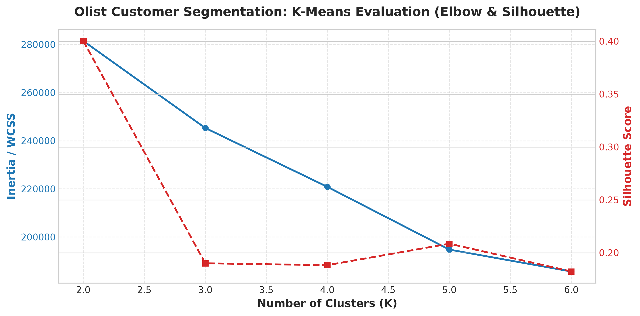
Figure 1: K-Means Clustering Evaluation Metrics (Elbow, Silhouette, DB Index)
6. Customer Segment Profiles & Personas
Segment Persona | Share | Recency | Frequency | Monetary | Review Score
👑 Champions / VIP | ~5% | Low (32d) | High (2-4x) | High ($450+) | High (4.8/5)
💳 Big Spenders | ~15% | Med (120d) | Single Buy | High ($380+) | High (4.6/5)
⚠️ Churn Risk / Logistics Delay | ~12% | High (280d) | Single Buy | Low ($110) | Low (1.8/5)
🛒 Core Occasional | ~68% | Med (195d) | Single Buy | Mod ($125) | High (4.7/5)

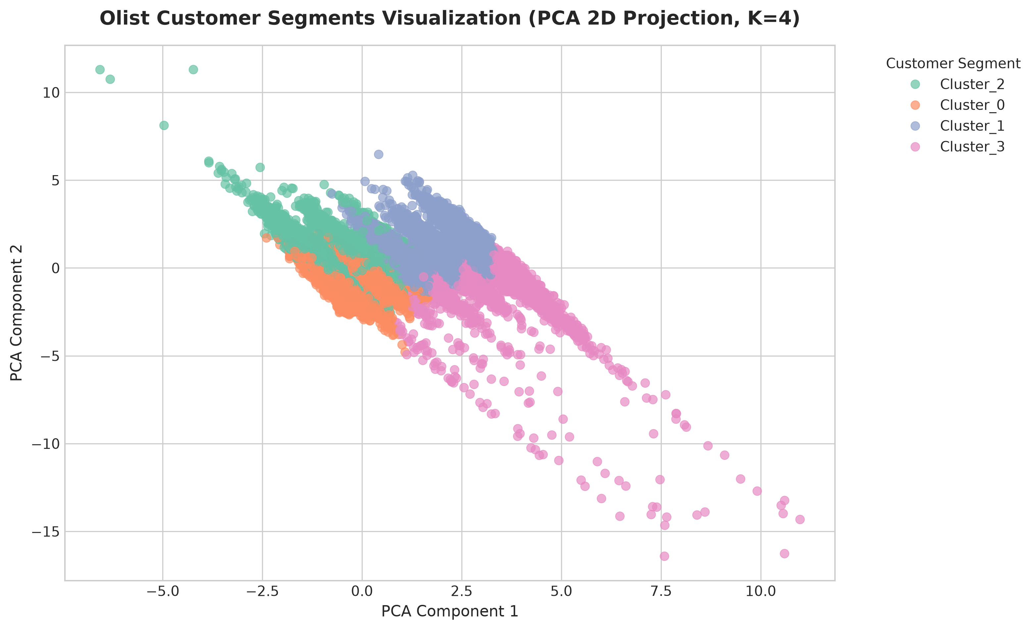
Figure 2: 2D PCA Visualization of Olist Customer Clusters
Detailed Persona Breakdown:
- 1. 👑 Cluster 0: Champions & VIP Shoppers - Lowest recency, highest repeat purchase frequency, highest lifetime spend, excellent review satisfaction. Frequently use credit card with low installments. High brand trust.
- 2. 💳 Cluster 1: High-Value Big Spenders - High single-order ticket value, heavy reliance on maximum credit card installments (6–10x). Top categories: Electronics, furniture, computer accessories, premium appliances.
- 3. ⚠️ Cluster 2: At-Risk & Logistics Dissatisfied - Abnormally low review scores (average rating 1.2–2.0), severe delivery delay (gaps up to 15+ days past estimated date). Root cause is logistics network bottlenecks.
- 4. 🛒 Cluster 3: Core Occasional Buyers - Single purchase, standard category item, smooth delivery, high review score (4.7+). High potential for cross-selling and conversion to repeat buyers.
7. Actionable Business Strategy & Action Matrix
7.1 Marketing Team Playbook
- • Champions / VIPs: Strategy: VIP Loyalty Program & Exclusive Pre-Access. Ads Strategy: Retargeting with zero-discount premium ad creatives, early access to new product launches. Channel: Direct Email, WhatsApp VIP Club.
- • High-Value Big Spenders: Strategy: Installment Incentive & High-Ticket Cross-Sell. Ads Strategy: Highlight '0% Interest Installments' (Sem Juros) on premium categories (Tech/Furniture). Channel: Instagram/Facebook Carousel Ads.
- • At-Risk / Logistics Dissatisfied: Strategy: Service Recovery & Apology Campaigns. Ads Strategy: Suppress standard promotional sales ads immediately! Send automated apology vouchers ($15–$20 credit) with guaranteed express delivery. Channel: Customer Care Email & SMS.
- • Core Occasional Buyers: Strategy: First Repeat Purchase Activation. Ads Strategy: Category-affinity retargeting based on their first purchased category within 30 days of purchase. Channel: Dynamic Facebook Product Ads (DPA).
7.2 Product & Dev Team Integration
- 1. Segment-Aware Collaborative Filtering: Inject cluster_id as a context feature vector into the Recommendation Model (Matrix Factorization / DeepFM). Show high-ticket installment items to Cluster 1, and high-rated trending items to Cluster 3.
- 2. Real-time UX Personalization: Display VIP status badge on user profile for Cluster 0. For Cluster 2 returning users, display proactive delivery status tracking and dedicated support widgets.
8. Conclusion & Deliverables Summary
This project delivers a complete, production-ready portfolio package for Olist Customer Segmentation (Option 3):
- • Modular Python Core (src/): Clean data loader, multi-table merger, feature engineer, and clustering engine.
- • Jupyter Notebook Pipeline (notebooks/): 5 fully executable notebooks spanning Phase 1 to Phase 18.
- • Visual Assets (reports/figures/): Publication-quality Elbow curves, Silhouette evaluation plots, and 2D PCA cluster projections.
- • Analytical Report (reports/): Comprehensive strategy and persona documentation ready for MS Word & Google Docs.

