Customer Information
- Quick customer look-up to find customer details
- Choose what data to save
- Check customer history

Free up staff with Online Bookings
- Let customers book repairs even when you are not in the shop, 24/7.
- Live availability for online bookings.
- Take payments online.
- Visual overview of your bookings.
- Let customers choose different service offerings online.
- You can configure when you want to take booking, and for what duration.
- Works with mobile phones.

Stay on top of workload with mechanics workflow
Make your repairs super easy
  - With a click of the button see which bike need most urgent attention.
  - Shows you what repairs need doing.
  - Use barcodes to make workflow admin super speedy.

Store repair and maintenance data
Keep your maintenance records centralised in BRM.
  - Record all repair and service history for each bike, either manually or automatically with barcodes.
  - Keeps a record for your liability insurance.
  - Easily available any time anywhere.

Store maintenance data
Keep your maintenance records centralised in BRM.
- Record all service and repair history for each asset, either manually or automatically with barcodes.
- Keeps a record for your liability insurance.
- Easily available any time anywhere.

Bike intro
The two wheelers segment consisting Scooters and Motorcycles, has seen the fastest growth in the recent decade in our country. The two wheelers have reached the farthest corners of country and very small towns and hamlets have also boasted of atleast one two wheeler. These two wheelers regular normal service and repairs for safety and durability of the vehicle. Especially in Urban and Semi urban areas, 2 wheeler Service station is a most common business activity. Such a service station can be established by entrepreneurs having experience, with very low investment.

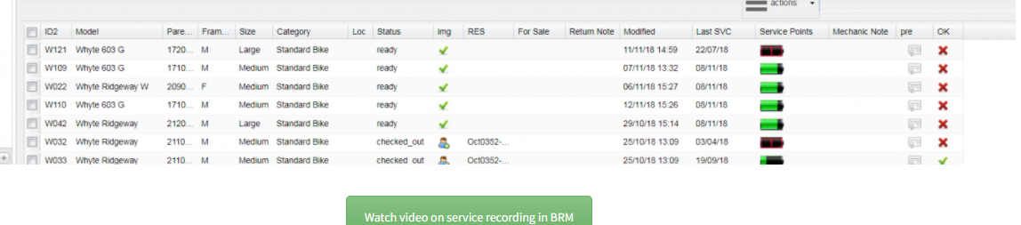

Why Use Repair Pilot?
• Increased Efficiency Across Your Business
• Improve Your Customers' Experience
• Automated Email/SMS Updates
• Simple to Use - Little to No Staff Training
• Allow Your Customer to Track Progress Online 24/7
• Access Anywhere, Anytime and on Any Device
• Know Your Numbers with Real Time Reporting

Increase Revenue
Repair Pilot can automate service and renewal reminders, increasing repeat custom and recurring revenue.

Increased Efficiency
The simple and intuitive interface allows your staff to do what they need too with minimal effort.

Increased Customer Experience
Give your customer access to the customer portal where they can see their job history, invoices, request quotes and more.

Online bike service project in java is a web application. Where a user can request the bike servicing. Users can pay bills online so it will be easy to maintain the record of the bike servicing process. The complete process of bike servicing will be managed online. There is no need to maintain the record manually.

- Customers will register and log in to the system, where they will be able to request servicing for their vehicle by giving information (vehicle number, model, problem description etc.).
- If the customer changes their mind or the request is not approved by the admin, the customer can delete the request (enquiry).
- Customer can see/edit their profile and check the status of their Request(Enquiry), which can be Pending, Approved, Repairing, Repairing Done, or Released.

This is a PHP Project entitled Vehicle Service Management System. This project is a simple web application for a vehicle repair/service shop or business. This application provides an online platform for the said shop's clients or possible clients to submit their service requests. This project can help to lessen the time consumed by both ends (Management and Clients) in terms of managing their service requests. It has a simple user interface and user-friendly functionalities.

This project has a Public Module and Admin Module. The Admin module is the side of the project where can the management manage all the data recorded/will be recorded on the system. The admin can manage the list of vehicle categories that does the shop handles and other important and relative data for this project such as the mechanic list and service requests list. On the admin side, this side can be managed by the 2 types of users which are the admin and the staff whereas the staff user has only limited. On the public side, the clients can explore the list of services does the company/shops provide. The client can submit their service request at this side and the submitted request will be marked as pending. This simple project also generates a date-wise printable service request report.

Admin Panel
- Secure Login/Logout
- Home Page
- Manage Mechanic List (CRUD)
- Manage Service Requests List (CRUD)
- Manage Vehicle Category List (CRUD)
- Manage Services List (CRUD)
- Generate a Date-wise and Printable Report
- Manage User List (CRUD)
- Manage Website Information
- Manage Account Credentials

Public Side
- Home Page
- Display the list of vehicle types/categories that does the shop's accommodates
- Display the services that do the shops provide.
- Submit Service Requests
- Display About Us Content
ADMIN can perform login operation there will be some fix admin which we can directly from the
database. The registration form is not available for the admin. Once admin is login the application.
- Admin can view the booking request sent by the customers.
- Admin can view the feedback sent by the customer.
- Admin can check the available parts in the shop so they can manage the requirements.
- Admin can new parts/collections in the database so it will be easy to maintain the record of parts.
- Admin can view all the invoice record.
- Admin can generate an invoice for a single customer.
- Admin can change the password.
- Admin have the access to ADD/DELETE/EDIT all the modules.
CUSTOMER:
- A new user can register in the application and an existing user can log in.
- User can check booking details
- Users can View the feedback which is provided by the other costumers.
- Users can send a service booking request.

