

Tribhuvan University
Faculty of Humanities and Social Sciences

SYNOPSIS ON
“Bike Sewa”

Submitted to
Department of Computer Application
Aadim National SS/College

In partial fulfillment of the requirements for the Bachelors in Computer Application

Submitted by
Ngima Sherpa
(BCA- 6th Sem)
2078/10/14
Table of Contents

1. Introduction 1
2. Problem Statement 1
2.1 Existing Problem 2
3.Objective 2
4. Scope and Limitation 2
4.1 Scope 2
4.2 Limitation 2
5. System Specifications 2
5.1.1 Software Requirements(min.): 3
5.1.2 Hardware Requirements(min.): 3
6. Tools and Technology used 3
7.Architectural Design 3
8. Feasibility Analysis 4
8.1 Economic Feasibility 5
8.2 Technical Feasibility 5
8.3 Operational Feasibility 5
8.4 Schedule Feasibility 5
9. Conclusion and Future Recommendations 7
9.1 Conclusion 7
9.2 Future Recommendations 7
References 8

List of Figure
Figure 1: Two Tier Architecture 4
Figure 2: Gantt chart of Bike Sewa 6

Bike Sewa

Introduction
Now a day, technology is on a boost. People wish to live a luxurious life with minimum physical work. Here we provide a web application ‘Bike Sewa’. This application is a web application that can be run on any browser. The proposed app will enable any bike user to search and communicate with a bike service center. The user can find the service center, book bike service provided by the respective service center.
The user can register/login, online booking of bike servicing, send a request for pick and drop, view profile, check old service details, make online payment, get an email notification for servicing alert, and can give feedback through online.
Whereas the service center can manage both bike and user details such as bike model, color, last servicing date, customer name, address, gender, phone, email etc and can manipulate those data and generate various monthly records such as the total number of customers, total income, the total number of bike servicing, upcoming servicing list, total number of booking and cancellation. According to those data, service centers can analyze business and can increase revenue.

Problem Statement
We all had to face different problems while we have to service our bikes at servicing center. Such as we have to wait in the queue, can’t book online for bike servicing, we don’t have our old servicing details, can’t request for pick up and drop, we can’t get any servicing alert, and many others.
when I went bike servicing center for my bike servicing, I found that they used excel for data storing and they only have a static website. So as an IT student I think I can solve this problem so I decided that I am going to make a web application where users can book for bike servicing, request for pick up and drop can view old servicing details, can make payment and give feedback from the online and servicing center can view the total number of customers, total bike servicing, total income, total customers, upcoming servicing list and the total number of booking and cancellation.

2.1 Existing Problem
When I visited the servicing center, I found the following problems.
- Customer can’t book online for servicing.
- Customer can’t view old servicing details.
- Customer can’t get email notification for servicing alert.
- Customer can’t send request for pick and drop.

3.Objective
The main objective of this project is as follows.
- To store maintenance and repair data of bikes.
- To allow customers book for bike servicing through online.
- To generate monthly reports

4. Scope and Limitation

Scope
- It provides Customer to book for bike servicing, send request for pick and drop, view old bike servicing records, view profile, send servicing alert through online.
- Service center can manage both bike and user details such as bike model, color, last servicing date, customer name, address, gender, phone, email etc.
- Service center can generate various data (total bike services, total income, total customer, upcoming servicing list, total number of booking and cancellation)

Limitation
- It needs internet for booking
- Customer have to book even without seeing actually how service center looks like
- Sometime it may contain technical problems

5. System Specifications
The Bike Sewa project is built in the java EE using the maven build tool following the MVC architect. As a back end, I am using MYSQL. And using tomcat server to deploy and run the application.

Software Requirements(min.):
- Operating system: Windows XP or later
- Web browser (Chrome, Mozilla…)

Hardware Requirements(min.):
- 512 MB of RAM
- Pentium 4 processor or higher

6. Tools and Technology used
The various system tools that have been used in developing both the frontend and the backend of the project are discussed below
Front End: Adobe XD 37.0.32.10, Html5, CSS3, JavaScript v8 8.9
Back End: Java EE v8 (Servlet, Jsp)
Server: Tomcat 8.5
Database: MySQL 8.0.22
IDE: Eclipse 2021
Version control: Git and GitHub
Methodology: Waterfall model

7.Architectural Design
The next phase of design will be planning the architecture of the application. There will be in some cases a separation of the user interface and data. The business layer will be totally independent and not embedded in the views of the website. Data will be stored in an SQL database. To query the database and code behind for server-side scripting will be in java EE. The other business objects will have their own layer. The architecture of the application is shown below in figure:

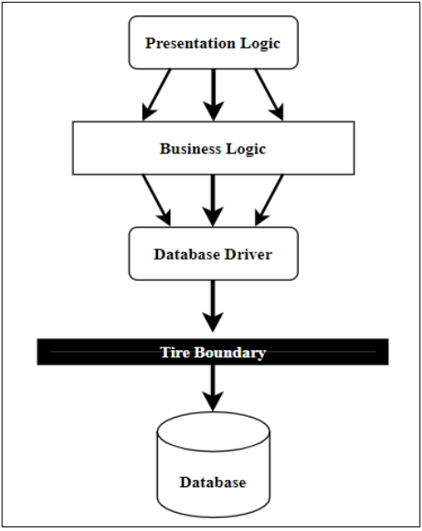
Figure 1: Two Tier Architecture

8. Feasibility Analysis
Feasibility study assesses the operational, technical and economic merits of the proposed project. The feasibility study is intended to be a preliminary review of the facts to see if it is worthy of proceeding to the analysis phase. From the systems analyst perspective, the feasibility analysis is the primary tool for recommending whether to proceed to the next phase or to discontinue the project.
Feasibility studies undergo four major analyses to predict the system to be success and they are as follows
- Operational Feasibility
- Technical Feasibility
- Economic Feasibility
- Schedule Feasibility

8.1 Economic Feasibility
This study is carried out to check the economic impact will have on the system and on the organization. The amount of fund that the company can pour into the research and development of the system is limited. The expenditures must be justified. Thus, this project is economically feasible as the only cost involved is having a computer with the minimum requirements. For the users to access the application, the only cost involved will be in getting access to the internet.

8.2 Technical Feasibility
This study is carried out to check the technical feasibility, that is, the technical requirements of the system. Any system developed must not have a high demand on the available technical resources. This will lead to high demands being placed on the client. The developed system must have a modest requirement, as only minimal or null changes for the implementing this system. In order to design this system, it uses off-shelf and existing technologies, software and hardware so there is no technological hurdle to build this system
Bike Sewa deals with the modern technology system that needs the well efficient technical system to run this project. All the resource constrains must be in the favors of the better influence of the system. Keeping all these facts in mind we had selected the favorable hardware and software utilities to make it more feasible.

8.3 Operational Feasibility
The aspect of study is to check the level of acceptance of the system by the user. This includes the process of training the user to use the system efficiently. The user must not feel threatened by the system, instead must accept it as a necessity. This system uses simple technologies to design. So, it is user friendly.

8.4 Schedule Feasibility
This assessment is the most important for project success; after all, a project will fail if not completed on time. In scheduling feasibility, an organization estimates how much time the project will take to complete.
To calculate and continually reexamine whether it is possible to complete all amount and scope of work lying ahead, utilizing the given number of resources, within required period of time. In our project we used Gantt Chart for Schedule feasibility study.
Gantt Chart
Gantt chart is a bar chart that provides a visual view of tasks scheduled over time. A Gantt chart is used for planning projects of all sizes, and it is a useful way of showing what work is scheduled to be done on a specific day. It can also help you view the start and end dates of a project in one simple chart. In our project, we used Ms. Excel for developing the Gantt chart which is shown below in the figure.
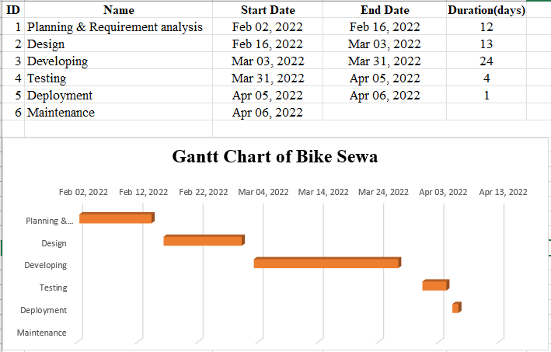
Figure 2: Gantt chart of Bike Sewa
In the above Gantt chart showing the start and finish dates of a project's elements such as planning & requirement analysis, design, development, testing, deployment and maintenance. It clearly shows that my project will start at feb-2 (MAG-19), and take 12 days for planning & requirement analysis and so on till Apr-6(CHAIT-23) I will finish design, development and testing. It will take 54 working days to finished my project. As we all know maintenance is ongoing process, so it has no time limit. Gantt chart helps in scheduling, managing, and monitoring specific tasks and resources in a project.

9. Conclusion and Future Recommendations

9.1 Conclusion
My goal is to create an application where any bike user can search and communicate with bike service center through online for their bike service and emergency services. The user can find the service center, book bike service provided by the respective service center. The user can send request for pick and drop, appointment for servicing as well as accessories purchase from the service center. The service center processes these requests and gives a response back to the user.
The current application has fulfilled these goals. We followed the specifications strictly but enhanced some of the features when there was need for it to be done. With the goals achieved the basis of the application and this project has been achieved.

9.2 Future Recommendations
Here is what can be added in the future on this website to increase its usability, user experience and portability of the website. There is a lot to be done hence this application can be considered as a starting point for something big to come. It will need more time and resources for all these to be done but it is still very realistic and possible to achieve
- Add vehicle tracking for accident warning system
- Develop mobile application
- Can add Insurance for bike
- Renew blue book
- Doorstep servicing (minor fixing)
- Send request for emergencies service

References

[1]https://www.onlinegantt.com/#/gantt
[2]https://www.softwaretestingclass.com/what-is-two-tier-and-three-tier-architecture
[3] https://corporatefinanceinstitute.com/resources/knowledge/other/feasibility-study/

