**UI Design System**

**Color Palette**

|  |  |  |
| --- | --- | --- |
| **Color** | **Hex** | **Usage** |
|  | #F8B195 | * Background Gradient * Leaderboard Row Highlight (when a row in the leaderboard is hovered) |
|  | #F67280 | * Background Gradient |
|  | #C06C84 | * Button Background |
|  | #6C5B7B | * Button Shadow (box shadow that appears around a button when it is hovered - does not include toggle buttons) * Heading Text Shadow |
|  | #355C7D | * Heading Colour |
|  | #4C1F8D | * “After Arrow” Icon |
|  | #416E2A | * “Before Arrow” Icon * “Toggle On” Colour |
|  | #000000 | * “Settings” Icon * “How to Play” Icon * “Hint” Icon * “Leaderboard” Icon * “Previous Page” Icon * Body Text * Button Text |
|  | #FFFFFF | * Colour-Inverted “Settings” Icon * Colour-Inverted “How to Play” Icon * Colour-Inverted “Hint” Icon * Colour-Inverted “Leaderboard” Icon * Colour-Inverted “Previous Page” Icon * “Toggle Off” Colour * Table Borders * Leaderboard Table Top Row Background |

**Fonts**

Arial, sans-serif

font-weight: Bold (except the text-area on the game page)

**Size**

h1: 70 px

All other text is within the range of 50px, 30 px, 20px to standard size,

varying page by page.

Note that the “filler” on the game page does not currently follow the guidelines for fonts as described above. The “filler” has not been defined yet, as we are waiting to implement more php and SQL to see how a list of words with an icon will look.

**Icons**

Note: All buttons, except for “After Arrow” and “Before Arrow,”

are clickable and function like buttons.







“After Arrow” “Before Arrow” “Settings” “How to Play”

“Hint” “Leaderboard” “Previous Page”



Colour-Inverted “Settings,” “How to Play,” “Hint,” “Leaderboard,” “Previous Page” Icons  
(how these icons appear when they are hovered over)

**Buttons**

**Main Page Buttons**

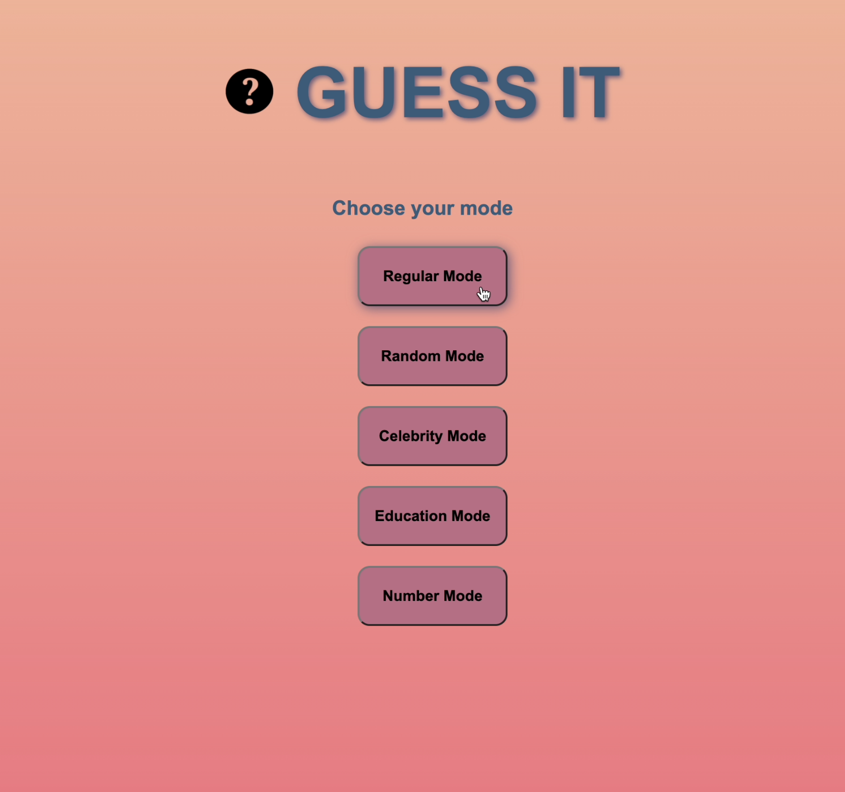

Font size: 15px, Width: 150px, Height: 60px, Font weight: Bold, Border-radius: 12px

Shadow is added to the button when it is hovered over

**Settings Page Buttons**

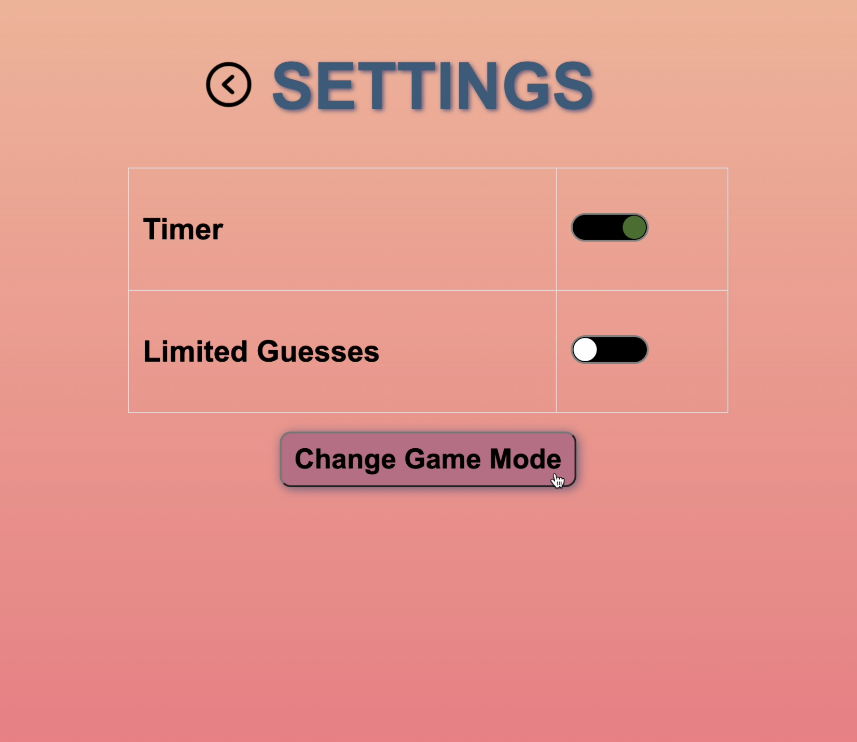

Font size: 30px, Width: 320px; Height: 60px; Font weight: Bold. Border-radius: 12px  
Shadow is added to the button when it is hovered over



The colour of the toggle buttons change from #FFFFFF to #416E2A when toggled on (and the reverse when toggled off)

**Form Elements**

**Game**

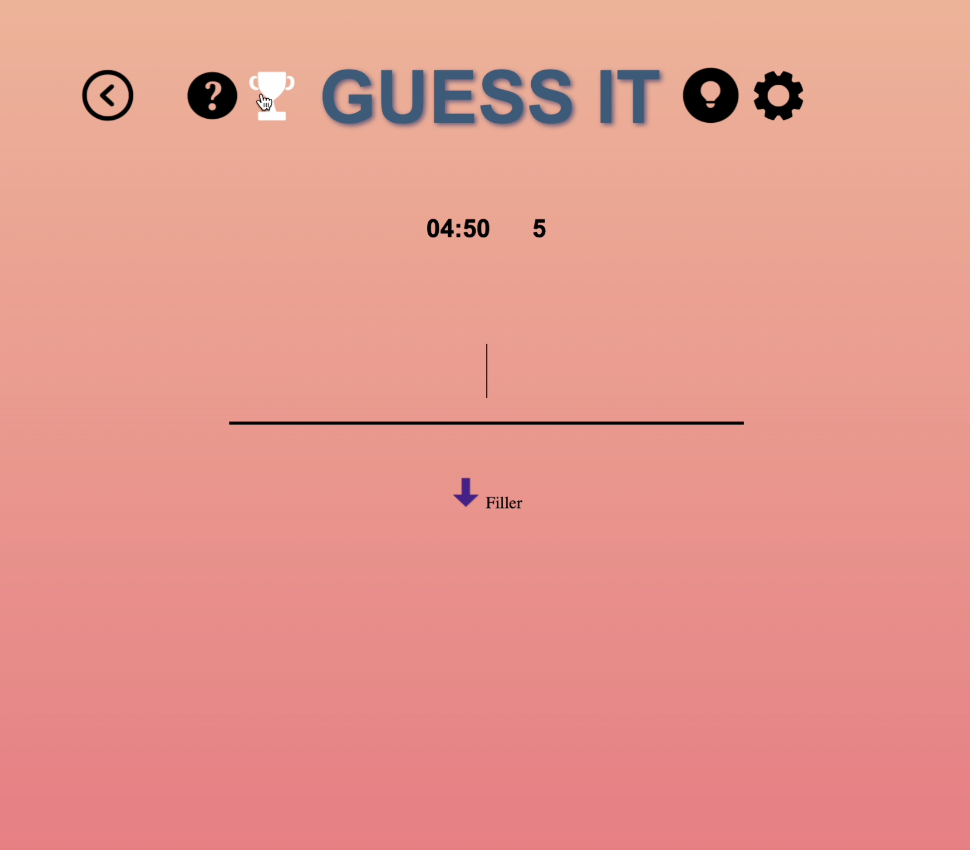

This form element receives guess inputs

**HTML Mock-ups**

**Mainpage**



Click on “How to Play” Icon to go to “How to Play” page

Click on “Regular Mode,” “Random Mode,” “Celebrity Mode,” “Education Mode,” or “Number Mode” Button to go to “Game” page

“How to Play” icon is inverted when hovered over

Buttons display shadows when hovered over

**Game**



Click on “Previous Page” Icon to go back to your previously viewed page

Click on “How to Play” Icon to go to “How to Play” page

Click on “Leaderboard” Icon to go to “Leaderboard” page

Click on “Hint” Icon to get a Hint Pop-up

Click on “Settings” Icon to go to “Settings” page

Icons are inverted when hovered over

**Hint Pop-up (from clicking “Hint” Icon)**

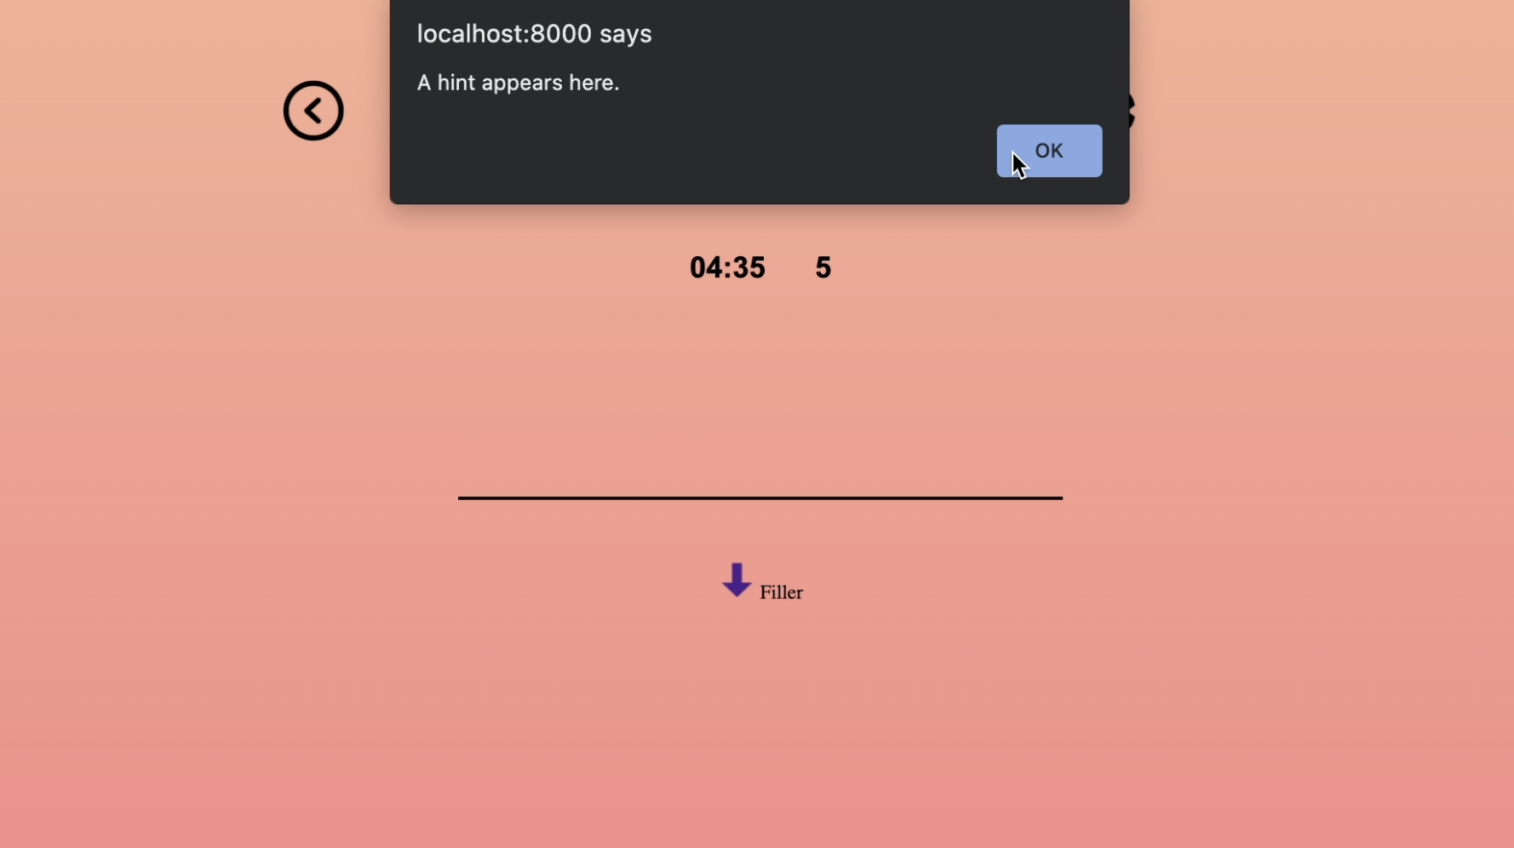

**How To Play**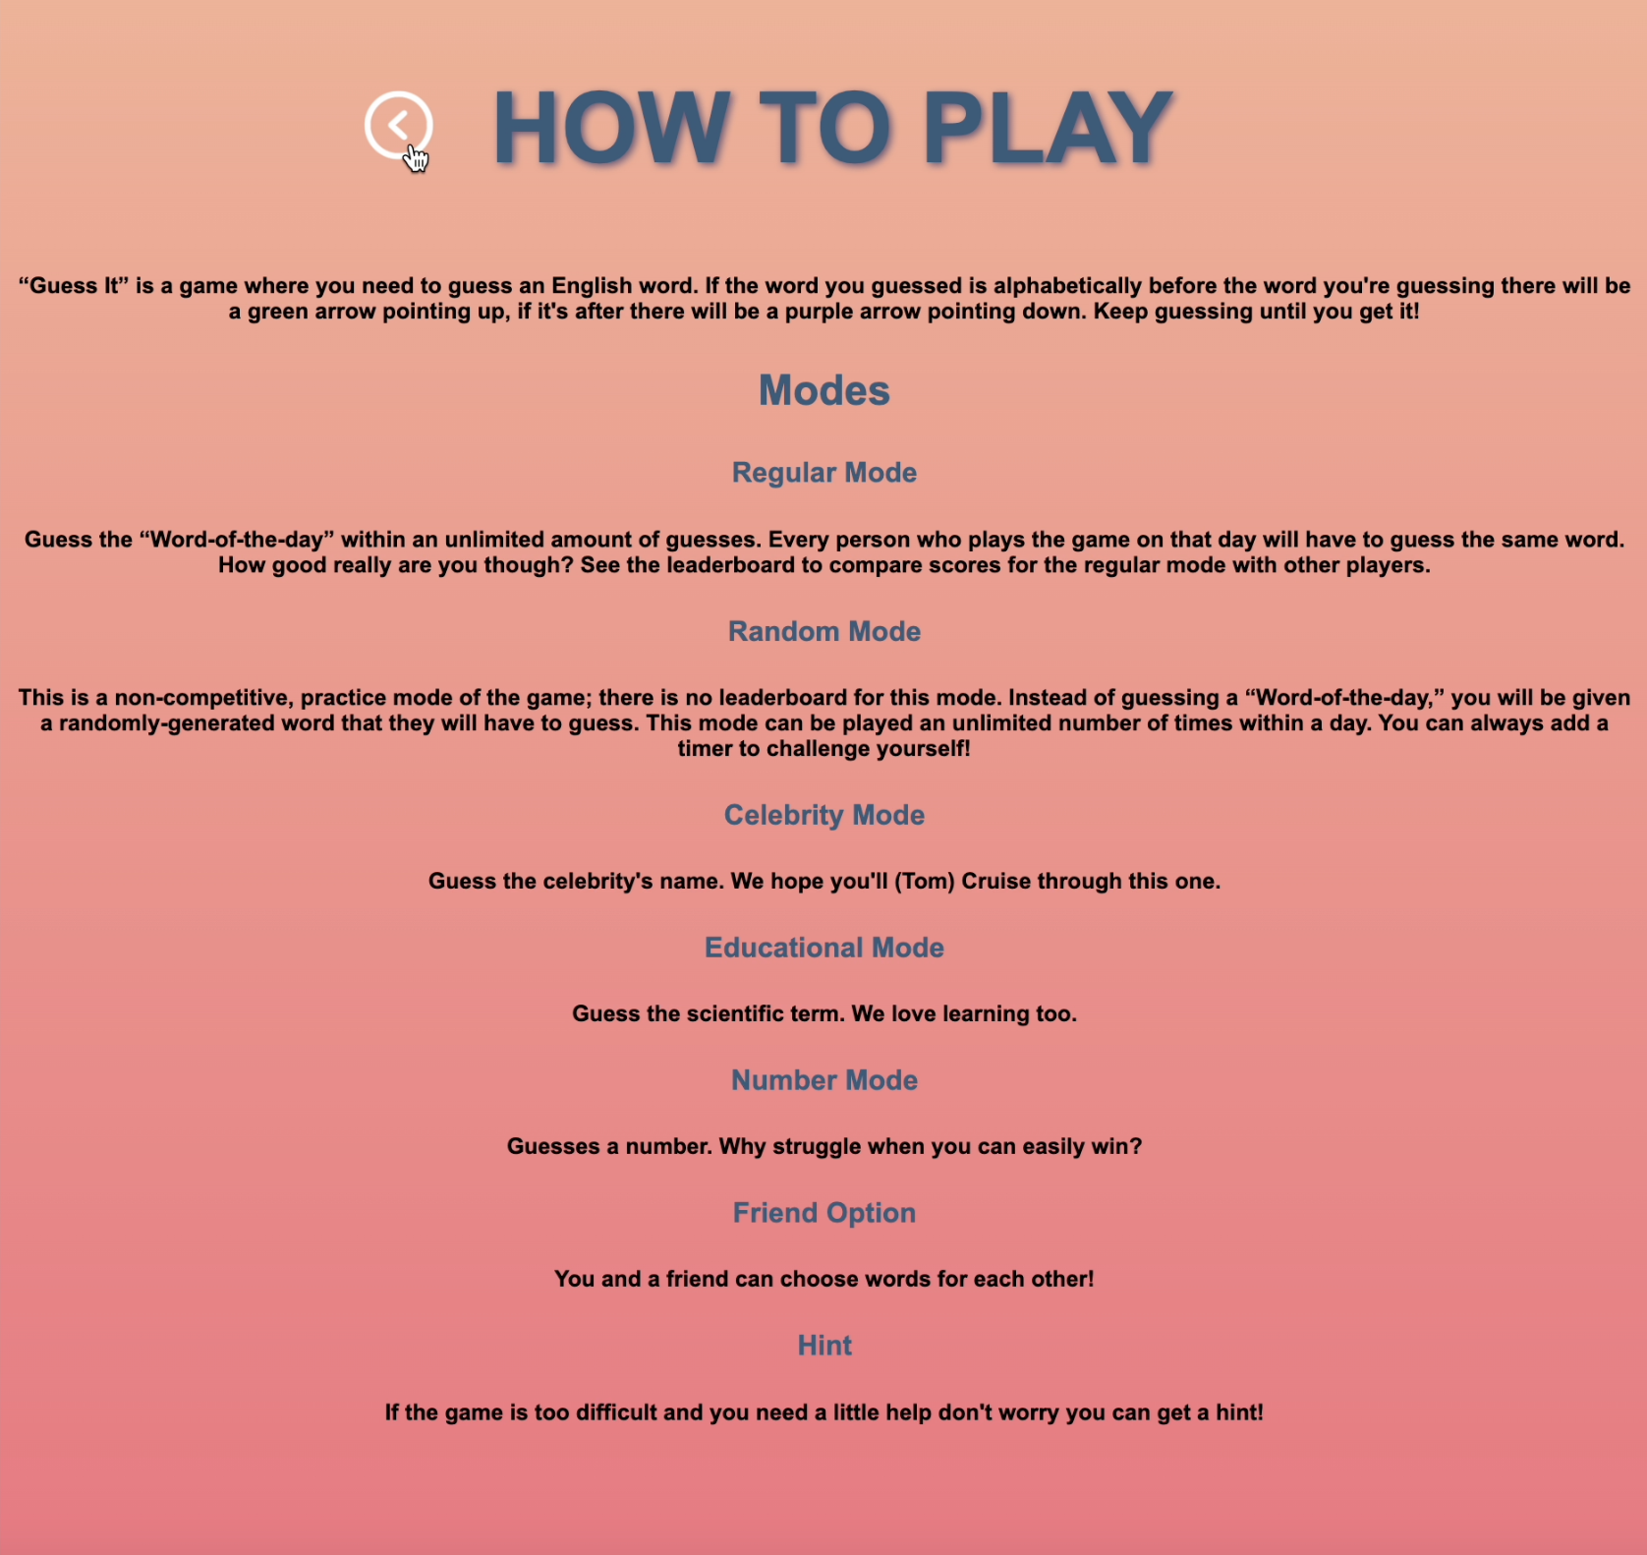

Click on “Previous Page” Icon to go back to your previously viewed page

“Previous Page” icon is inverted when hovered over

**Leaderboard**

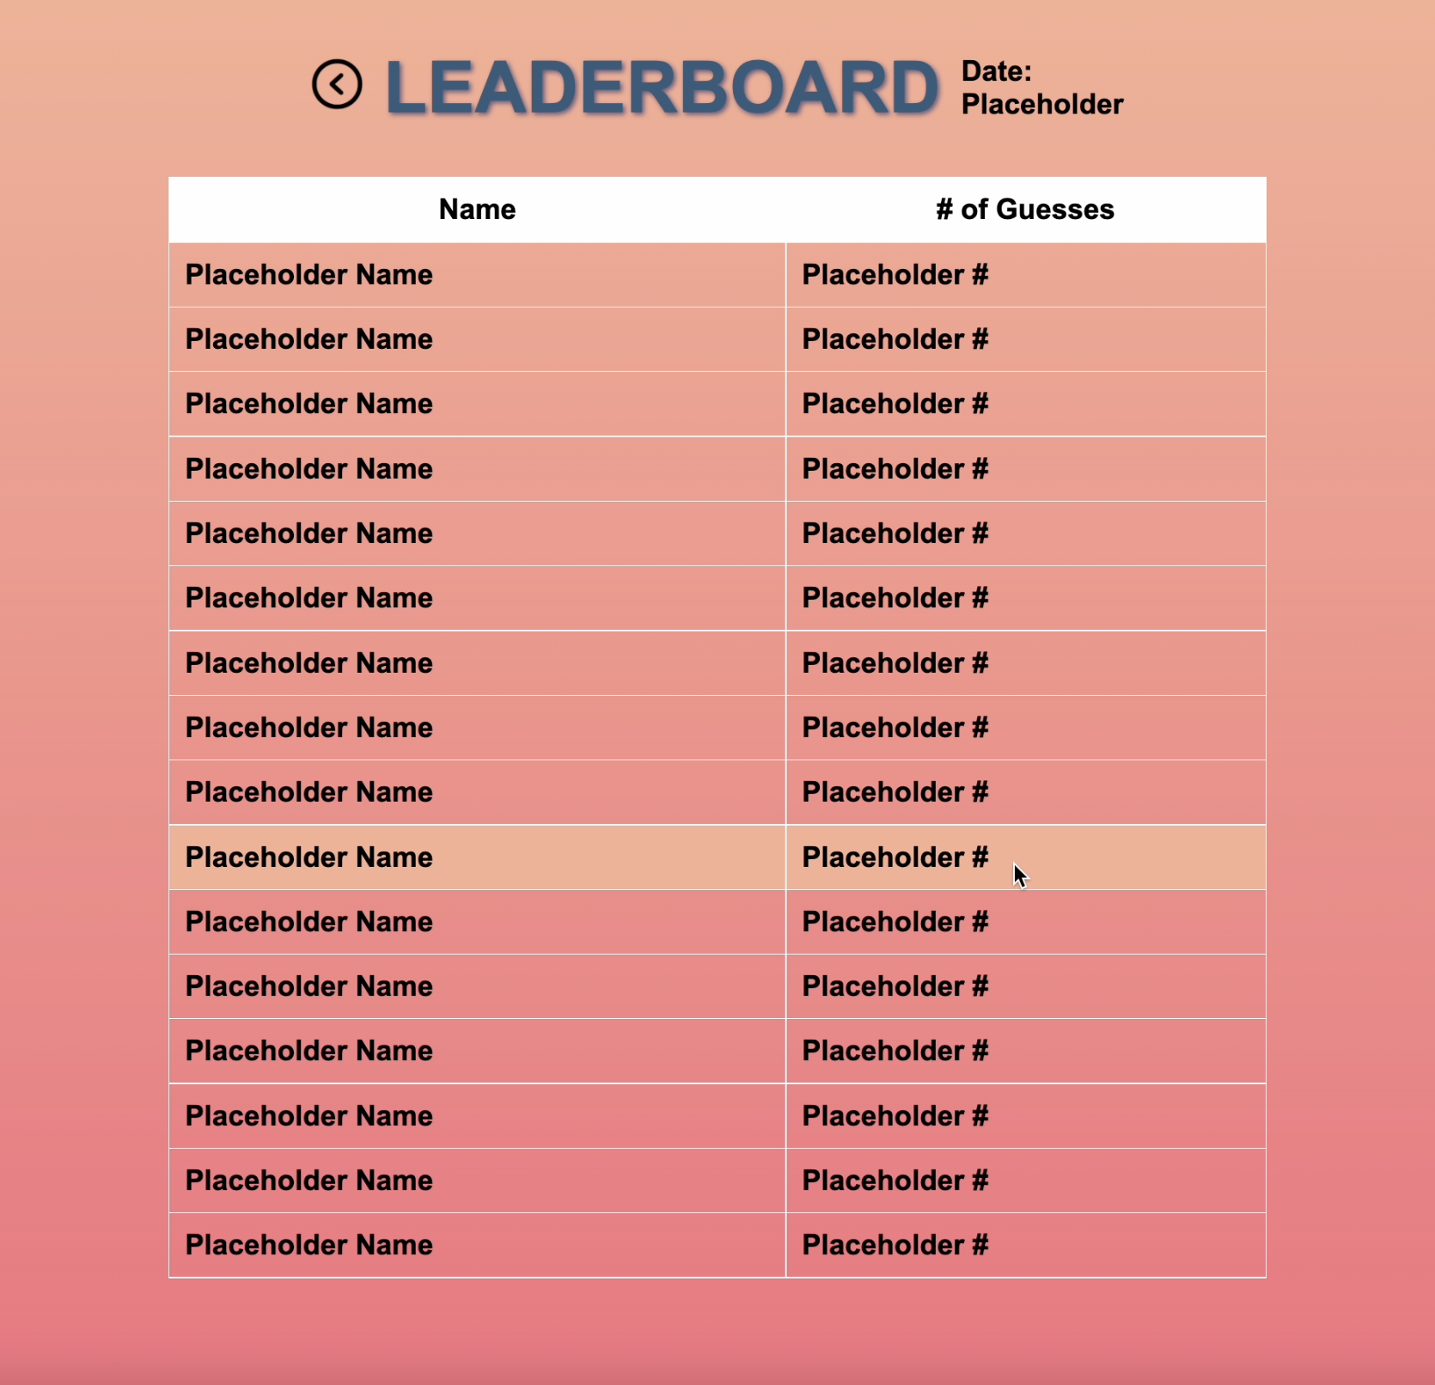

Click on “Previous Page” Icon to go back to your previously viewed page

“Previous Page” icon is inverted when hovered over

Rows in the Leaderboard table are highlighted in #F8B195 when hovered over

**Settings**

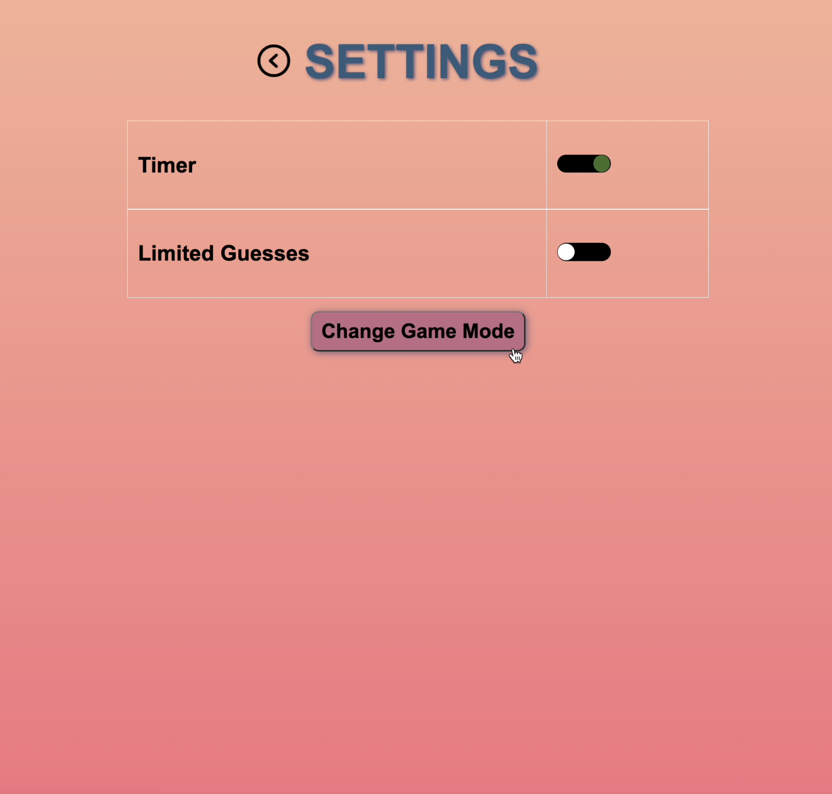

Click on “Previous Page” Icon to go back to your previously viewed page

“Previous Page” icon is colour-inverted when hovered over

Buttons display shadows when hovered over

The colour of the toggle buttons change from #FFFFFF to #416E2A when toggled on (and the reverse when toggled off)