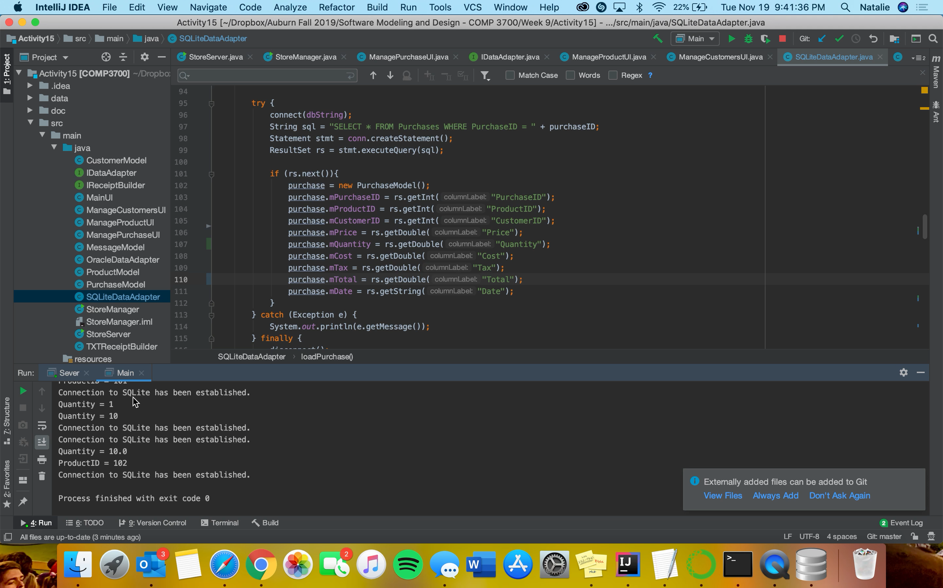

Attached is my testing video along with my link to the youtube video if the below video doesn’t work.

Test:

<https://www.youtube.com/watch?v=HjpWLJDWsCs>