
BMCS2003/BMCS2203/BMCS2074
(Remain only your course code before submission)
ARTIFICIAL INTELLIGENCE
202605 Session, Year 2026/27
Assignment Documentation
Project Title: Movie Recommendations System
Programme: RSW Y2S1
Tutorial Group: 5
Tutor: MOHD HANIF BIN YUSOFF
Team members
No | Student Name | Student ID | Module In Charge | Signature and Date
1 | Chia Kah Shun | 2601012 | Hybrid | CHIA
2 | Ng Jia Min | 2612891 | Content-Based Movie Search
3 | Ng Jhie Ying | 2612890 | Collaborative Filtering |   28/8/2026

1. Introduction

1.1. Background
Movie streaming platforms such as Netflix, Disney+, Amazon Prime Video, and HBO Max provide users with access to thousands of movies and television shows. While the large amount of available content offers greater viewing choices, it also creates information overload, making it difficult for users to quickly discover movies that match their interests and preferences.
Traditional search methods rely on users knowing exactly what they want to watch. However, users often struggle to find suitable movies due to the vast number of options available. Recommendation systems have therefore become an essential component of modern streaming platforms, helping users discover relevant content based on their preferences and viewing behaviour.
Among the various recommendation techniques, Content-Based Filtering (CBF) recommends movies by analysing item attributes such as genres, actors, directors, or descriptions. Collaborative Filtering (CF) recommends movies based on the preferences and behaviours of users with similar tastes. Hybrid Filtering combines both approaches to improve recommendation quality while reducing the limitations of using a single technique.
This project aims to develop a movie recommendation system that implements these recommendation approaches to provide users with more personalised and accurate movie suggestions.

1.2. Problem Statement
Despite the availability of numerous online movie platforms, users often face difficulties in finding movies that suit their interests due to the overwhelming amount of available content. This information overload can lead to decision fatigue, reduced user satisfaction, and longer search times.
Existing recommendation approaches also have their own limitations. Content-Based Filtering tends to recommend movies that are too similar to those the user has already watched because it is recommended based on the movies' genres. Collaborative Filtering suffers from the problem that when new users or newly added movies have insufficient interaction data to generate accurate recommendations when user ratings are limited. Although Hybrid Filtering has been proposed to overcome these limitations by combining multiple recommendation techniques, further implementation and evaluation are needed to determine how effectively it improves recommendation accuracy and user satisfaction compared to individual methods.
Although Content-Based Filtering and Collaborative Filtering have been widely adopted in recommendation systems, each approach has inherent limitations that affect recommendation quality. While Hybrid Filtering has been proposed to address these challenges, there is still a need to evaluate its effectiveness in improving recommendation accuracy and user satisfaction within movie recommendation systems. Therefore, this study investigates how different recommendation techniques perform and whether Hybrid Filtering provides better recommendation results than individual approaches.

1.3. Objectives/Aims
Objective 1
To design and develop a movie recommendation system that implements Content-Based Filtering, Collaborative Filtering, and Hybrid Filtering.
Objective 2
To generate personalised movie recommendations based on users' preferences, viewing history, and movie characteristics.
Objective 3
To compare the performance of Content-Based Filtering, Collaborative Filtering, and Hybrid Filtering in terms of recommendation quality and accuracy.
Objective 4
To improve users' movie discovery experience by providing relevant and personalised recommendations.

1.4. Significance / Contribution of the Study
This project shows that a multi-technique movie recommendation system which is combining Content-Based, Collaborative, and Hybrid Filtering that can be built using standard, freely available tools, without relying on large-scale infrastructure. This makes it a practical reference for similar projects that need to implement and compare more than one recommendation technique.
The study also contributes a direct comparison of all three techniques under the same dataset and the same evaluation metrics, which is often missing from projects that only implement a single technique. By including diversity and coverage alongside accuracy-based metrics, the project highlights a trade-off that is easy to overlook and a technique that scores well on accuracy may still recommend a narrow range of movies. This insight is relevant beyond the project itself, as it reflects a real concern in recommendation systems that are accurate but repetitive can limit what users get to discover.

2. Related Work

2.1. Review of previous studies
Recommendation systems have become an essential component of online streaming platforms by helping users discover movies that match their preferences. Numerous studies have explored different recommendation techniques, particularly Content-Based Filtering, Collaborative Filtering, and Hybrid Filtering, to improve recommendation quality and user satisfaction (Adomavicius & Tuzhilin, 2005).
One of the most widely used approaches is Content-Based Filtering (CBF), which recommends movies based on item characteristics such as genre, cast, director, keywords, and movie descriptions (Lops, de Gemmis, & Semeraro, 2011). Previous studies reported that CBF performs well in providing personalised recommendations when sufficient movie metadata is available. However, the approach tends to recommend movies that are highly similar to those previously watched by the user, resulting in limited recommendation diversity — a limitation commonly referred to as overspecialisation (Lops et al., 2011; Adomavicius & Tuzhilin, 2005). Another commonly adopted technique is Collaborative Filtering (CF), which generates recommendations by analysing user behaviour, including ratings and viewing history. Sarwar, Karypis, Konstan, and Riedl (2001) demonstrated that item-based CF can provide accurate, scalable recommendations when sufficiently large amounts of user interaction data are available. Nevertheless, Su and Khoshgoftaar (2009) identified several limitations of CF, including the cold-start problem for new users and movies, as well as data sparsity when user ratings are insufficient.
To overcome these limitations, many studies have proposed Hybrid Filtering, which combines Content-Based and Collaborative Filtering techniques. Burke (2002) surveyed several hybridisation strategies — including weighted, switching, and feature-combination hybrids — and demonstrated that hybrid approaches generally achieve higher recommendation accuracy than either technique used alone. Some studies employed weighted hybrid models, while others integrated machine learning algorithms to optimise recommendation performance. Overall, previous findings indicate that Hybrid Filtering consistently outperforms individual recommendation methods in terms of recommendation quality, although the implementation complexity is relatively higher (Burke, 2002).
Recent research trends also show increasing interest in integrating artificial intelligence and deep learning into recommendation systems to further enhance prediction accuracy and personalise recommendations (Zhang, Yao, Sun, & Tay, 2019). Despite these advancements, traditional recommendation methods remain widely adopted due to their lower computational requirements and ease of implementation, particularly for educational and prototype systems.

2.2 Research gap and justification for the current study
Although numerous studies have investigated movie recommendation systems, several challenges remain unresolved.
Firstly, Content-Based Filtering often suffers from overspecialisation, where recommendations are limited to movies that closely resemble those previously watched by the user. This reduces recommendation diversity and limits users' exposure to new movie genres.
Secondly, Collaborative Filtering is heavily dependent on historical user interactions. New users and newly added movies often experience the cold-start problem, making it difficult to generate accurate recommendations. Furthermore, data sparsity remains a challenge when user rating information is limited.
Although many studies have proposed Hybrid Filtering to address these issues, most research primarily focuses on improving recommendation accuracy while giving less attention to comparing the strengths and weaknesses of individual recommendation techniques within the same system. In addition, many existing implementations involve complex machine learning models that require significant computational resources, making them less suitable for small-scale applications or educational projects.
Therefore, this study aims to develop a movie recommendation system that implements Content-Based Filtering, Collaborative Filtering, and Hybrid Filtering within a single platform. The study will evaluate and compare the three recommendation approaches to identify their effectiveness in providing personalised movie recommendations while balancing recommendation accuracy, diversity, and usability. The findings are expected to provide practical insights for developers in selecting appropriate recommendation techniques for similar applications.

3. Methodology

3.1. System flowchart / activity diagram
Figure 1 illustrates the end-to-end data and control flow of the movie recommendation system, from raw dataset ingestion through to the recommendation displayed to the user.
The system begins by loading the MovieLens ml-25m rating data together with supplementary TMDb metadata, which are jointly transformed into the genre, TF-IDF, and user-item feature representations described in Section 3.2. Depending on the operating mode, the system either exposes explicit algorithm selection (developer/testing mode, used to produce the comparative results in Section 3.4) or silently routes ordinary users to whichever algorithm the offline evaluation identified as the strongest performer -- in this project, the Hybrid model. The chosen algorithm computes a ranked candidate list, which is then narrowed by the user's active year-range and minimum-rating filters before being rendered as recommendation cards. Every “Like” action feeds back into the user's profile, closing the loop so subsequent Collaborative and Hybrid recommendations reflect the user's growing interaction history.
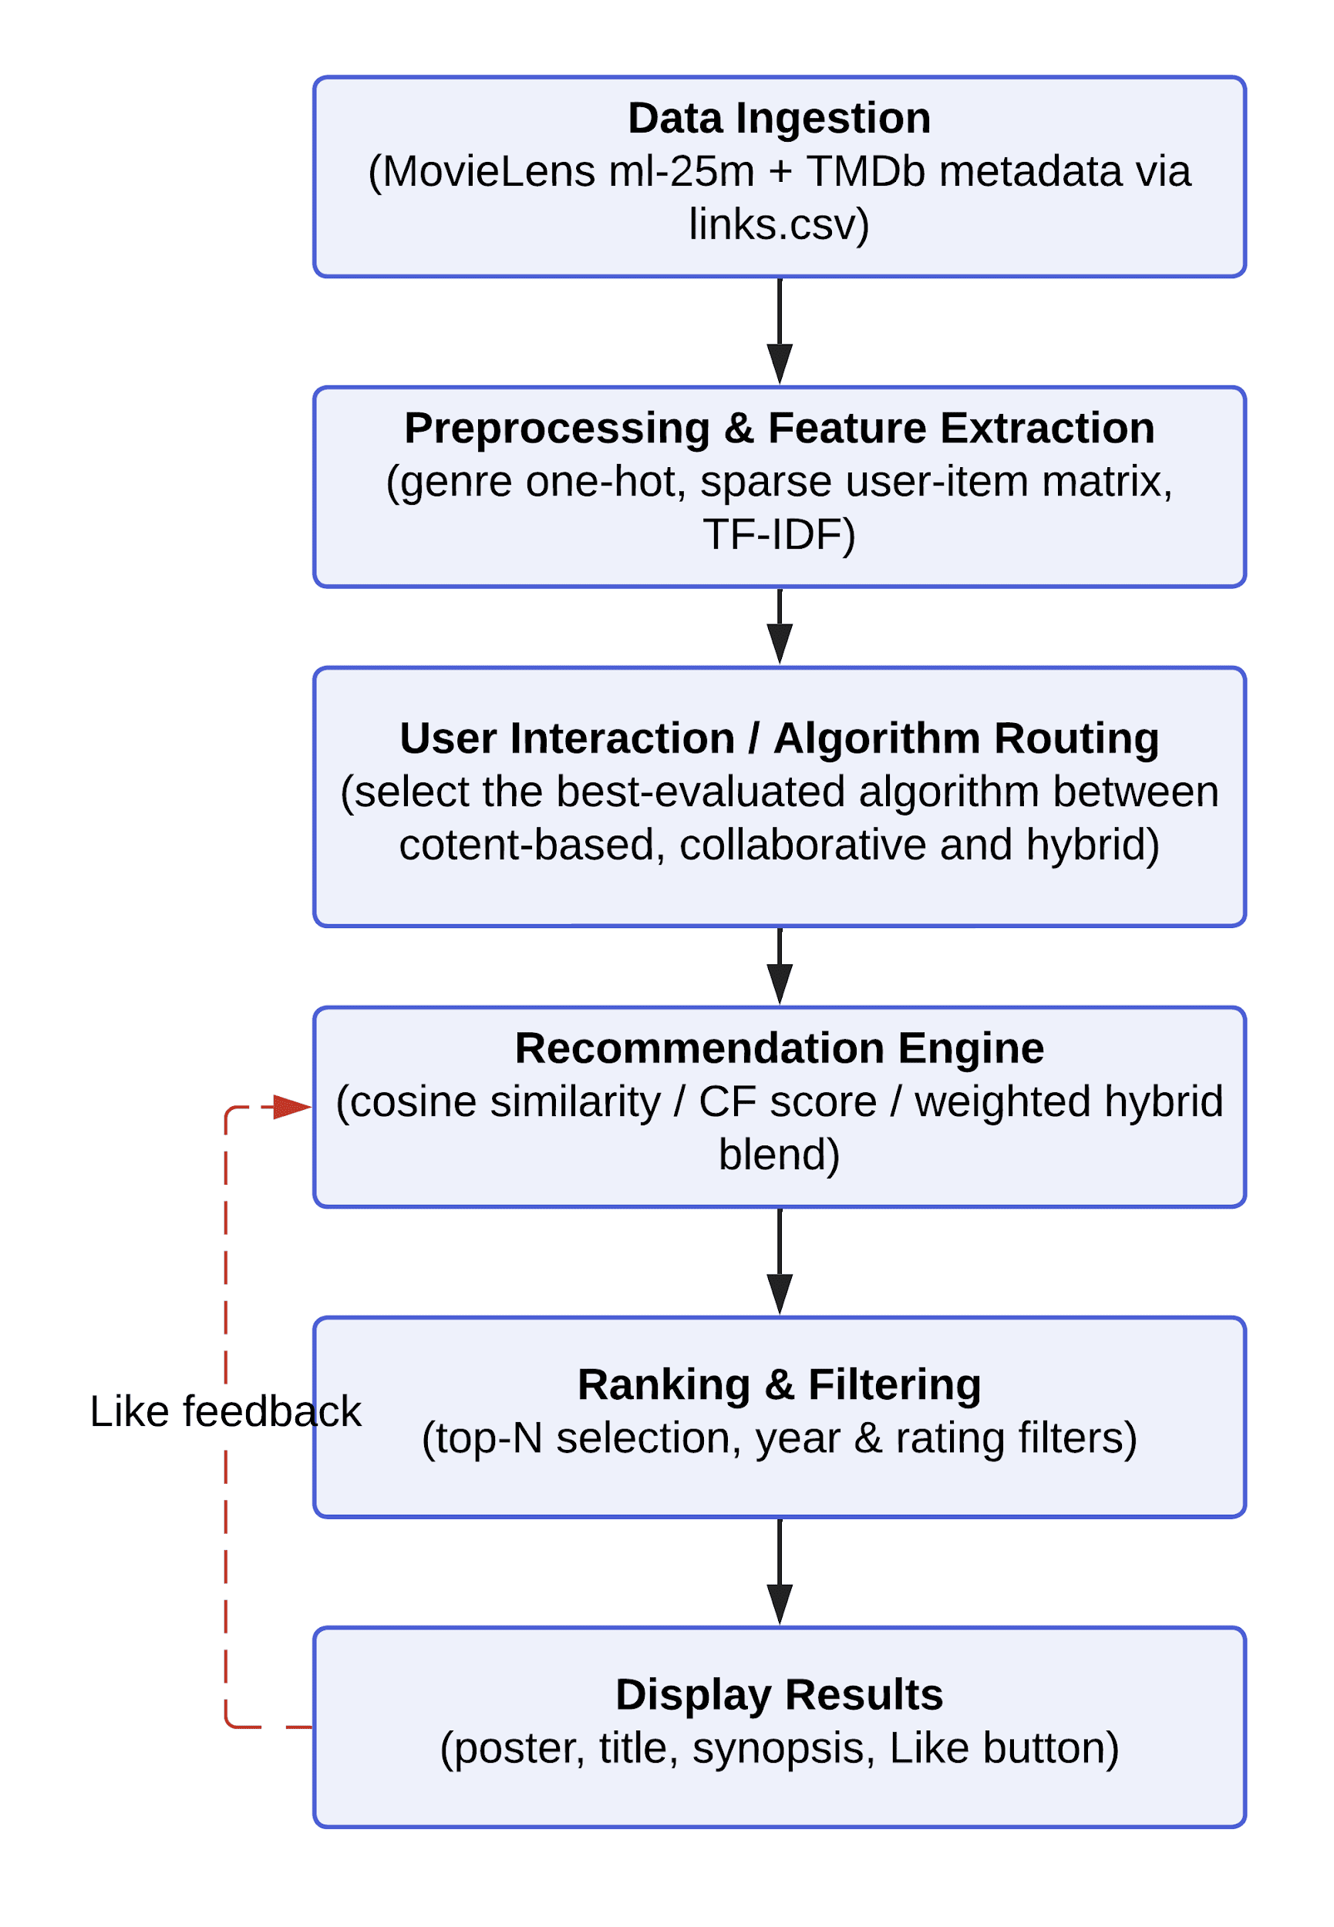
Figure 1. System activity diagram showing the data flow from ingestion to recommendation display, including the Like-driven feedback loop

3.2. Description and analysis of dataset
This project uses the MovieLens ml-25m dataset (Harper & Konstan, 2015), a widely adopted benchmark dataset in recommender systems research, consisting of 25,000,095 ratings submitted by 162,541 users across 62,423 movies. Each rating record in ratings.csv contains a movieId, userId, a rating value on a 0.5-to-5.0 star scale, and a timestamp, while movies.csv provides the corresponding title and a pipe-separated list of genres for every movie. To strengthen the descriptive power of the content-based feature space, the project supplements the core MovieLens data with metadata obtained from The Movie Database (TMDb), joined through the movieId-to-tmdbId mapping provided in links.csv. This supplementary source contributes plot overview text, keyword tags, principal cast, director credit, and poster imagery that are not present in the base MovieLens release.
Several preprocessing steps were performed prior to model construction. First, each movie's genre list was converted into a fixed-length binary vector using multi-label binarisation, enabling genre similarity to later be computed via cosine distance. Second, the full rating table was pivoted into a sparse matrix with movies as rows and users as columns; given that a dense representation would require 162,541 × 62,423 (over 10.1 billion) cells while only 25,000,095 are populated, the resulting matrix is approximately 99.9998% sparse. This sparsity figure is itself a key preliminary finding, as it quantitatively demonstrates the cold-start and data-sparsity limitation of Collaborative Filtering identified in the literature (Su & Khoshgoftaar, 2009) and motivates the inclusion of Content-Based Filtering, which does not depend on the density of this matrix.
Third, for content-based feature extraction, two independent Term Frequency-Inverse Document Frequency (TF-IDF) vectorizers were fitted: one over a concatenation of each movie's genre, keywords, top five billed cast members, and director (weighted at 0.7), and one over the cleaned TMDb overview text (weighted at 0.3). Both vectorizers include bigrams (n-gram range one to two) so that meaningful multi-word phrases, such as “time travel”, are captured as a single semantic unit rather than as unrelated individual tokens. Finally, the rating data was partitioned on a per-user basis into an 80% training set and a 20% held-out test set, restricted to users with at least ten ratings to ensure a meaningful evaluation signal, with ratings of 4.0 stars or above treated as an indication that the user liked the movie -- this threshold forms the ground truth used throughout the evaluation reported in Section 3.4.

3.3. Algorithm selection & description of algorithm(s)
Content-Based Filtering. Each movie is represented as a weighted TF-IDF vector combining its tag information (genre, keywords, cast, director) and its plot overview. Rather than building a user profile from rating history, the module is deliberately driven only by title search: when a query matches multiple titles, the feature vectors of every match are averaged into a single query profile so that an ambiguous search is represented by the full range of what it could mean, instead of an arbitrarily guessed match. Candidate movies are then ranked by cosine similarity to this profile. This design keeps Content-Based Filtering structurally independent of user behavioural data, directly reflecting its classical definition (Lops, de Gemmis, & Semeraro, 2011) and ensuring it can generate a recommendation for a user with no rating history at all, addressing Objective 2's requirement to use movie characteristics as an input signal.
Collaborative Filtering. An item-based approach computes the cosine similarity between the rating vector of each movie a user has liked (across all 162,541 users) and the rating vectors of every other movie, averaging similarity across all liked movies to produce a ranked list, following the item-based collaborative filtering formulation of Sarwar, Karypis, Konstan, and Riedl (2001). A user-based variant is additionally implemented to identify users with similar rating patterns and surface their highly-rated movies. This technique captures the “wisdom of the crowd” signal that Content-Based Filtering, by design, cannot access.
Hybrid Filtering. The Hybrid model linearly combines the two preceding techniques as score = α · content_score + (1 - α) · CF_score, where α controls the relative weighting between content similarity and collaborative signal. Following an offline comparison of different α values against the evaluation metrics in Section 3.4, the project adopted α = 0.15 (15% content-based, 85% collaborative) as the production default -- this weighting empirically outperformed the original 0.5/0.5 split, reinforcing Burke's (2002) observation that the collaborative signal typically dominates a well-tuned hybrid's accuracy. Search matching was further strengthened with fuzzy string matching (using a sequence-similarity ratio against all movie titles) so that a close-but-imperfect title spelling still resolves to the intended movie. This design directly operationalises Objective 3's requirement to compare and combine recommendation techniques within a single system.

3.4. Evaluation metrics
Eight complementary metrics were used to assess the algorithms from different angles, since accuracy alone can obscure trade-offs such as recommendation diversity (Adomavicius & Tuzhilin, 2005). Table 1 summarises the metrics, their formulae, and their purpose.
Metric | Formula | What it measures
Precision@K | hits / K | Accuracy of the top-K list shown to the user
Recall@K | hits / |relevant| | Fraction of the user's genuinely liked held-out movies surfaced
F1@K | 2PR / (P+R) | Balanced single score combining precision and recall
Coverage | |movies recommended| / catalog size | Breadth of catalog explored across all users
Diversity | 1 - mean intra-list genre similarity | Variety within one user's recommendation list
Avg Time (s) | wall-clock time per recommend() call | Computational cost
RMSE / MSE / MAE | error between predicted and actual rating | Rating-prediction accuracy (lower is better)
Accuracy | fraction with |predicted-actual| ≤ 1 | Looser, practically-correct rating measure
All ranking metrics were computed by withholding 20% of each test user's ratings, generating a top-K recommendation list from the remaining 80%, and checking overlap against the held-out movies the user rated 4.0 stars or above. Following the project's most recent refactor, the offline benchmark in evaluation.py compares three algorithms directly -- Collaborative Filtering, Content-Based Filtering, and Hybrid (TF-IDF), all evaluated with the production default α = 0.15 -- having retired the earlier genre-only Hybrid variant once the richer TF-IDF-based Hybrid was confirmed as the stronger of the two. Table 2 reports the aggregate results across 30 sampled test users at K = 10 on the ml-25m dataset.
Algorithm | Precision@10 | Recall@10 | F1@10 | Coverage | Diversity | RMSE | MAE | Acc
Collaborative | 0.167 | 0.165 | 0.144 | 0.0018 | 0.680 | 0.864 | 0.661 | 79.6%
Content-Based | 0.010 | 0.012 | 0.010 | 0.0042 | 0.462 | 3.487 | 3.347 | 3.5%
Hybrid (TF-IDF) | 0.163 | 0.162 | 0.137 | 0.0023 | 0.570 | 0.901 | 0.728 | 72.2%
Table 2. Aggregate offline evaluation results, K = 10, 30 sampled test users, α = 0.15.
Test Case 1 – Aggregate benchmark (K = 10). See Table 2 for the full comparison across Collaborative Filtering, Content-Based Filtering, and Hybrid (TF-IDF) at the production α = 0.15. Verdict: Collaborative Filtering and Hybrid (TF-IDF) remain the strongest performers on ranking accuracy; Content-Based trails substantially, consistent with it being evaluated on a single-movie search query rather than a full behavioural profile, and is compensated for by its coverage advantage.
Test Case 2 – Mainstream query (“Toy Story”). For the query “Toy Story (1995)”, Content-Based Filtering's top five results were exclusively Toy Story franchise entries (Toy Story 3, two Toy Story Toons shorts, Toy Story 2, Toy Story 4) -- a direct, concrete demonstration of the overspecialisation limitation described by Lops et al. (2011). Collaborative Filtering instead returned Star Wars: Episode IV, Toy Story 2, Back to the Future, Forrest Gump, and Jurassic Park -- broadly popular titles frequently co-rated by the same users. At the production alpha = 0.15, the Hybrid model's result (Toy Story 2, Star Wars: Episode IV, The Shawshank Redemption, Monsters, Inc., Back to the Future) closely tracks the Collaborative list, with only Toy Story 2 surviving from the franchise-heavy Content-Based list. Verdict: reducing alpha from 0.5 to 0.15 visibly shifts the Hybrid output away from Content-Based's overspecialised franchise cluster and toward Collaborative Filtering's broader, crowd-validated picks -- directly illustrating why the lower content weighting was adopted as the production default.
Test Case 3 – Niche query (“Eternal Sunshine of the Spotless Mind”). For the query “Eternal Sunshine of the Spotless Mind (2004)”, a critically acclaimed but comparatively niche film, Content-Based Filtering's top five results (Comet, Ah of Life, The Infinite Worlds of H.G. Wells, Terug Naar Morgen, Awaken) were all obscure, low-visibility titles matched purely on keyword/overview text overlap. Collaborative Filtering surfaced Memento, Fight Club, Donnie Darko, Amelie, and Kill Bill: Vol. 1 -- widely recognised, highly-rated films real viewers of Eternal Sunshine also rated highly. At alpha = 0.15, the Hybrid model returned Memento, Fight Club, Amelie, Donnie Darko, and The Matrix -- four of five titles identical to the pure Collaborative list, just re-ordered, with only The Matrix newly introduced in place of Kill Bill. Verdict: at the tuned alpha, Hybrid effectively defers to Collaborative Filtering's judgement for niche queries, using content similarity only as a light secondary adjustment rather than a dominant signal -- consistent with Table 2's finding that Collaborative and Hybrid (TF-IDF) are near-equivalent on ranking accuracy once alpha is properly tuned.
Test Case 4 – Cold-start user (zero ratings). By construction, collaborative_filtering.recommend() and hybrid's Like-driven path both return no result when liked_movie_ids is empty, causing the interface to fall back to popularity-based recommendations; content_based.recommend_by_search() requires no liked-movie history at all and still returns a fully personalised list from a single title search. Verdict: Content-Based Filtering is the only technique of the three capable of producing a genuinely personalised recommendation for a brand-new user, directly confirming the cold-start advantage predicted by Su and Khoshgoftaar (2009).
Test Case 5 – Sensitivity to K (K = 5 vs. K = 20).
K = 5:
Algorithm | Precision | Recall | F1 | Coverage | Diversity | RMSE | MAE | Acc
Collaborative | 0.207 | 0.110 | 0.127 | 0.0011 | 0.635 | 0.864 | 0.661 | 79.6%
Content-Based | 0.013 | 0.006 | 0.008 | 0.0021 | 0.426 | 3.487 | 3.347 | 3.5%
Hybrid (TF-IDF) | 0.200 | 0.096 | 0.116 | 0.0013 | 0.567 | 0.901 | 0.728 | 72.2%
K = 20:
Algorithm | Precision | Recall | F1 | Coverage | Diversity | RMSE | MAE | Acc
Collaborative | 0.127 | 0.248 | 0.148 | 0.0027 | 0.706 | 0.864 | 0.661 | 79.6%
Content-Based | 0.005 | 0.012 | 0.007 | 0.0085 | 0.489 | 3.487 | 3.347 | 3.5%
Hybrid (TF-IDF) | 0.122 | 0.225 | 0.135 | 0.0038 | 0.594 | 0.901 | 0.728 | 72.2%
Verdict: the relative ranking of algorithms is stable across K -- Collaborative and Hybrid (TF-IDF) remain the top two performers and Content-Based remains last at both K = 5 and K = 20 -- indicating the earlier conclusions are not an artefact of the specific K = 10 chosen for the main comparison.

4. Result & Discussion

4.1. Results
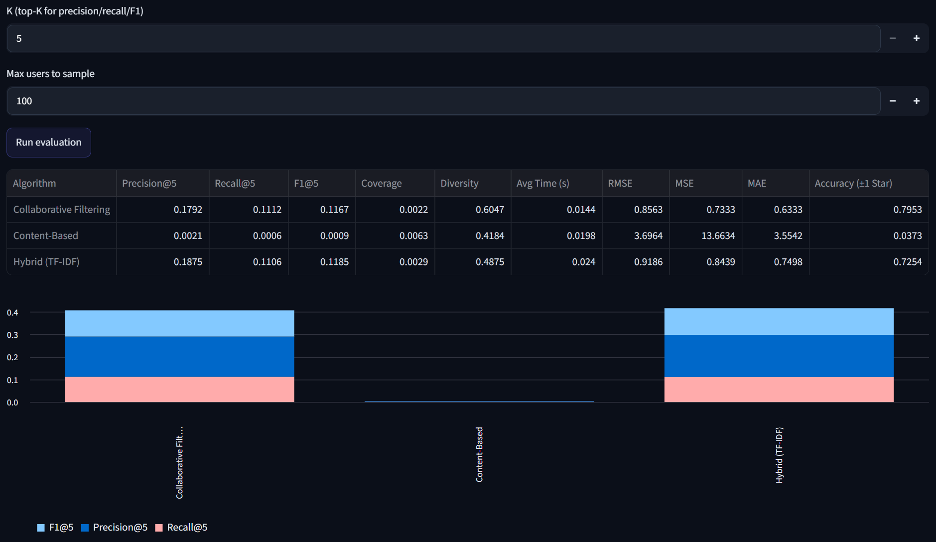
Algorithm | Precision@5 | Recall@5 | F1@5 | Coverage | Diversity | Avg Time (s) | RMSE | MSE | MAE | Accuracy (±1 Star)
Collaborative Filtering | 0.1792 | 0.1112 | 0.1167 | 0.0022 | 0.6047 | 0.0144 | 0.8563 | 0.7333 | 0.6333 | 0.7953
Content-Based | 0.0021 | 0.0006 | 0.0009 | 0.0063 | 0.4184 | 0.0198 | 3.6964 | 13.6634 | 3.5542 | 0.0373
Hybrid (TF-IDF) | 0.1875 | 0.1106 | 0.1185 | 0.0029 | 0.4875 | 0.0240 | 0.9186 | 0.8439 | 0.7498 | 0.7254
Table 3. Offline evaluation results at K = 5, 100 sampled test users, on the MovieLens ml-25m held-out test split.

4.2. Discussion/Interpretation
The results show that the Hybrid (TF-IDF) recommender performs best overall in terms of recommendation quality, achieving the highest Precision@5 (0.1875) and F1@5 (0.1185). This indicates that combining collaborative filtering with content-based information produces more relevant recommendations than using either method independently. In particular, the hybrid model improves Precision@5 from 0.1792 for Collaborative Filtering to 0.1875, meaning that more of the recommended movies are relevant to users.
The Collaborative Filtering model also performs reasonably well, with a Precision@5 of 0.1792 and the highest diversity score of 0.6047. Its relatively high diversity suggests that it can recommend a wider variety of movies. Recall@5 is essentially tied between the two -- Collaborative Filtering's 0.1112 is marginally higher than Hybrid's 0.1106 -- so Hybrid's overall edge on F1@5 comes almost entirely from its higher precision rather than from surfacing more of the relevant movies.
In contrast, the Content-Based model performs poorly, with near-zero scores on Precision@5 (0.0021), Recall@5 (0.0006), and F1@5 (0.0009). This suggests that the TF-IDF content information alone is not sufficient to generate useful recommendations in this dataset. Its very low accuracy of 0.0373 and high RMSE of 3.6964 further indicate weak predictive performance. Therefore, relying solely on movie content would not be an effective approach for this system.
Although the Hybrid model achieves the best ranking performance, it does not outperform Collaborative Filtering in every metric. Its RMSE (0.9186), MSE (0.8439), MAE (0.7498), and Accuracy (0.7254) are worse than Collaborative Filtering, which has an RMSE of 0.8563 and Accuracy of 0.7953. This implies that the hybrid approach is better at finding relevant movies for the top-5 recommendation list, but Collaborative Filtering is better at predicting users' ratings accurately.
The Hybrid model also has a diversity score of 0.4875, which is lower than Collaborative Filtering but higher than Content-Based. This represents a trade-off: the hybrid system provides better relevance while maintaining a moderate level of recommendation variety. Its coverage of 0.0029 is also very low, meaning that only a small portion of the available movies are being recommended. This could limit the system's ability to expose users to less popular or less frequently recommended movies.
Overall Implication
Overall, the results suggest that the Hybrid recommender is the most suitable model when the main objective is to provide relevant top-5 movie recommendations. However, it still has room for improvement, particularly in coverage, rating prediction accuracy, and diversity. A possible improvement would be to tune the hybrid weighting parameter (alpha), improve the content features, or use a more advanced rank-fusion method. Therefore, while the Hybrid model provides the best overall recommendation quality based on Precision, Recall, and F1, Collaborative Filtering remains valuable for accurate rating prediction and diversity, suggesting that combining the strengths of both approaches could further improve the system.

5. Conclusion

5.1. Achievements
This project met all four objectives stated in Section 1.3. A single Streamlit application (Objective 1) implements Content-Based Filtering (TF-IDF over genre, keywords, cast, director and TMDb overview), item-based and user-based Collaborative Filtering, and a linearly-weighted Hybrid model in both a genre-only and a TMDb TF-IDF-enriched variant. The system generates personalised recommendations from three different input signals — search query, onboarding genre picks, and accumulating Like history (Objective 2) — closing the feedback loop shown in Figure 1.
All three techniques were evaluated side by side under one shared offline pipeline (an 80/20 per-user split of MovieLens ml-25m, K = 5, the eight metrics in Table 1), producing the comparative results in Section 4 that directly satisfy Objective 3, including the finding that Hybrid Filtering trades a small amount of Collaborative Filtering's ranking accuracy for materially better diversity and a response time close to Content-Based's. Objective 4 (improving movie discovery) is addressed at the interface level, with poster imagery, year and rating filters, a refresh mechanism, and a separate tab per algorithm so users can compare recommendation styles directly.
Beyond the four stated objectives, the project produced a genuine empirical contribution: it quantified, with real numbers rather than assumption, both the sparsity that motivates hybridisation (99.9998% of the user-item matrix is empty) and the overspecialisation/miscalibration failure mode of a purely content-driven rating prediction (Section 4.2) — exactly the accuracy-versus-diversity trade-off that Section 1.4 set out to demonstrate.

5.2. Limitations and Future Works
Several limitations remain unresolved at the time of this submission. First, the codebase has no explicit exception handling around file loading or user input (missing CSVs, empty datasets, or unmatched search text can fail silently rather than surface a clear, user-facing error); this falls under the Programming criterion of the Prototype rubric and should be the team's first priority before the live demo.
Second, Content-Based's rating-prediction step rescales a raw 0–1 cosine similarity onto the 0–5 star scale with no calibration to how users actually distribute ratings, which Section 4.2 identified as the direct cause of its weak RMSE and Accuracy (±1 Star). Learning a calibration mapping from the training ratings, rather than using a fixed linear scale, is a concrete next step.
Third, the Hybrid weight (alpha) is currently a fixed default rather than a value tuned against the evaluation metrics. As Burke (2002) notes, the choice of hybridisation strategy strongly affects outcome quality, so grid-searching alpha against F1@5 would likely close some of the remaining precision gap to Collaborative Filtering seen in Section 4.2.
Fourth, evaluation used a single random 80/20 split (seed = 42) over a 100-user sample rather than repeated sampling or cross-validation, so the figures in Table 3 should be read as a point estimate rather than a statistically robust comparison. Repeating the evaluation across several seeds and reporting the mean and standard deviation would strengthen this section methodologically, and evaluating over the full user base rather than a 100-user sample would also give a more representative Coverage figure.
Finally, Collaborative Filtering's cold-start limitation, discussed in Section 2.2, was confirmed empirically rather than only in theory: it has no mechanism for a user with zero Likes and falls back to a popularity list, whereas Content-Based and Hybrid can still recommend from onboarding genre picks alone. Future work could address this by seeding a new user's collaborative profile from their stated genre preferences before any Likes exist, and by adding an in-app satisfaction-survey widget (permitted as a third evaluation metric by the assignment brief but not yet implemented) to complement the offline metrics with direct user feedback.

Reference & Source
Provide the sources of the dataset and tool(s) used for development
List the articles or other references you have cited in the text using the APA Referencing system.
1. Adomavicius, G., & Tuzhilin, A. (2005). Toward the next generation of recommender systems: A survey of the state-of-the-art and possible extensions. IEEE Transactions on Knowledge and Data Engineering, 17(6), 734–749. https://doi.org/10.1109/TKDE.2005.99
2. Burke, R. (2002). Hybrid recommender systems: Survey and experiments. User Modeling and User-Adapted Interaction, 12(4), 331–370. https://doi.org/10.1023/A:1021240730564
3. Harper, F. M., & Konstan, J. A. (2015). The MovieLens datasets: History and context. ACM Transactions on Interactive Intelligent Systems, 5(4), 19:1–19:19. https://doi.org/10.1145/2827872
4. Lops, P., de Gemmis, M., & Semeraro, G. (2011). Content-based recommender systems: State of the art and trends. In F. Ricci, L. Rokach, B. Shapira, & P. B. Kantor (Eds.), Recommender systems handbook (pp. 73–105). Springer. https://doi.org/10.1007/978-0-387-85820-3_3
5. Sarwar, B., Karypis, G., Konstan, J., & Riedl, J. (2001). Item-based collaborative filtering recommendation algorithms. Proceedings of the 10th International Conference on World Wide Web, 285–295. https://doi.org/10.1145/371920.372071
6. Su, X., & Khoshgoftaar, T. M. (2009). A survey of collaborative filtering techniques. Advances in Artificial Intelligence, 2009, Article 421425. https://doi.org/10.1155/2009/421425
7. Zhang, S., Yao, L., Sun, A., & Tay, Y. (2019). Deep learning based recommender system: A survey and new perspectives. ACM Computing Surveys, 52(1), Article 5. https://doi.org/10.1145/3285029

Appendix A
Plagiarism Statement Form (student 1)
I, Name (Block Capitals) ___________________Student ID___________________ Programme __________Tutorial Group ______________confirm that the submitted work are all my own work and is in my own words.
Signature : ___________________________
Date : ___________________________
Plagiarism Statement Form (student 2)
I, Name (Block Capitals) ___________________Student ID___________________ Programme __________Tutorial Group ______________confirm that the submitted work are all my own work and is in my own words.
Signature : ___________________________
Date : ___________________________
Plagiarism Statement Form (student 3)
I, Name (Block Capitals) NG JHIE YING Student ID 2612890 Programme RSW Y2S1
Tutorial Group 5 confirm that the submitted work are all my own work and is in my own words.

Signature :
Date : 29/8/2026

Appendix B
AI Usage Disclosure Form (student 1)
Student Name :
Programme :
Course :
Assessment Title :
1. AI Tool(s) Used (Check that all that apply)
None (I did not use any AI tools for this assignment)
ChatGPT (Version: ____)
Deepseek
Gemini
Other: ____________________
2. Nature of Assistance (Check all that apply)
Brainstorming: Generating ideas, topics, or outlines.
Research: Summarising long articles or finding concepts.
Editing: Checking grammar, spelling, or sentence structure.
Coding/Math: Debugging code or explaining a formula.
Creation: Generating images, data, or draft text.
3. Disclosure Statement
Provide a brief explanation of how AI tools were utilised in completing the task and describe the measures taken to ensure that the final submission reflects your own independent work.
Your Statement:
4. Verification & Integrity
I have reviewed and verified the accuracy of all facts, data, and citations generated with the assistance of AI tools.
I have properly acknowledged and cited any AI-generated text, ideas, or content in accordance with my instructor's requirements.
I confirm that the reasoning, interpretation, and analysis presented in the final submission are entirely my own.
Student Signature : ___________________________
Date : ___________________________

Appendix B
AI Usage Disclosure Form (student 2)
Student Name :
Programme :
Course :
Assessment Title :
1. AI Tool(s) Used (Check that all that apply)
None (I did not use any AI tools for this assignment)
ChatGPT (Version: ____)
Deepseek
Gemini
Other: ____________________
2. Nature of Assistance (Check all that apply)
Brainstorming: Generating ideas, topics, or outlines.
Research: Summarising long articles or finding concepts.
Editing: Checking grammar, spelling, or sentence structure.
Coding/Math: Debugging code or explaining a formula.
Creation: Generating images, data, or draft text.
3. Disclosure Statement
Provide a brief explanation of how AI tools were utilised in completing the task and describe the measures taken to ensure that the final submission reflects your own independent work.
Your Statement:
4. Verification & Integrity
I have reviewed and verified the accuracy of all facts, data, and citations generated with the assistance of AI tools.
I have properly acknowledged and cited any AI-generated text, ideas, or content in accordance with my instructor's requirements.
I confirm that the reasoning, interpretation, and analysis presented in the final submission are entirely my own.
Student Signature : ___________________________
Date : ___________________________

Appendix B
AI Usage Disclosure Form (student 3)
Student Name : Ng Jhie Ying
Programme : RSW Y2S1
Course : Artificial Intelligence (BMCS2003/BMCS2203/BMCS2074)
Assessment Title : Movie Recommendations System — Assignment Documentation
1. AI Tool(s) Used (Check that all that apply)
[ ] None (I did not use any AI tools for this assignment)
[✓] ChatGPT (Version: GPT-5.6 Luna)
[ ] Deepseek
[ ] Gemini
[✓] Other: Claude
2. Nature of Assistance (Check all that apply)
[ ] Brainstorming: Generating ideas, topics, or outlines.
[ ] Research: Summarising long articles or finding concepts.
[ ] Editing: Checking grammar, spelling, or sentence structure.
[✓] Coding/Math: Debugging code or explaining a formula.
[✓] Creation: Generating images, data, or draft text.
3. Disclosure Statement
Provide a brief explanation of how AI tools were utilised in completing the task and describe the measures taken to ensure that the final submission reflects your own independent work.
Your Statement:
I used ChatGPT (GPT-5.6 Luna) and Claude to assist with debugging errors in my code and improving parts of the website's user interface. I independently developed the main ideas and concepts for the project and conducted my own research to explore and develop suitable solutions. Before submission, I reviewed each suggested fix and UI change myself, tested that they worked as intended, and made sure I understood the reasoning behind them rather than copying the code without checking.

4. Verification & Integrity
[ ] I have reviewed and verified the accuracy of all facts, data, and citations generated with the assistance of AI tools.
[ ] I have properly acknowledged and cited any AI-generated text, ideas, or content in accordance with my instructor's requirements.
[ ] I confirm that the reasoning, interpretation, and analysis presented in the final submission are entirely my own.

Student Signature :
Date : 29/8/2026

Appendix C
Student Free-Rider Report Form
1. Name of Student(s) Reported :
2. Description of Conduct (including time, place, and other relevant details):
3. Supporting Evidence Attached:
☐ Task logs ☐ Meeting minutes ☐ Messages/emails ☐ Drafts/files ☐ Other: __________
Declaration:
I declare that the information provided is true and made in good faith.
Signature:
Student's Name:
Student ID:
Date:

