

**TCP2201 OBJECT ORIENTED ANALYSIS AND DESIGN**

**PROJECT: ROBOT WAR**

# Documentation

Screenshot of the program.

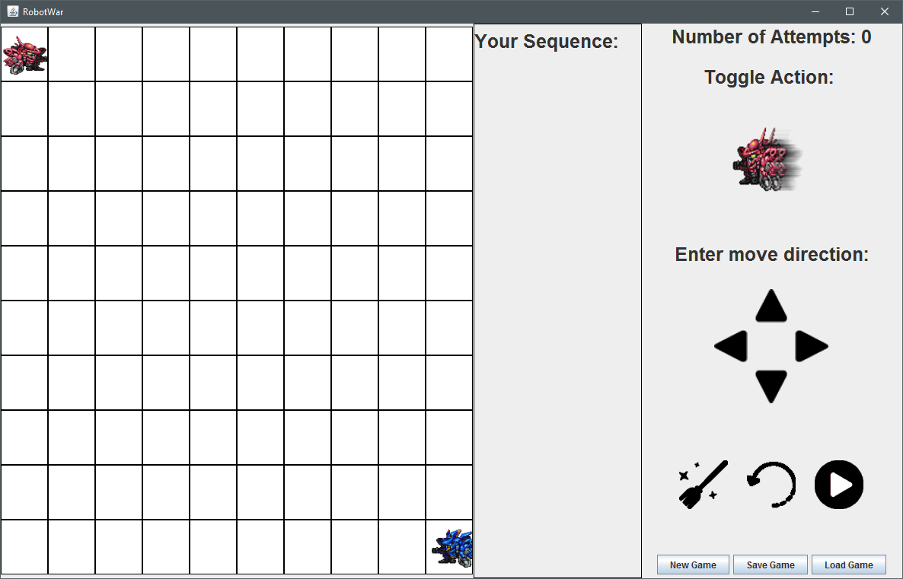

How to use the program?

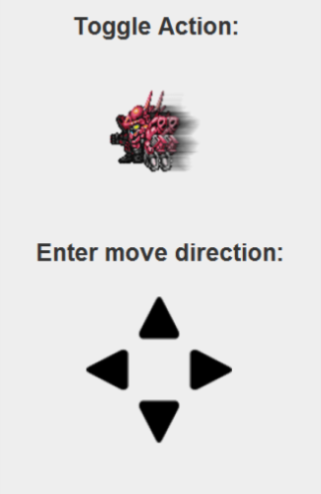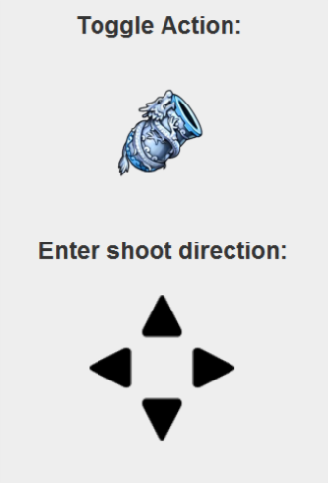

By clicking on the icon, users will be able to toggle between moving and shooting.

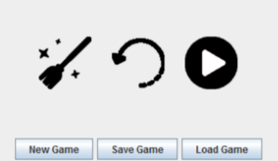

New Game –Reinitializes everything, including computer sequence will be regenerated.

Save Game – Saves the current game state, including sequence selected and computer sequence.

Load Game – Loads back the game state.

Clear user sequence



Undo the last sequence selected



Executes the game (Once user have 18 sequences loaded in)



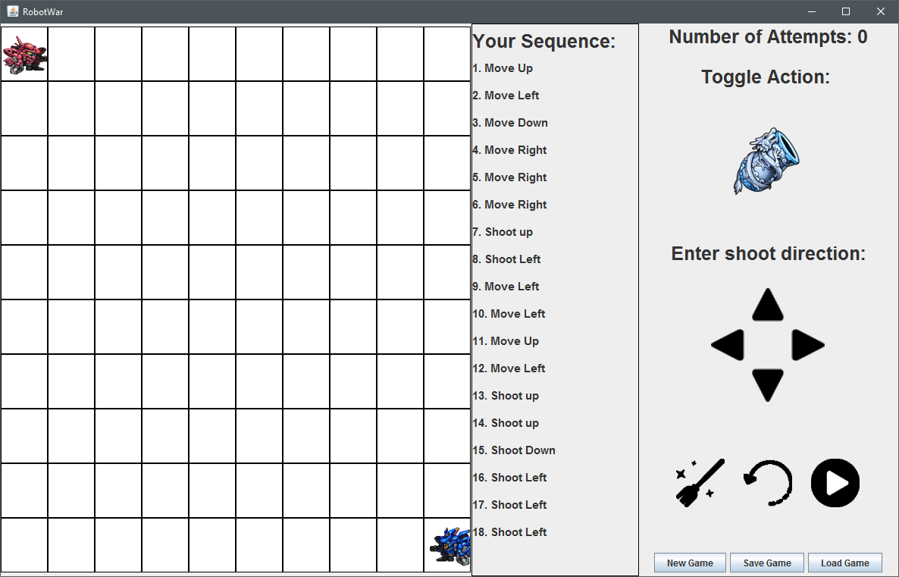.

User sequence are shown in a box as depicted in the image above.

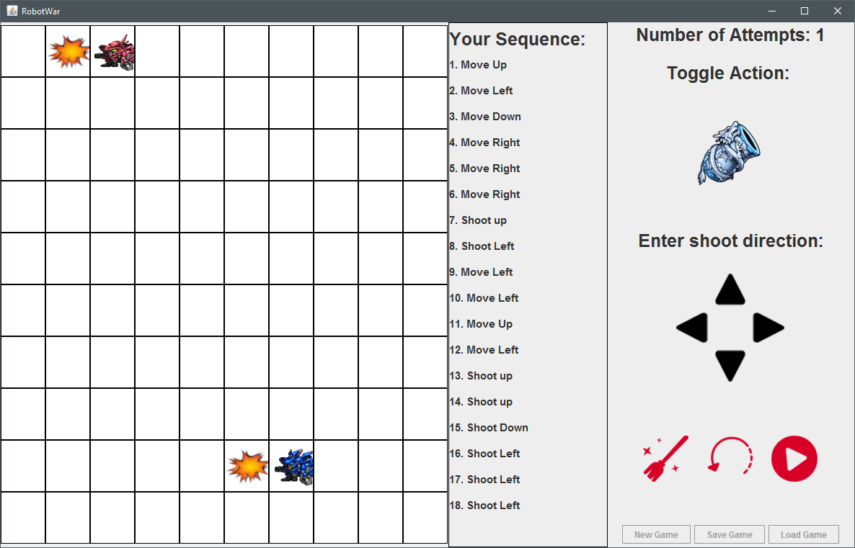

During the game execution, control buttons will be disabled. Other than that everything still works as intended.

**UML Class Diagram**

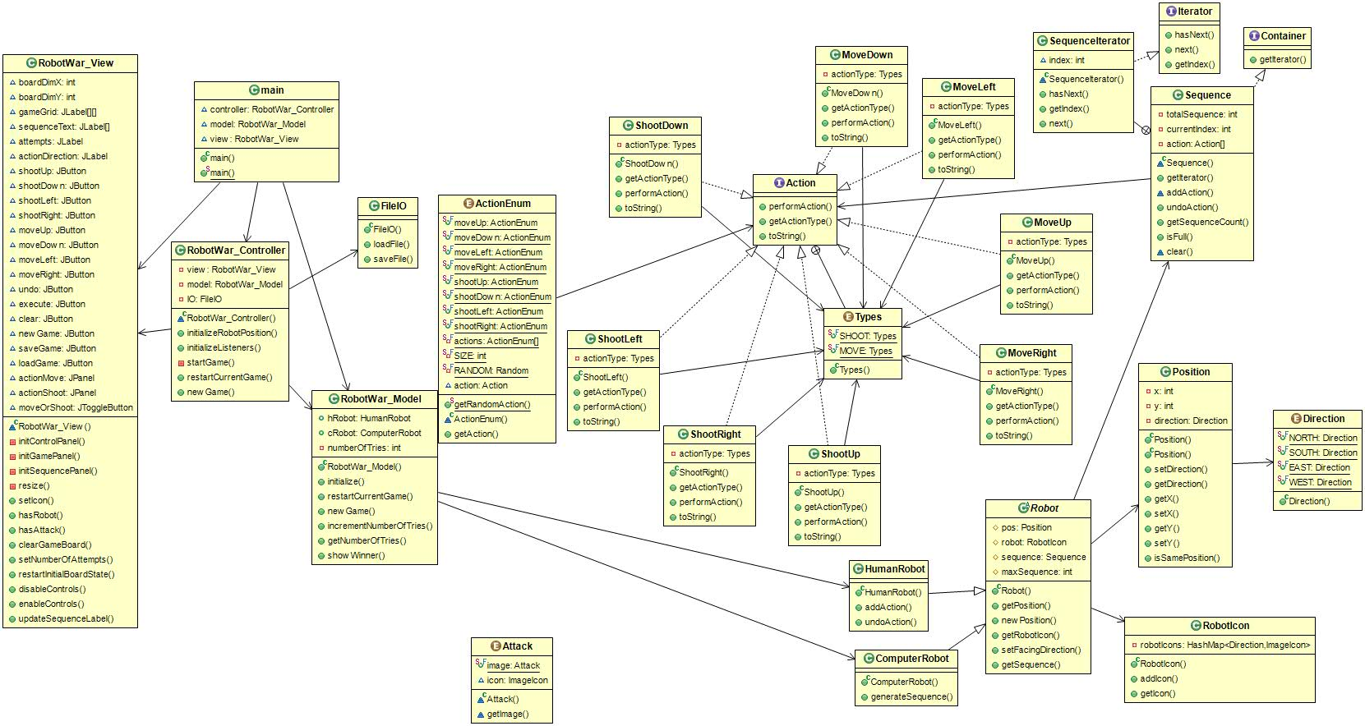

**Use Case Diagram**

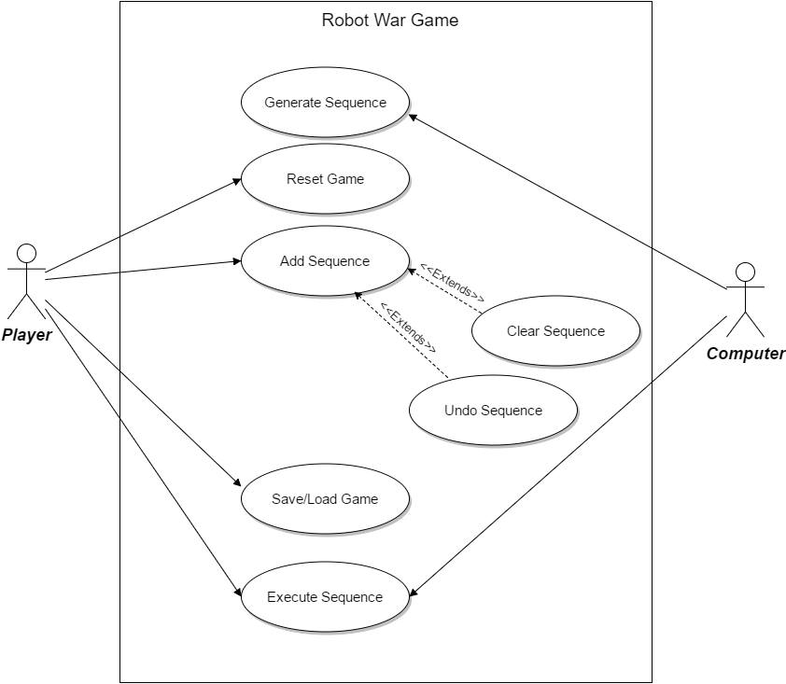

**Sequence Diagram**

1. Add Sequence

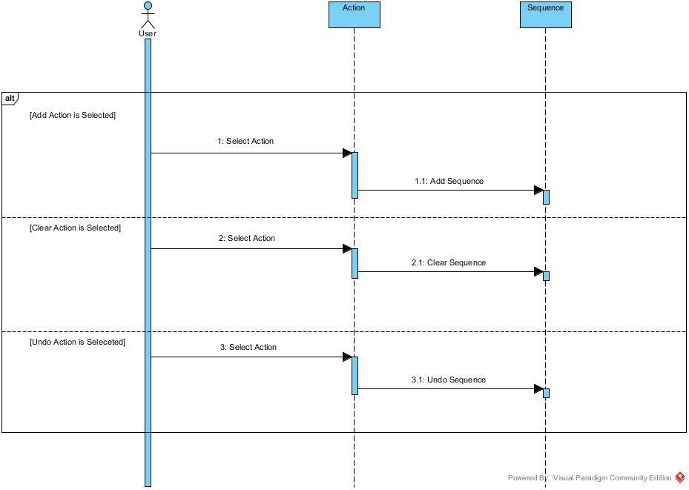

1. Generate Sequence

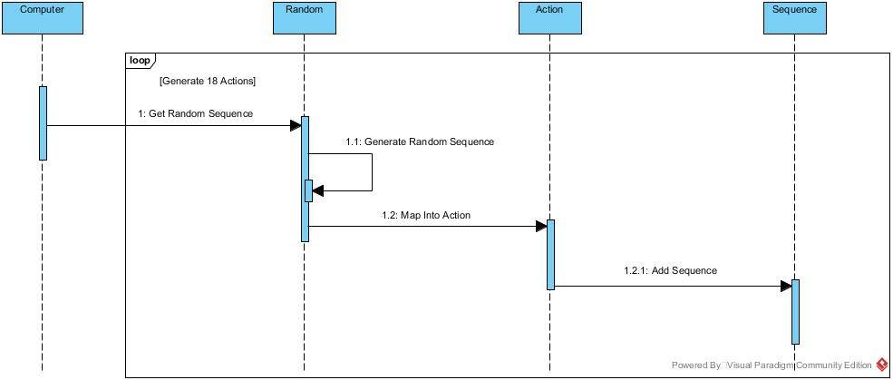

1. Execute Sequence (Start Game)

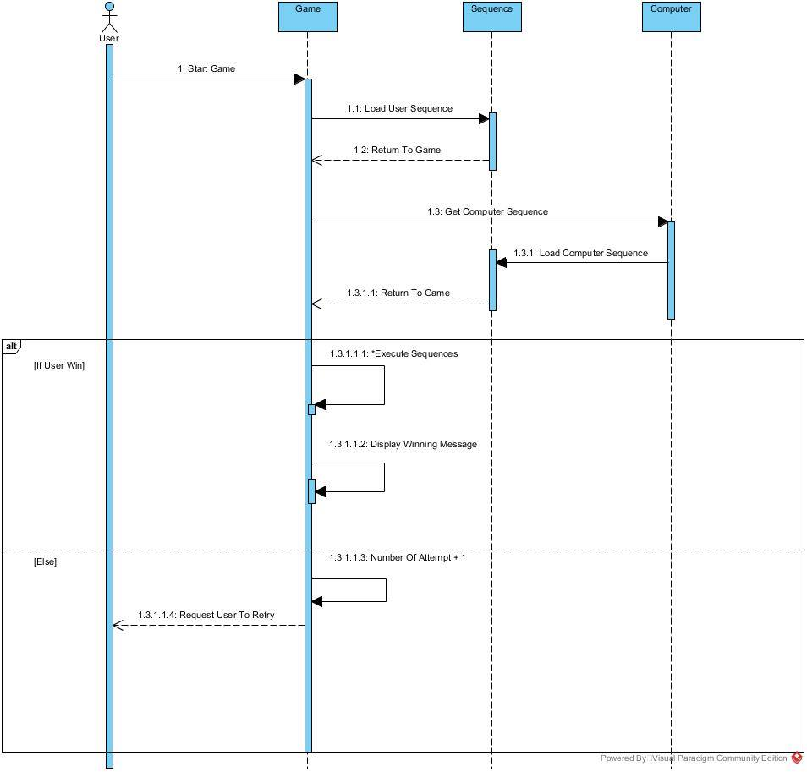

1. New Game

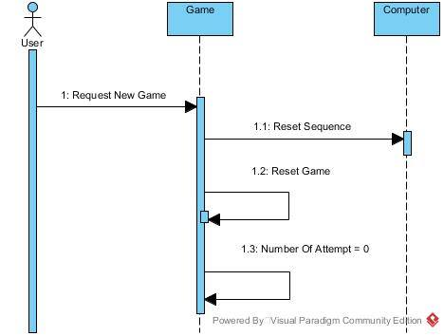

1. Save/Load Game

