Question 1

Use CSS to apply the following to the file “lab1q1.html” using embedded style
- Change the font color of h1 to blue and h2 to olive.
- Create a style class called “double” that changes the size of text to be 2 times larger than the base font of the system. Apply it to the first paragraph (“This course covers…”).
- Use “mmu.jpg” in the images folder as a background image at the bottom right of the page with no repeat option. The image should remain in place when the user scrolls up and down.
- Display all hyperlinks in maroon without underlining them. When the mouse hover over a link, change the color to blue, background color to yellow with an underline.
- Use inheritance to change the font color of the word web in the nested ordered list to red

Use inline style to change the font color of the word web in h2 to green

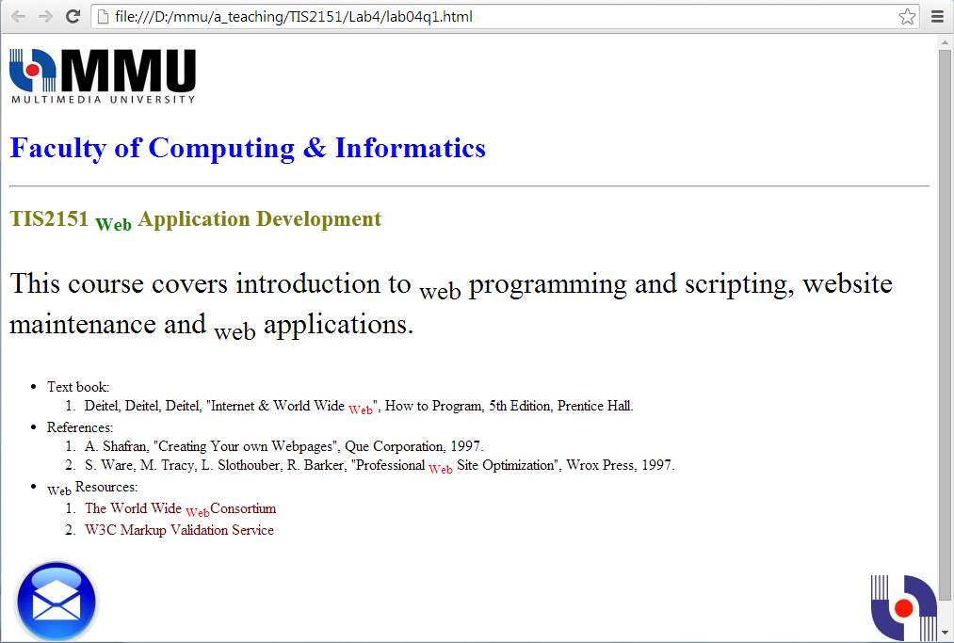
Question 2

Write a HTML5 document for the following HTML page by applying CSS rules:

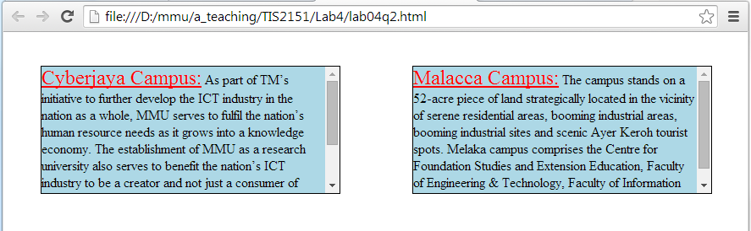

- Use absolute positioning so the two paragraphs are side by side as in the figure.
- Give both paragraphs a border and a background color of light blue.
- Set the paragraphs height to 140pixels and witdh to 40% .
- Allow the user to scroll the paragraphs up and down..
- Create a style class called “redLine” that will enlarge the font to 1.5 times default font size, set the font color to red with an underline.
- Apply the class redline to the words “Cyberjaya Campus” and “Malacca Campus”.

Use the text below:

Cyberjaya Campus: As part of TM&rsquo;s initiative to further develop the ICT industry in the nation as a whole, MMU serves to fulfil the nation&rsquo;s human resource needs as it grows into a knowledge economy. The establishment of MMU as a research university also serves to benefit the nation&rsquo;s ICT industry to be a creator and not just a consumer of technology. Through the establishment of a local private university, the nation can train its required human resources within its borders, a sound strategy from the economic management perspective.

Malacca Campus: The campus stands on a 52-acre piece of land strategically located in the vicinity of serene residential areas, booming industrial areas, booming industrial sites and scenic Ayer Keroh tourist spots. Melaka campus comprises the Centre for Foundation Studies and Extension Education, Faculty of Engineering & Technology, Faculty of Information Science & Technology and Faculty of Business & Law.

Question 3

Using external style sheet, do the following:
- Make a navigation button using a div with a link inside it.
- Give it a 2 pixels blue border, blue background and 200 pixels width.
- Set the hyperlink to red, no underline, with font size of 20 pixels and bold
- Make the button change when the user hovers the mouse over the button. Change background color to white and border color to orange

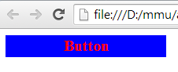 | 