Question 1

Use HTML5 to create a document that contains the following text and image:


Faculty of Computing & Informatics
TIS2151 Web Application Development
This course covers introduction to web programming and scripting, CSS and web applications.
Text book:
Deitel, Deitel, Deitel, “Internet & World Wide Web”, How to Program, 5th Edition, Prentice Hall.
References:
A. Shafran, “Creating Your own Webpages”, Que Corporation, 1997.
S. Ware, M. Tracy, L. Slothouber, R. Barker, “Professional Web Site Optimization”, Wrox Press, 1997.
Web Resources:
The World Wide Web Consortium (http://www.w3c.org)
W3C Markup Validation Service (http://validator.w3.org)


- Use “Lab 1 – Question 1” as title element
- Use width and height attributes of the img element to reduce the size of the MMU logo image by 50 percent (The image named logo.jpg is 400 pixels wide and 120 pixels high)
- Use h1 for the first line of text
- Use h2 for the second line of text
- Insert a horizontal rule between the h1 element and the h2 element
- Use p for rest of the text
- Use sub for the word “web”
- Create three unordered lists: text book, references and web resources. Each unordered list should contain a nested, ordered list of item. Create hyperlink for each of web resources
- Use the image “email.jpg” as an email link. Use attribute alt to provide a description of the image

Open your new document in a web browser to view the marked-up document and then validate your HTML5 document.

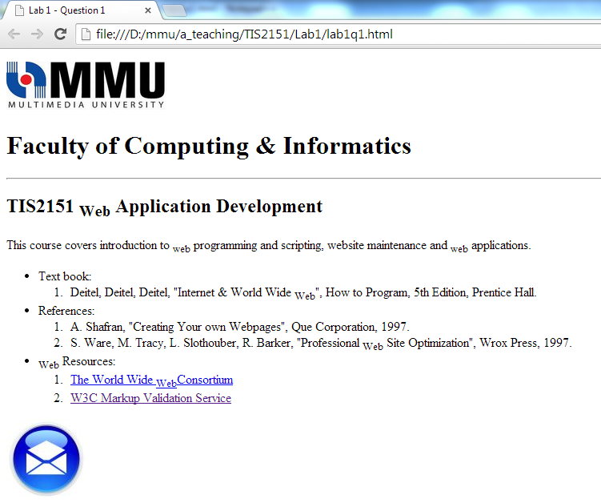
Question 2

Write a HTML5 document that produces the table shown in the following figure.

