Question 1

Create a text shadow on the h1 “WEB APPLICATIONS DEVELOPMENT” with an offset-x of 5px, an offset-y of 10px, a blur radius of 12px and red shadow. Increase the font size to 400%.

Question 2

Create three div elements, each with a width and height of 300px and 200px respectively. On the first element, create slightly rounded corners using a border of 6px black and border radius of 20px. On the second element, use a border of 6px black and increase the border radius to 50px. On the third, use a border of 6px black and increase the border radius to 200px. Make the background color of each element red and display the value of the border-radius inside each element in normal text, 50px from the top border.

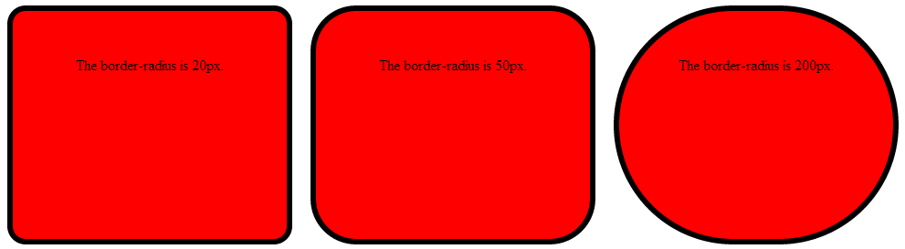

Question 3

Create three div elements in plum, each with a width and height of 200px, with top and right margins of 100px. On the first box, add a dimgrey shadow with an offset-x of 30px and offset-y of 30px, and a blur radius of 30px. On the second box, add a blue shadow with an offset-x of -30px and offset-y of -30px, and a blur radius of 60px. On the third box, add a pink shadow with an offset-x of 30px and offset-y of 30px, and a blur radius of 5px. Display the shadow position in each div using h4, centered. Below is the html page in a browser.

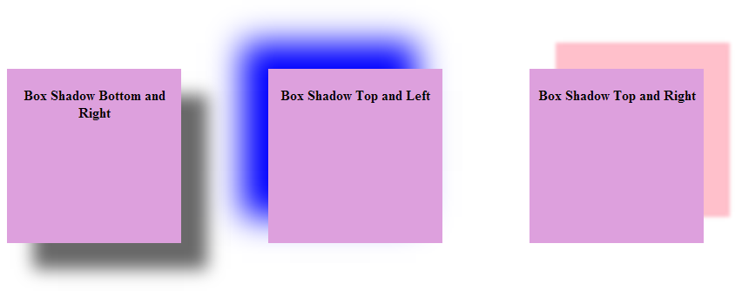

Question 4

Create two div elements with width and height of 400px. Create a diagonal linear gradient using five colors in the first div. Start the gradient in the bottom left corner with the colors changing as they move along the gradient line to the top right. Create a radial gradient using five colors in the second div. Start the gradient in the top left corner with the colors changing as they move along the gradient line to the right.

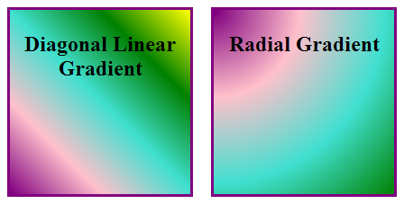

Question 5
Complete the following CSS code to automatically alter the number of columns and the rules between columns based on the screen size of the device on which the page is viewed:

- If the page is rendered on handheld devices with max-width of 480px, or a device with a screen that has a max-device-width of 480px, or on a screen having max-width of 480px, set column-count to 1
- Else if the page is rendered on devices with min-width of 481px and max-width of 1024px, set column-count to 2, column-gap to 30px and column-rule to 1px outset black
- Else if the page is rendered on devices with min-width of 1025px, set column-count to 3, column-gap to 35px and column-rule to 1px outset black

<!DOCTYPE html>

<html>
<head>
<meta charset = "utf-8">
<title>Media Queries</title>
<style type = "text/css">
p
{ margin: 0.9em 0em; }
/* styles for smartphones with screen widths 480px or smaller */

/* styles for devices with screen widths of 481px to 1024px */

/* styles for devices with screen widths of 1025px or greater */
</style>
</head>
<body>
<header>
<h1>Computers, Hardware and Software</h1>
</header>
<div>
<p>A computer is a device that can perform computations and make
logical decisions phenomenally faster than human beings can.
Many of today's personal computers can perform billions of
calculations in one second&mdash;more than a human can perform
in a lifetime. Supercomputers are already performing thousands
of trillions (quadrillions) of instructions per second! To put
that in perspective, a quadrillion-instruction-per-second
computer can perform in one second more than 100,000
calculations for every person on the planet! And&mdash;these
"upper limits" are growing quickly!</p>
<p>Computers process data under the control of sets of
instructions called computer programs. These programs guide
the computer through orderly sets of actions specified by
people called computer programmers. The programs that run on a
computer are referred to as software. In this book, you'll
learn today's key programming methodology that's enhancing
programmer productivity, thereby reducing software-development
costs&mdash;object-oriented programming.</p>

<p>A computer consists of various devices referred to as hardware
(e.g., the keyboard, screen, mouse, hard disks, memory, DVDs
and processing units). Computing costs are dropping
dramatically, owing to rapid developments in hardware and
software technologies. Computers that might have filled large
rooms and cost millions of dollars decades ago are now
inscribed on silicon chips smaller than a fingernail, costing
perhaps a few dollars each. Ironically, silicon is one of the
most abundant materials&mdash;it's an ingredient in common
sand. Silicon-chip technology has made computing so economical
that more than a billion general-purpose computers are in use
worldwide, and this is expected to double in the next few
years.</p>
<p>Computer chips (microprocessors) control countless devices.
These embedded systems include anti-lock brakes in cars,
navigation systems, smart home appliances, home security
systems, cell phones and smartphones, robots, intelligent
traffic intersections, collision avoidance systems, video game
controllers and more. The vast majority of the microprocessors
produced each year are embedded in devices other than general-
purpose computers.</p>
</div>
</body>
</html>

