Question 1

- Multimedia University has asked you to create an HTML document that allows prospective students to provide feedback about their campus visit. Your HTML document should contain a form with

  - Hidden inputs (recipient= “admin@mmu.edu.my”, subject=”MMU Feedback Form” )
  - text boxes for a name and e-mail address
  - checkboxes that allow prospective students to indicate what they liked most about the campus. The checkboxes should include: students, location, campus, atmosphere, dorm rooms and sports
  - radio buttons that ask the prospective students how they became interested in the university. Options should include: friends, television, Internet and other.
  - a text area for additional comments,
  - a submit button and
  - a reset button.

Use post method to send the information on the form to http://www.mmu.edu.my. Set the Name field as autofocus.

Open your new document in a web browser to view the marked-up document and then validate your HTML5 document.

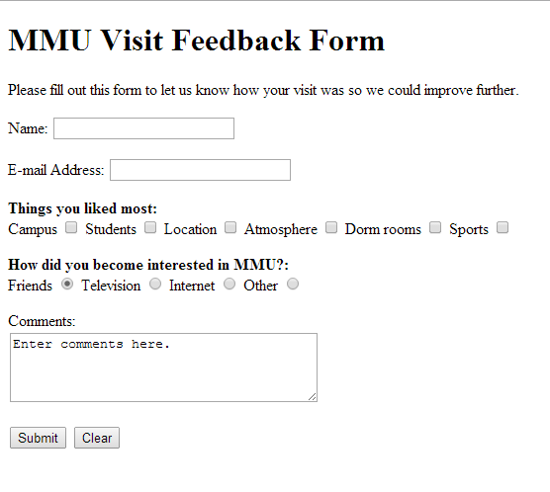

Question 2

Create a HTML5 document titled “Web Application Development”. Use meta tags to include:
- a series of keywords that describe your document
- a description of your document

Question 3

Write HTML5 code for the following page. Set the email field as “required”. Use post method to send the information on the form to http://www.mmu.edu.my

