Question 1

Write HTML5 code for the following page. Set the Tel field as “required”. Use post method to send the information on the form to http://www.mmu.edu.my

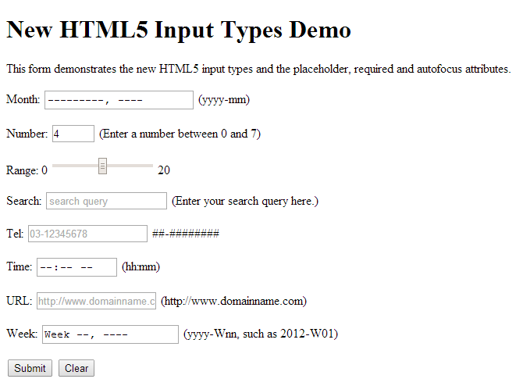

Question 2

Write an HTML5 element (or elements) to accomplish each of the following tasks:

- Teachers were asked to evaluate students in an examination on a scale of 1 to 100. Use a meter element with text to its left and right to indicate that the average rating was 65 out of 100.

- Create a details element that displays the summary text "StudentResults" for Part(a). When the user clicks the arrow next to the summary text, an explanatory paragraph about the survey should be displayed.

- Create a text input element for a telephone number. The element should automatically receive the focus when the form is rendered in a browser.

- How to bypass validation procedure.

- Use a datalist to provide an autocomplete list for five fruits.

- Create a range input element that allows the user to select a number from 5 to 50.

- Specify that autocomplete should always be allowed for a form.

- Use a mark element to highlight the first sentence in the following paragraph.

<p> Teachers were asked to evaluate students in an examination on a scale
of 1 to 100. The average result was 65. </p>

Question 3

The header element creates a header for the page. The header element contains ________.
a) text
b) a section
c) graphics
d) an article

The time element enables you to identify a ________.
a) date
b) location
c) time zone
d) time

The ________ element groups navigation links.
a) navigation
b) link
c) header
d) nav

The ________ element describes an image in the document so that it could be moved to the side of the page or to another page.
a) figcaption
b) header
c) article
d) figure

The ________ element provides a caption for the image in the figure element.
a) header
b) figcaption
c) footer
d) caption

The ________ element describes content that’s separate from the main content of the page and might be used or distributed elsewhere, such as a news article, forum post or blog entry.
a) details
b) summary
c) article
d) footer

The ________ element displays a right-pointing arrow next to a summary or caption when the document is rendered in a browser.
a) summary
b) details
c) figcaption
d) article

When the arrow next to a summary element is clicked, the arrow points downward and reveals the content in a(n) ________ element.
a) article
b) footer
c) section
d) details

The ________ element describes a section of a document, usually with a heading for each section.
a) details
b) article
c) section
d) sectionheading

The ________ element describes content that’s related to the surrounding content (such as an article) but that’s somewhat separate from the flow of the text.
a) aside
b) figcaption
c) summary
d) header

The ________ renders a visual representation of a measure within a range.
a) slider control
b) meter element
c) wbr element
d) details element

The ________ element describes content that usually appears at the bottom of the content or section element.
a) details
b) summary
c) footer
d) aside

The ________ element enables you to highlight text.
a) label
b) highlight
c) section
d) mark

The ________ element indicates the appropriate place to break a word when the text wraps to multiple lines.
a) wbr
b) break
c) brk
d) mark

