Nikhil Khatu

ECE 506 – Architecture of Parallel Computers

Professor Yan Solihin

9/14/2013

**Machine Problem 1**

Our Machine Problem uses the OpenMP API to parallelize/multi-thread a program which involves multiple ‘for’ loops.

The output of ‘*cat /proc/cpuinfo*’ is provided at the end of the report. The environment consists of the following:

* 64 bit Windows 7 host OS with Virtualbox hypervisor
* Intel(R) Core(TM) i7-3770S CPU @ 3.10GHz
  + 4 cores
  + hyper-threading turned off in BIOS
* 16 GB DDR3 RAM
* 64 bit Ubuntu 12.04 guest OS

The system time is printed at program initiation and at finish with the following line added to the code:

*system("date");*

The number of threads allowed to be executed by our MP1 program is regulated by the following command in the bash cli of the Ubuntu OS:

*export OMP_NUM_THREADS=<max_#_of_threads_allowed>*

Upon varying the maximum number of threads and executing the program we record the corresponding values.

|  |  |
| --- | --- |
| **Number of Threads** | **Execution Time** |
| 1 | 23 |
| 2 | 11 |
| 3 | 9 |
| 4 | 6 |
| 8 | 6 |

One can observe that every time the number of threads is doubled the time to execute is halved; however a cap of four cores caps the benefit of multi-threading execution time gains to under 4 threads. In the following graph we can see that as the number of threads goes to infinity the execution time will remain at 6 seconds.

Host Machine Specifications:

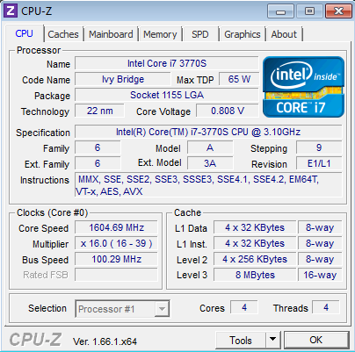

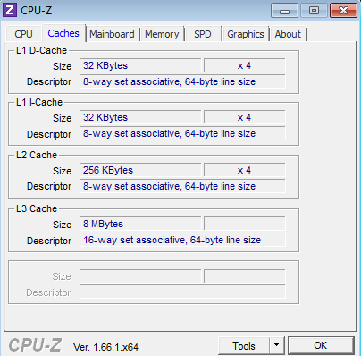

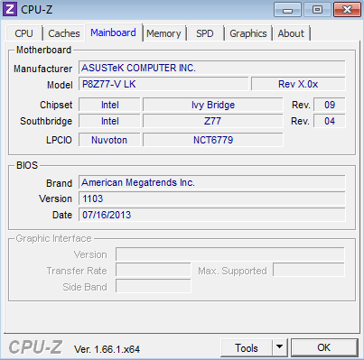

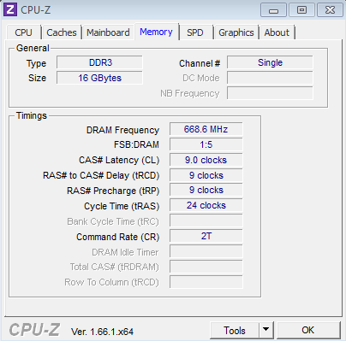

Guest Machine Specifications:

processor : 0

vendor_id : GenuineIntel

cpu family : 6

model : 58

model name : Intel(R) Core(TM) i7-3770S CPU @ 3.10GHz

stepping : 9

cpu MHz : 2985.104

cache size : 6144 KB

physical id : 0

siblings : 4

core id : 0

cpu cores : 4

apicid : 0

initial apicid : 0

fpu : yes

fpu_exception : yes

cpuid level : 5

wp : yes

flags : fpu vme de pse tsc msr pae mce cx8 apic sep mtrr pge mca cmov pat pse36 clflush mmx fxsr sse sse2 ht syscall nx rdtscp lm constant_tsc rep_good nopl pni ssse3 lahf_lm

bogomips : 5970.20

clflush size : 64

cache_alignment : 64

address sizes : 36 bits physical, 48 bits virtual

power management:

processor : 1

vendor_id : GenuineIntel

cpu family : 6

model : 58

model name : Intel(R) Core(TM) i7-3770S CPU @ 3.10GHz

stepping : 9

cpu MHz : 2985.104

cache size : 6144 KB

physical id : 0

siblings : 4

core id : 1

cpu cores : 4

apicid : 1

initial apicid : 1

fpu : yes

fpu_exception : yes

cpuid level : 5

wp : yes

flags : fpu vme de pse tsc msr pae mce cx8 apic sep mtrr pge mca cmov pat pse36 clflush mmx fxsr sse sse2 ht syscall nx rdtscp lm constant_tsc rep_good nopl pni ssse3 lahf_lm

bogomips : 5970.20

clflush size : 64

cache_alignment : 64

address sizes : 36 bits physical, 48 bits virtual

power management:

processor : 2

vendor_id : GenuineIntel

cpu family : 6

model : 58

model name : Intel(R) Core(TM) i7-3770S CPU @ 3.10GHz

stepping : 9

cpu MHz : 2985.104

cache size : 6144 KB

physical id : 0

siblings : 4

core id : 2

cpu cores : 4

apicid : 2

initial apicid : 2

fpu : yes

fpu_exception : yes

cpuid level : 5

wp : yes

flags : fpu vme de pse tsc msr pae mce cx8 apic sep mtrr pge mca cmov pat pse36 clflush mmx fxsr sse sse2 ht syscall nx rdtscp lm constant_tsc rep_good nopl pni ssse3 lahf_lm

bogomips : 5970.20

clflush size : 64

cache_alignment : 64

address sizes : 36 bits physical, 48 bits virtual

power management:

processor : 3

vendor_id : GenuineIntel

cpu family : 6

model : 58

model name : Intel(R) Core(TM) i7-3770S CPU @ 3.10GHz

stepping : 9

cpu MHz : 2985.104

cache size : 6144 KB

physical id : 0

siblings : 4

core id : 3

cpu cores : 4

apicid : 3

initial apicid : 3

fpu : yes

fpu_exception : yes

cpuid level : 5

wp : yes

flags : fpu vme de pse tsc msr pae mce cx8 apic sep mtrr pge mca cmov pat pse36 clflush mmx fxsr sse sse2 ht syscall nx rdtscp lm constant_tsc rep_good nopl pni ssse3 lahf_lm

bogomips : 5970.20

clflush size : 64

cache_alignment : 64

address sizes : 36 bits physical, 48 bits virtual

power management: