PCA Conclusion

The eigenvectors from PCA can be found on folder /reports/data with files pca_{room}_eigenvectors.csv

1. Features’ distribution

Conference Room data

Without PCA | With PCA
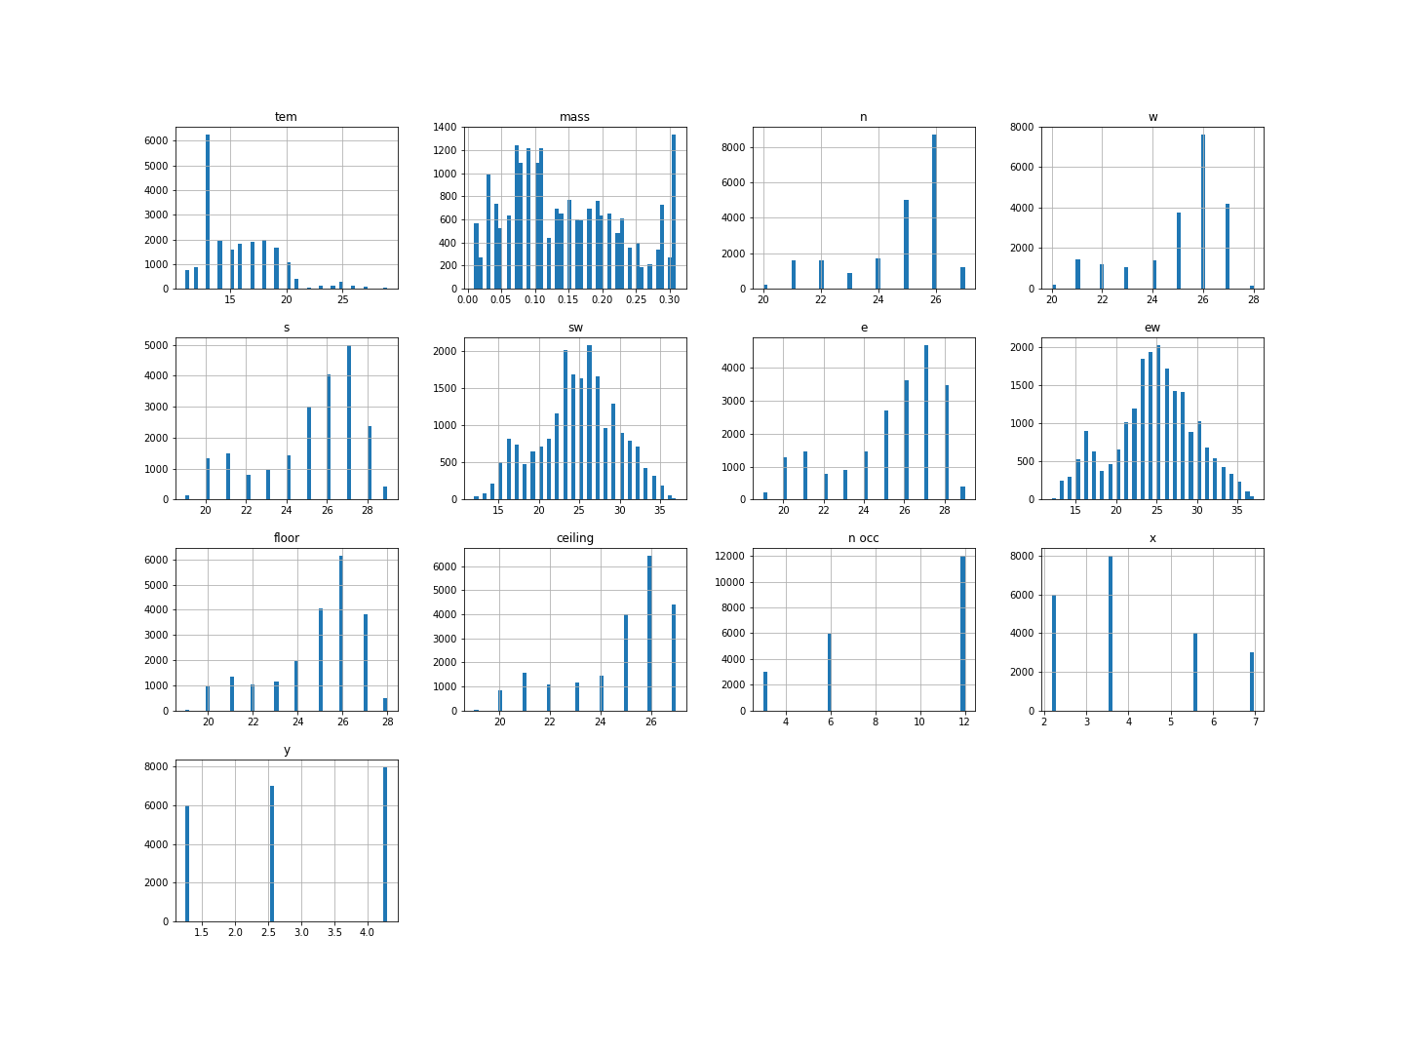 | 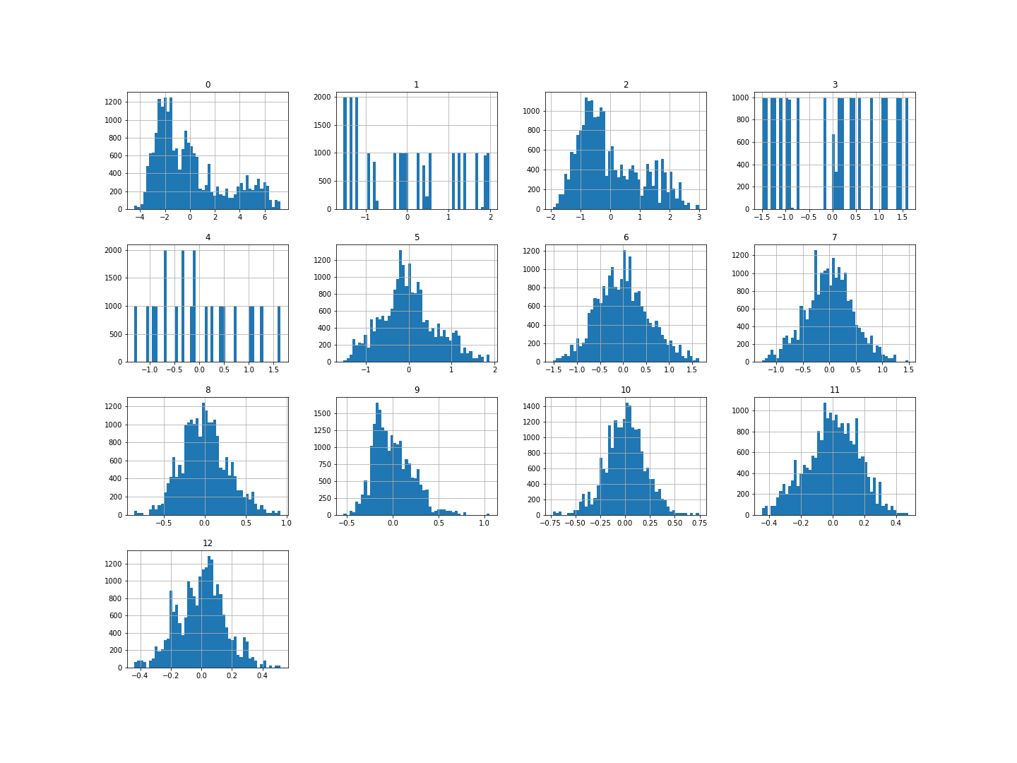

Enclosed Office

Without PCA | With PCA
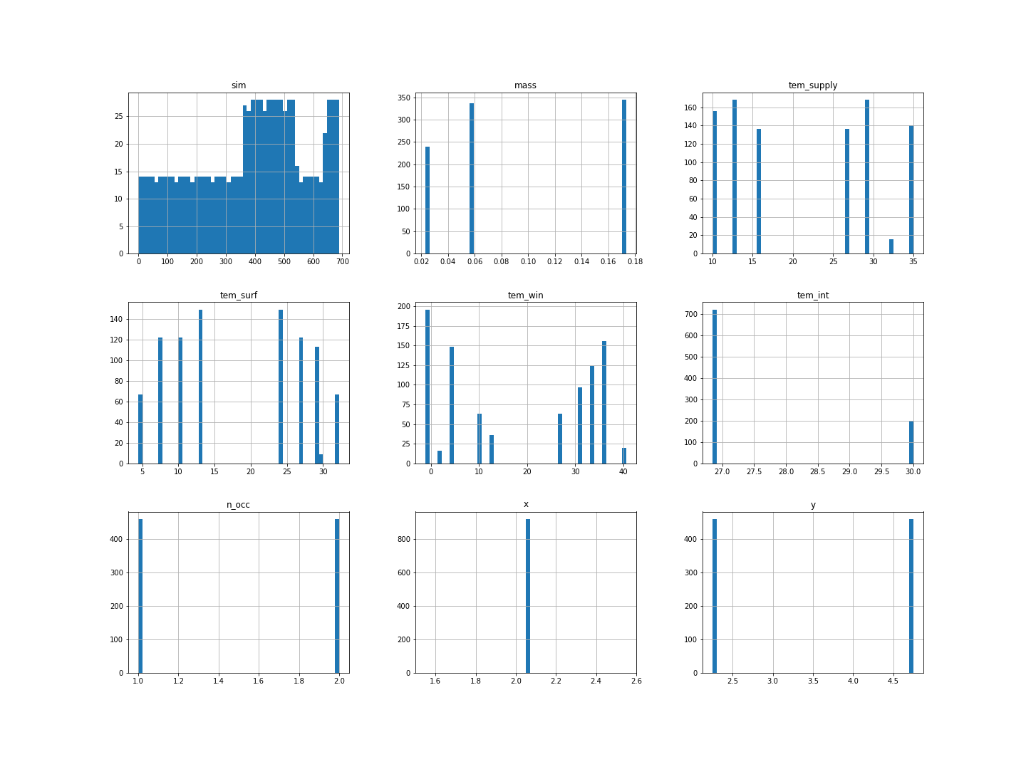 | 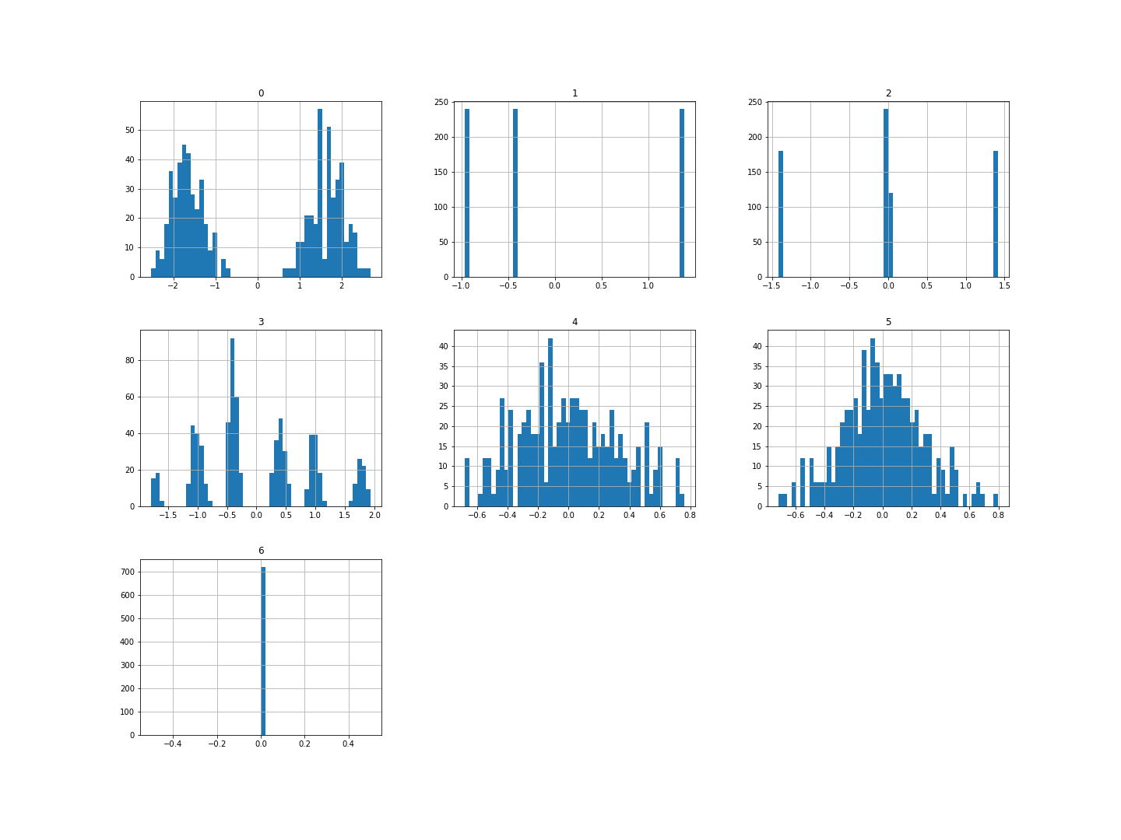

Open Office

Without PCA | With PCA
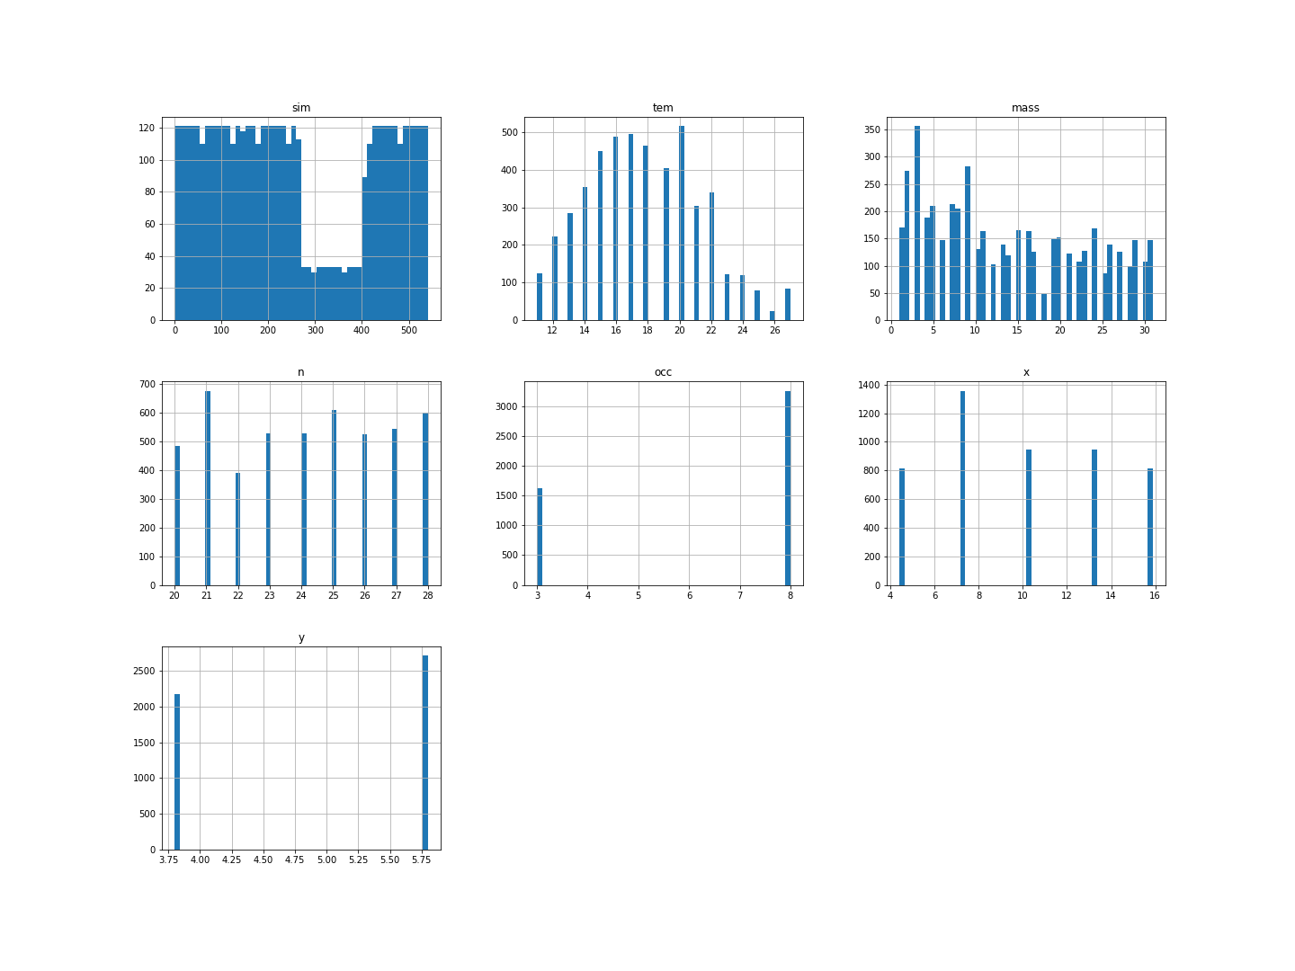 | 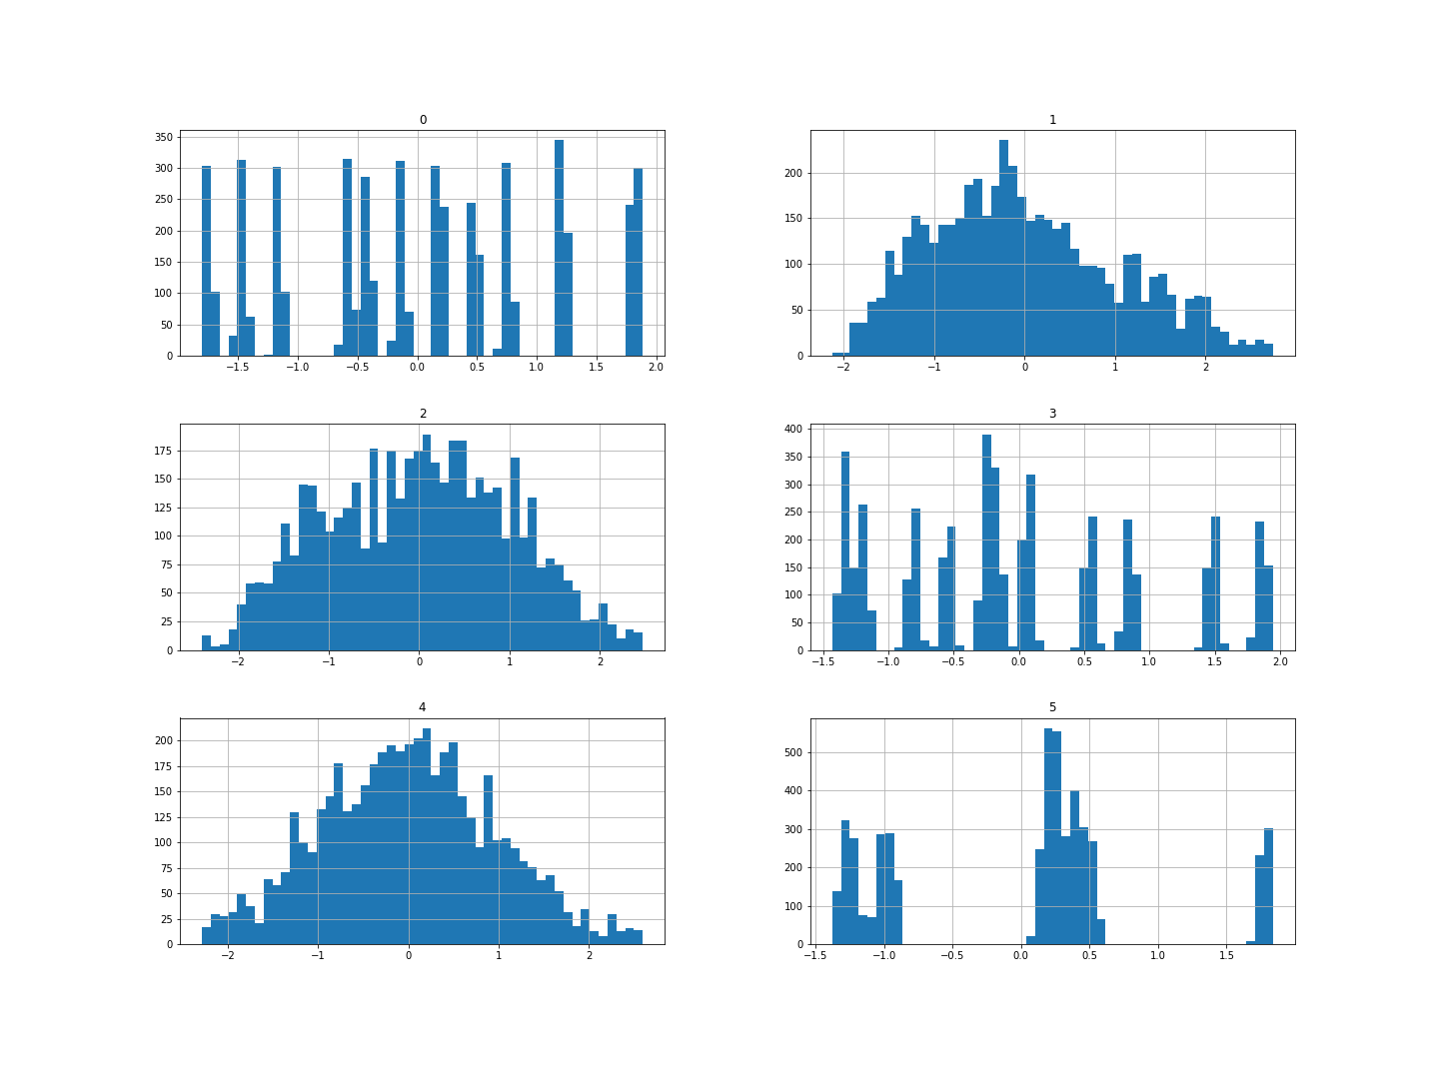

Small Office

Without PCA | With PCA
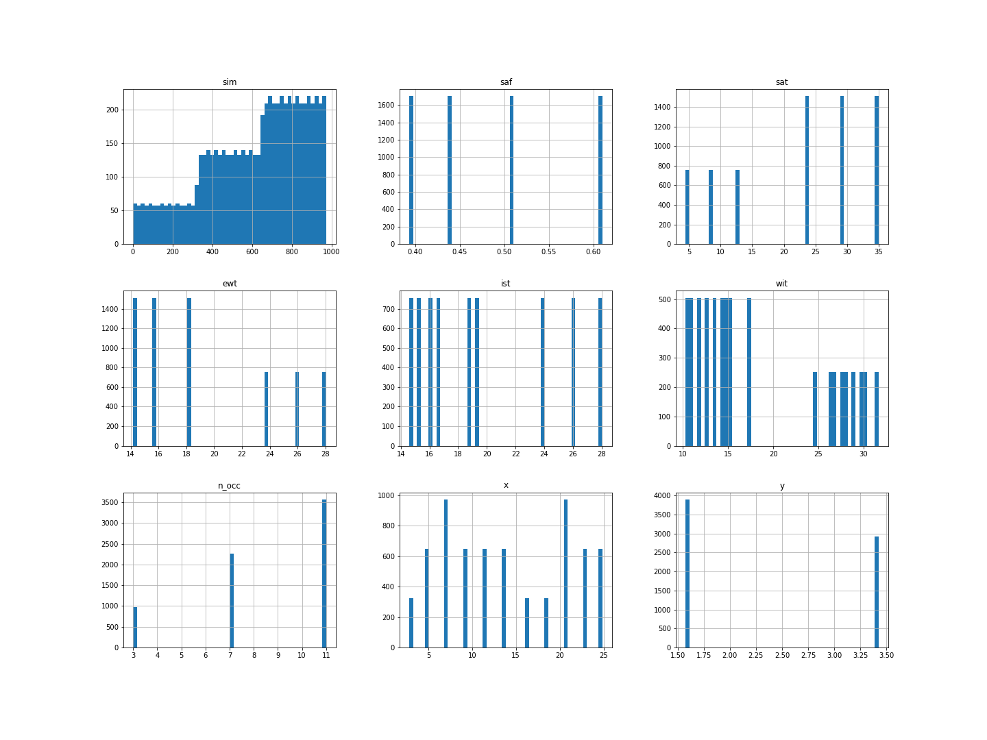 | 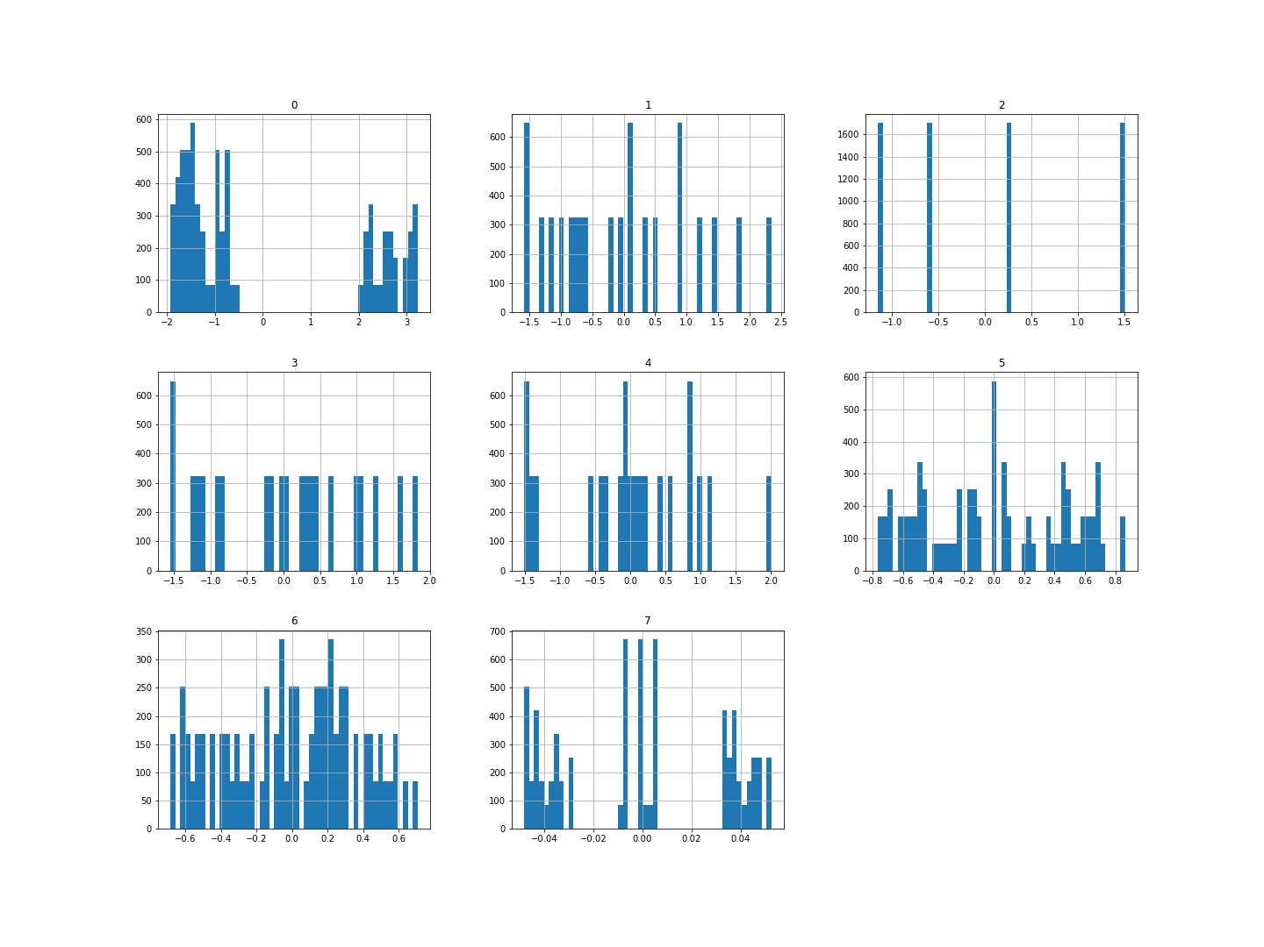

2. PCA’s Explained Variance Ratio

Conference Room data

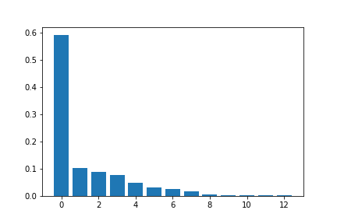
Enclosed Office

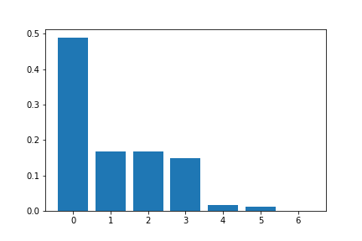

Open Office

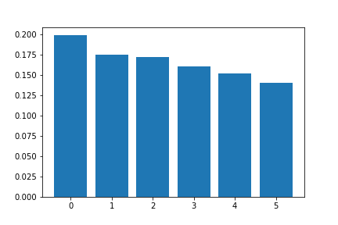
Small Office

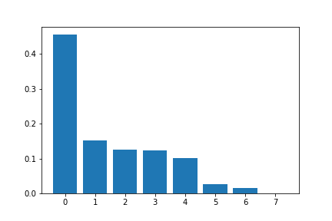
3. PCA Evaluation on Machine Learning models

3.1 Linear Regression

 | MSE without PCA | MSE with PCA | Training time without PCA | Training time with PCA
Conference Room with target MRT | 0.0363 | 0.0363 | 0.0126 | 0.0143
Conference Room with target T | 0.1325 | 0.1325 | 0.0094 | 0.0113
Conference Room with target V | 0.0011 | 0.0011 | 0.0147 | 0.0123
Enclosed Office with target MRT | 1.7880 | 1.7880 | 0.0037 | 0.0034
Enclosed Office with target T | 3.0036 | 3.0036 | 0.0052 | 0.0041
Enclosed Office with target V | 0.0017 | 0.0017 | 0.0046 | 0.0067
Open Office with target MRT | 0.0025 | 0.0025 | 0.0053 | 0.0073
Open Office with target T | 0.0412 | 0.0412 | 0.0065 | 0.0059
Open Office with target V | 0.0002 | 0.0002 | 0.0080 | 0.0064
Small Office with target MRT | 0.4468 | 0.4468 | 0.0096 | 0.0070
Small Office with target T | 0.1658 | 0.1658 | 0.0043 | 0.0080
Small Office with target V | 0.0004 | 0.0004 | 0.0067 | 0.0075

3.2 Feedforward Neural Network

 | MSE without PCA | MSE with PCA | Training time without PCA | Training time with PCA
Conference Room with target MRT | 0.0059 | 0.0023 | 190.46 | 200.49
Conference Room with target T | 0.0282 | 0.0168 | 198.22 | 199.61
Conference Room with target V | 0.0003 | 0.0003 | 203.27 | 193.58
Enclosed Office with target MRT | 0.1429 | 0.1337 | 8.6314 | 6.0204
Enclosed Office with target T | 0.5687 | 0.2845 | 6.2719 | 6.1693
Enclosed Office with target V | 0.0004 | 0.0003 | 6.2108 | 6.2445
Open Office with target MRT | 0.0024 | 0.0027 | 43.7616 | 44.0263
Open Office with target T | 0.0266 | 0.1383 | 45.3539 | 46.2882
Open Office with target V | 0.0001 | 0.0002 | 47.3532 | 44.3448
Small Office with target MRT | 0.0614 | 0.0128 | 66.4922 | 64.8353
Small Office with target T | 0.0842 | 0.0151 | 67.4418 | 66.7365
Small Office with target V | 5.5294e-05 | 5.3817e-05 | 64.6739 | 0.0075

