**A DISTRIBUTOR SELLING PHONES**

|  |  |  |
| --- | --- | --- |
|  | **Requirements Analysis & Design (RAD) By Students:**   1. **521H0502 : Nguyen Khac Huy** 2. **521H0108**: **Nguyen Nhat Nam** |  |
| **Reference:** | **Team_XX_RAD_Requirements_Modelling_v0.1** |  |
| **Audience:** | **Mr. Pham Thai Ky Trung Document Version:** | December 26th , 2023 |
| **Outcome:** | **A Distributor selling electronics devices products** |  |
| **Abstract:** | This paper presents a comprehensive study of a distributor system that sells electrical products, with requirements modeled using the UML framework. | |

# Intellectual Property

**Copyright 2023 Team XX.**

The following documentation, the content therein and/or the presentation of its information is proprietary to and embodies the confidential processes, designs, technologies and otherwise of Team XX. All copyright, trademarks, trade names, patents, industrial designs, and other intellectual property rights contained herein are, unless otherwise specified, the exclusive property of TeamXX.

The ideas, concepts and/or their application, embodied within this documentation remain and constitute items of intellectual property which nevertheless belong to Team XX.

The information (including, but by no means limited to, data, drawings, specification,

documentation, software listings, source and/or object code) shall not be disclosed, manipulated, disseminated or otherwise in any manner inconsistent with the nature and/or conditions under which this documentation has been issued.

The information contained herein is believed to be accurate and reliable. Team XX accepts no responsibility for its use in any way whatsoever. Team Five shall not be liable for any expenses, damages and/or related costs which may result from the use of the information contained herein. The information contained herein is subject to change without notice.

All Rights Reserved. Copyright herein is expressly protected at common law, statute and under various International and Multi-National Treatises (including, but by no means limited to, the Berne Convention for the Protection of Literary and Artistic Works).

**TABLE OF CONTENTS**

**CHAPTER 1 – EXECUTE SUMMARY**

The comprehensive project includes creating an advanced B2B information system for the retail stores of agents. A variety of features will be available on this Point-of-Sale (POS) website, including: Account Management, which grants each agent private access to their store; Product Management, which allows administrators to manage product listings and sales staff to view products without access to sensitive information; Customer Management, which enables interaction with both new and returning customers; Sales Management, which manages transaction records and reporting; and Inventory Management, which keeps track of distributor interactions and maintains accurate stock levels. Every part is made to improve administrative effectiveness and streamline retail operations.

**CHAPTER 2 - INTRODUCTION**

The system design will be made available under the name "Agent’s Retail Store Management System," with a 1.0 initial release anticipated (though this could change). Since the application will inevitably undergo more iterations, this first system should be viewed as the foundational model with room to expand and develop in response to shifting end-user requirements.

It is anticipated that the data in this document will be used to create the pertinent test and development plan documents, which should be cited appropriately.

Three deliverables will comprise the Agent’s Retail Store Management System workflow

* Use case model survey: A list of actors and use case diagrams are included in the survey.
* Optional domain object model: This activity's deliverables include cooperation,diagrams of the class and sequence for every use case.
* Comprehensive use case descriptions for each case: Future stages of the of the software system development process are guided by these documents.

CHAPTER 3 – ANALYSIS PRESENTATION

The theories in this document with the main intent are:

* 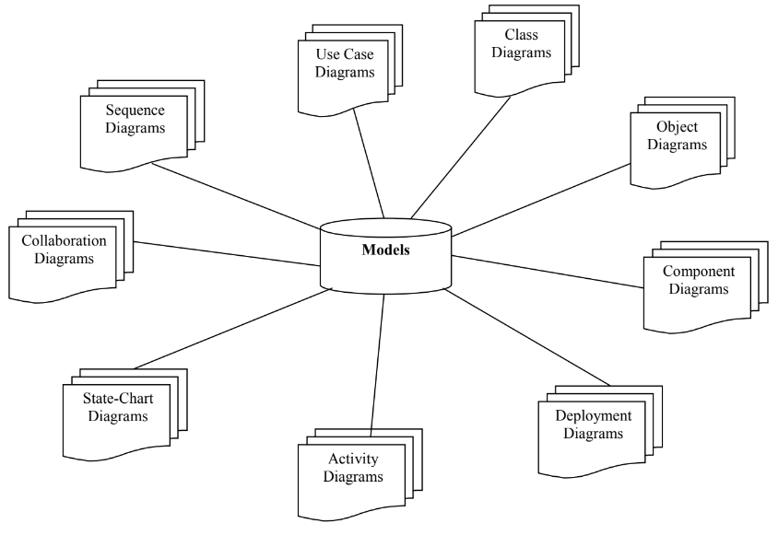A Model would be a complete description of a system from a particular perspective.
* An Actor would be someone or something that must interact with the system under development.
* A use case would be a pattern of behavior the system exhibits that each use case is a sequence of related transactions performed by an actor and the system in a dialogue.
* A flow of events document would be created for each use cases.
* A use case diagram would present an outside view of the system.
* A sequence diagram display would object interactions arranged in a time sequence.
* A class diagram would show the existence of classes and their relationships in the logical view of a system.
* An activity diagram would be a variant of state-chart diagrams organized according to actions, and mainly targeted towards representing the internal behavior of a method.

**3.1 Actors**

1. Admin: Manages personnel, categories, products, inventory, customers, and orders.
2. Information Management Officer: Handles information and category management.
3. Inventory Management Officer: Responsible for inventory management.
4. Customer Care: Engages in customer management and order management.
5. Customer: Can search, evaluate, view products, register for an account, login, and recover passwords.
6. Shipping Unit: Deals with the shipping aspect of orders

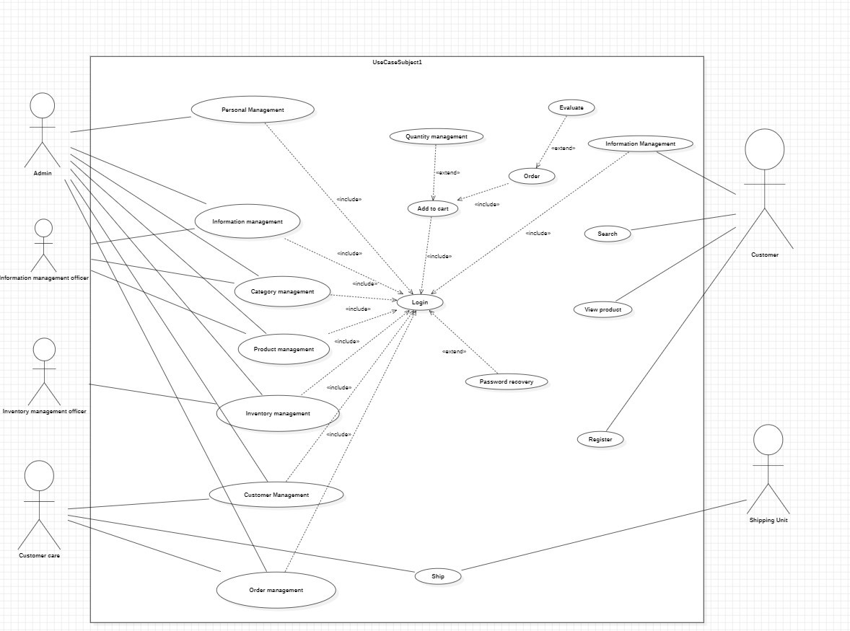**3.2 Use Case Diagram**

**3.3 List Of Use Cases.**

1. Account Management: Admins and managers create, manage, update, and deactivate user accounts for retail store agents.
2. Product Management: Admins oversee product listings, including adding, updating, and deleting products, while sales staff have view-only access.
3. Customer Management: Sales staff create new customer profiles for first-time purchases and view customer information and purchase history.
4. Sales Management: Retail store agents manage sales transactions, generate reports, view transaction details, and handle voids and refunds.
5. Inventory Management: Agents manage inventory levels, handle goods received from distributors, and create goods delivery notes for agents.
6. Total Sale Tracking: Calculate and view the total sales for the company and generate sales reports.
7. Login: Users, admins, and sales staff log in to access their respective accounts and functionalities.
8. Logout: Users, admins, and sales staff log out to secure their accounts and end their sessions.
9. Account Activation/Deactivation: Managers and admins activate and deactivate user accounts for security and access control.
10. Order Management: Retail store agents create, view, modify, and cancel customer orders with admin oversight.
11. Supplier Management: Admins manage supplier information, including adding, updating, and deleting supplier details.
12. Payment Processing: Retail store agents process payments for sales transactions, record payment methods, and address payment errors as necessary.
13. Promotion Management: Admins create and manage promotions, applying them to products and tracking their effectiveness.
14. Return and Refund Handling: Agents manage product returns, process refunds, and update inventory after returns are completed.
15. Expense Tracking: Admins and managers record and analyze store expenses, including approving expense reports.
16. Reporting and Analytics: Generate various reports, analyze sales data, and forecast sales trends to make informed decisions.
17. Product Category Management: Admins create and manage product categories, assigning products to relevant categories for easier organization.
18. Notification and Alerts: Send and receive notifications and alerts for critical events and set user-specific notification preferences.
19. Customer Feedback Handling: Collect and address customer feedback to make improvements and enhance the customer experience.
20. Supplier Order Management: Create supplier orders, track shipments, and receive goods from suppliers to maintain inventory.
21. Employee Training and Onboarding: Provide training materials, onboard new staff, and evaluate employee performance to ensure a skilled workforce.
22. Search and View Product: Customers search for and view product details in the catalog to enhance their shopping experience.

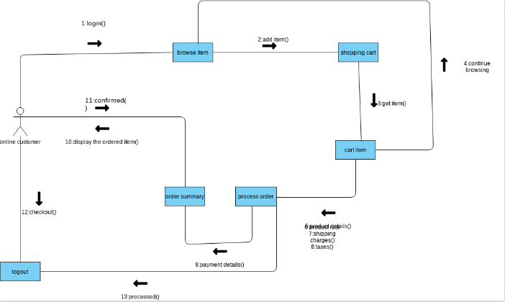**3.4 Collaboration Diagram**

**3.5 Activity Diagram**

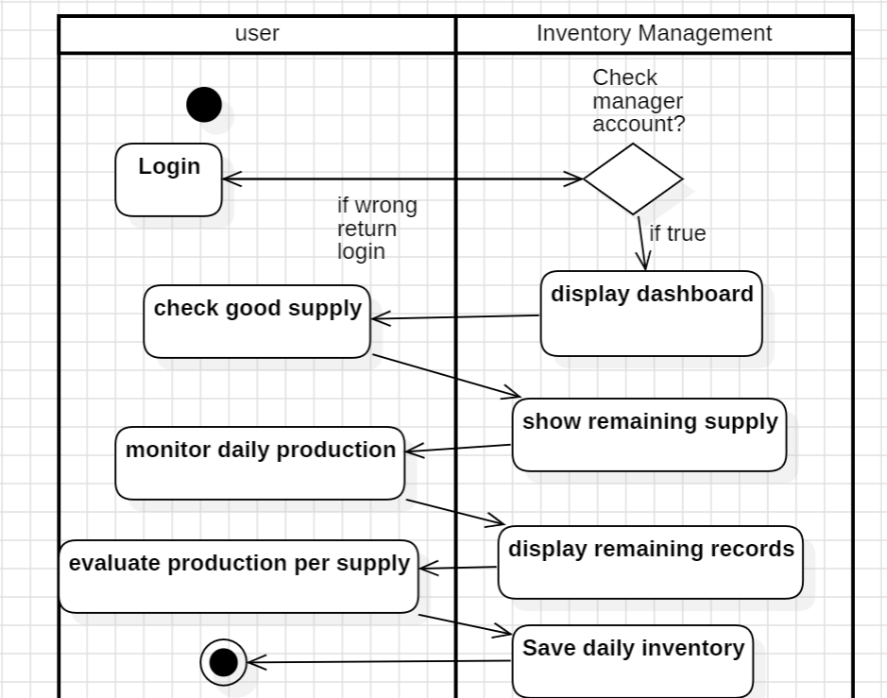

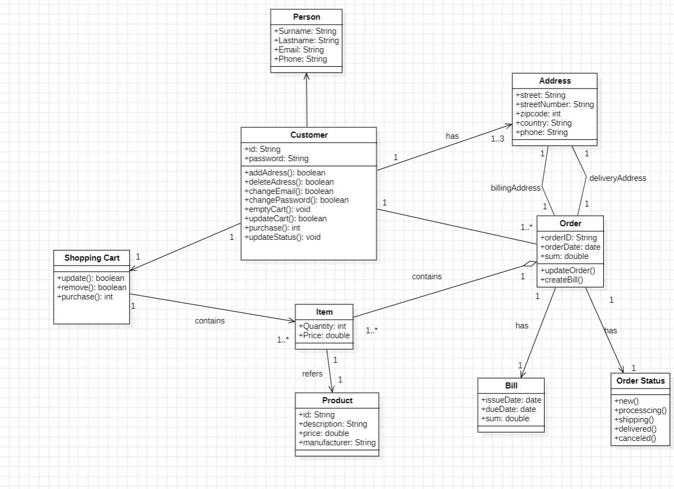**3.6 Class Diagram**

**3.7 Use Case Detail Description**

***3.7.1 Account management***

|  |  |  |
| --- | --- | --- |
| Use case name | Account Management | |
| Trigger event | Manager or Admin needs to create, update, or deactivate user accounts. | |
| Brief Description | This use case enables Managers and Admins to perform account management tasks such as creating new user accounts, updating existing account details, and deactivating user accounts when necessary. | |
| Actors | Manager | |
| Precondition | The Manager or Admin must be logged into the system with the appropriate permissions to access the Account Management functionality. | |
| Post-condition | User account information is successfully updated or a new account is created, ensuring accurate and up-to-date access control. | |
| Stakeholders | Admin, Manager | |
| Flow of activity | Actor | System |
| Manager or Admin logs into the system.  Manager or Admin accesses the Account Management section.  Manager or Admin selects the action to create, update, or deactivate a user account.  Manager or Admin provides the necessary user account information (e.g., username, password, role).  The system validates the information and updates the account or creates a new one accordingly. | The system ensures that the Manager or Admin has the appropriate permissions to perform the requested action.  The system validates and stores the user account information securely.  The system notifies the Manager or Admin of the action's success. |
| Exeption condition | If the Manager or Admin does not have the necessary permissions, the system denies access to the Account Management functionality.  If there are issues with data validation or storage, the system provides error messages and does not update the account. | |

***3.7.2 Product Management***

|  |  |  |
| --- | --- | --- |
| Use case name | Product Management | |
| Trigger event | Admin needs to manage the product catalog, including listing, updating, or deleting products. | |
| Brief Description | This use case allows Admins to perform essential product management tasks, such as viewing product listings, adding new products, updating product details, and deleting products when necessary. Sales staff have view-only access. | |
| Actors | Admin, Sales staff | |
| Precondition | The Admin must be logged into the system with the appropriate permissions to access the Product Management functionality. | |
| Post-condition | Product information is accurately updated, new products are added, and outdated products are removed from the catalog. Sales staff can only view product listings. | |
| Stakeholders | Admin, Sales staff | |
| Flow of activity | Actor | System |
| Admin logs into the system.  Admin accesses the Product Management section.  Admin selects actions like adding a new product, updating product details, or deleting a product.  Admin provides or updates product information (e.g., barcode, name, price, category, creation date).  The system validates and processes the provided information, updating the catalog accordingly. | The system ensures that the Admin has the necessary permissions for product management.  It validates and securely stores product information.  In the case of deletion, the system checks whether the product is in any open orders; if so, it prevents deletion. |
| Exeption condition | If the Admin lacks the required permissions, access to Product Management is denied.  Deletion of a product is not allowed if it is part of any open orders. The system prevents deletion in such cases. | |

***3.7.3 Customer Management***

|  |  |  |
| --- | --- | --- |
| Use case name | Customer Management | |
| Trigger event | Sales staff needs to create a new customer or view customer information and purchase history. | |
| Brief Description | This use case allows sales staff to create new customer profiles when making first-time purchases and view existing customers' personal information (name, phone number, address) and their purchase history. | |
| Actors | Sales staff | |
| Precondition | The sales staff must be logged into the system. | |
| Post-condition | New customer profiles are created as needed, and sales staff can access customer information and purchase history for improved service. | |
| Stakeholders | Customer, sales staff | |
| Flow of activity | Actor | System |
| Sales staff logs into the system.  They use the Sales interface to create a new customer profile, entering necessary personal information.  Sales staff can also view customers' personal information and their purchase history. | The system validates the information provided during customer creation.  It securely stores customer information and purchase history.  The system allows sales staff to access customer profiles and purchase history. |
| Exeption condition | If there are issues with data validation or storage, the system provides error messages and does not create or update customer profiles. | |

***3.7.4 Sales Management***

|  |  |  |
| --- | --- | --- |
| Use case name | Sales Management | |
| Trigger event | Sales staff needs to manage sale transactions, including creating receipts and generating reports. | |
| Brief Description | This use case enables sales staff to manage sale transactions within agents' retail stores, including creating sales receipts and generating reports for accounting and record-keeping purposes. | |
| Actors | Sales staff | |
| Precondition | The sales staff must be logged into the system. | |
| Post-condition | Sale transactions are accurately recorded, and receipts are generated. Reports provide valuable insights into sales activities. | |
| Stakeholders | sales staff | |
| Flow of activity | Actor | System |
| Sales staff logs into the system.  They use the Sales Management section to create sale transactions, including product selection and customer details.  Sales staff generate sale receipts for customers.  They can also access and generate sales reports based on criteria such as date, agent, or product. | The system ensures that sales staff have the necessary permissions for sales management.  It records sale transactions, including product details and customer information.  The system generates sale receipts and provides sales reports upon request. |
| Exeption condition | If there are issues with data validation or storage, the system provides error messages and does not record the sale transaction or generate reports. | |

***3.7.5 Inventory Management***

|  |  |  |
| --- | --- | --- |
| Use case name | Inventory Management | |
| Trigger event | The distributor imports goods, or goods need to be delivered to agents' retail stores. | |
| Brief Description | This use case allows the management of inventory across all agents' retail stores. It includes receiving goods from the distributor and creating Goods Delivery Notes for agent stores. | |
| Actors | Admin | |
| Precondition | The admin must be logged into the system. | |
| Post-condition | Inventory levels are accurately updated, and records of goods received and delivered are maintained. | |
| Stakeholders | Admin, distributor | |
| Flow of activity | Actor | System |
| Admin logs into the system.  They access the Inventory Management section.  Admin creates Goods Received entries when goods are imported from the distributor.  Admin generates Goods Delivery Notes to deliver goods to agent retail stores. | The system tracks inventory levels and updates them as goods are received and delivered.  It records Goods Received entries and Goods Delivery Notes for accurate inventory management. |
| Exeption condition | If there are issues with data validation or storage, the system provides error messages and does not update the inventory records. | |

***3.7.6 Search Product (Customer)***

|  |  |  |
| --- | --- | --- |
| Use case name | Search Product (Customer) | |
| Trigger event | A customer wants to search for specific products in the catalog. | |
| Brief Description | This use case allows customers to search for products within the catalog. Customers can specify search criteria, such as product name or category, to find the products they are interested in. | |
| Actors | Customer | |
| Precondition | The customer must be logged into the system. | |
| Post-condition | The customer receives search results that match their criteria. | |
| Stakeholders | Customer, sales staff | |
| Flow of activity | Actor | System |
| The customer logs into the system.  They navigate to the "Search Product" feature.  The customer enters search criteria, such as product name or category.  The system performs the search and displays relevant products. | The system processes the search query and retrieves matching products.  It displays the search results to the customer. |
| Exeption condition | If there are no matching products, the system informs the customer that no results were found. | |

***3.7.7 View Product Details (Customer)***

|  |  |  |
| --- | --- | --- |
| Use case name | View Product Details (Customer) | |
| Trigger event | A customer wants to view detailed information about a specific product. | |
| Brief Description | This use case allows customers to view comprehensive details of a product, including its name, description, price, and other relevant information. | |
| Actors | Customer | |
| Precondition | The customer must be logged into the system. | |
| Post-condition | The customer can access detailed product information.. | |
| Stakeholders | Customer | |
| Flow of activity | Actor | System |
| The customer logs into the system.  They navigate to the product they are interested in.  The customer selects the product to view its details.  The system displays comprehensive product information | The system retrieves and displays detailed product information in response to the customer's request.. |
| Exeption condition | If the selected product is not found or there are issues with data retrieval, the system provides an error message. | |

CHAPTER 4 – DESIGN PRESENTATION

*4.1 Design Class Diagram*

*4.2 Map persistent objects to the tables in a database*

*4.3 Modifying Seuqence Diagram*

*4.4 UI Design*

CHAPTER 5 – IMPLEMENTATION

# Conclusions/ Recommendations

During the process of implementing the project, our team has acquired a lot of knowledge about information systems from planning, system analysis, design to building application programs. Regarding the analysis and design of the system, the business processes have been fully implemented as a basis for building practical application programs. The system helps to provide accurate, fast and complete information, well serving the import and export management process, supporting accounting staff in managing import and export of the company's goods. . The system has introduced the main functions of the program, but some parts are still not handled well.

The development direction of the topic is to update, upgrade and fix errors that arise during use, expand new functions to be able to fully meet the requirements of users, build programs. perfect to solve well the problems that reality posed.

# References

B.1. Slide Requirements Modelling

B.2. Book-MultiAuthor, Gra

Link github: