**Step 1: Install Ubuntu**

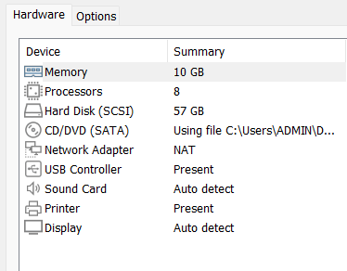

**Step 2: Install Openstack using Devstack in Ubuntu**

Reference: <https://www.youtube.com/watch?v=KCZ9PDoBfmo>

*sudo useradd -m -d /opt/stack -s /bin/bash stack*

*sudo chmod +x /opt/stack*

*echo "stack ALL=(ALL) NOPASSWD: ALL" | sudo tee /etc/sudoers.d/stack*

*sudo su - stack*

*sudo apt install git -y*

*git clone <https://git.openstack.org/openstack-dev/devstack>*

*cd devstack*

*nano local.conf*

*[[local|localrc]]*

*# Password for KeyStone, Database, RabbitMQ and Service*

*ADMIN_PASSWORD=1*

*DATABASE_PASSWORD=1*

*RABBIT_PASSWORD=1*

*SERVICE_PASSWORD=1*

*# Host IP - get your Server/VM IP address from <ip addr> command*

*HOST_IP=192.168.204.144*

*# Enable basic services*

*ENABLED_SERVICES+=,key,n-api,n-crt,n-obj,n-cpu,n-cond,n-sch,n-cauth,placement-api,placement-client*

*# Enable Senlin and Senlin-Dashboard*

*enable_plugin senlin https://opendev.org/openstack/senlin stable/2023.2*

*enable_plugin senlin-dashboard https://opendev.org/openstack/senlin-dashboard stable/2023.2*

*# Name the logfile*

*LOGFILE=/opt/stack/logs/stack.sh.log*

Step 3: Install ( This will take at least 10 mins)

*./stack.sh*

*Shift +ctrl + ‘+’*

*Ctrl + “-”*

*source ~/devstack/openrc*

**Step 4: Launch at least 2 instance and create ssh key**

Reference: <https://www.youtube.com/watch?v=a4su8OLXSvc&list=PLFj79il4Np7AeggY5Z8IQzwyUB5nrM2XW>

*chmod 600 debian12*

*ssh -i debian12.key debian@172.24.4.245*

