Find Next Trip (No Dates Ever Filled In)
F1 & F2 & G1 & No City – PASTE SAME URL BACK IN AFTER DONE BUILDING
http://localhost:3000/trips?mode=B&countryCode=US%2CCA&favorites=team%3ANHL%3AK8vZ9171oy7%3AEdmonton+Oilers&favorites=artist%3Aartist%3AChris_Isaak%3AChris+Isaak&sportsGenres=Baseball&start=2026-03-02&end=2026-09-02&tripDays=3&radiusMiles=90
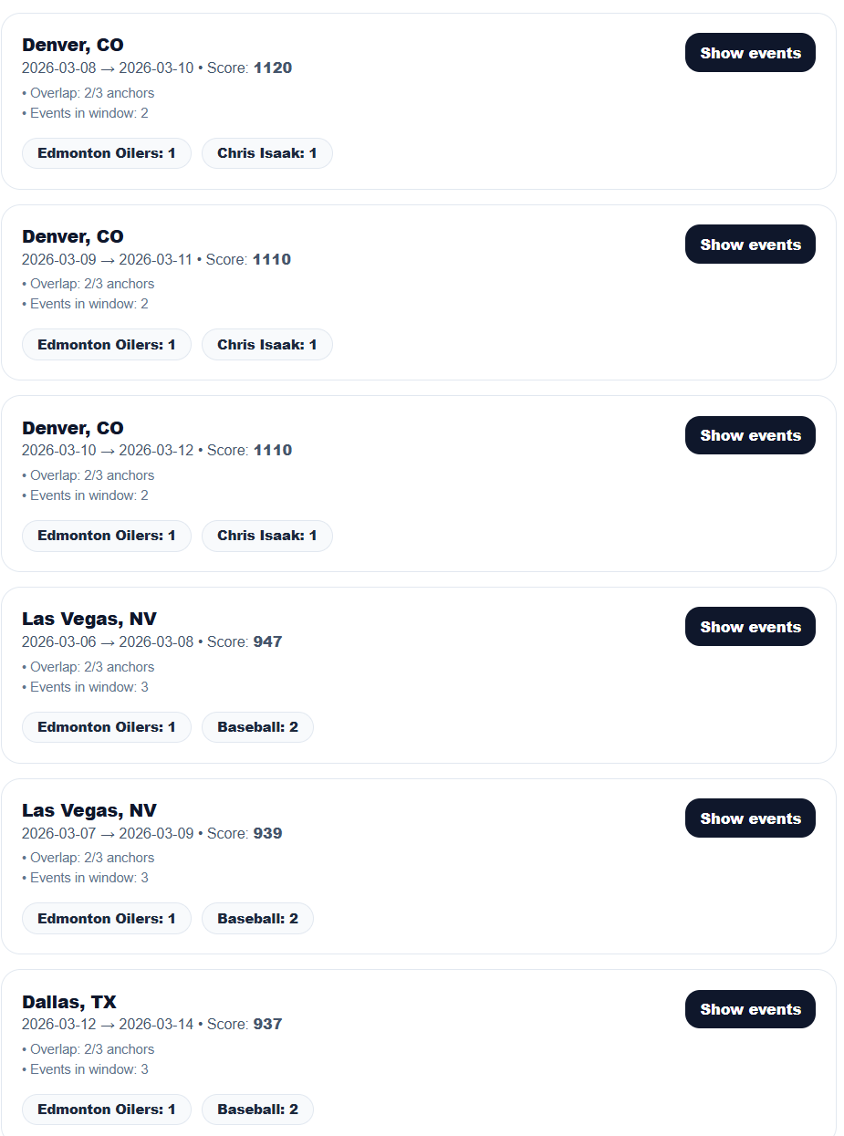
I would expect to see all trips that provide for both F1 and F2 together (regardless of G1), and then a few trips that include at least F1 and G1, and a few trips that include at least F2 and G1. With lots of variety to popular cities high on the G1 popular cities list and a good variety of dates .trips that include at least 1 F1 event or 1 F2 event, and then lots of country music events on the same trip as well as some premium options in each trip.
F1 & F2 & G1 & G2 & No City
http://localhost:3000/trips?mode=B&countryCode=US%2CCA&favorites=team%3ANHL%3AK8vZ9171oy7%3AEdmonton+Oilers&favorites=artist%3Aartist%3AChris_Isaak%3AChris+Isaak&sportsGenres=Baseball&musicGenres=Country&start=2026-03-02&end=2026-09-02&tripDays=3&radiusMiles=90
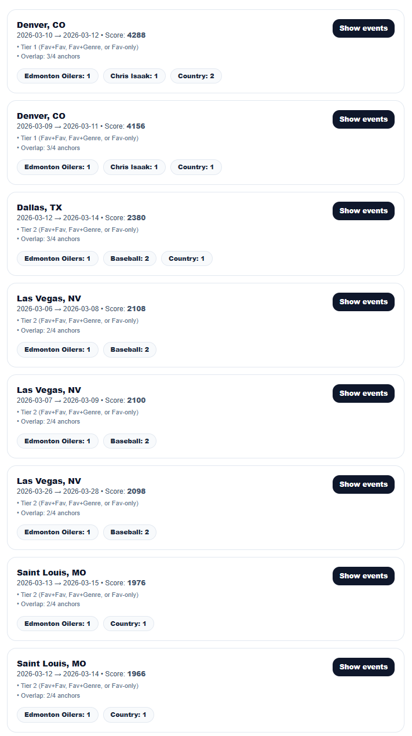
All cross over trips with F1 and F2 should be highest scores for sure. Then I’d like to see a few trips for each of F1 or F2 that include some other G1 and G2 events nearby as well as some premium options in each trip. The results included too many Las Vegas (4 … should max at 2

F1 & G1 & G2 & No City
http://localhost:3000/trips?mode=B&countryCode=US%2CCA&favorites=artist%3Aartist%3ALuke_Combs%3ALuke+Combs&sportsGenres=Baseball&musicGenres=Hip-Hop%2FRap&start=2026-03-02&end=2026-09-02&tripDays=3&radiusMiles=90
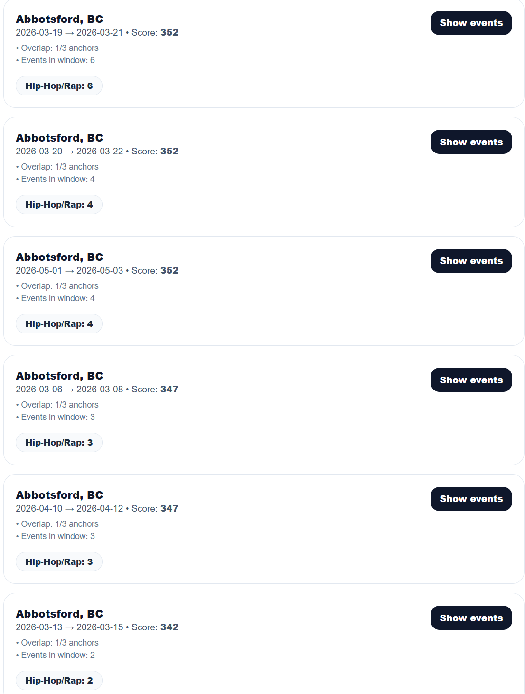
I would expect to see a Luke Combs concert in every trip, and then lots of baseball and hip hop options in the same trip as well as some premium options in each trip as well as some premium options in each trip.

G1 & No City
http://localhost:3000/trips?mode=B&countryCode=US%2CCA&sportsGenres=Basketball&start=2026-03-02&end=2026-09-02&tripDays=3&radiusMiles=90
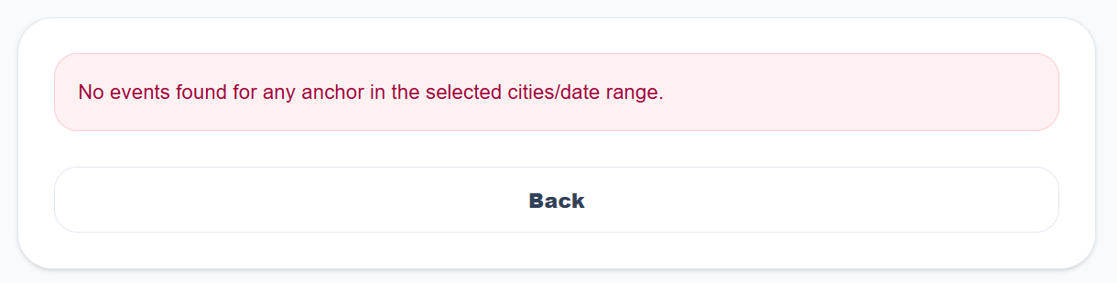
I would expect to see trips that include lots of basketball events, and I would expect to see no more than two trips to the same city, and hopefully a variety of dates as well as some premium options in each trip.

G1 & G2 & No City
http://localhost:3000/trips?mode=B&countryCode=US%2CCA&sportsGenres=Basketball&musicGenres=Hip-Hop%2FRap&start=2026-03-02&end=2026-09-02&tripDays=3&radiusMiles=90
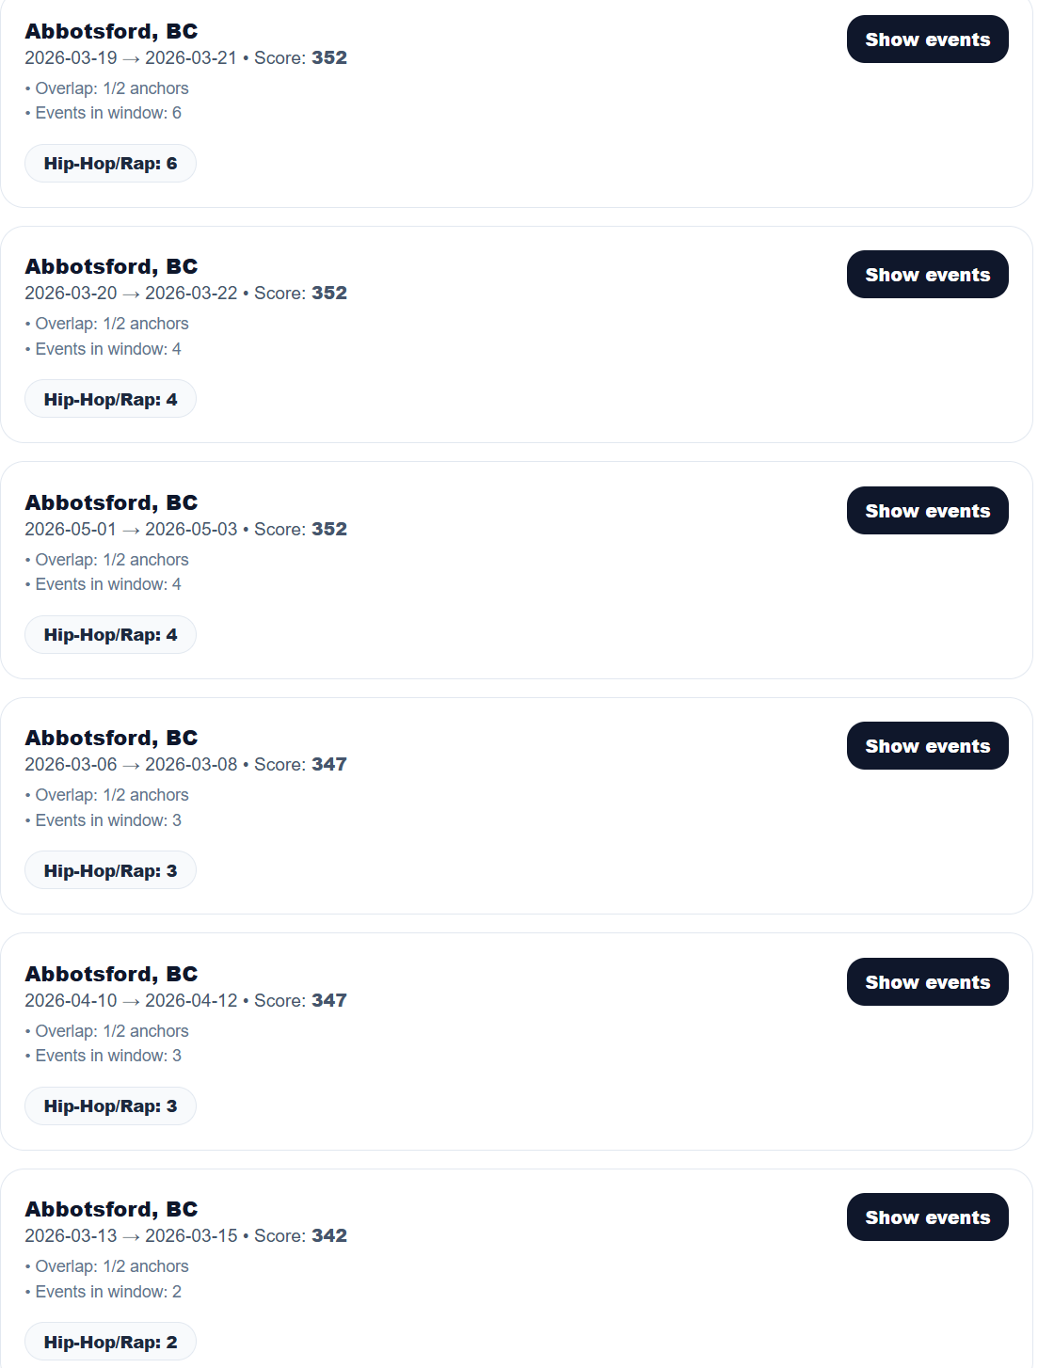
I would expect to see trips that include lots of basketball AND hiphop events, and I would expect to see no more than two trips to the same city, and hopefully a variety of dates as well as some premium options in each trip.

