You can choose to submit either A1 (worth 150 points), AD1 (worth 180), or both (worth 180) for first assignment you will get a score for assignment 1 either 150 points base or 180 points base.

Grading Criteria:
- If the submitted program cannot be compiled or run on a Microsoft visual studio C++ compiler, the assignment will not get any credit.
- If the file name does not follow the naming instruction as stated in syllabus, the assignment will get 5 to 15 points deduction.
- If the header section of the submitted file does not include personal information and purpose of the file, the assignment will get 5 to 30 points deduction.
- Late assignments will not get any credit for the assignment.
- A submission does not follow the instructions of the assignment will get little credit.
- A portion of the assignment is not finished or incomplete will get little or no credit.
- Submit an assignment to a wrong drop box. The wrong drop box one will not get any credit.
- If use A for AD or AD for A assignments in the file name, the student will not get any credit for the assignments.
- If the submitted file(s) cannot be opened by the instructor’s software (WinZip, Visual Studio, or text editor) the assignment will have little credit.
- If the submission file does not include all necessary programming files to run the program, the program will get little credit.
- If the program does not separate into several files (driver, header file, implementation file, etc.) as describe in the assignment, the program will get little credit.
- If the displaying result of the program is not exactly match with the graphic in the assignment description or the displaying result of the executable file which comes with the assignment, the assignment will get little credit.
- If the program does not have enough detail documentation in the programming area the program will get 5 to 30 points deduction.
- If the program includes some unrelated documentation the program will get some points deduction.

A1.

Modify class GradeBook (GradeBook.cpp, and GradeBook.h) (attached) as follows:
a) Include a second private data member instructorName in the GradeBook class. It represents the course instructor’s name. The data type of the instructorName is a string.
b) Create a new setInstructorName function in the GradeBook class. The function sets the instructor name. It accepts a string argument and does not return anything.
c) Create a new getInstructorName function in the GradeBook class. The function retrieves the instructor name. It does not accept any argument and returns one string data.
d) Modify the constructor to accept two parameters—one for the course name and one for the instructor’s name.
d) Modify member function displayMessage such that it will display the welcome message and course name, then outputs "This course is presented by: " followed by the instructor’s name.
e) Adjust all the necessary statements in the GradeBook.cpp file to display the required space(s) and line space(s).

This assignment comes with a CISP400V10A1.zip file. It includes five files (CISP400V10A1.cpp, CISP400V10A1.exe, V10A1.cpp, GradeBook.cpp and GradeBook.h).
You can put the V10A1.cpp, GradeBook.cpp, and GradeBook.h file into a Visual Studio project and run to a result as following. You should understand the GradeBook class first (GradeBook.cpp and GradeBook.h) before you start doing this assignment.
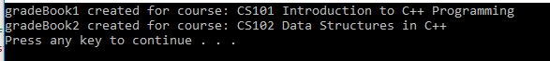

The CISP400V10A1.exe file is an executable file. You can double click the file to get to the expecting result of this assignment. The GradeBook.h and GradeBook.cpp are bases for you for this program. So, you don’t need to start from scratch but please remove all the non-related information for this assignment. The CISP400V10A1.cpp is a driver program for you to test the required assignment implementation

Put the your (modified or completed) GradeBook.h , GradeBook.cpp and CISP400V10A1.cpp(attached) file in a project you can compile the project and run to the following result. Please be awarded that you can adjust only your program (GradeBook.h , GradeBook.cpp) to generate the required result but not the code in CISP400V10A1.cpp file.

The following is the display of the expecting result.
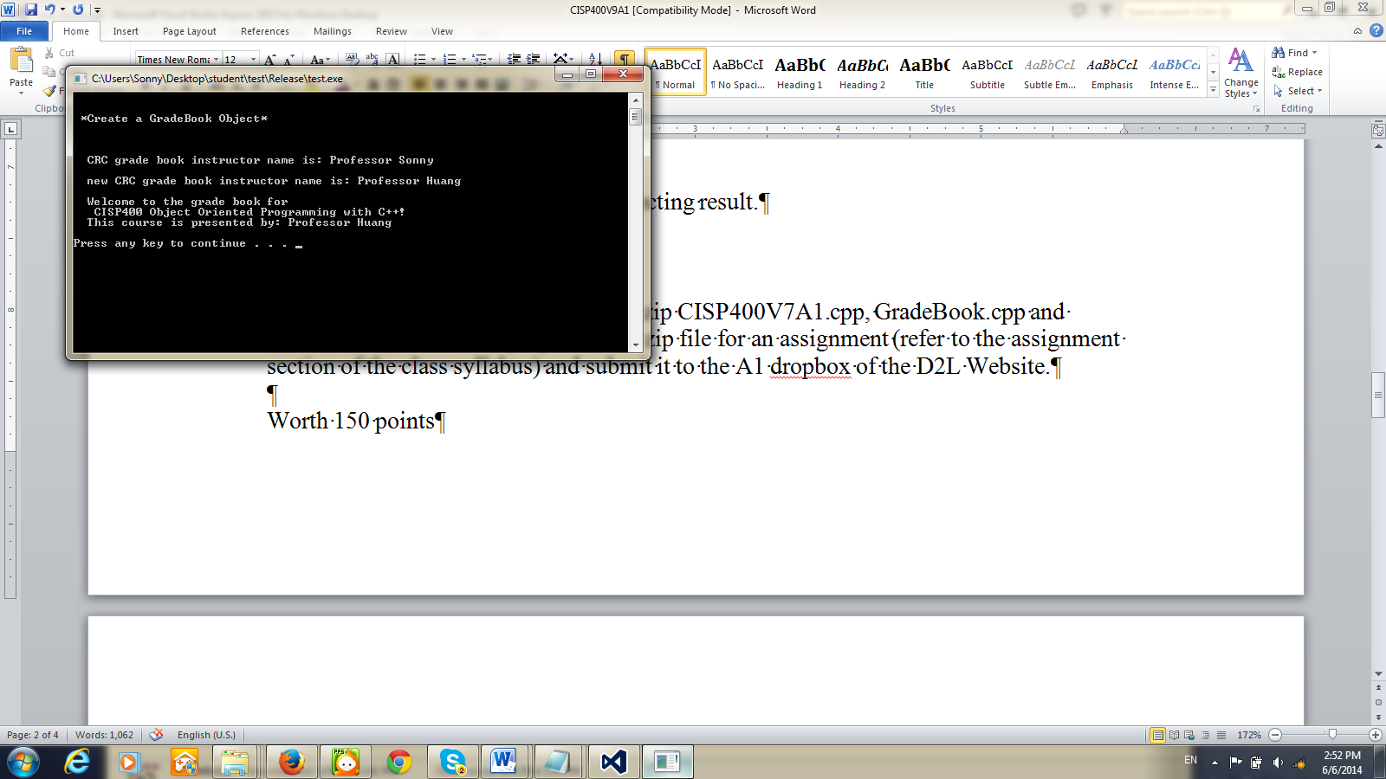

Please document the files(CISP400V10A1.cpp, GradeBook.cpp, and GradeBook.h) properly and zip them into a proper named zip file for an assignment (refer to the assignment section of the class syllabus) and submit it to the A1 dropbox of the D2L Website.

Worth 150 points

AD1

Create an Employee class that includes three private data members— firstName (type string), lastName (type string), and monthlySalary (type int).

It also includes several public member functions.
1. A constructor initializes the three data members.
2. A setFirstName function accepts a string parameter and does not return any data. It sets the firstName.
3. A getFirstName function does not accept any parameter and returns a string. It returns the firstName.
4. A setLastName function accepts a string parameter and does not return any data. It sets the lastName.
5. A getLastName function does not accept any parameter and returns a string. It returns the lastName.
6. A setMonthlySalary function accepts an integer parameter and does not return any data. It sets the monthlySalary. If the monthly salary is less than or equal zero, set it to 1000 and it displays the employee’s first name, last name and the inputted salary with a statement “**==The salary is set to $1000.”
7. A getMonthlySalary function does not accept any parameter and returns an integer. It returns the monthlySalary.
8. An increaseMonthlySalary function accepts an integer parameter and does not return any data. It increases the monthlySalary by integer%. The increase could be positive or negative. When this function is called the salary adjusted employee’s name and salary information will be displayed (please see the following image for details).

This assignment comes with a CISP400V10AD1.zip file. It includes two files (CISP400V10AD1.cpp, and CISP400V10AD1.exe). The CISP400V10AD1.exe file is an executable file. You can double click the file to get to the expecting result of this assignment. The CISP400V10AD1.cpp is a driver program for you to use to test the implementation of this assignment. You need to create and finish coding the Employee.h(Employee class declaration) and Employee.cpp (the implementation of Employee class) based on the above specification.

Put the Employee.h, Employee.cpp and the CISP400V10AD1.cpp (attached) in a project, you can compile the project and run to the following result. Please be awarded that you can adjust only your program to generate the required result but not the code in CISP400V10AD1.cpp file.

The following is the display of the expecting result.

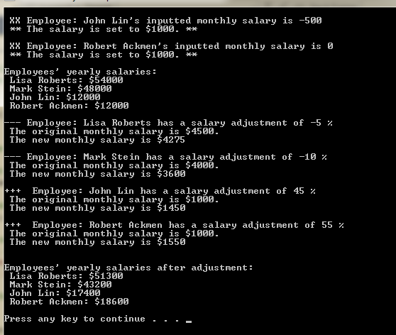

Please document the files (CISP400V10AD1.cpp, Employee.cpp and Employee.h) properly and zip them into a proper named zip file for an advance assignment (refer to the assignment section of the class syllabus) and submit it to the A1 dropbox of the D2L Website.

Worth 180 points

