ShopHub — an ecommerce operations platform
Agile & DevOps laboratory submission
Name | Sarthak Pagare
Email | sarthakpagare005@gmail.com
Repository | https://github.com/nglfrsarthak/shop-hub
Toolchain | Jira (the work) + GitHub (the code) — and nothing else
Pipeline | Continuous integration, never continuous deployment
Latest commit | deb5d0e — fix: align the lifecycle and payment rules with the Jira acceptance criteria
Suite | npm test → 78 acceptance tests / 8 suites; npm run smoke → 30 checks

1. Short description
ShopHub is an ERP-style backend and browser console for a mid-size online retailer. It implements the whole trading loop of an online store — a catalogue of products, SKUs and prices; a server-side cart; checkout that reserves stock; a closed order state machine; idempotent card payments; returns, refunds and reconciliation; fulfilment with dispatch and tracking; and role-scoped reporting over an append-only audit ledger.
The schema has 18 tables and the HTTP surface has 51 endpoints, described by the API's own GET /api/v1/meta. Money is always an integer number of paise; stock is always explained by a movement ledger; and every state change is checked against a closed state machine. There are six roles — customer, agent, warehouse, merchandiser, finance, admin — and every endpoint that mutates data is scoped to the roles allowed to call it.
The toolchain is deliberately and strictly two tools: Jira for the work, GitHub for the code. The work items on the board are the specification; the commits on GitHub are the implementation; and a single CI workflow on every push is the only automated gate. A Dockerfile exists, but it is local run convenience only — CI neither builds nor publishes an image.
This document is the submission. Every screenshot in it was captured from the real tool by driving a real browser or running the real command; nothing was redrawn, mocked or simulated. Where evidence could not be captured, it is shown as an explicit placeholder with instructions, never as a fabricated image.

2. Theory
§2.1 Two tools, and only two
The brief for this lab is a two-tool toolchain: Jira for the work, GitHub for the code. This is a constraint, and constraints are useful — they force the boundary between the two tools to be clean. Jira owns what is being built: epics, stories, acceptance criteria, the sprint. GitHub owns how it is built: the commits, the reviewable history, the CI workflow. Neither tool tries to do the other's job, so there is exactly one place to look for "what is planned" and exactly one place to look for "what is true".
§2.2 Epics, stories, acceptance criteria and the Definition of Done
Work is organised the way Agile practice prescribes:
- An epic is a large slice of value (for example, E3 — stock levels and the no-oversell rule).
- A story is a small, independently deliverable unit phrased from the user's point of view: As a <role>, I want <goal> so that <benefit>.
- Acceptance criteria (ACs) are the testable statements that decide whether the story is done. An AC that cannot be turned into a passing test is not an AC, it is a wish.
The Definition of Done used here is strict: a story is Done only when every one of its acceptance criteria is exercised by an automated test that passes, and the code is committed and green in CI. This is why the test suite is organised by epic — E1 through E7 — so that the distance between a line of Jira and a line of code is one test name.
§2.3 The pipeline: continuous integration, never continuous deployment
Continuous integration means every push is automatically built and verified. That is the whole pipeline here. Continuous deployment — automatically shipping a green build to production — is deliberately not used. This lab is about the inner loop: how a change moves from a story, through a commit, to a verified build. Deployment adds environment-specific concerns (hosting, secrets, migration) that are out of scope, and pretending otherwise would make the evidence weaker, not stronger. The Dockerfile builds a container that runs the app locally for convenience; CI does not touch it.
§2.4 Evidence over assertion
Every claim in this submission is backed by a real artefact: a screenshot of the real tool, or the real output of the real command, captured by a script. The capture scripts (scripts/capture-shots.mjs, scripts/code-output-shots.mjs) drive a real browser over the Chrome DevTools Protocol and run the real commands, writing the bytes they saw next to the image. Nothing is redrawn. Where a piece of evidence genuinely cannot be produced — the Jira burndown chart on the free plan, for instance — the submission says so plainly and shows a placeholder instead.
§2.5 Invariants
An invariant is a statement that must be true at every moment, not merely after a particular request. The system enforces and tests several:
- on_hand equals the sum of that variant's stock movements.
- on_hand and reserved are never negative, and reserved never exceeds on_hand.
- Every order total is internally consistent (total = subtotal + tax + shipping).
- No order holds stock it does not own.
- Every meaningful write leaves an audit event.
§2.6 Money is an integer number of paise
Floating-point money drifts. Every monetary column in the schema is an integer, in paise (1 rupee = 100 paise), and every price, tax and shipping figure is computed in integers. The suite has a test that asserts no money column is ever stored as a float, and another that reproduces a cart total by hand and compares it exactly.
§2.7 Closed state machines
Orders, returns and tracking events each move through a closed sequence: a transition is legal only if it appears in an explicit map, and everything else is refused with 422 and the list of states that are legal. Crucially, the status endpoint refuses the transitions that move money or stock — → shipped and → cancelled — and names the endpoint that must be used instead. A closed machine means an invalid state is unrepresentable, not merely unlikely.
§2.8 Idempotency
A customer who taps "pay" twice must be charged once. Payments require an idempotency_key; replaying a key returns the original payment with replayed: true and writes no second row. Two concurrent requests with the same key produce exactly one payment row. The same discipline governs "mark this notification read" — the second call is a no-op, not an error.
§2.9 Role-based access control
Every list and mutation is scoped to the roles permitted to see or change it. A customer sees only their own orders and returns; a warehouse operator sees inventory and a dispatch queue; finance sees the payment ledger and reconciliation; admin sees the audit ledger. Refusals are meaningful: a 403 names the roles that would have been allowed, so a programmer reading the response knows what to change.

3. Jira — the work
§3.1 The project and the board
The project is SCRUM in Jira Cloud, on a scrum board backed by a backlog. It holds seven epics (E1–E7) and 26 work items. The audit that closes this lab moved the last 16 stories to Done, so the board's Done column now holds every item in the sprint.
SS-1 — The board after the audit.
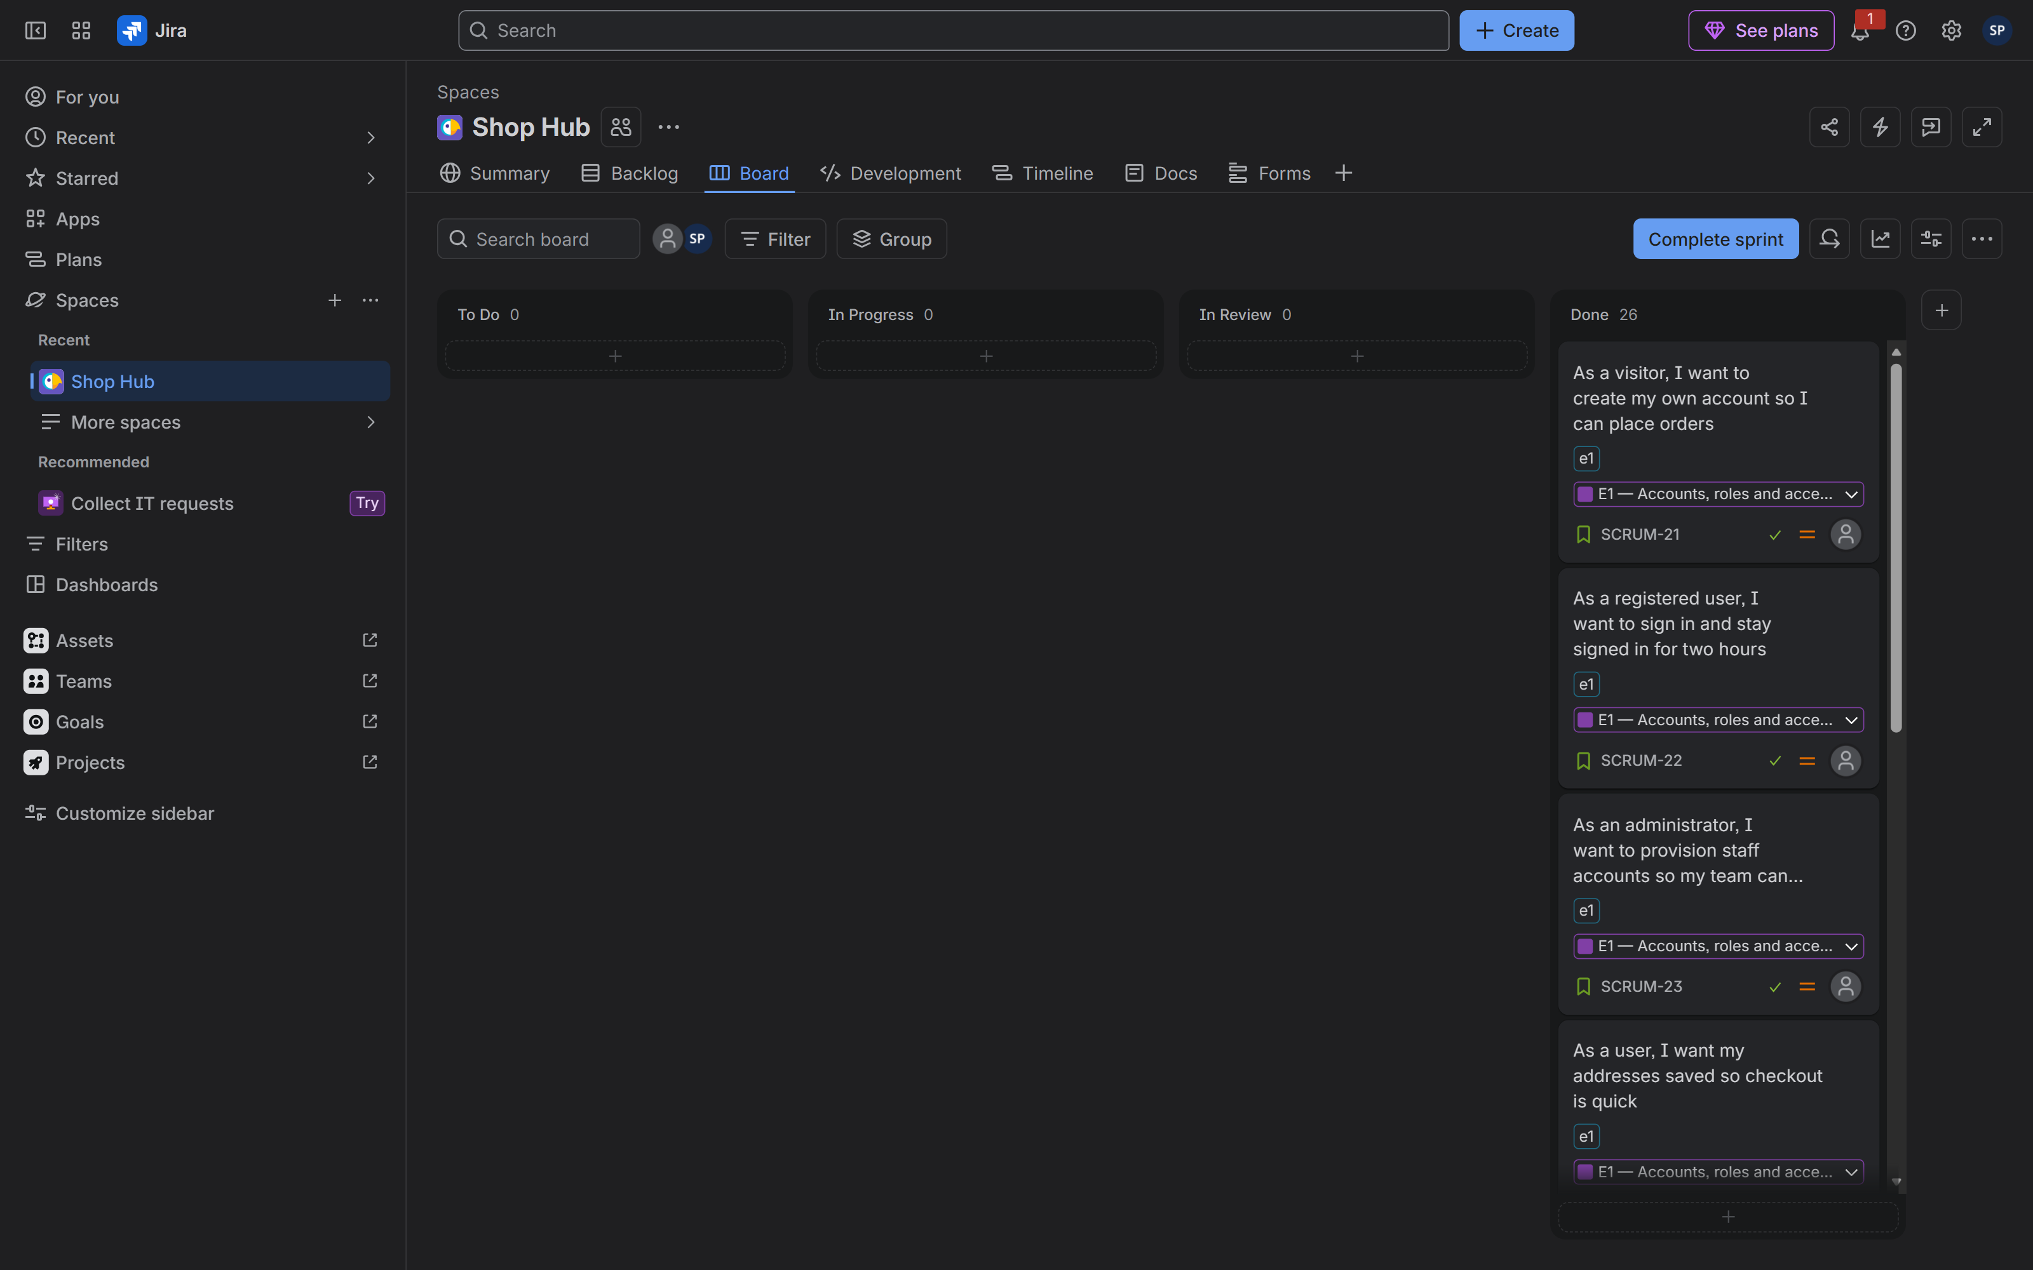 | Tool: Jira Cloud  Where: https://sarthakpagare005.atlassian.net/jira/software/projects/SCRUM/boards/1  Must show: The board with every column visible and the Done column populated — To Do 0, In Progress 0, In Review 0, Done 26  Why: Shows the Definition of Done from §2.2 satisfied for the whole sprint; the board is the single source of "what is planned" from §2.1  The SCRUM board with all 26 items in Done

§3.2 The backlog and the epics
The backlog is grouped by epic, so each story sits directly under the value it delivers. The seven epics are:
Epic | Theme | Stories
E1 | Accounts, roles, addresses and notifications | 4
E2 | Catalogue, SKUs and pricing | 4
E3 | Stock levels and the no-oversell rule | 4
E4 | Cart, checkout and the order lifecycle | 5
E5 | Payments, returns and refunds | 4
E6 | Fulfilment, dispatch and tracking | 3
E7 | Reporting and audit | 2

SS-2 — The backlog grouped by epic.
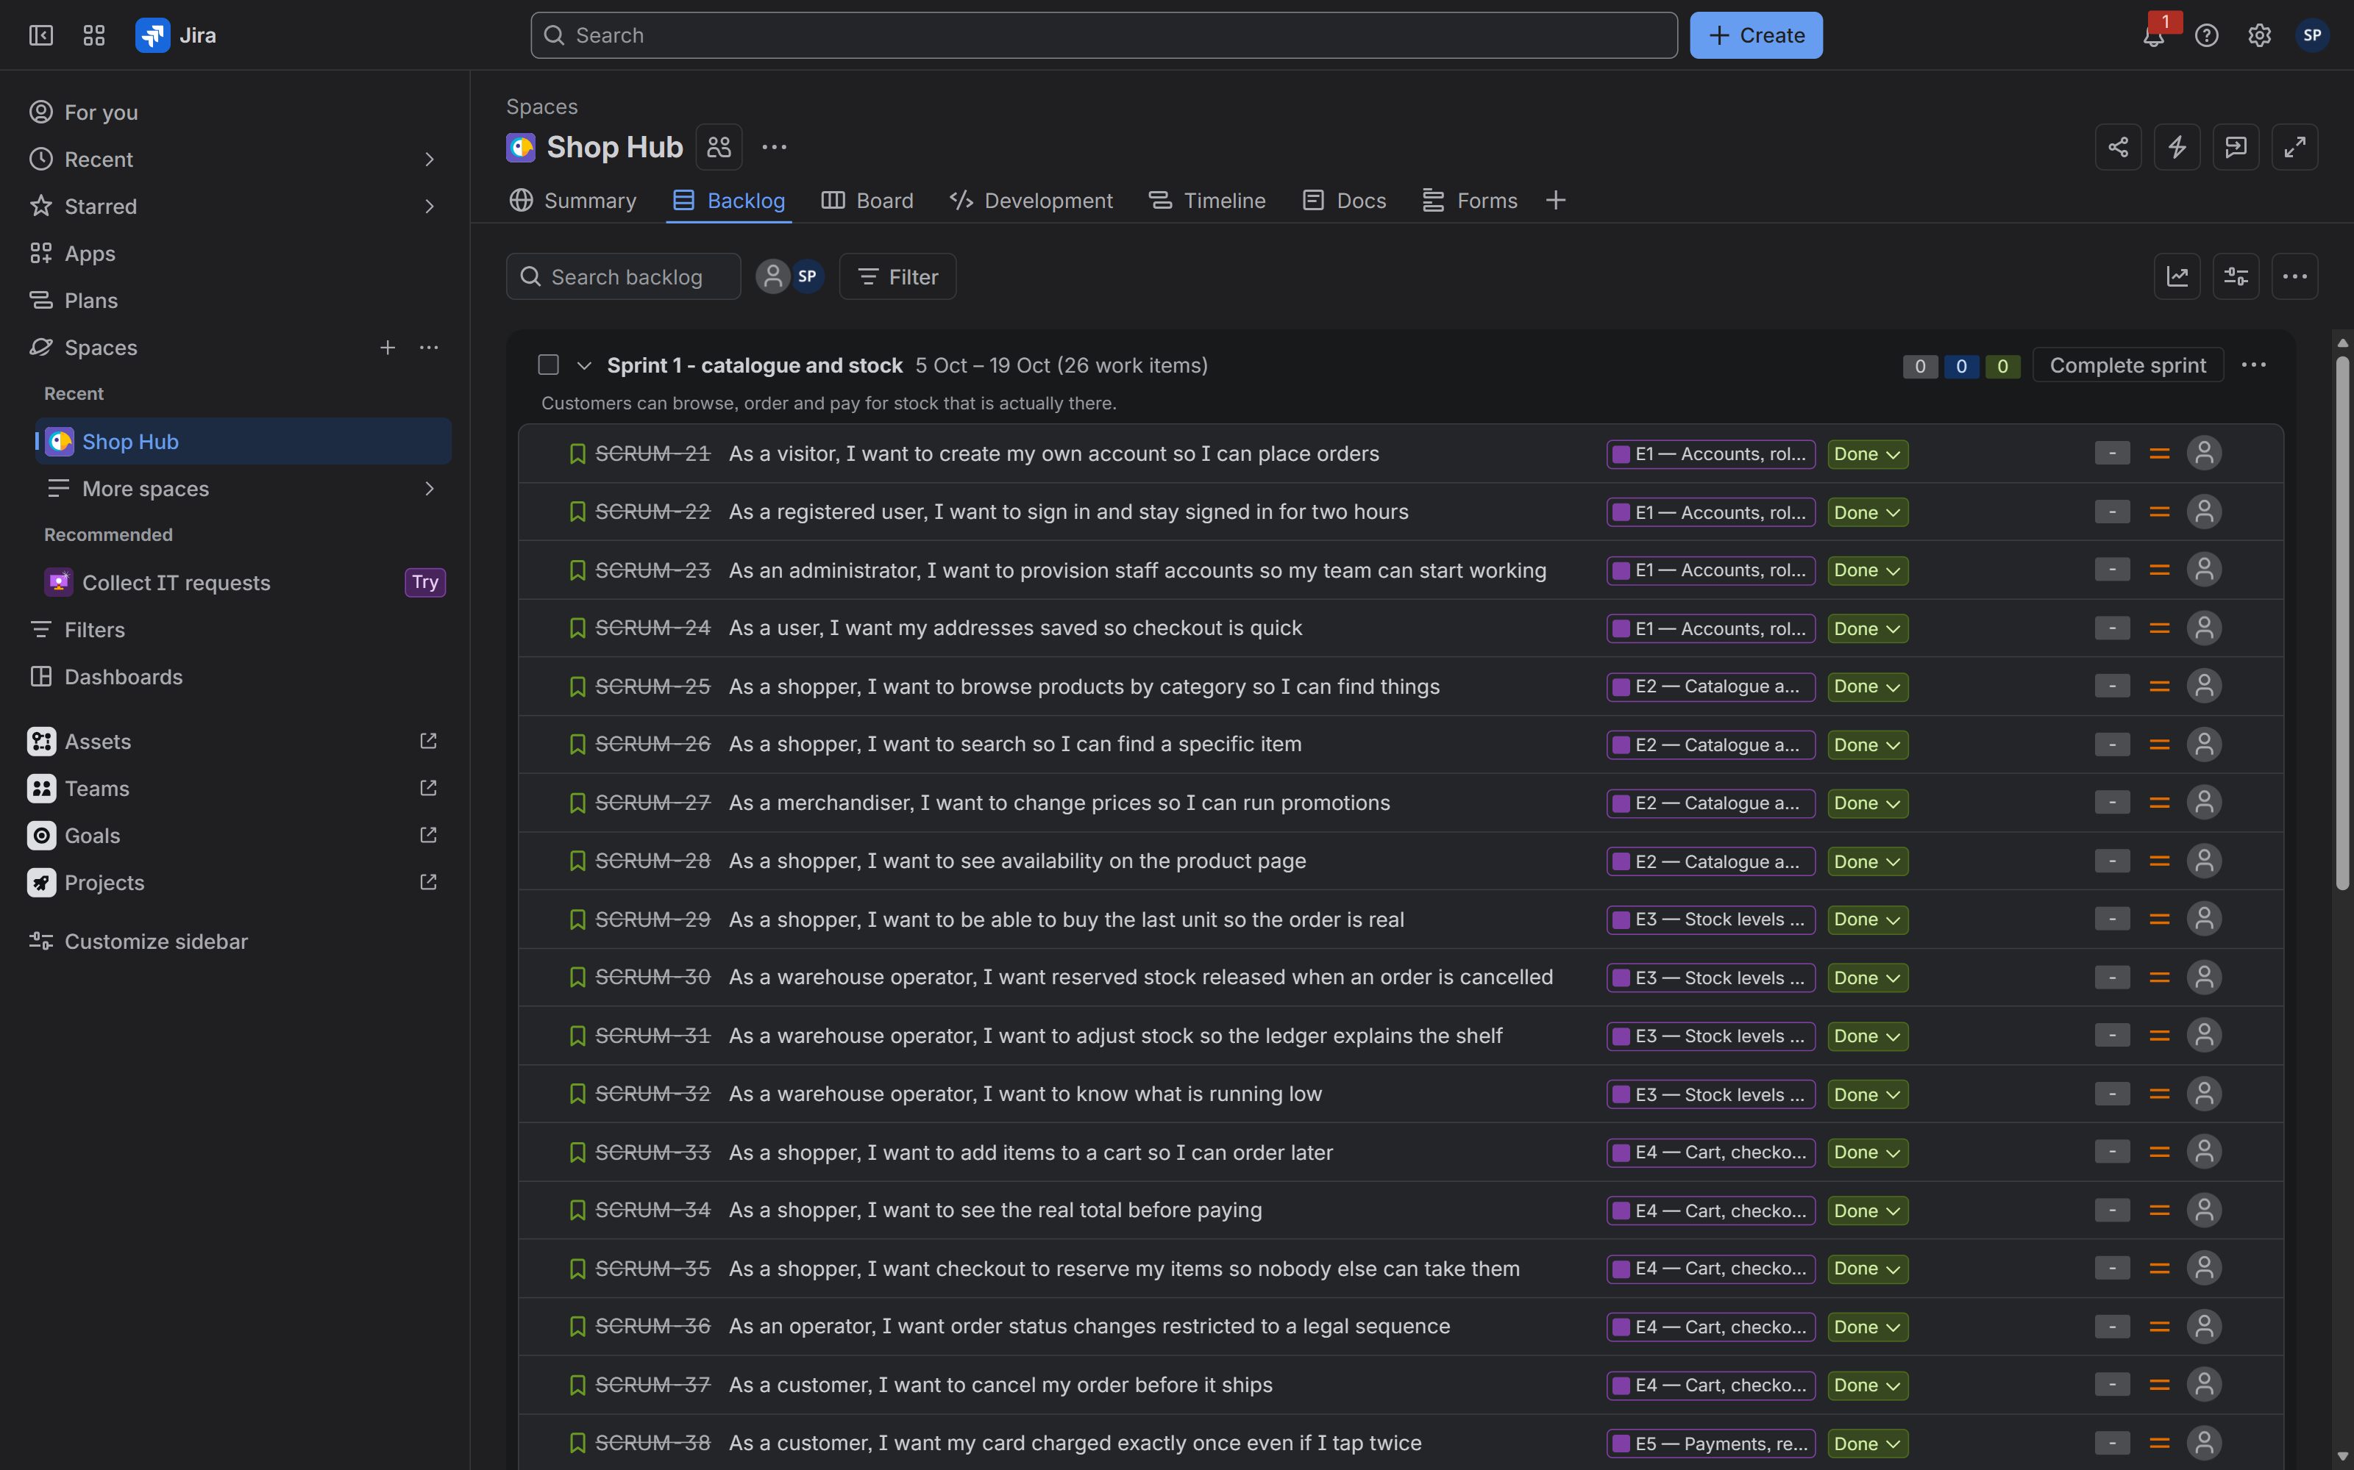 | Tool: Jira Cloud  Where: Backlog view of project SCRUM  Must show: The epics, with their stories nested beneath them and statuses visible  Why: Shows the epic → story → acceptance-criteria hierarchy described in §2.2  The backlog with epics and their nested stories

§3.3 A story and its acceptance criteria
Every story carries its ACs on the issue itself. The example below is the no-oversell story, which is the one that turns a race condition into an invariant.
SS-3 — A story with its acceptance criteria.
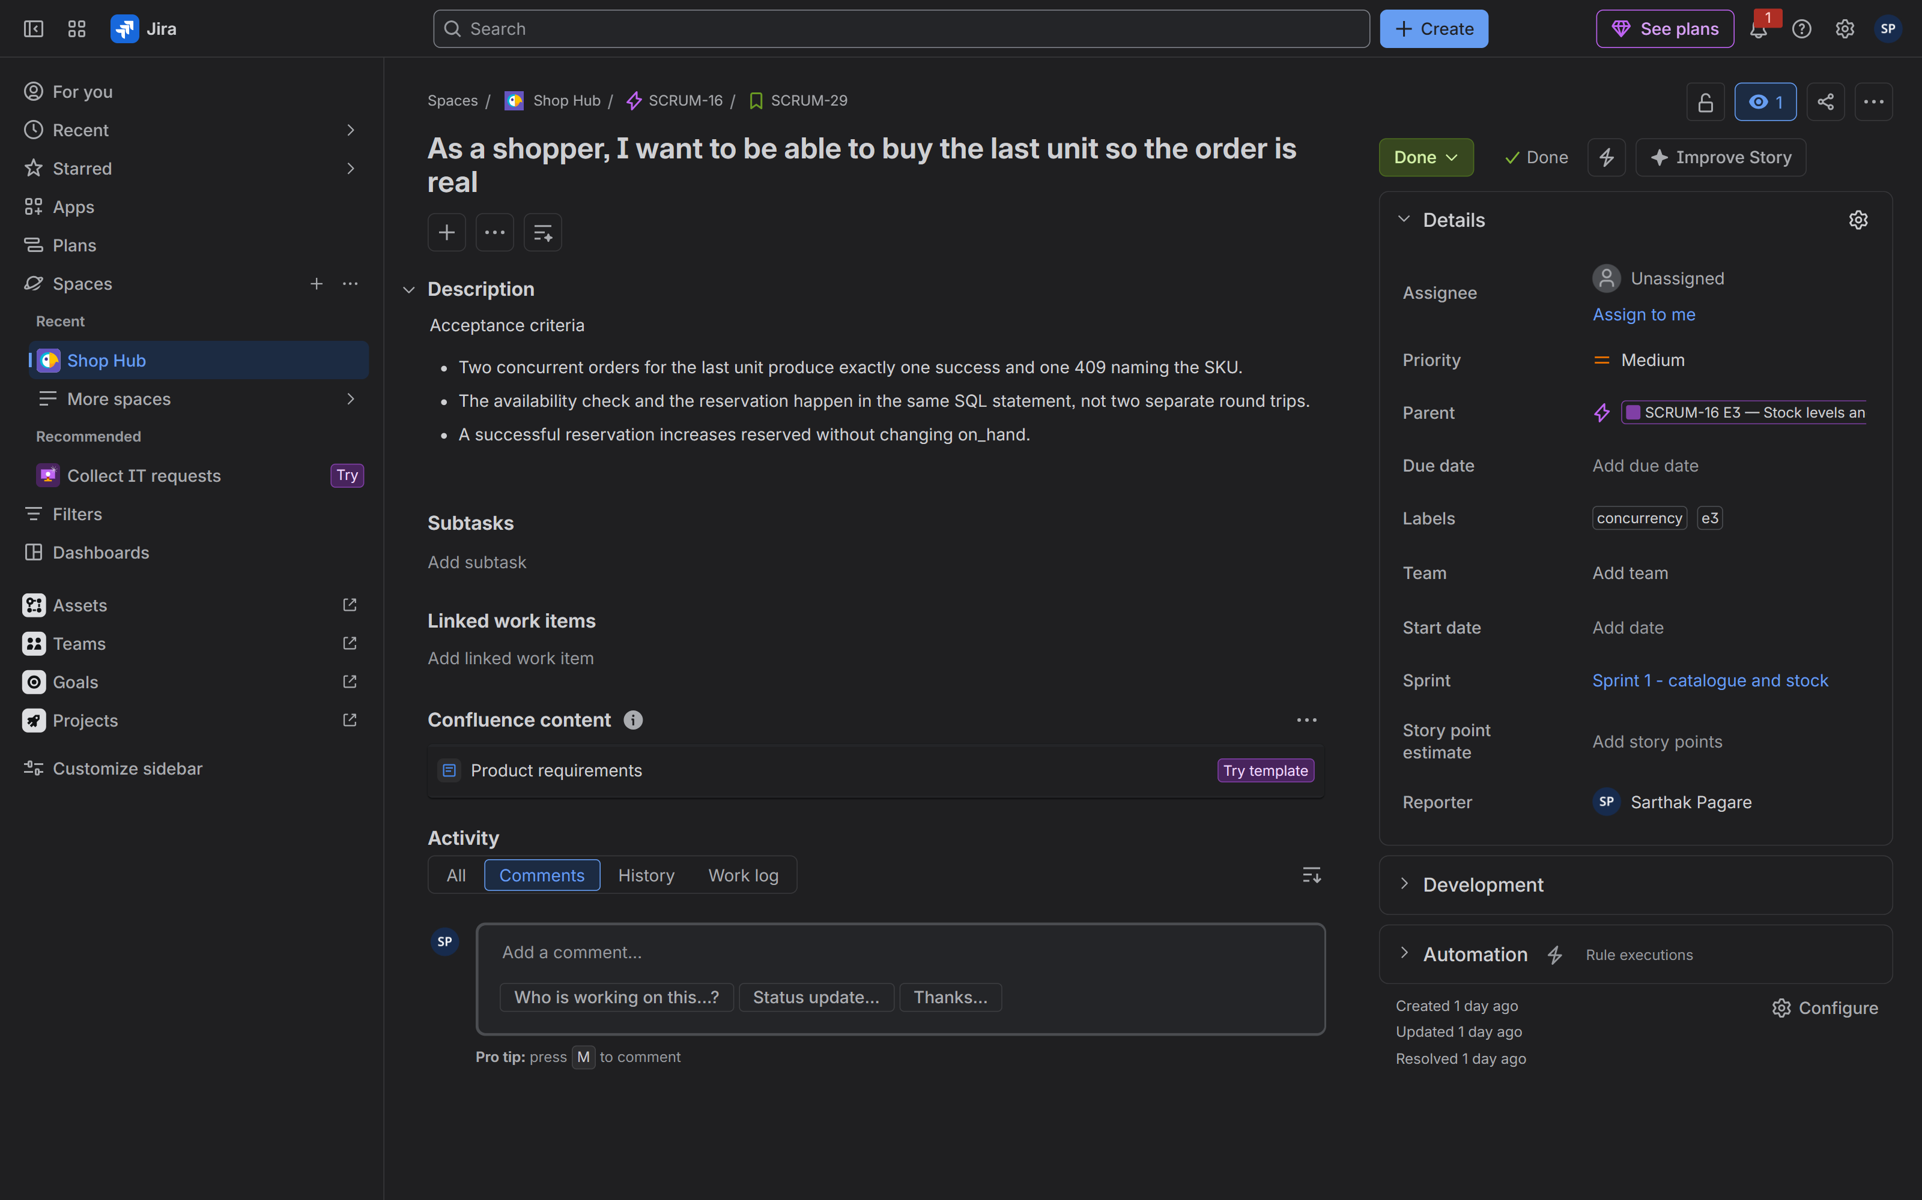 | Tool: Jira Cloud  Where: Issue detail, e.g. /browse/SCRUM-29  Must show: The story statement and the numbered acceptance criteria  Why: Acceptance criteria are the contract that §2.2 says must be testable; this is where the contract lives  A story showing its acceptance criteria

§3.4 An epic and its children
SS-4 — An epic with its child stories.
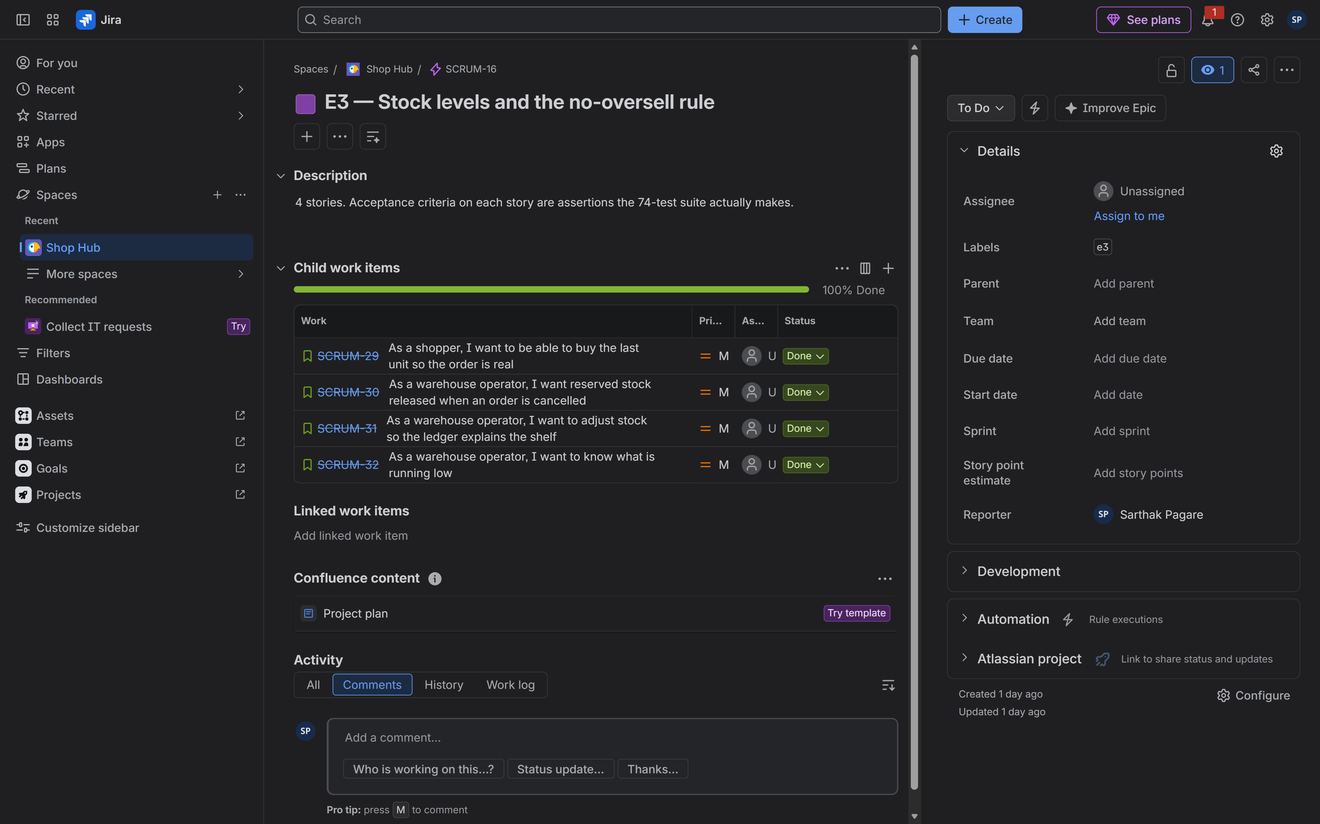 | Tool: Jira Cloud  Where: Epic detail, e.g. /browse/SCRUM-16 (E3)  Must show: The epic's stories and their statuses  Why: Shows that an epic is a delivery slice, and its children are the units of Done (§2.2)  The E3 epic with its stock stories

§3.5 The sprint
Work was time-boxed into a single sprint. The sprint panel records the name, goal and dates, which is what a burndown is drawn against.
SS-5 — The sprint panel.
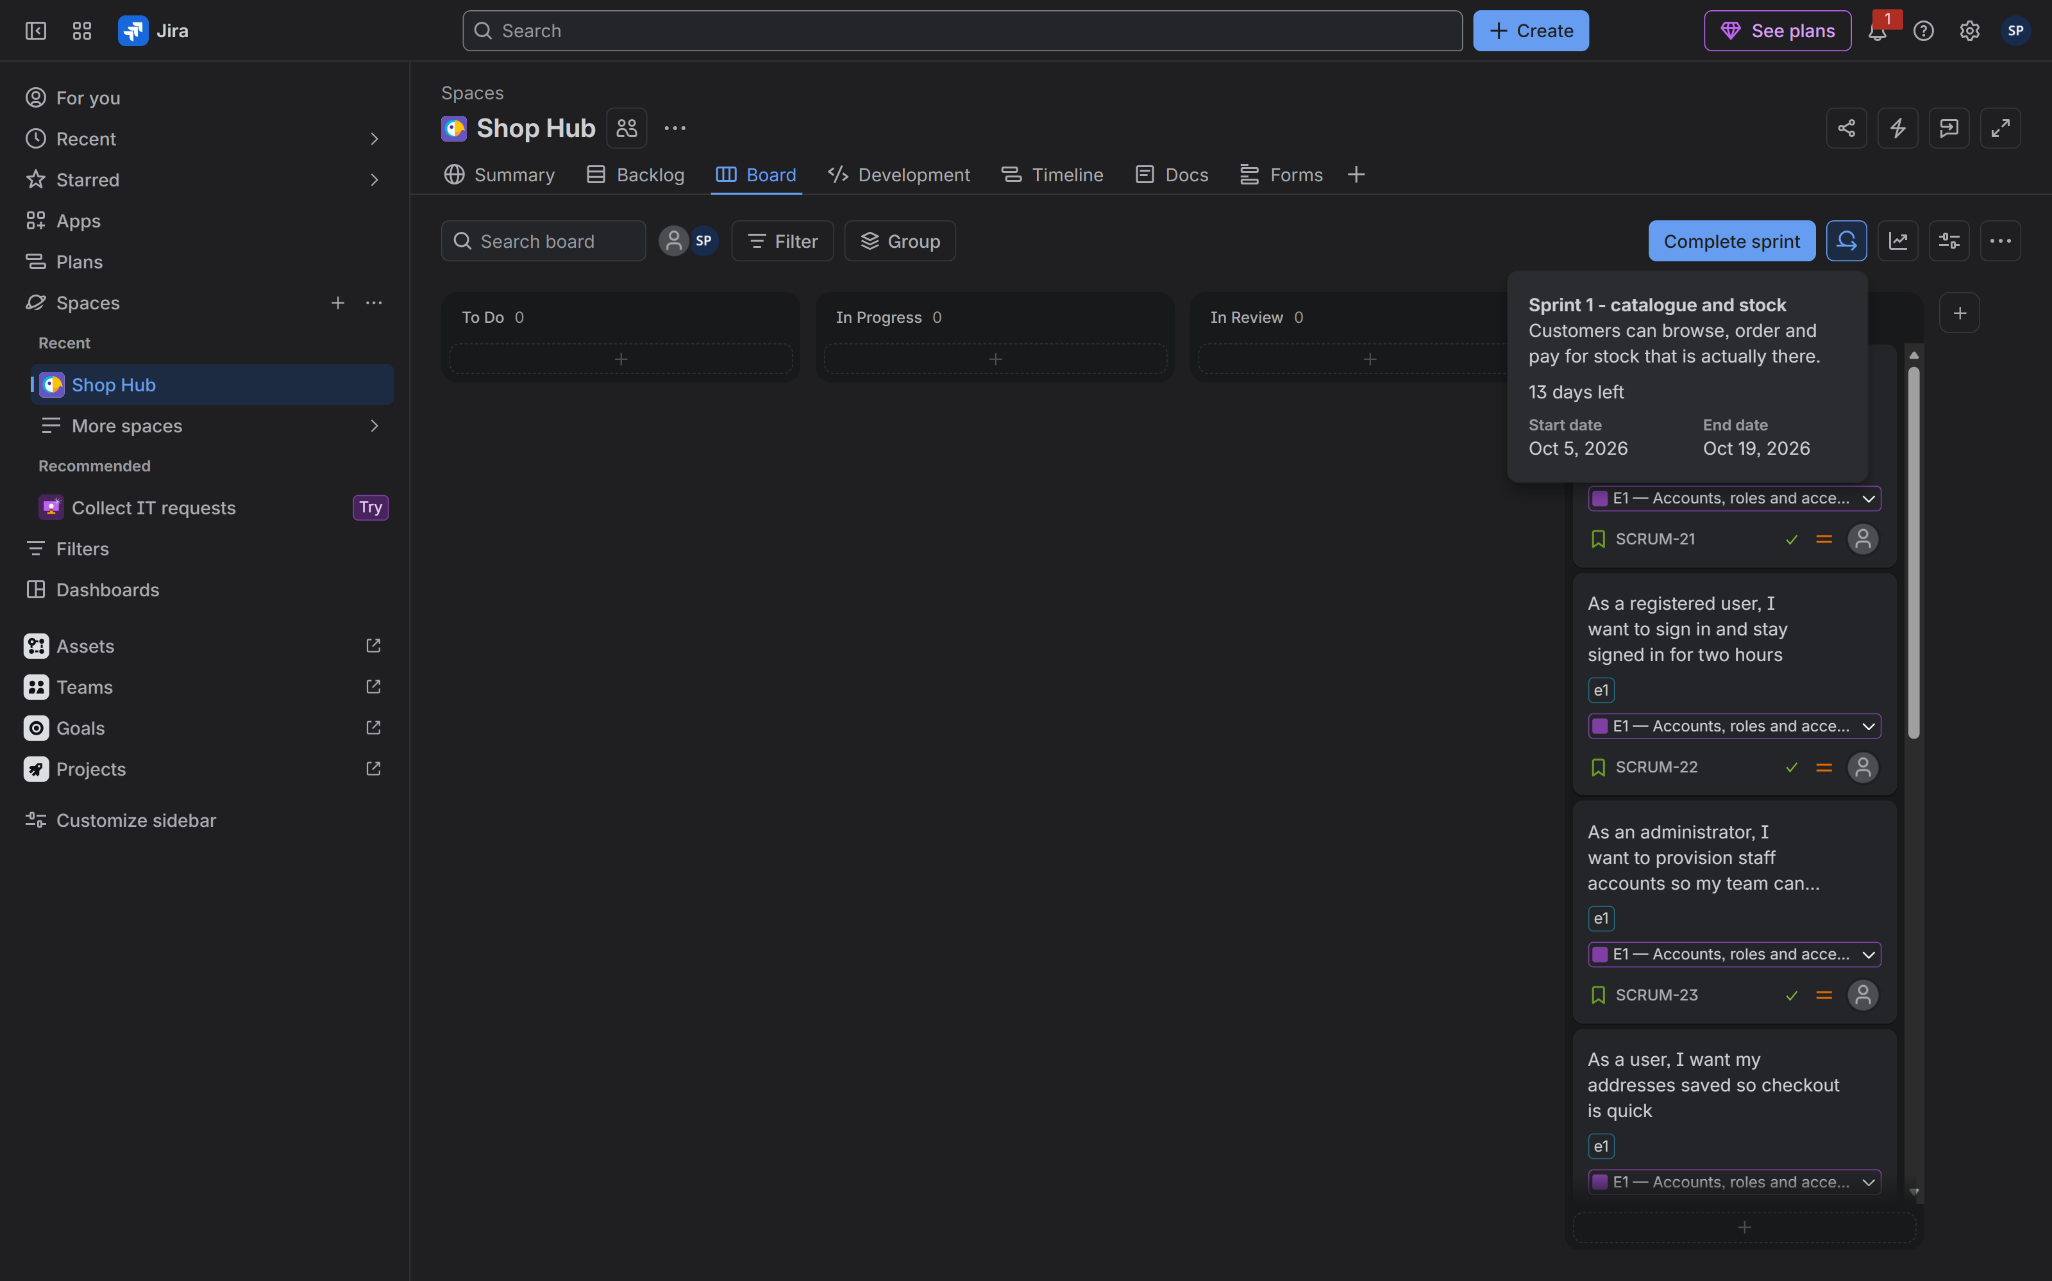 | Tool: Jira Cloud  Where: Board → Sprint details  Must show: Sprint name, goal, start and end dates  Why: The time-box is the unit of planning in §2.2  The sprint details panel

§3.6 The burndown chart — not captured, and why
Placeholder — no image is shown, because none could be captured.
Tool | Jira Cloud
Capture | Board → Reports → Burndown
Must show | The remaining-work line falling to zero by the sprint end date
Why | It would visualise the sprint completion implied by §3.5
Where to capture | https://sarthakpagare005.atlassian.net/jira/software/projects/SCRUM/boards/1 → Reports → Burndown

This screenshot could not be captured because the Jira free plan does not include the Reports / burndown feature. Rather than draw a chart that was never produced by the tool, this submission states the gap. The completion it would have shown is, however, directly evidenced: every item in the sprint is in Done (SS-1), and the sprint panel records the time-box (SS-5).
§3.7 Closing the loop: the audit and the fix commit
The last task was an explicit audit. Every open story's acceptance criteria were compared, line by line, against the code. All 16 open stories / 53 acceptance criteria were checked. Most were already satisfied; the differences were collected into a single commit, deb5d0e, so that one commit closes the gap between the board and the code. The stories were then moved to Done.
Story | Epic | ACs | Outcome of the audit
SCRUM-31 | E3 | 3 | Already met — movements and audit on every adjustment
SCRUM-32 | E3 | 3 | Already met — on_hand − reserved compared to the reorder point
SCRUM-33 | E4 | 3 | Already met — 409 with SKU and available quantity
SCRUM-34 | E4 | 3 | Already met — integer paise, 18% GST, free shipping at ₹500
SCRUM-35 | E4 | 3 | Already met — reservation and order created in one transaction
SCRUM-36 | E4 | 4 | Changed — status placed renamed created; 422 now reports allowed; shipped is terminal
SCRUM-37 | E4 | 3 | Already met — cancel releases stock; paid cancel refunds in the same call
SCRUM-38 | E5 | 3 | Changed — a missing/short idempotency_key is now 422, not 400
SCRUM-39 | E5 | 3 | Changed — a declined card writes no payments row; the failure is audited
SCRUM-40 | E5 | 3 | Changed — failed attempts are counted from the audit ledger, not a phantom row
SCRUM-41 | E5 | 5 | Changed — added the in_transit step to the closed return sequence
SCRUM-42 | E6 | 3 | Changed — added GET /fulfilment/dispatch-queue (paid + picking, FIFO)
SCRUM-43 | E6 | 3 | Changed — the re-dispatch 409 now carries the shipment reference
SCRUM-44 | E6 | 3 | Already met — append-only tracking events with a closed sequence
SCRUM-45 | E7 | 5 | Already met — the API chooses the dashboard per role
SCRUM-46 | E7 | 3 | Already met — append-only audit ledger, admin-only

The two changes that touched a state machine are worth quoting, because they are where the theory of §2.7 becomes code:
// app/src/routes/orders.js
export const ORDER_FLOW = {
created: ['paid', 'cancelled'],
paid: ['picking', 'cancelled'],
picking: ['packed', 'cancelled'],
packed: ['shipped'],
shipped: ['delivered'],
delivered: [],
cancelled: [],
};
// The status endpoint may not perform the transitions that move stock or money.
export const WORKFLOW_FLOW = {
created: [],
paid: ['picking'],
picking: ['packed'],
packed: [],
shipped: [],
delivered: [],
cancelled: [],
};
// app/src/routes/payments.js
export const RETURN_FLOW = {
requested: ['approved', 'rejected'],
approved: ['in_transit'],
in_transit: ['received'],
received: ['refunded'],
refunded: [],
rejected: [],
};

4. GitHub — the code and the pipeline
§4.1 The repository
The repository is public and its README states the shape of the system up front: 18 tables, 51 endpoints, the two-tool toolchain, and the explicit note that CI never publishes an image.
SS-6 — The repository.
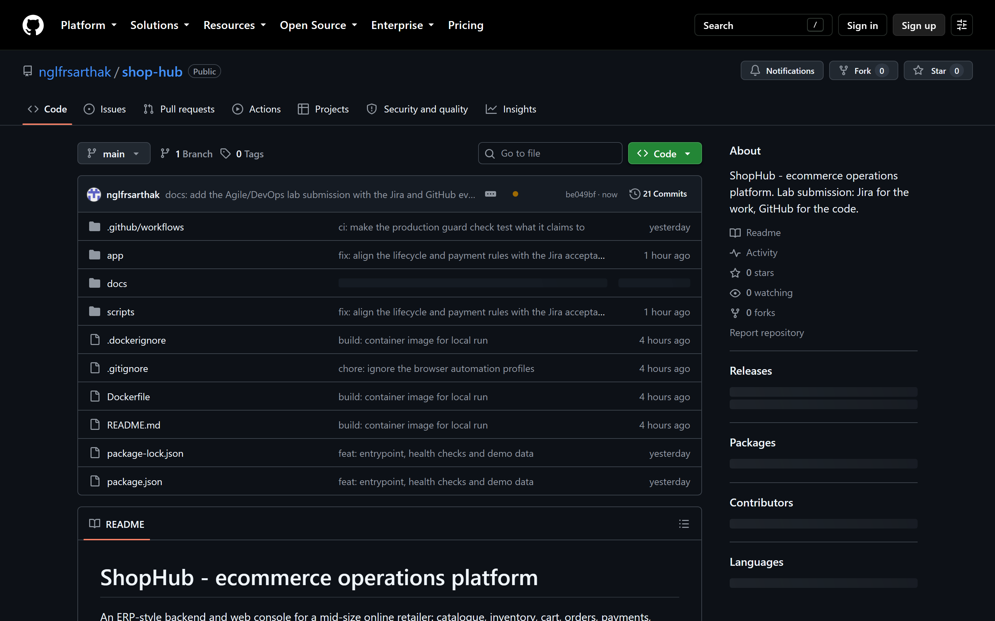 | Tool: GitHub  Where: https://github.com/nglfrsarthak/shop-hub  Must show: The rendered README, the file tree and the commit count  Why: The single source of "what is true" from §2.1  The repository with its README rendered

§4.2 The commit history
History is deliberately legible: one epic or one fix per commit, with a message that says why. The history reads as the build order of the schema and then one epic per commit, ending with the audit fix.
SS-7 — The commit history.
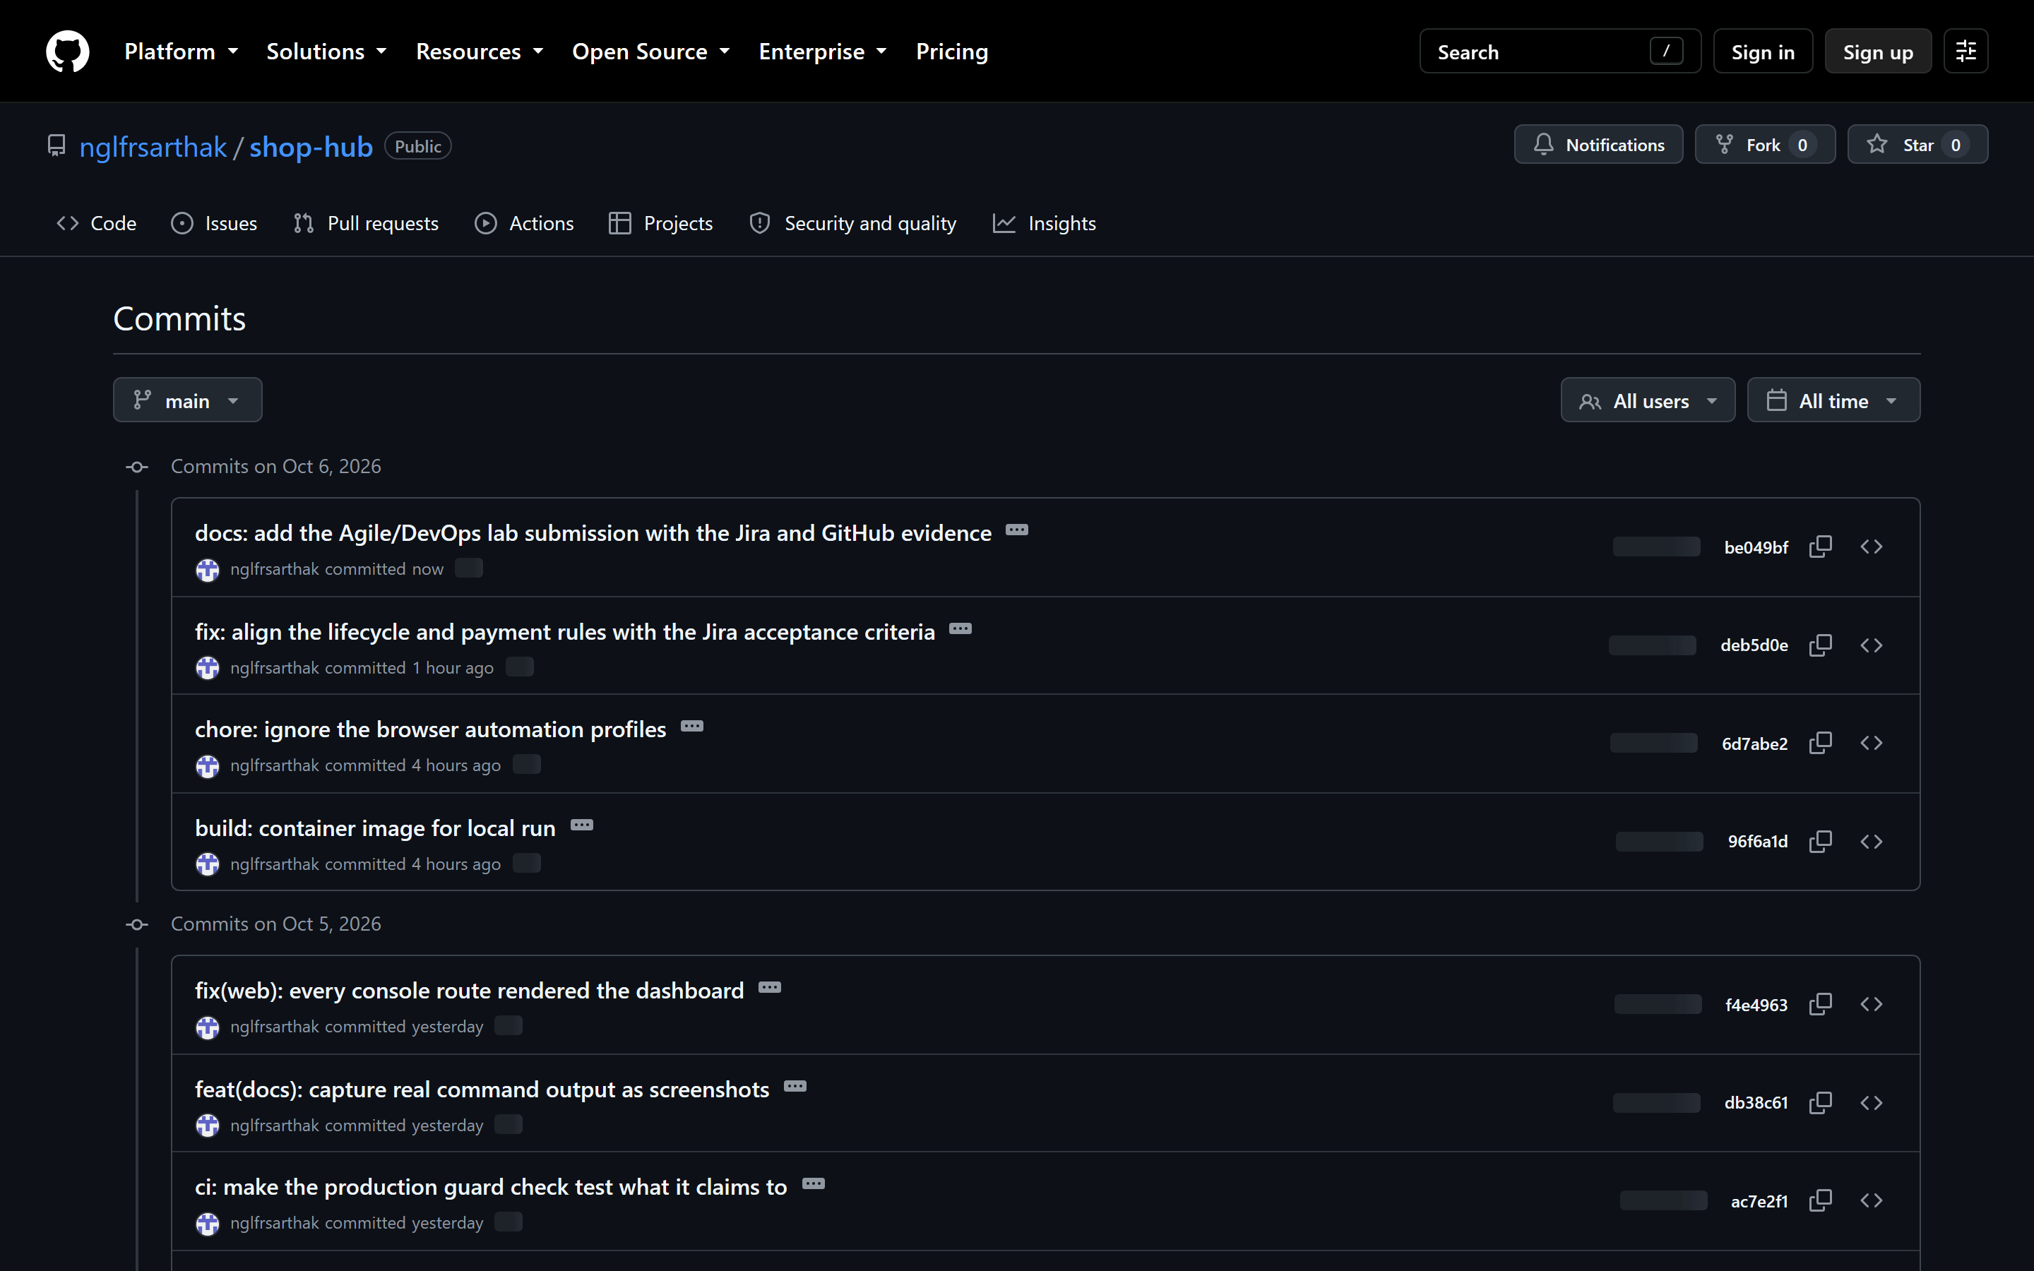 | Tool: GitHub  Where: /commits/main  Must show: A commit list where each entry maps to one epic or one fix  Why: Reviewable history is the "how" side of the §2.1 split  The commit history, one epic or fix per commit

§4.3 The no-oversell commit
The no-oversell rule is the clearest single example of an invariant enforced in SQL rather than in application logic. The conditional UPDATE makes the check and the write the same atomic statement, so two concurrent shoppers can never both win the last unit.
// app/src/routes/inventory.js
export function reserveStock(variantId, qty) {
const info = db.prepare(`
UPDATE stock_levels SET reserved = reserved + ?
WHERE variant_id = ? AND (on_hand - reserved) >= ?
`).run(qty, variantId, qty);
return info.changes > 0;
}
SS-8 — The commit that adds the no-oversell rule.
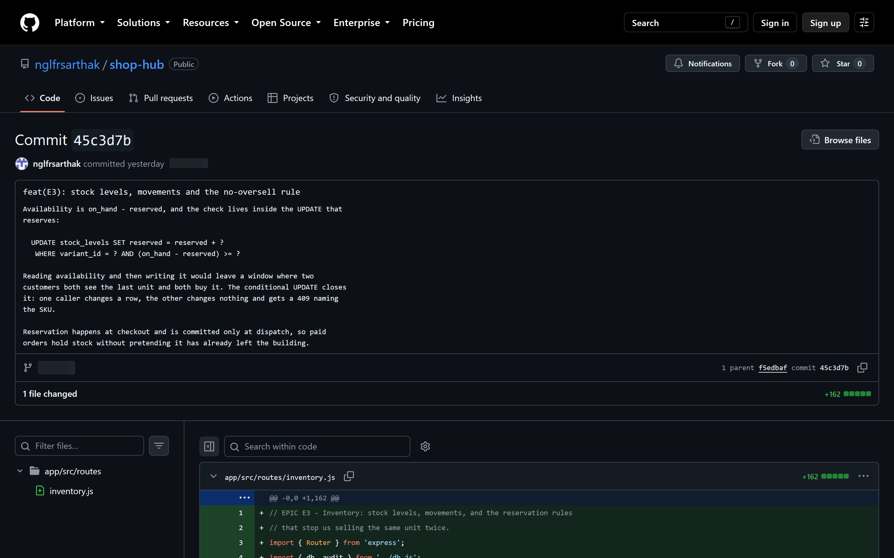 | Tool: GitHub  Where: Commit 45c3d7b — feat(E3): stock levels, movements and the no-oversell rule  Must show: The diff, including the conditional UPDATE above  Why: The invariant from §2.5, enforced where the race is  The no-oversell commit and its diff

§4.4 The source on GitHub
SS-9 — The inventory source on GitHub.
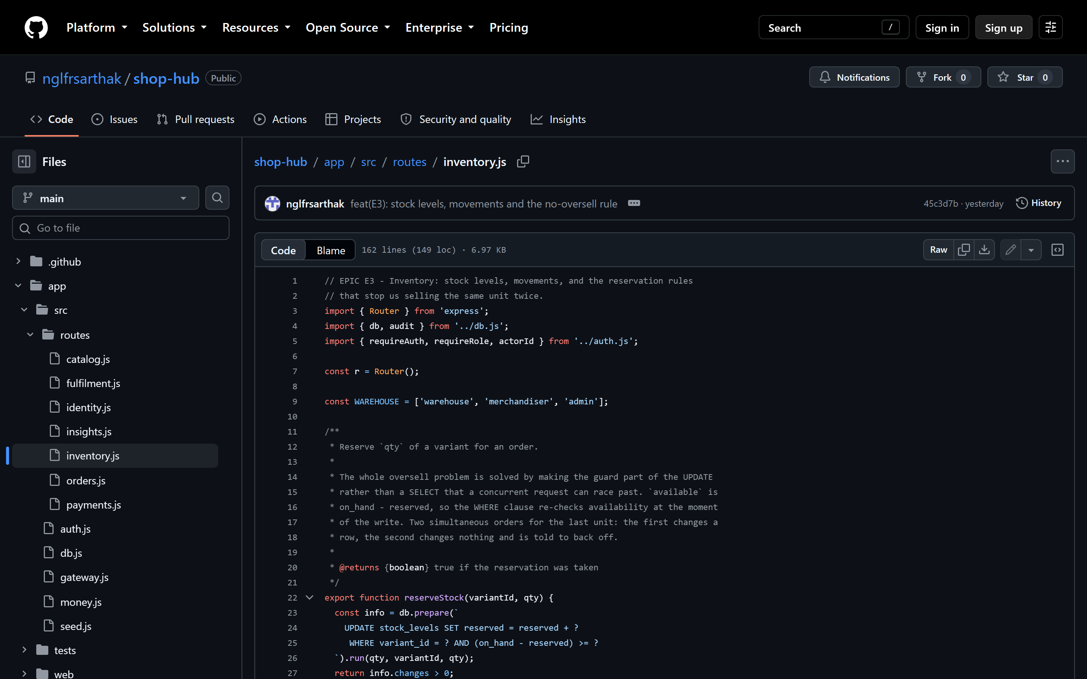 | Tool: GitHub  Where: app/src/routes/inventory.js on main  Must show: reserveStock, releaseStock and commitStock in the published source  Why: The published code and the local evidence agree — the point of §2.4  inventory.js on GitHub

§4.5 The workflow as code
CI is a single workflow, .github/workflows/ci.yml, triggered on every push and pull request. It has three jobs, each with one reason to fail, so a red cross always says what broke:
- Tests — install, run npm test, then start a real server and run the smoke test against it.
- Lint — parse every source file; fail if a signing key is hard-coded in application source; and assert the production guard, that production refuses to start without an explicit JWT_SECRET, loads when given one, and that a fresh clone still runs in development.
- API contract — start the API and assert its self-description from GET /api/v1/meta.
There is no deploy job. That is the "never CD" rule of §2.3, enforced by the workflow's shape.

5. Running files — the console
The browser console is a vanilla-JS client served from the API's own origin. It does no business logic: it renders what the API sends, and it maps the API's error codes to clear messages. The screenshots below were captured by the capture script signing in through the real sign-in form and clicking through the real screens.
§5.1 The sign-in gate
SS-10 — Sign-in gate.
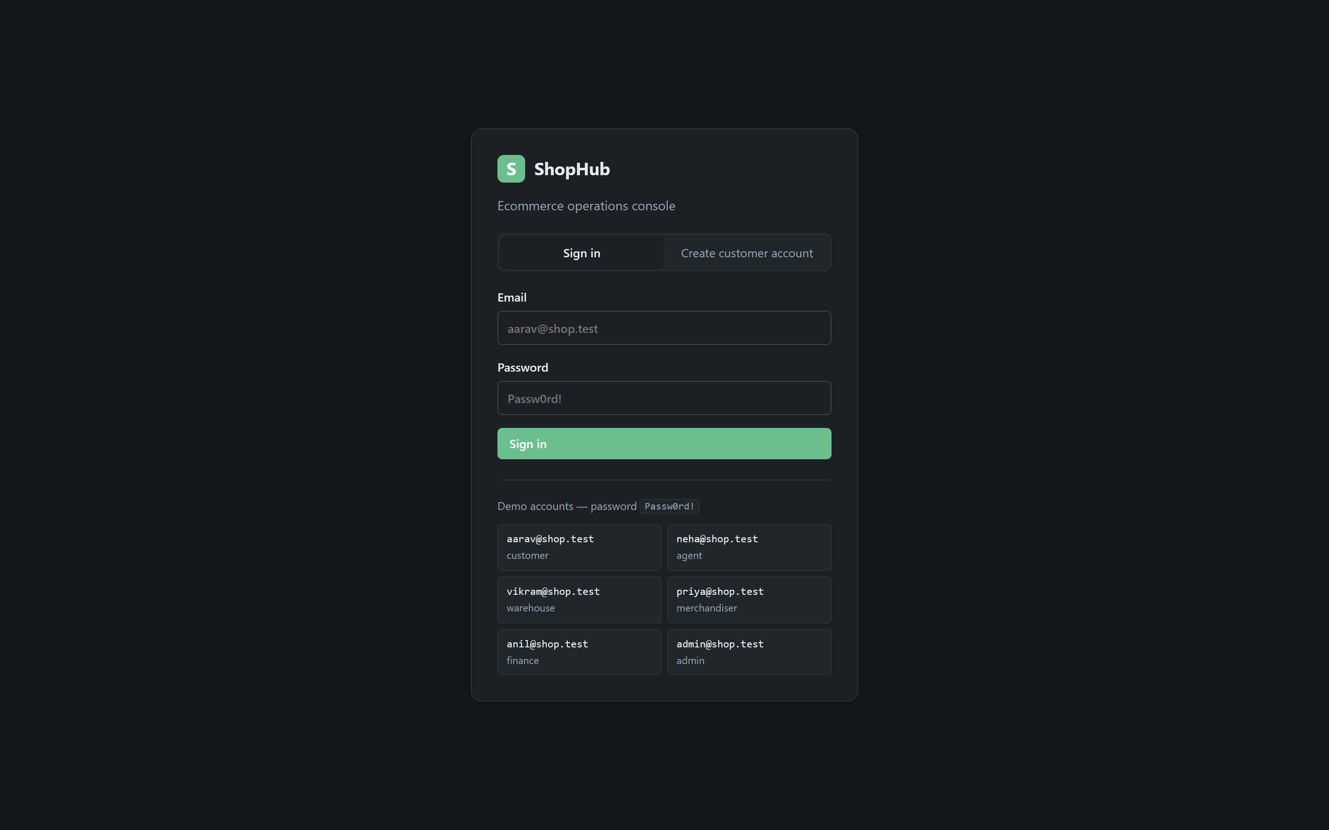 | Tool: App console (http://127.0.0.1:3010)  Where: The landing screen  Must show: The six demo roles and the refusal notice  Why: The entry point for every role-scoped view in §2.9  The sign-in screen

§5.2 A customer's view
SS-11 — Customer dashboard.
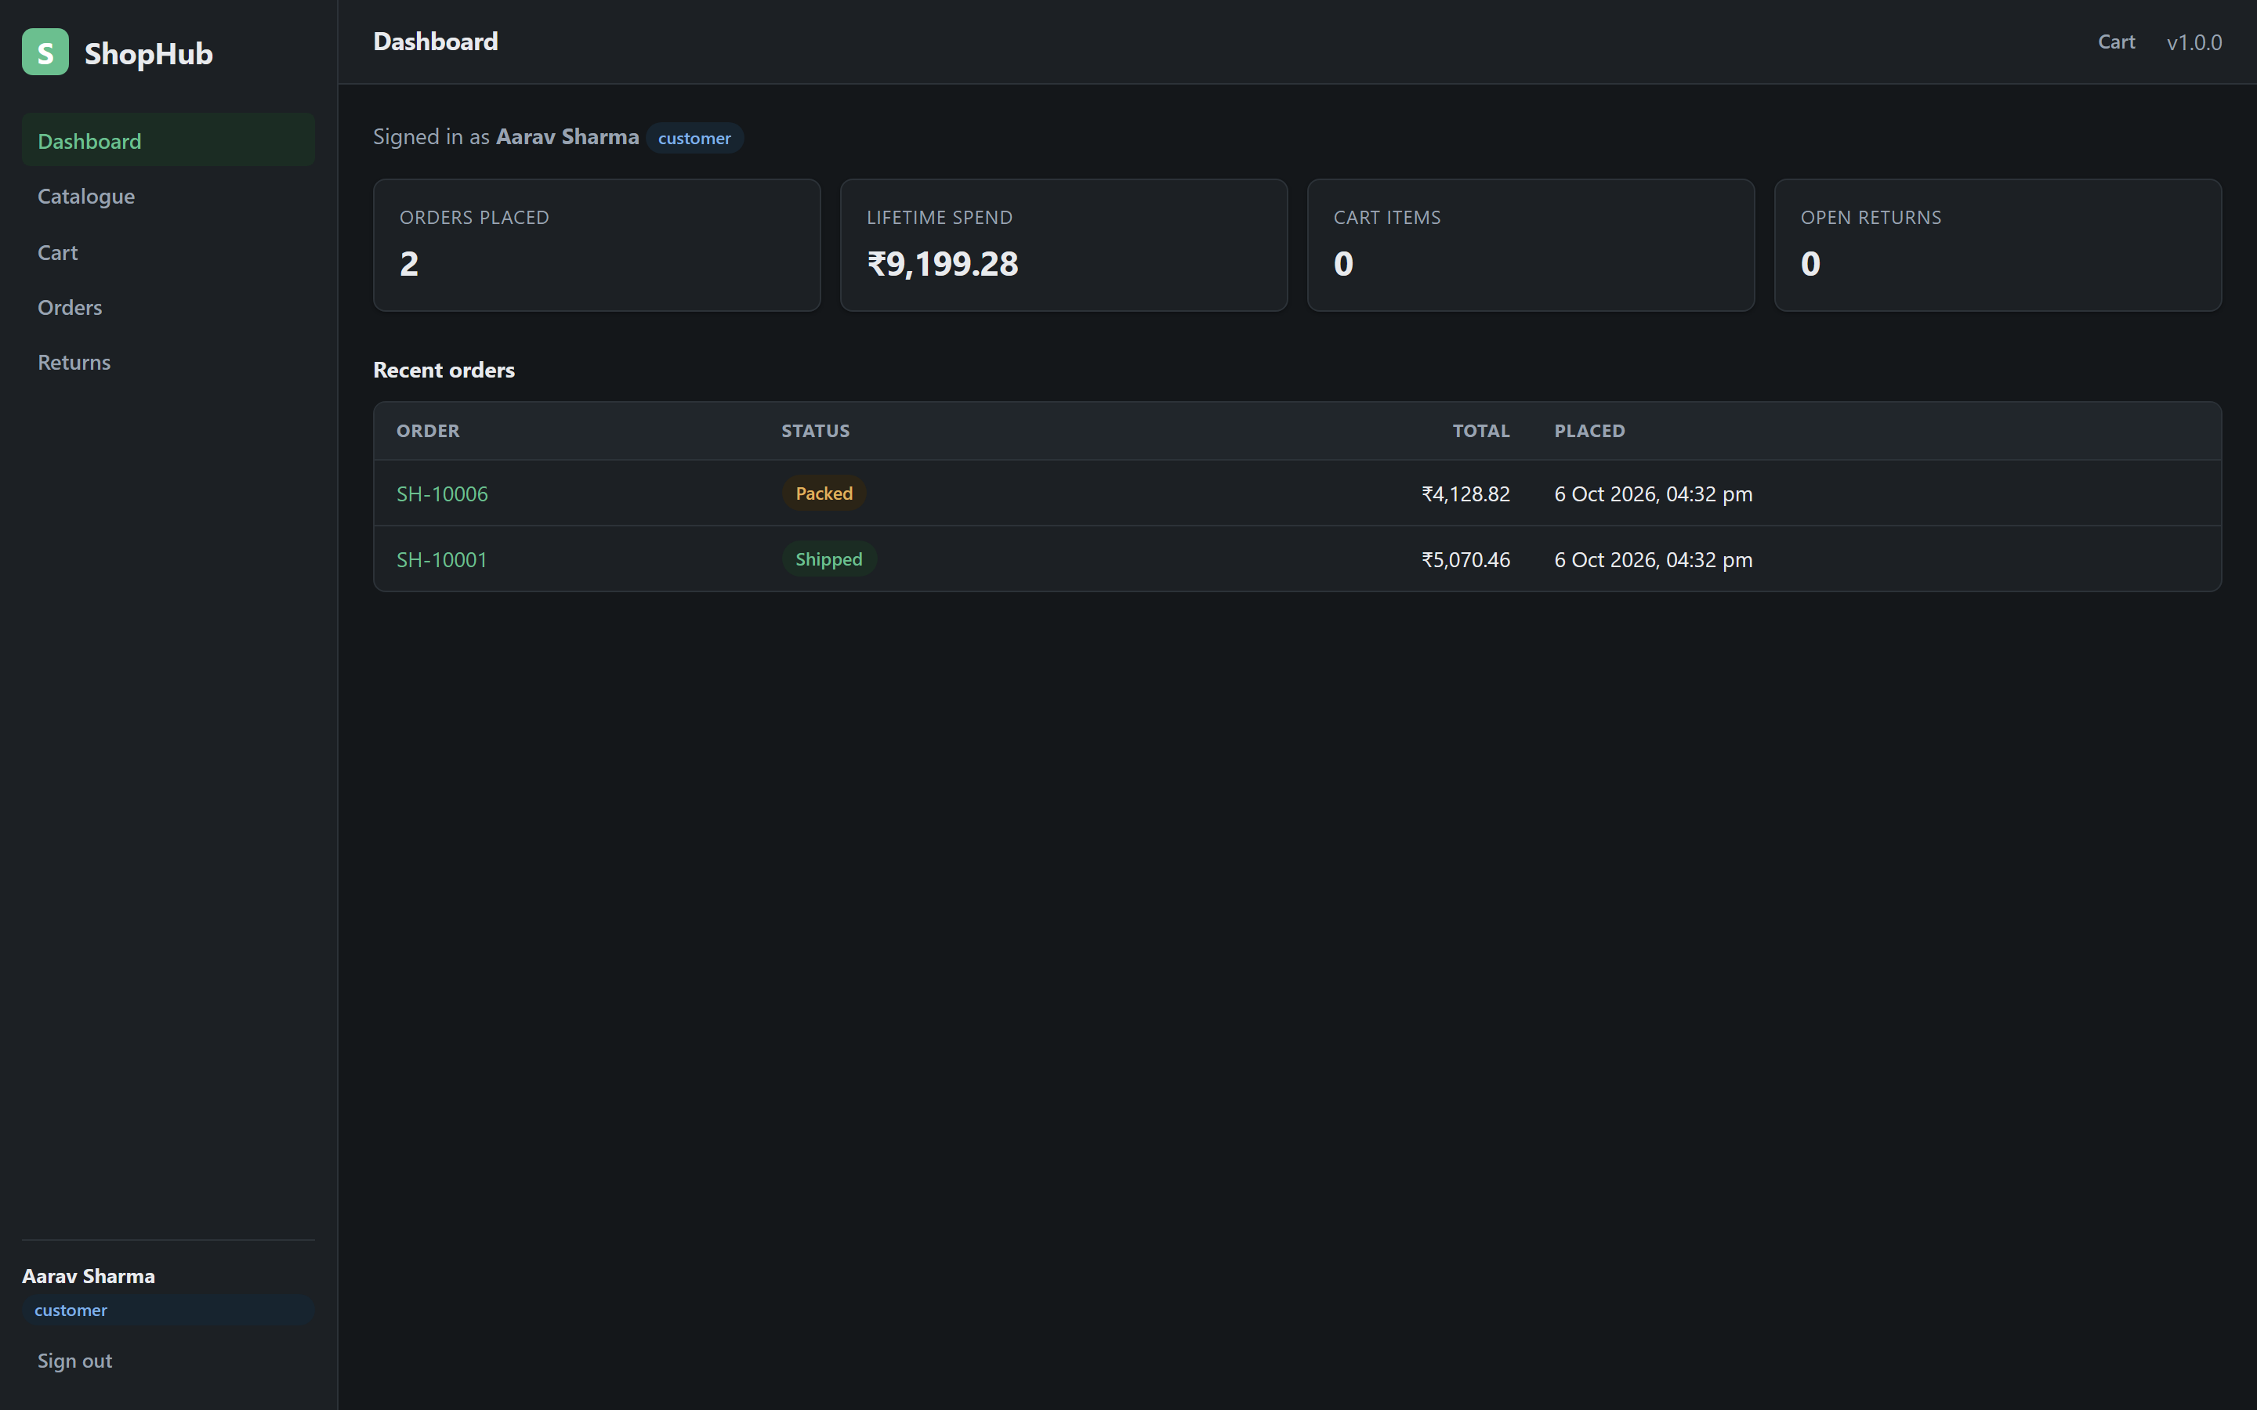 | Tool: App console  Where: Sign in as a customer  Must show: Orders placed, lifetime spend, cart contents and open returns  Why: The role-chosen dashboard from §2.9 and E7  The customer dashboard

SS-12 — Catalogue.
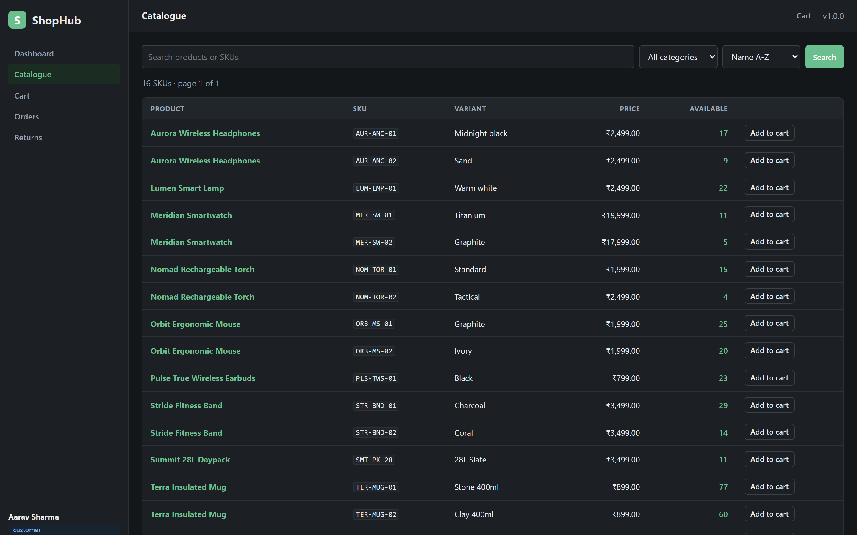 | Tool: App console  Where: Catalogue  Must show: Search, category, sort, and live availability per SKU  Why: Availability is computed from stock, never stored (§2.5)  The catalogue

SS-13 — A product with two SKUs.
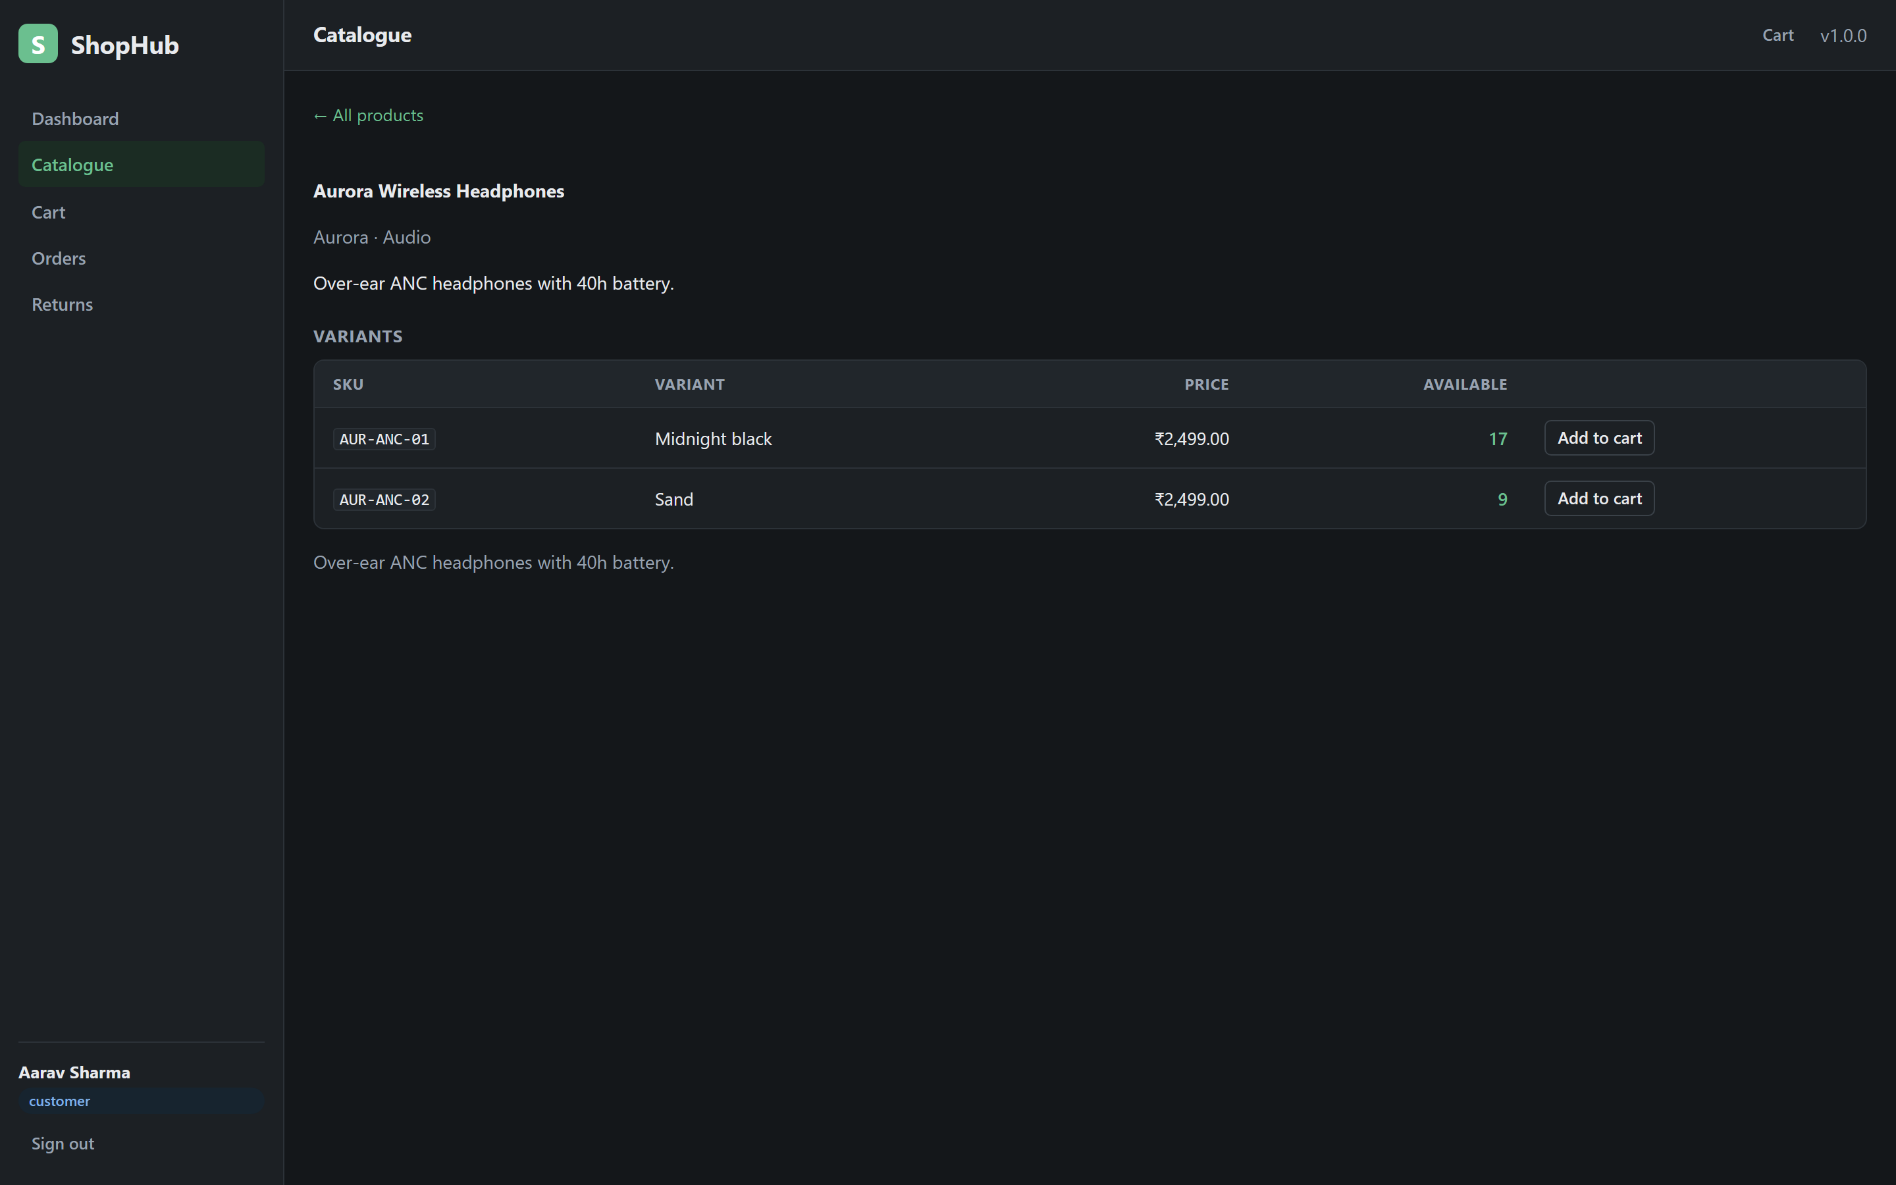 | Tool: App console  Where: A product page  Must show: Two SKUs, prices in paise, computed availability  Why: The money rule from §2.6 shown in the UI  A product with its SKUs

SS-14 — Cart totals.
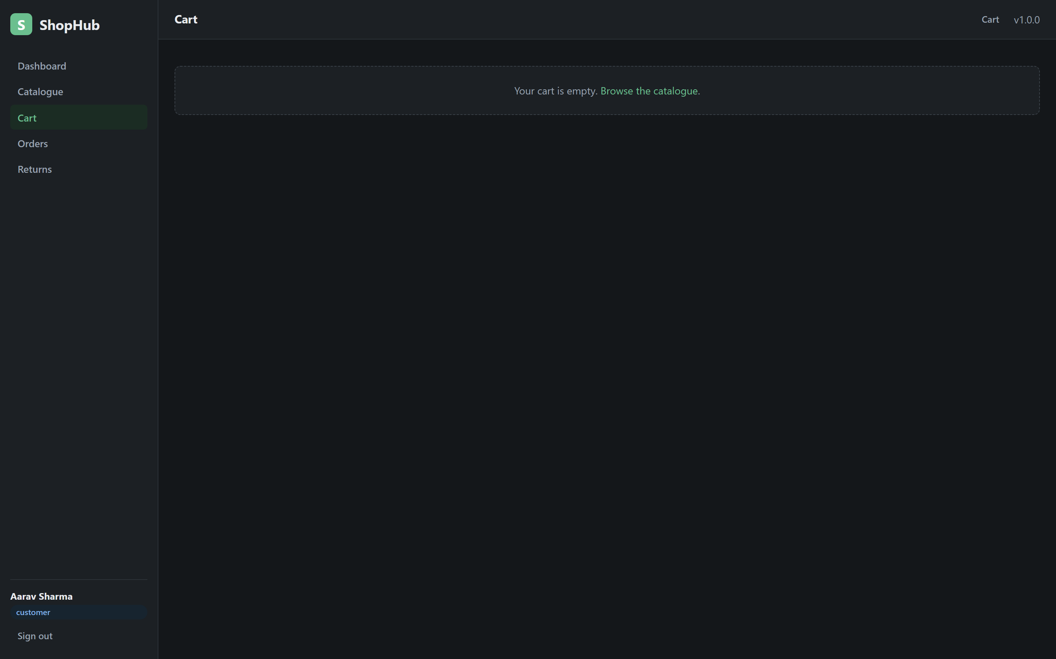 | Tool: App console  Where: Cart  Must show: Subtotal, 18% GST, shipping and grand total — all integer paise  Why: The identity in §2.5 and the money rule in §2.6  A cart with integer totals

SS-15 — Order list.
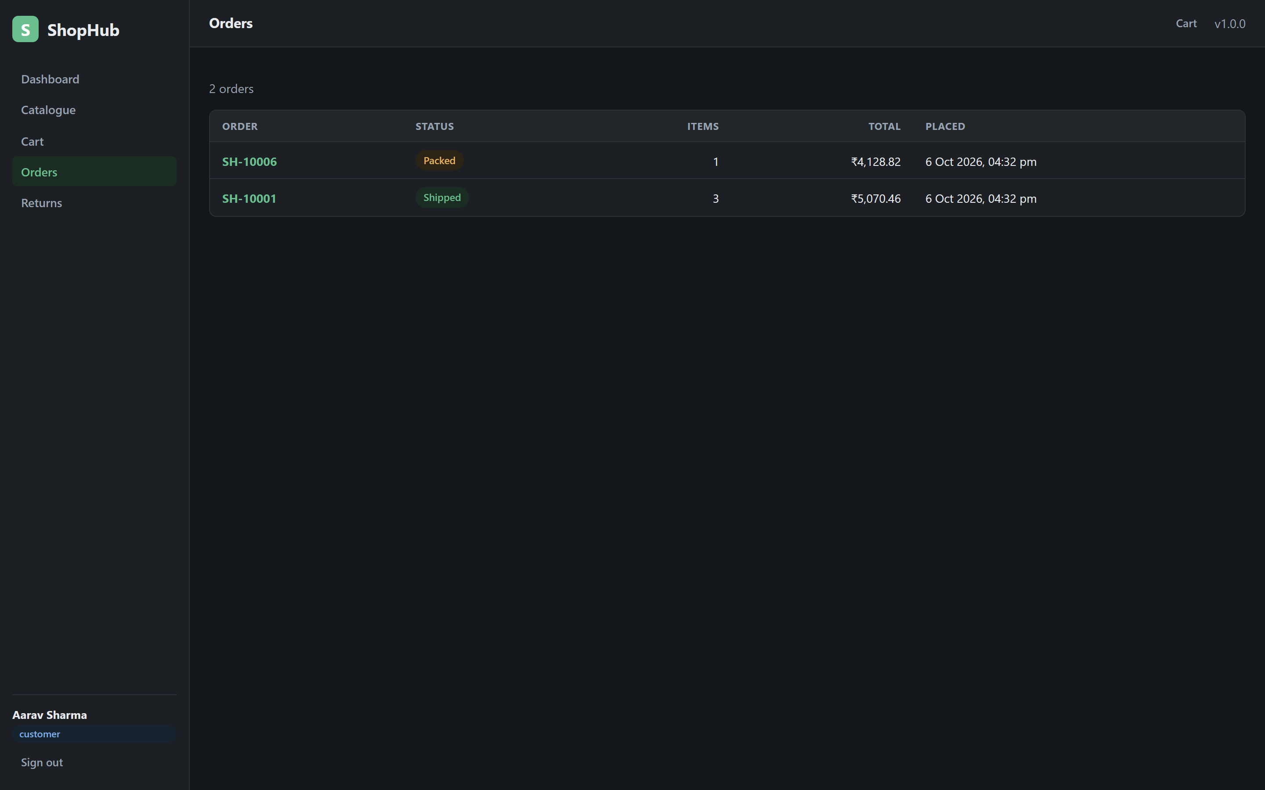 | Tool: App console  Where: Orders  Must show: Only the signed-in customer's own orders  Why: Ownership scoping from §2.9  A customer's own orders

SS-16 — Order detail.
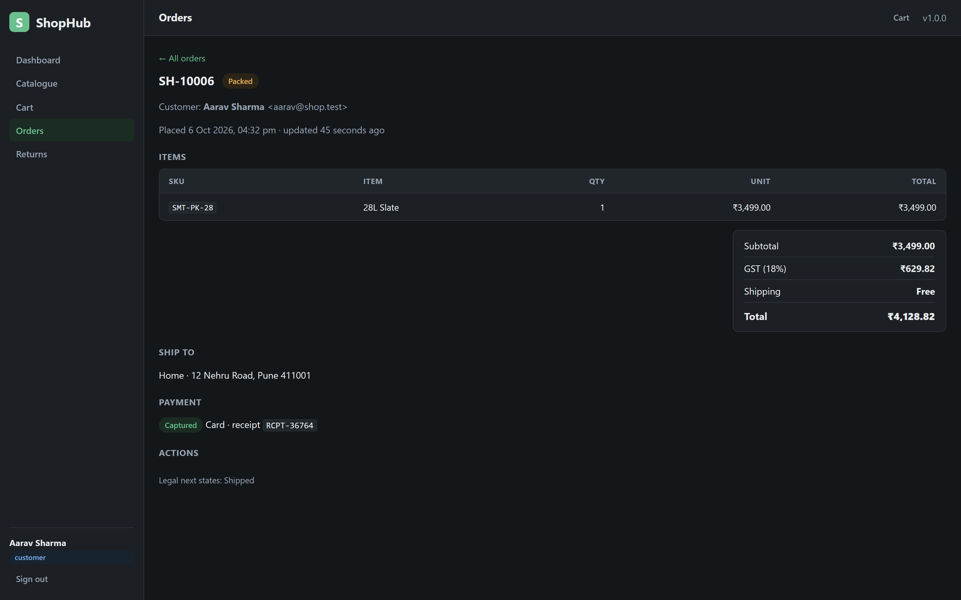 | Tool: App console  Where: An order  Must show: Snapshotted lines, totals, and the legal next states for the role  Why: The closed state machine from §2.7, surfaced to the user  An order's detail and legal next states

SS-17 — A refusal that names the roles.
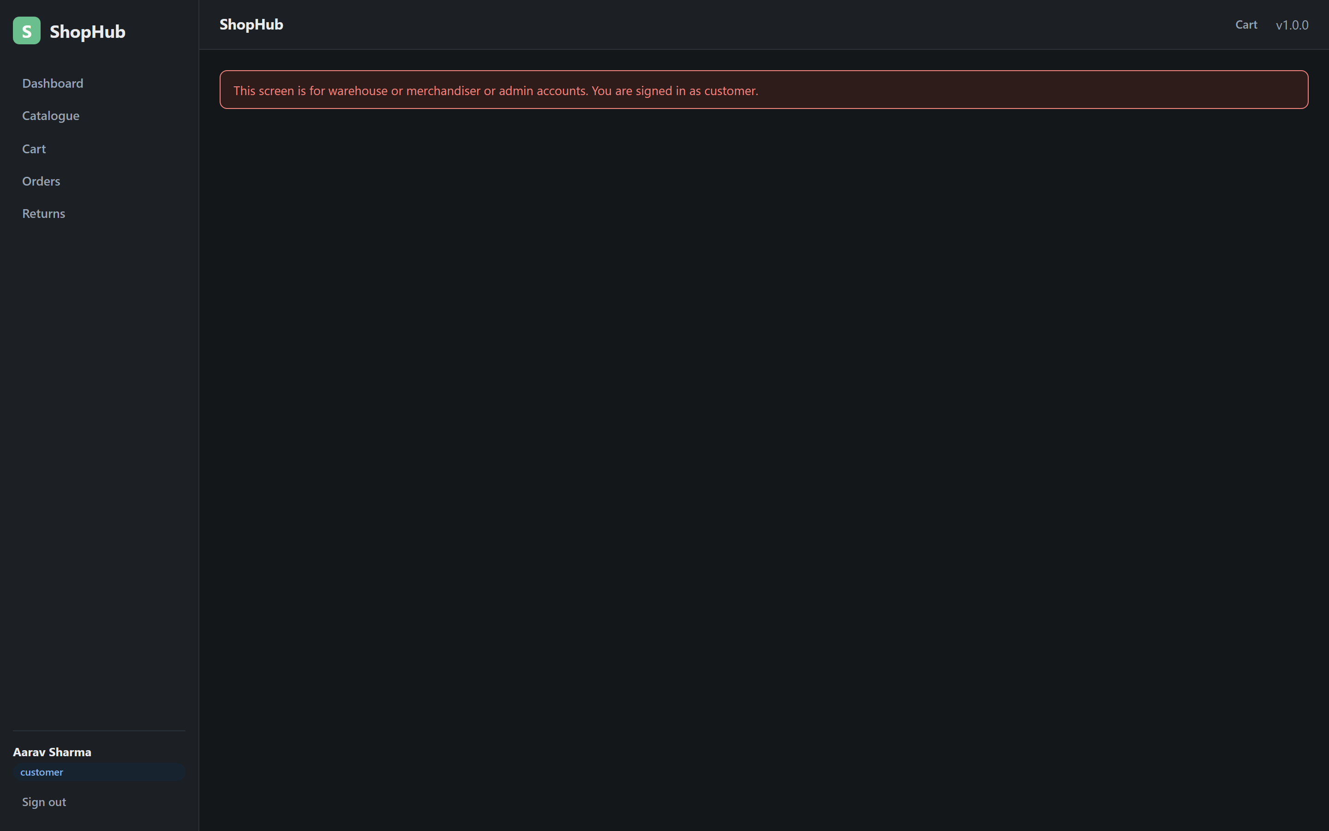 | Tool: App console  Where: A customer navigating to an inventory route  Must show: A 403; the error mapper names the roles that were needed  Why: Meaningful refusal from §2.9  A 403 refusal naming the roles needed

§5.3 A warehouse operator's view
SS-18 — Warehouse dashboard.
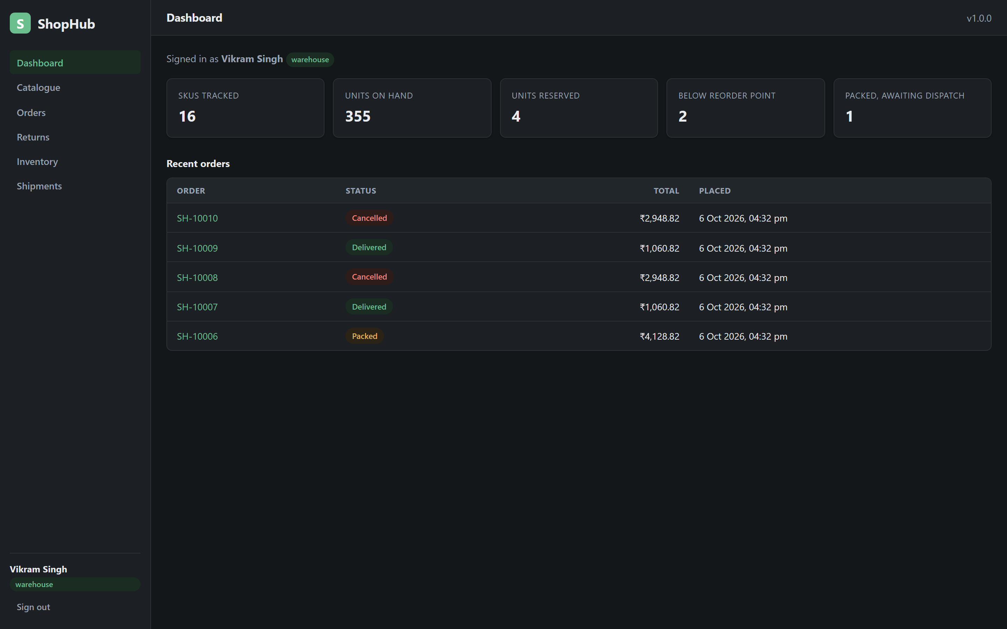 | Tool: App console  Where: Sign in as a warehouse operator  Must show: On hand, reserved, below reorder point, packed orders  Why: The role-chosen dashboard and the invariant from §2.5  The warehouse dashboard

SS-19 — Stock levels and the low-stock report.
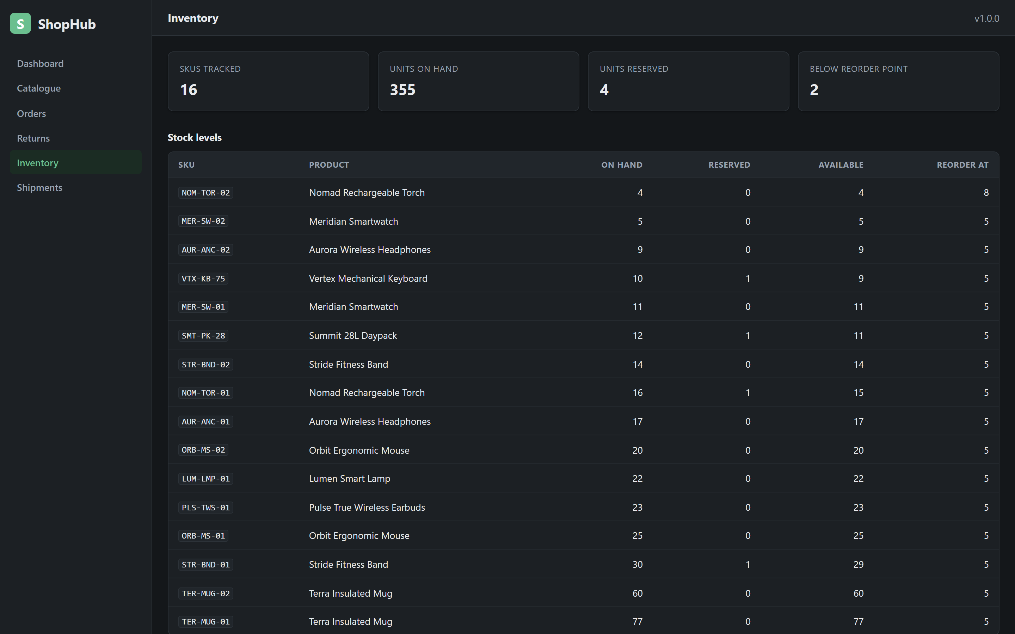 | Tool: App console  Where: Inventory  Must show: on_hand − reserved as availability, with the reorder point  Why: E3's low-stock rule and the §2.5 invariant  Stock levels and the low-stock report

SS-20 — The dispatch queue.
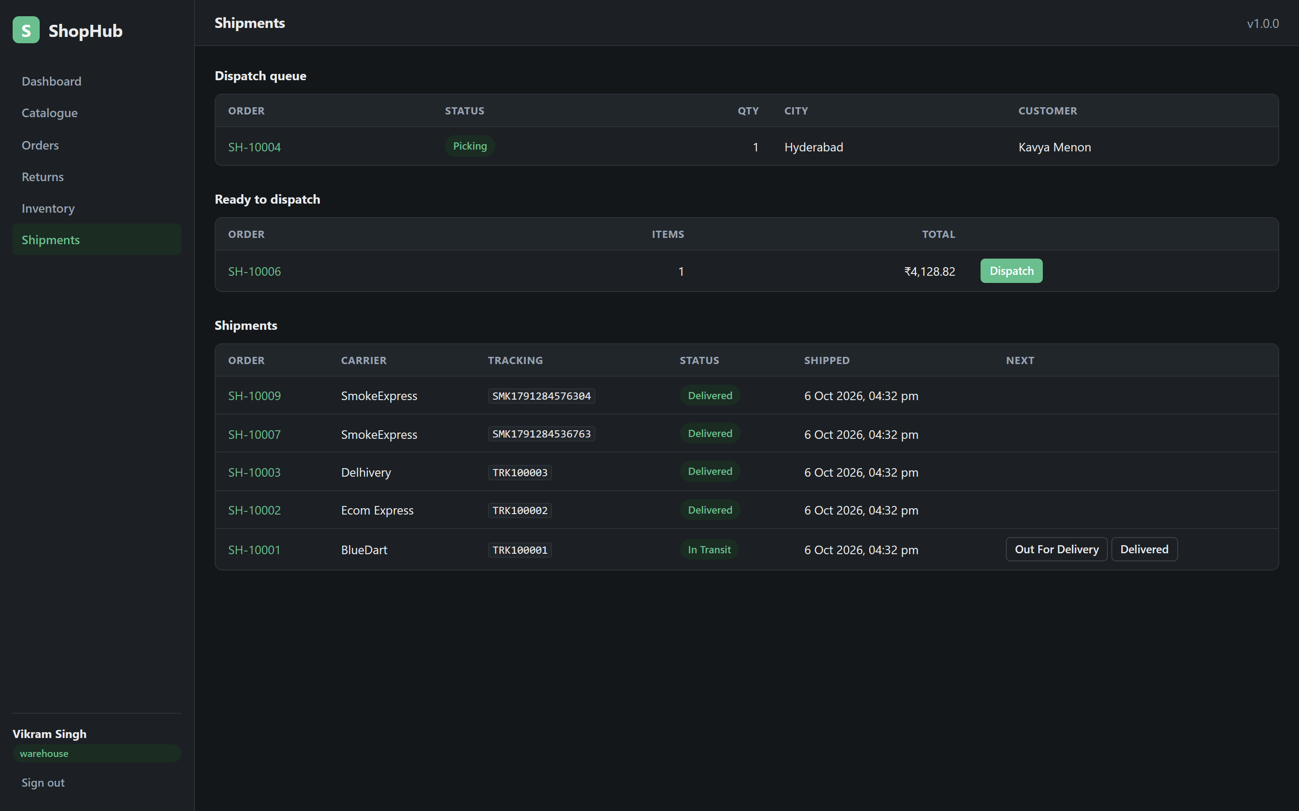 | Tool: App console  Where: Shipments  Must show: Orders in paid or picking, oldest first, with the shipment events  Why: The new GET /fulfilment/dispatch-queue added to satisfy SCRUM-42 (§2.2)  The dispatch queue

§5.4 A finance view
SS-21 — Reconciliation.
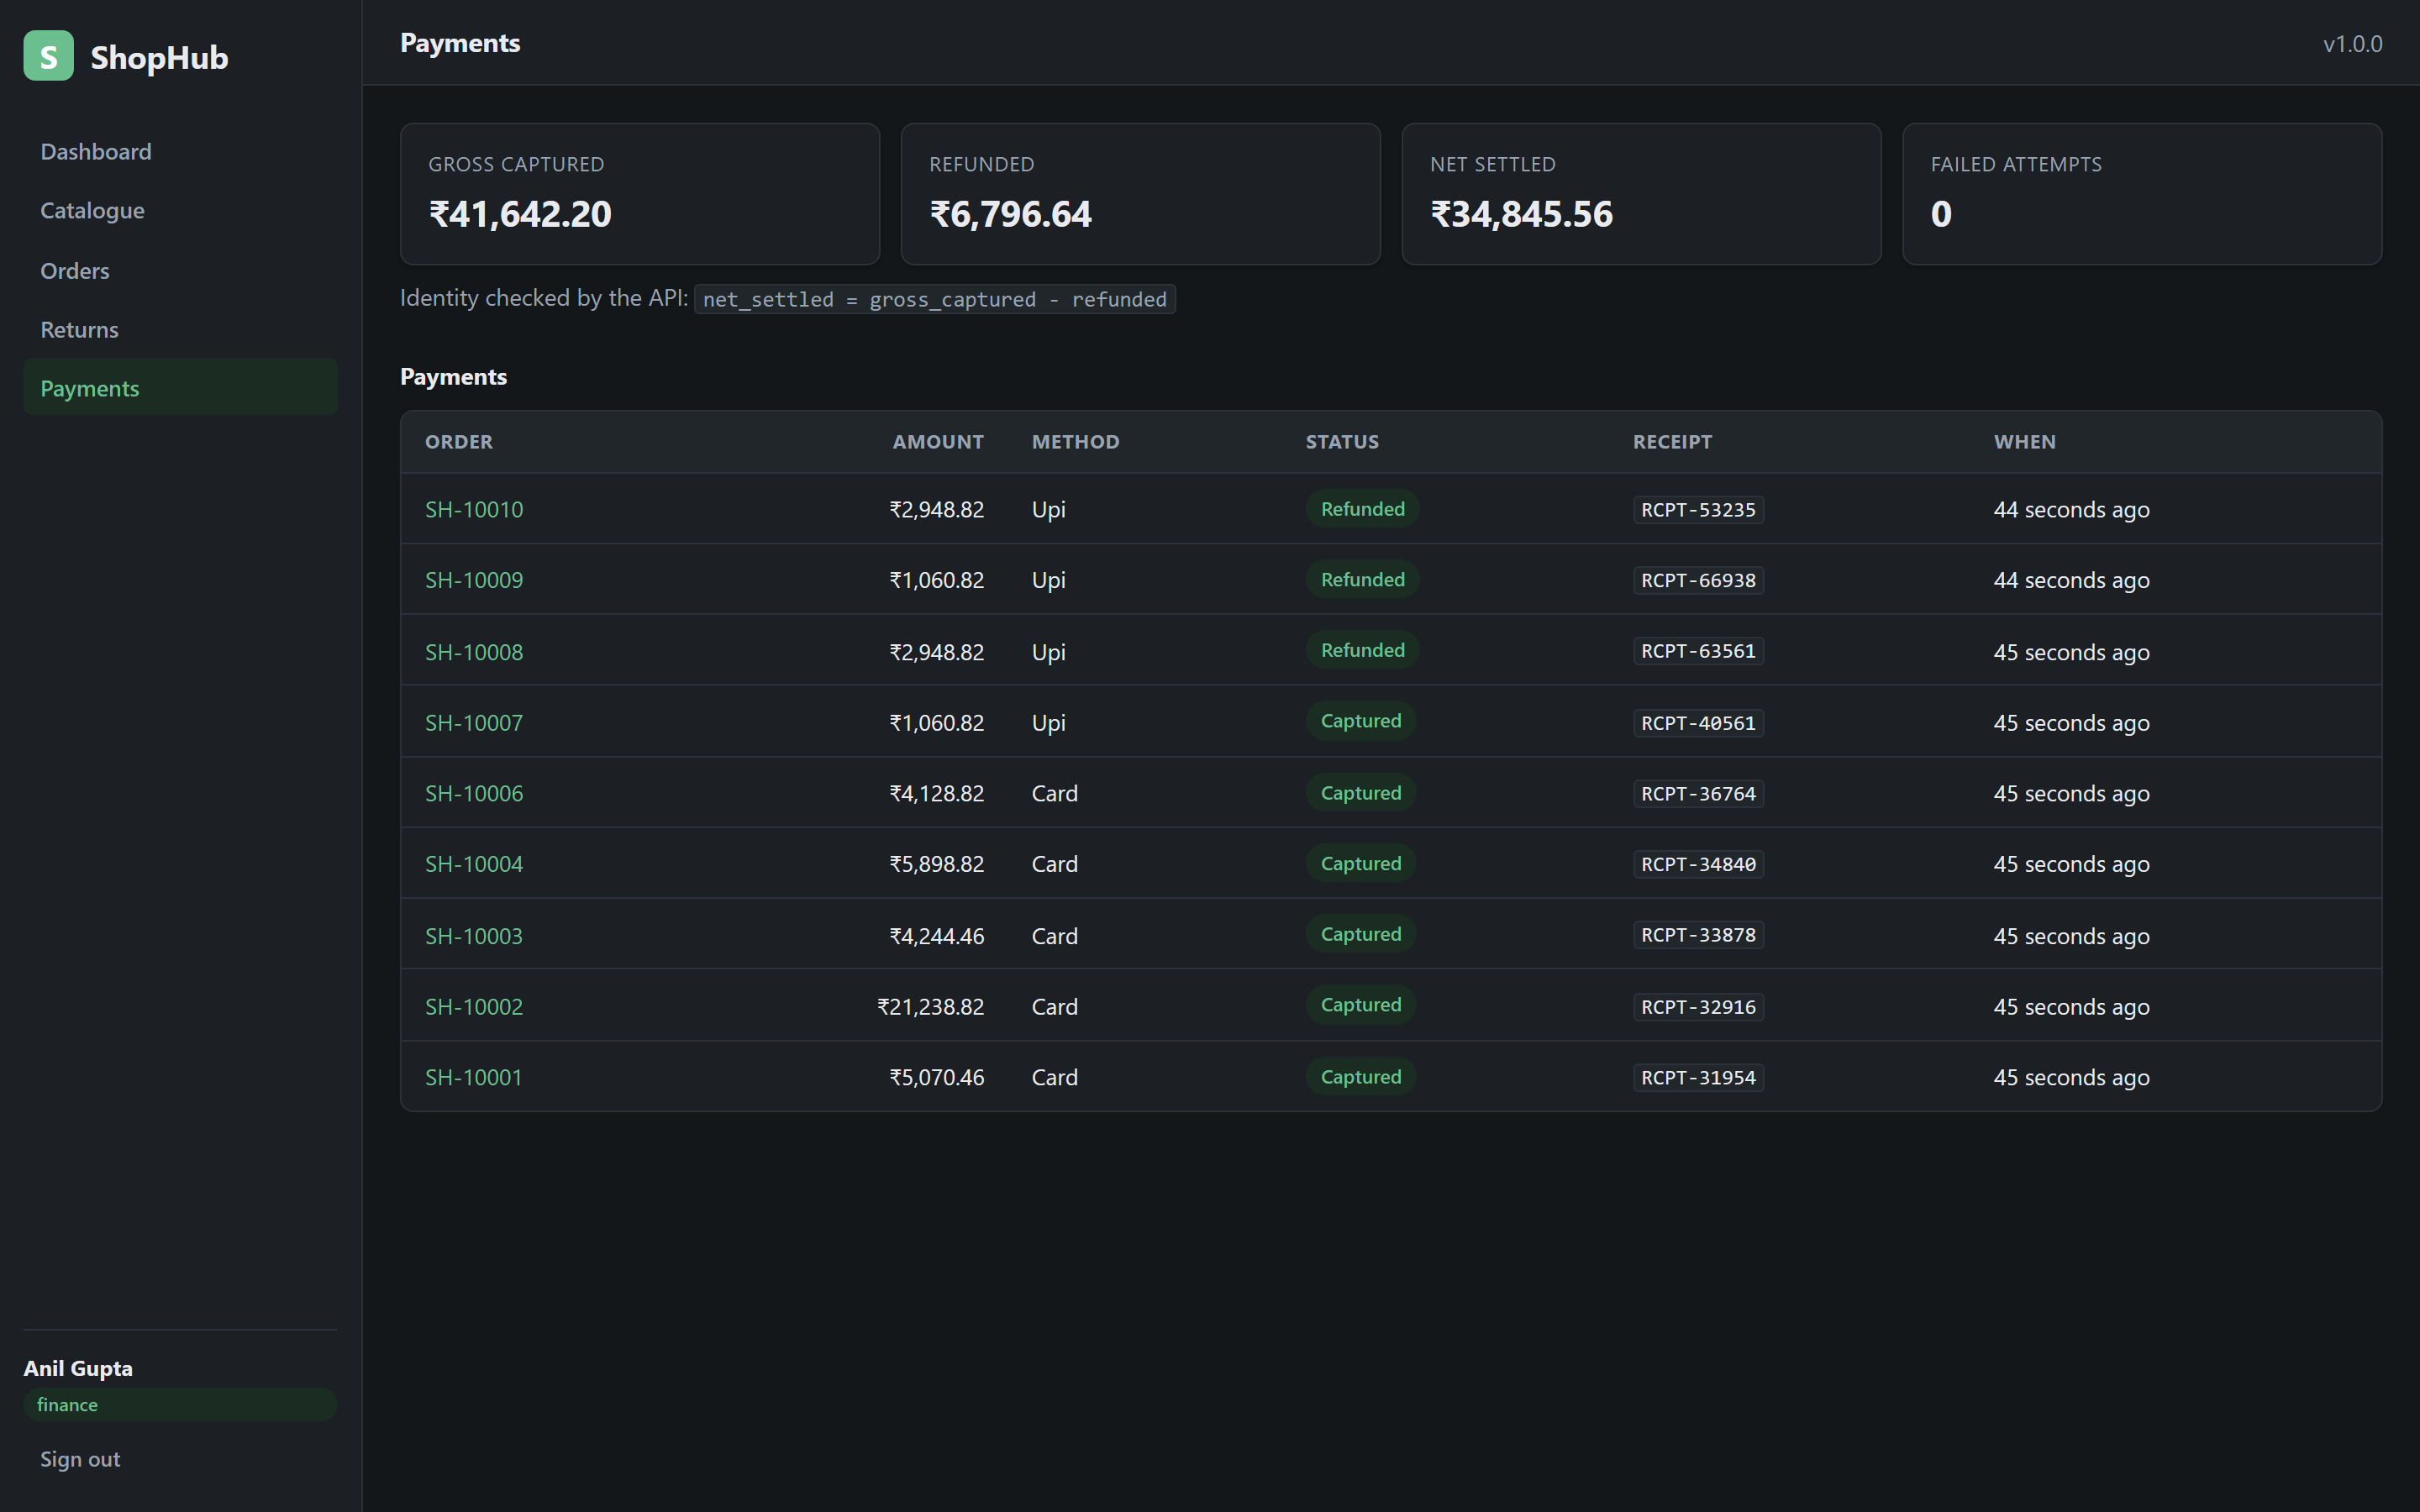 | Tool: App console  Where: Sign in as finance → Payments  Must show: Gross captured, refunded and net settled, and the identity the API asserts  Why: The reconciliation identity from §2.5, asserted server-side so a mismatch fails the request  Finance reconciliation

§5.5 Returns and admin
SS-22 — The returns board.
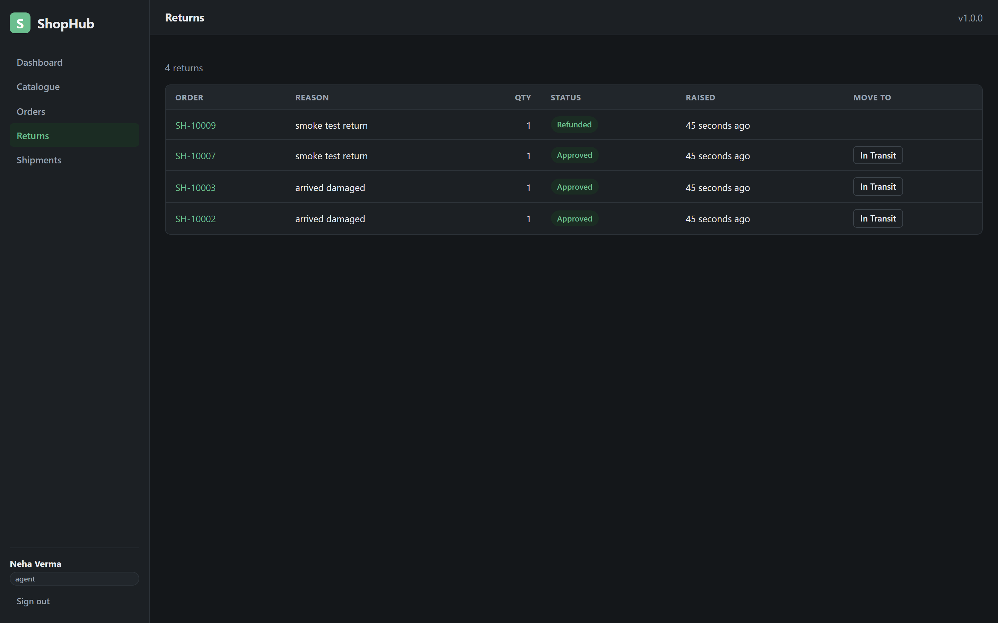 | Tool: App console  Where: Returns  Must show: Each return with its legal next state, including in_transit  Why: The closed return sequence from §2.7, with the step added for SCRUM-41  The returns board with legal next states

SS-23 — Users and the audit ledger.
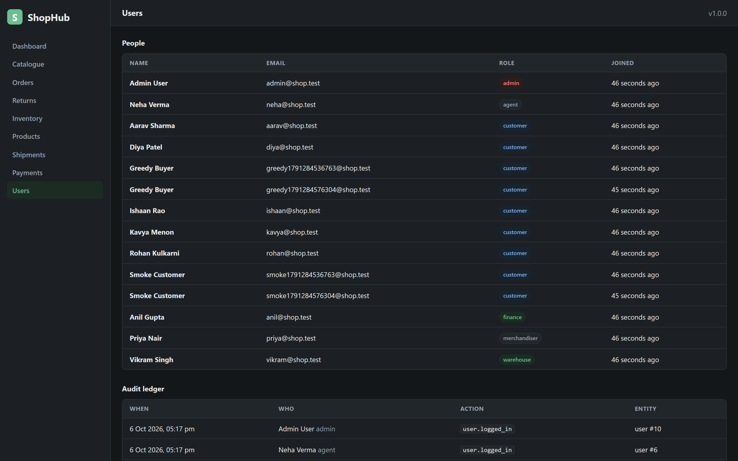 | Tool: App console  Where: Sign in as admin  Must show: Provisioned staff accounts and the append-only audit ledger  Why: The audit invariant from §2.5 and the role scoping from §2.9  Admin users and the audit ledger

6. Code outputs
These are the real outputs of the real commands, captured byte for byte and wrapped in a terminal-styled page. Each screenshot carries the exact command, and the same output is reproduced verbatim as a code block where it is short enough to be worth reading as text. If an image and its code block ever disagree, the code block is the one to believe.
§6.1 The acceptance suite
SS-24 — npm test.
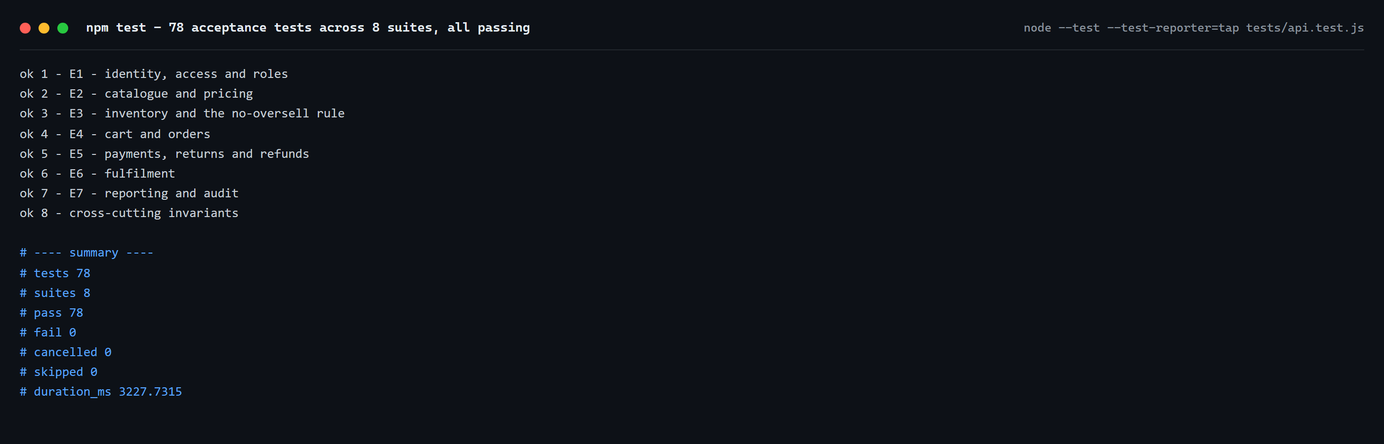 | Tool: Terminal (Node test runner)  Where: cd app && npm test  Must show: 78 acceptance tests across 8 suites, all passing  Why: The Definition of Done from §2.2: every acceptance criterion is a passing test  npm test — 78 acceptance tests across 8 suites

§6.2 The API's self-description
SS-25 — GET /api/v1/meta.
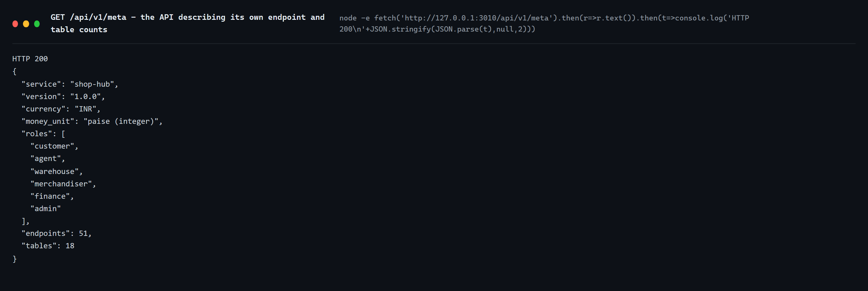 | Tool: HTTP  Where: curl http://127.0.0.1:3010/api/v1/meta  Must show: The service name, integer-paise money, six roles, 51 endpoints, 18 tables  Why: The machine-readable shape of §1, and the contract the CI job asserts  The API describing itself

§6.3 The console client's self-check
SS-26 — node scripts/console-check.mjs.
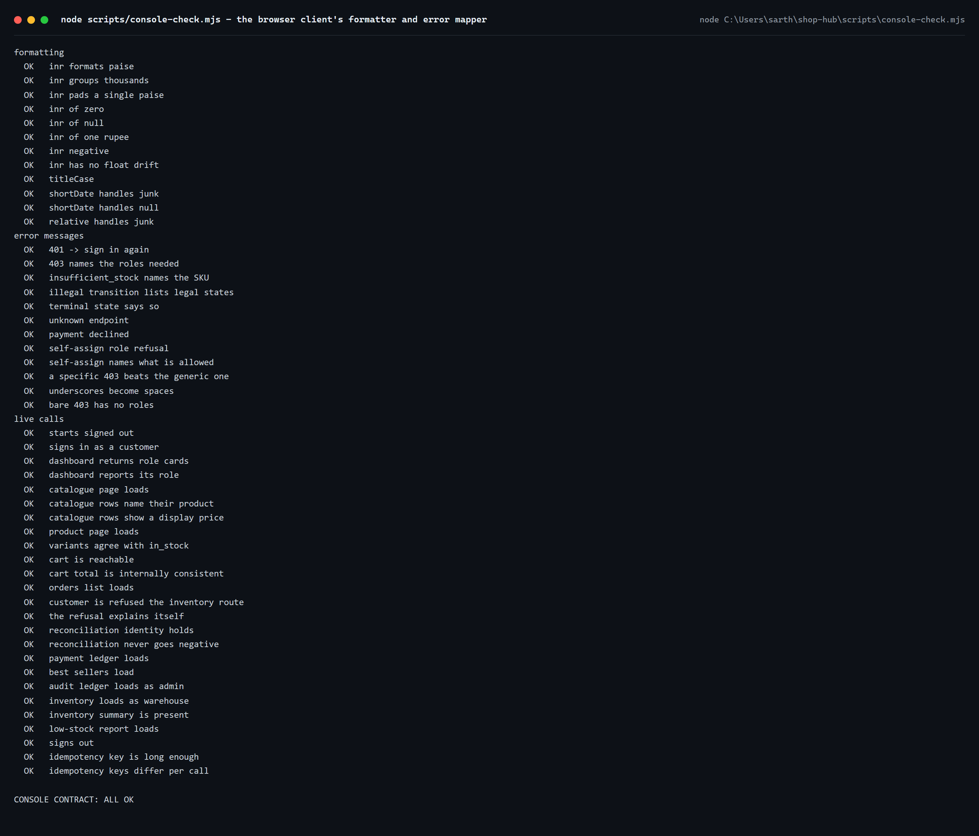 | Tool: Node  Where: node scripts/console-check.mjs  Must show: The formatter and error-mapper checks, and the live API calls, all passing  Why: The client half of §2.9 — error mapping — verified independently of the server suite  The console contract check

§6.4 The CI run for the pushed commit
SS-27 — the CI run.
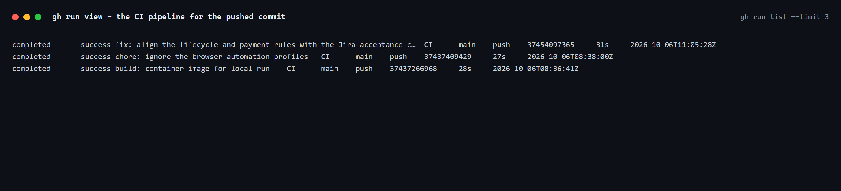 | Tool: GitHub Actions  Where: gh run view for the push of deb5d0e  Must show: The workflow jobs and their outcome — green  Why: The pipeline from §2.3, and the "one reason to fail per job" design from §4.5  The CI run for the pushed commit

§6.5 The commit history as text
SS-28 — git log --oneline.
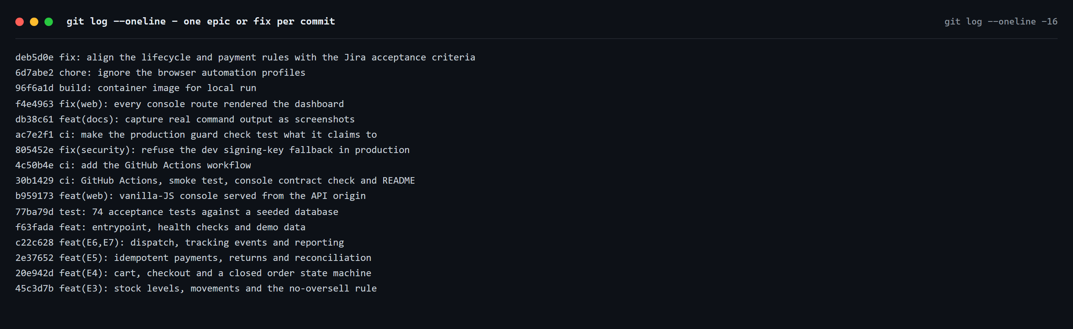 | Tool: Git  Where: git log --oneline  Must show: The same history as SS-7, as text — one epic or fix per commit  Why: The "how" side of §2.1, in a form that can be read rather than seen  The commit history as text

§6.6 Red runs that were useful
Two historical CI runs are kept because they are honest: a red cross told the team exactly what broke, and the fix is in the history.
SS-29 — a first CI failure.
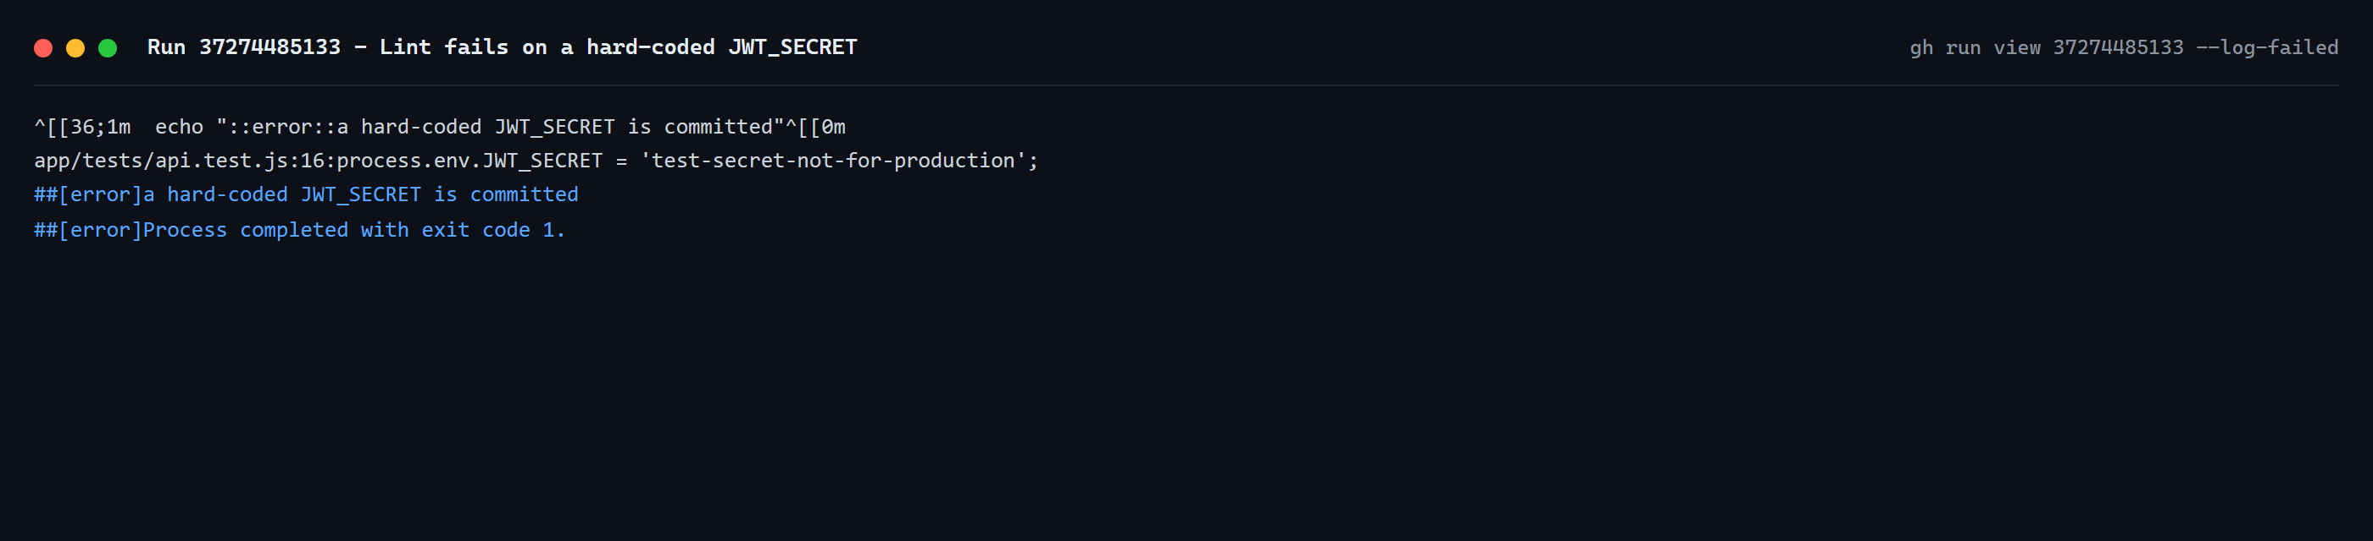 | Tool: GitHub Actions  Where: gh run view 37274485133 --log-failed  Must show: Lint failing on a hard-coded JWT_SECRET  Why: The lint job from §4.5 doing exactly the job it exists for  The lint job failing on a hard-coded secret

SS-30 — a check that passed for the wrong reason.
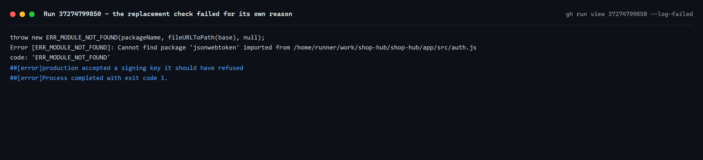 | Tool: GitHub Actions  Where: gh run view 37274799850, --log-failed  Must show: The replacement check failing because of a missing dependency, not the thing it claimed to test  Why: §2.4 in practice — a check that passes for the wrong reason is worse than no check, so it was fixed to fail for the right one  A check that failed for its own reason

§6.7 The live smoke test
SS-31 — the smoke test.
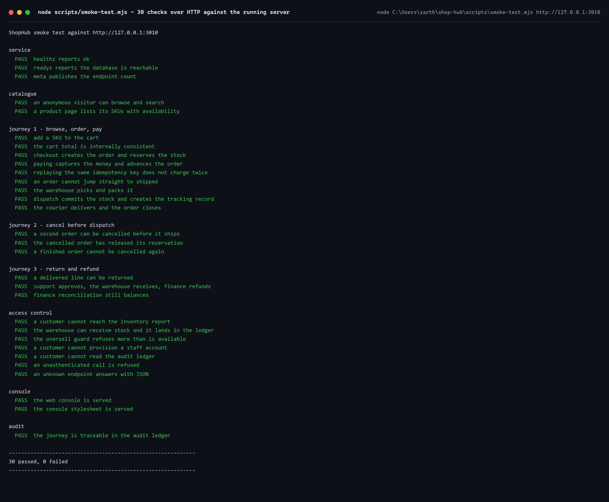 | Tool: Terminal  Where: node scripts/smoke-test.mjs http://127.0.0.1:3010  Must show: 30 checks over real HTTP against a running server, all passing  Why: End-to-end verification of the running system, the top of the test pyramid from §2.4  The smoke test over HTTP, 30 checks passing

7. Conclusion
ShopHub is a complete trading loop for an online retailer, built the way the lab prescribes: the work lived in Jira, the code lived in GitHub, and CI verified every push and nothing more. The final audit compared all 53 acceptance criteria of the 16 open stories against the code, made the small set of changes needed to align them, and moved every story to Done. The evidence in this document — the board, the repository, the running console and the real command output — was captured from the tools themselves, and the one gap, the burndown chart, is stated plainly rather than papered over with a drawing.

