SHOES STORE

SHOES STORE WEB APPLICATION

Use Case Specifications

**Project Code: TCS**

**Document Code: SRS_SSW_WEBAPP_MasterPage _v0.1**

**Ha Noi**

Record of change

*A - Added M - Modified D - Deleted

|  |  |  |  |  |
| --- | --- | --- | --- | --- |
| Effective Date | Changed Items | A* M, D | Change Description | New Version |
| 06-Nov-08 |  | A | First created | 1.0 |
| 11-Nov-08 |  | M | Changes after first review from CIE | 1.1 |
|  |  |  |  |  |
|  |  |  |  |  |
|  |  |  |  |  |
|  |  |  |  |  |
|  |  |  |  |  |
|  |  |  |  |  |
|  |  |  |  |  |
|  |  |  |  |  |
|  |  |  |  |  |
|  |  |  |  |  |
|  |  |  |  |  |
|  |  |  |  |  |
|  |  |  |  |  |
|  |  |  |  |  |
|  |  |  |  |  |
|  |  |  |  |  |
|  |  |  |  |  |
|  |  |  |  |  |
|  |  |  |  |  |

SIGNATURE PAGE

**ORIGINATOR:** 29-Oct-08

Team leader

**REVIEWERS:** 06-Nov-08

PTL

06-Nov-08

APPROVAL:

TABLE OF CONTENTS

1 Introduction 6

1.1 Purpose 6

1.2 Scope 6

1.3 Definitions, Acronyms, and Abbreviations 6

1.4 References 6

2 HIGH LEVEL REQUIREMENTS 7

2.1 Business Essence 7

2.2 High level use case 7

Use cases diagrams 8

2.2.1 Actor description 8

2.2.2 Use case description 8

2.3 Screens 9

2.3.1 Screen flow 9

2.3.2 Screen description 9

3 Specific Requirements 11

3.1 Functionality 11

3.2 Data field valid conditions 28

4 Non Functional Specification 30

4.1 Usability 30

4.2 Reliability 30

4.2.1 Error handling 30

4.2.2 Availability 31

4.2.3 System Dependencies 31

4.2.4 **Bugs** and Defect **Rates** 31

4.3 Performance 32

4.3.1 Response time 32

4.3.2 Throughput 32

4.3.3 Volume 32

4.4 Supportability 32

# Introduction

## Purpose

ShoesStore Web Application Use Case Specifications document is the complete and comprehensive description of software requirement. This system is a web application based application, which performs various functions on the ShoesStore data and Admin functions.

This document will be the basic for further analysis and design model.

## Scope

The scope of this project:

+ Planning, Studying requirement, Designing, Coding and Testing.

+ Deploying the system.

## Definitions, Acronyms, and Abbreviations

|  |  |  |
| --- | --- | --- |
| No | Abbreviations | Description |
| 1 |  |  |
| 2 |  |  |

## References

EXAMPLE Standard 07-08.pdf

NguyenVanLong_QnA_Document.xls

Project Brief.doc

# HIGH LEVEL REQUIREMENTS

## Business Essence

Main functions of system are listed as following:

+ Update Personal Details

+ Write Review

+ Order Tracking

+ Add to Cart

+ Manage Cart

+ Checkout

+ Authenticated User

+ Browse Products

+ View Blog

+ Search and Filter

+ Admin Management

## High level use case

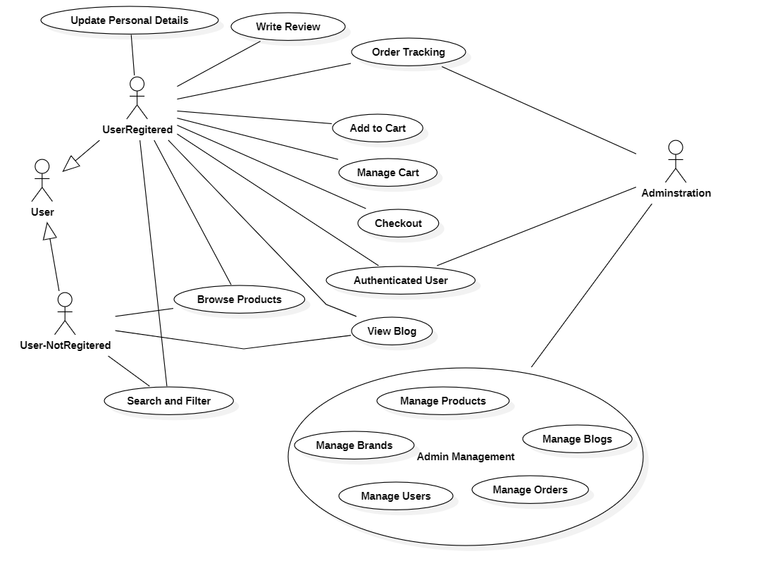

High-level use case

## Use cases diagrams

### Actor description

|  |  |  |
| --- | --- | --- |
| # | Actor | Description |
| 1 | User-NotRegisterd | Can view prodcut list, product detai and view blogs. |
| 2 | User-Registerd | Can Add product to cart, manage cart, checkout, tracking order and feedback product. In additon, they can change their personal information. |
| 3 | Administrator | Can manage brands, products, imports, orders, blogs of system. |

### Use case description

|  |  |  |  |
| --- | --- | --- | --- |
| # | Code | Name | Brief Description |
| 1 | UC01 | Update Personal Details | Allows user to update their personal information and change their password. |
| 2 | UC02 | Write Review | Allows user to share their feedback about the product |
| 3 | UC03 | Order Tracking | Allows user to track their orders |
| 4 | UC04 | Add to Cart | Allows user to add items to their shopping cart |
| 5 | UC05 | Manage Cart | Allows user to update their shopping cart |
| 6 | UC06 | Checkout | Allows user to place and pay for orders |
| 7 | UC07 | Browse Products | Allows user to see products curently avaiable in system |
| 8 | UC08 | View Blog | Allows user to see blogs curently avaiable in system |
| 9 | UC09 | Search and Filter | Allows user to search and filter products by options |
| 10 | UC10 | Manage Brands | Allows adminstrator to manage brands in the system by adding, updating, deleting, and viewing them. |
| 11 | UC11 | Manage Products | Allows adminstrator to manage products in the system by adding, updating, deleting, and viewing them. |
| 12 | UC12 | Manage Blogs | Allows adminstrator to manage blogs in the system by adding, updating, deleting, and viewing them. |
| 13 | UC13 | Manage Import | Allows adminstrator to view and add product import orders. |
| 14 | UC14 | Manage Orders | Allows user to check and modify the status of orders |
| 15 | UC15 | Authenticate User | System verifies permissions of user |

## Screens

### Screen flow

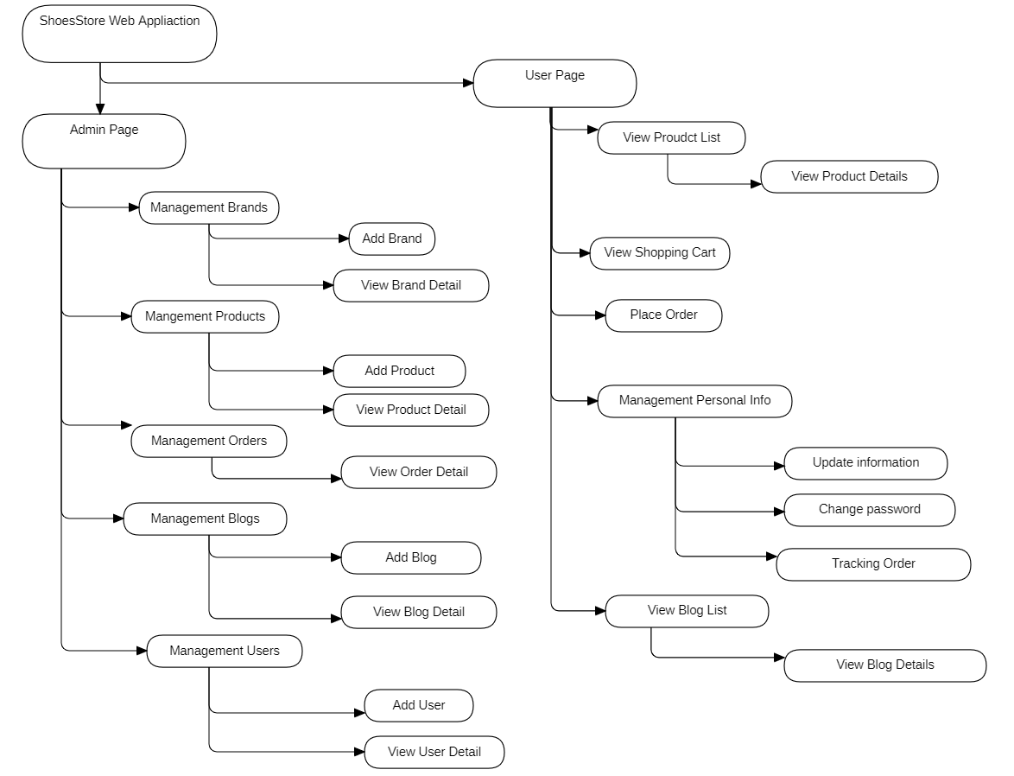

### Screen description

|  |  |  |
| --- | --- | --- |
| # | Screen name | Brief Description |
| 1 | Management Brands | Allows admin to view the list of bradns on the system website |
| 2 | Add Brand | Allows admin to add new brand on the system website |
| 3 | View Brand Detail | Allows admin to view the detail of brand and update brand |
| 4 | Management Products | Allows admin to view the list of products on the system website |
| 5 | Add Product | Allows admin to add new product on the system website |
| 6 | View Product Detail | Allows admin to view the detail of product and update product |
| 7 | Management Orders | Allows admin to view the list of ordes on the system website |
| 8 | View Order Detail | Allows admin to view the detail of order and update status |
| 9 | Management Blogs | Allows admin to view the list of blogs on the system website |
| 10 | Add Blog | Allows admin to add new blog on the system website |
| 11 | View Blog Detail | Allows admin to view the detail of blog and update blog |
| 12 | Management Users | Allows admin to view the list of users on the system website |
| 13 | Add User | Allows admin to add new user on the system website |
| 14 | View User Detail | Allows admin to view the detail of user and update user |
| 15 | View Product List | Allows user to view the list of products on the system website |
| 16 | View Product Details | Allows user to view the detail of product on the system website |
| 17 | View Review | Allows user to view feedback from other customers about the product |
| 18 | Write review | Allows user to write their feedback about the product after testing it |
| 19 | Add to Cart | Allows user to add products to the shopping cart |
| 20 | View Shopping Cart | Allows user to view products in the shopping cart |
| 21 | Update quantity/size | Allows user to modify the quantity or size of item in the shopping cart |
| 22 | Delete Product | Allows user to remove item from the shopping cart |
| 23 | Place Order | Allows user to enter and confirm information to place an order |
| 24 | Payment | Allows user to choose a payment method to place an order |
| 25 | Management Personal Info | Allows user to view and manage personal information |
| 26 | Update information | Allows user to update personal information |
| 27 | Change password | Allows user to change password |
| 28 | Tracking Order | Allows user to track orders |
| 29 | View Blog List | Allows user to view the list of blogs on the system website |
| 30 | View Blog Details | Allows user to view the detail of blog on the system website |

# Specific Requirements

## Functionality

* + 1. UC01:

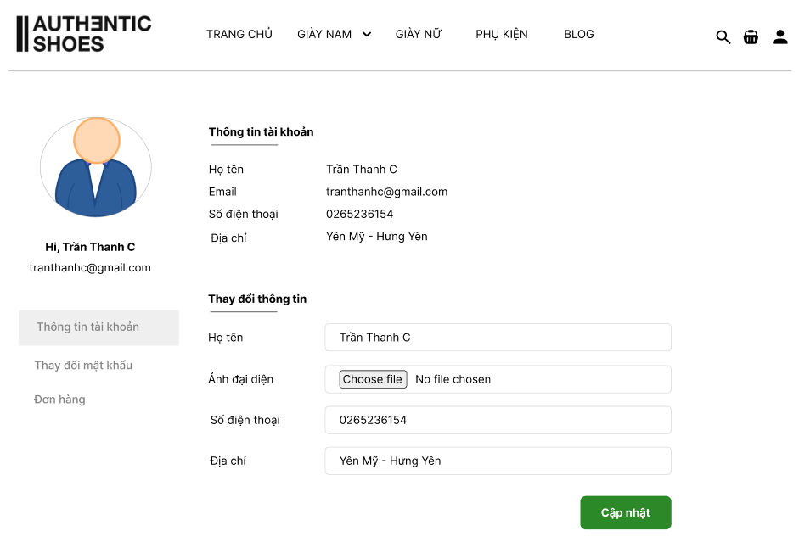

|  |  |  |  |  |  |
| --- | --- | --- | --- | --- | --- |
| **UC01: Update Personal Details** | | | | | |
| Goal in Context | | | This use case allows the actor to view the personal information of their account.  The actor can update their personal information. | | |
| Pre-Condition | | | The actor has successfully logged into the website application. | | |
| Post-Condition | | | The tool shall bring back data that is appropriate to the actor’s request.  The system update data into database. | | |
|  | | | | | |
| **Step** | **Subject** (Actor) | **Verb** (Event) | | **Object** (Entity) | **Response** |
| **Main Success Scenario** | | | | | |
| Pre-Condition | | The actor has successfully logged into the website application and purchased this product. | | | |
| 1. | User | Click | | “User” Icon in the Header bar | Website displays detailed personal information for the account. |
| 2. | User | Input | | Cells | Input data into “Full name”, “Phone number”, “Address” cells, selected file in “Avatar image” cells.  (see 3.2. Data field valid conditions). |
| 3. | User | Click | | Button “Update” | System checks empty condition on field “Full name”, “Phone number” and “Address”. If fields is empty then displays message “Field is empty. Please fill!”  Else  If validation process is completed successfully without any warning message then system saves the personal information into database. |

**3.1.2 UC02: Write Review**

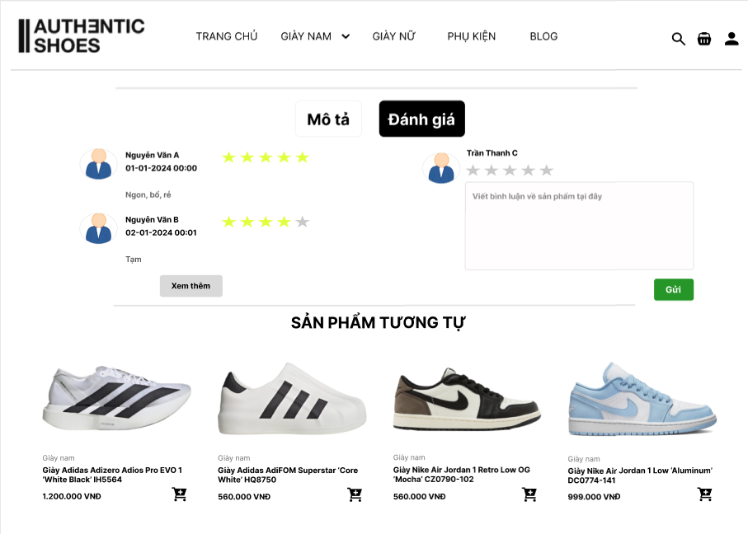

|  |  |  |  |  |  |
| --- | --- | --- | --- | --- | --- |
| **UC02: Write Review** | | | | | |
| Goal in Context | | | This use case allows the actor to display feedback from other customer.  The actor can write their own review about the product. | | |
| Pre-Condition | | | The actor has successfully logged into the website application.  The actor has purchased this product. | | |
| Post-Condition | | | The tool shall bring back data that is appropriate to the actor’s request | | |
|  | | | | | |
| **Step** | **Subject** (Actor) | **Verb** (Event) | | **Object** (Entity) | **Response** |
| **Main Success Scenario** | | | | | |
| Pre-Condition | | The actor has successfully logged into the website application and purchased this product. | | | |
| 1. | User | Click | | “Product” in “Product List” Table | Website displays detailed information about the product. |
| 2. | User | Click | | The “Review” section under the product image | System displays the feedback from other customers and a form to user can write their review about the product |
| 3. | User | Click | | “Star” Icon | System highlights the selected star icons is yellow. |
| 4. | User | Input | | Cells | Input data into “Your feedback” cell (see 3.2. Data field valid conditions).  Actor cannot submit a review until all valid conditions of fields on that row are satisfied. |
| 5. | User | Click | | Button “Send” | System checks empty condition on field “Your Feedback" and number of star. If fields is empty then displays message “You can send a review empty.”  Else  System checks duplicate data, if the user's review already exists then displays message “You already review this product.”  If validation process is completed successfully without any warning message then system saves the review into database. |

* + 1. **UC03: Order Tracking**

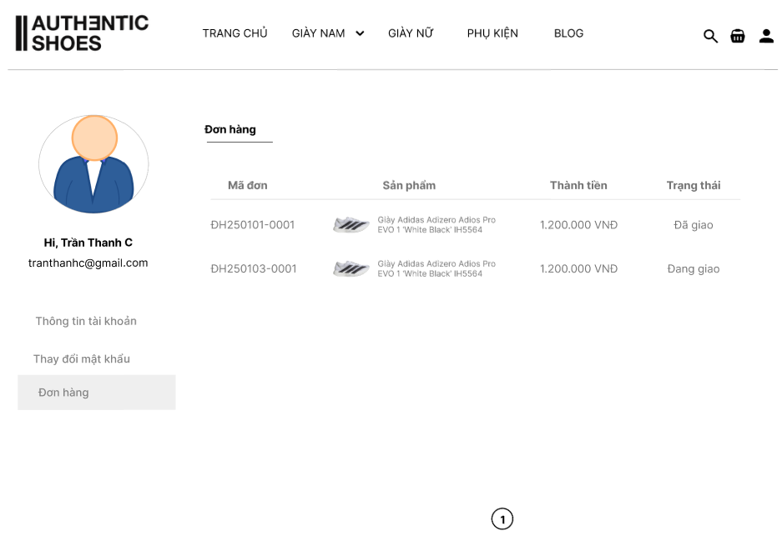

|  |  |  |  |  |  |
| --- | --- | --- | --- | --- | --- |
| **UC03: Order Tracking** | | | | | |
| Goal in Context | | | This use case allows the actor to view the list of all orders. | | |
| Pre-Condition | | | The actor has successfully logged into the website application. | | |
| Post-Condition | | | The tool shall bring back data that is appropriate to the actor’s request | | |
|  | | | | | |
| **Step** | **Subject** (Actor) | **Verb** (Event) | | **Object** (Entity) | **Response** |
| **Main Success Scenario** | | | | | |
| Pre-Condition | | The actor has successfully logged into the website application. | | | |
| 1. | User | Click | | The “Order” section on the left sidebar | Website displays detailed information about the product. |
| 2. | User | Click | | Any Order | System returns and displays the detailed information of the selected order on the screen. |

**3.1.4 UC04: Add to Cart**

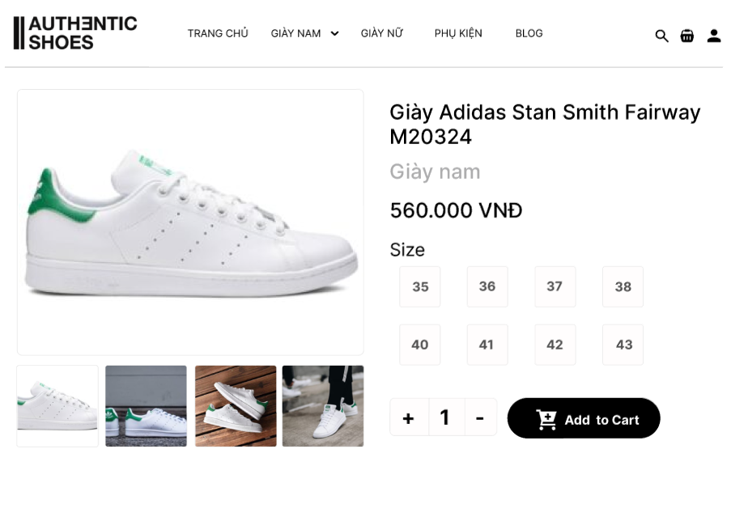

|  |  |  |  |  |  |
| --- | --- | --- | --- | --- | --- |
| **UC04: Add to Cart** | | | | | |
| Goal in Context | | | This use case allows the actor to add products to the shopping cart. | | |
| Pre-Condition | | | The actor has successfully logged into the website application. | | |
| Post-Condition | | | The tool shall bring back data that is appropriate to the actor’s request. | | |
|  | | | | | |
| **Step** | **Subject** (Actor) | **Verb** (Event) | | **Object** (Entity) | **Response** |
| **Main Success Scenario** | | | | | |
| Pre-Condition | | The actor has successfully logged into the website application. | | | |
| 1. | User | Click | | “Product” in “Product List” Table | Website displays detailed information about the product. |
| 2. | User | Click | | The “Size” in the table Size. | Website checks quantity of size product. If quantiy is sufficent, the size box is highlighted.  Else  Website displays message “This size is out of stock. Please select a different size”. |
| 3. | User | Input/Click | | “Quantity” under the table Size | Website checks quantity of size product. If quantiy is sufficent, display the product quantity based on the number entered by the user.  Else  Website displays message “This size is out of stock. Please select a different size”. |
| 4. | User | Click | | “Add to cart” Button | Website add product into the shopping cart and update the quantity of products currently in the shopping cart. |

**3.1.5 UC05: Manage Cart**

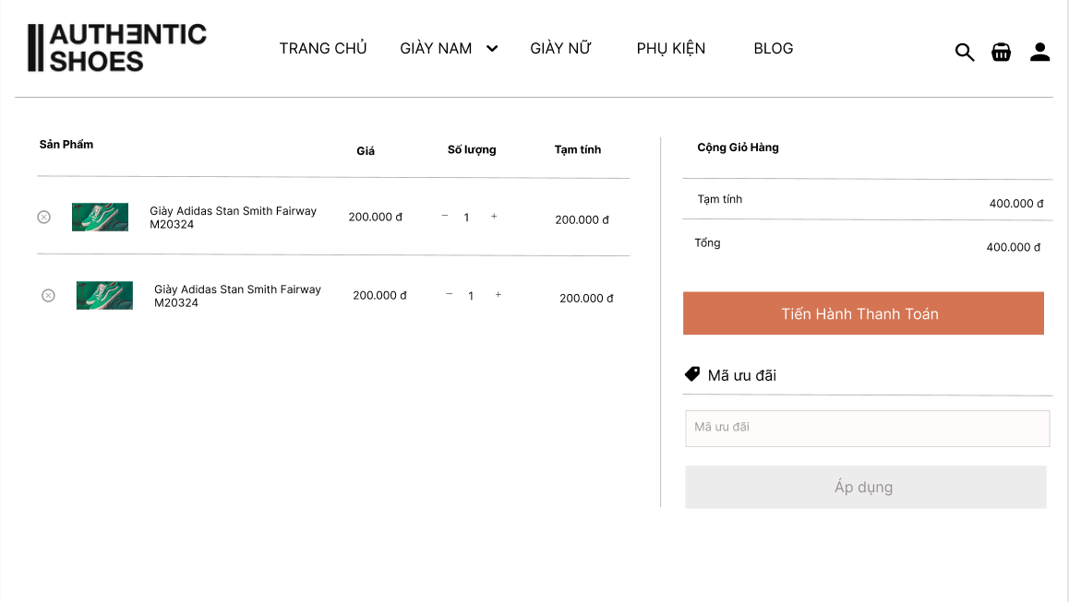

|  |  |  |  |  |  |
| --- | --- | --- | --- | --- | --- |
| **UC05: Manage Cart** | | | | | |
| Goal in Context | | | This use case allows users to view the list of products in their shopping cart. Users can add products to the cart, update product quantities or size, or remove products from the cart. Users can also proceed to checkout and make payments for the products in the shopping cart. | | |
| Pre-Condition | | | The actor has successfully logged into the website application. | | |
| Post-Condition | | | The tool shall bring back data that is appropriate to the actor’s request | | |
|  | | | | | |
| **Step** | **Subject** (Actor) | **Verb** (Event) | | **Object** (Entity) | **Response** |
| **Main Success Scenario** | | | | | |
| Pre-Condition | | The actor has successfully logged into the website application. | | | |
| 1. | User | Click | | Icon “Shopping Cart” on the menu bar | Website displays the shopping cart screen. |
| 2. | User | Click | | Icon “ X ” next to the Product | The product is removed from the shopping cart, and the cart list is updated. |
| 3. | User | Input/Click | | Product Quantity in the Input Box Or Button “+”, Buton” - “ | The product quantity is updated, and the total amount is automatically recalculated. |
| 4. | User | Input | | "Proceed to Checkout" Button | The system navigates to the checkout screen. |

**3.1.6 UC06: Checkout**

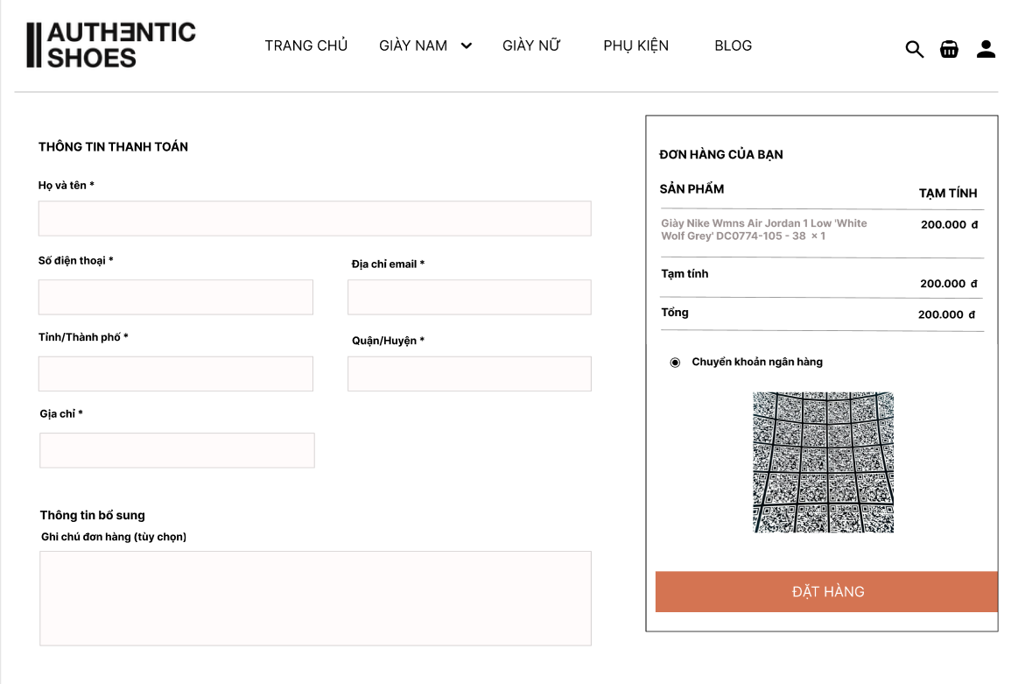

|  |  |  |  |  |  |
| --- | --- | --- | --- | --- | --- |
| **UC06: Checkout** | | | | | |
| Goal in Context | | | This use case allows users to complete their order payment by:   * Entering shipping information (full name, phone number, and address). * Selecting a payment method. * Confirming the order and receiving a success notification. | | |
| Pre-Condition | | | The user has added at least one product to the shopping cart.  The user has logged in or provided contact information. | | |
| Post-Condition | | | The order is stored in the system.  The system notifies the user of successful payment confirmation. | | |
|  | | | | | |
| **Step** | **Subject** (Actor) | **Verb** (Event) | | **Object** (Entity) | **Response** |
| **Main Success Scenario** | | | | | |
| Pre-Condition | | The user has logged in or provided the required information (full name, address, phone number, and email). | | | |
| 1. | User | Input | | Full Name, Phone Number, Email, Address | The system verifies and validates the provided information. |
| 2. | User | Select | | City/Province and District | The system displays a list of applicable areas. |
| 3. | User | Choose | | Payment Method (Bank Transfer, COD, etc.) | The system saves the selected payment method. |
| 4. | User | Click | | "Place Order" Button | The system checks the information, creates the order, and displays a success notification. |

**3.1.7 UC07: Browse Products**

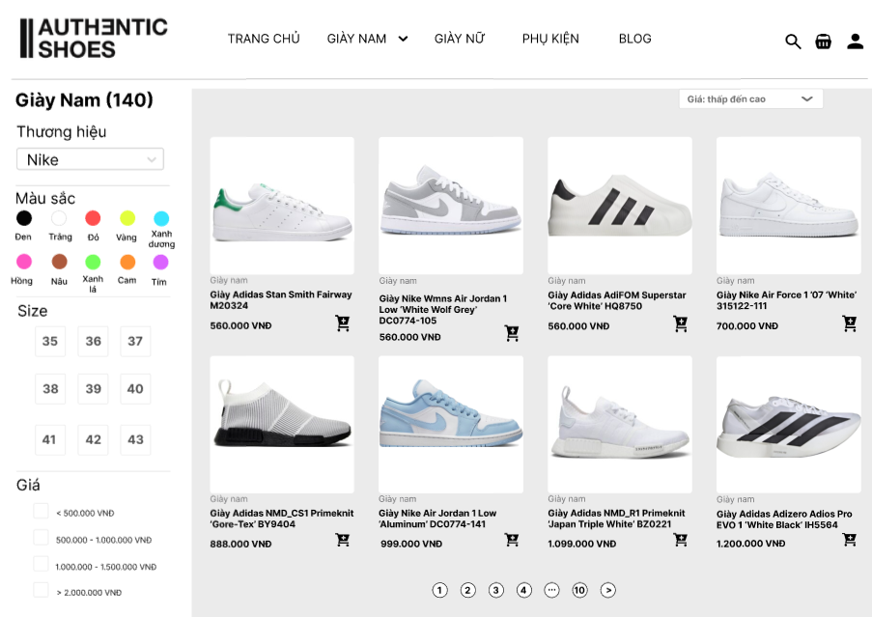

|  |  |  |  |  |  |
| --- | --- | --- | --- | --- | --- |
| **UC07: Browse Products** | | | | | |
| Goal in Context | | | This use case allows user to browse products by category. | | |
| Pre-Condition | | | None. | | |
| Post-Condition | | | The tool shall bring back data that is appropriate to the actor’s request. | | |
|  | | | | | |
| **Step** | **Subject** (Actor) | **Verb** (Event) | | **Object** (Entity) | **Response** |
| **Main Success Scenario** | | | | | |
| Pre-Condition | | None. | | | |
| 1. | User | Click | | Category in the header bar | Website displays the list of products along with their summary information. |
| 2. | User | Select | | Any Product | Website returns and displays the detailed information of the selected product on the screen. |

**3.1.8 UC08: Search and Filter**



|  |  |  |  |  |  |
| --- | --- | --- | --- | --- | --- |
| **UC08: Search and Filter** | | | | | |
| Goal in Context | | | This use case allows user to search and filter products by brand, colour, size, price as well as sort them by other criteria. | | |
| Pre-Condition | | | None. | | |
| Post-Condition | | | The tool shall bring back data that is appropriate to the actor’s request. | | |
|  | | | | | |
| **Step** | **Subject** (Actor) | **Verb** (Event) | | **Object** (Entity) | **Response** |
| **Main Success Scenario** | | | | | |
| Pre-Condition | | None. | | | |
| 1. | User | Select | | Brand combobox | Website returns and displays the list of products on the screen by brand. |
| 2. | User | Click | | Colour, Size box and “Price” checkbox | Website returns and displays the list of products on the screen by colour, size and price. |
| 3 | User | Select | | Sort combobox | Website returns and displays the list of products on the screen by criteria. |

**3.1.9 UC09: View Blog**

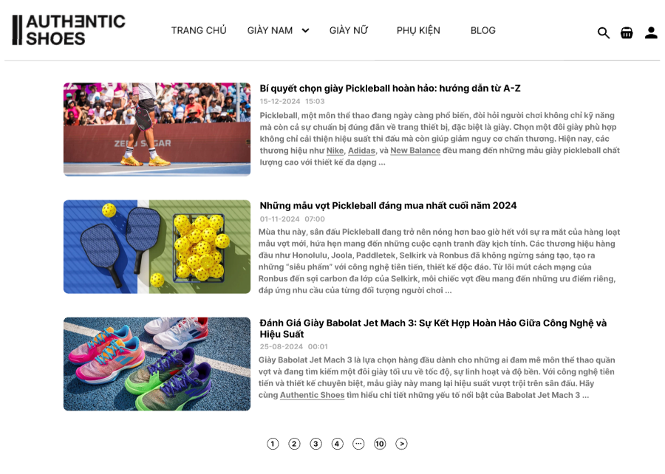

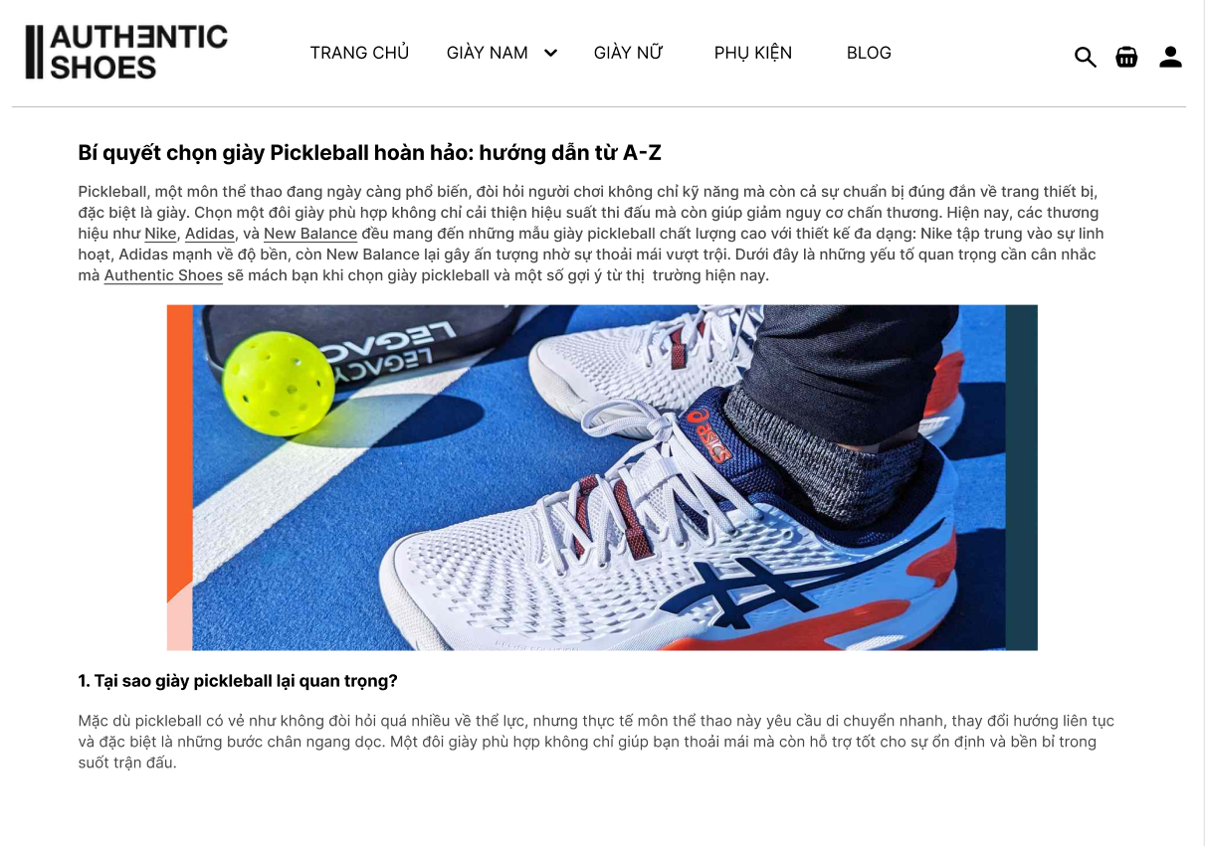

|  |  |  |  |  |  |
| --- | --- | --- | --- | --- | --- |
| **UC09: View Blog** | | | | | |
| Goal in Context | | | This use case allows the actor to view the list of all blogs.  They can select a blog from the list and view its details. | | |
| Pre-Condition | | | None | | |
| Post-Condition | | | The tool shall bring back data that is appropriate to the actor’s request | | |
|  | | | | | |
| **Step** | **Subject** (Actor) | **Verb** (Event) | | **Object** (Entity) | **Response** |
| **Main Success Scenario** | | | | | |
| Pre-Condition | | None. | | | |
| 1. | User | Click | | “Blog” in the Header bar | Website displays the blogs along with their summary information.  (see Figure 9a: View Blog List) |
| 2. | User | Select | | Any Blog | System returns and displays the detailed information of the selected article on the screen.  (see Figure 9b: View Blog Details) |

**3.1.10 UC10: Management Products**

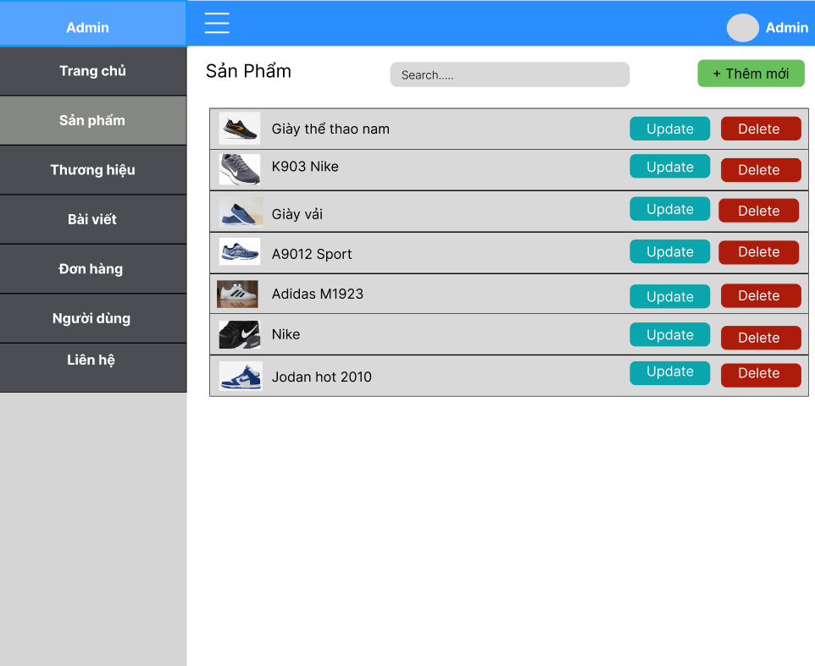

|  |  |  |  |  |  |
| --- | --- | --- | --- | --- | --- |
| **UC10: Management Product** | | | | | |
| Goal in Context | | | This use case allows the admin to view the list of all products. The admin can add a new product, update existing products, or delete products. | | |
| Pre-Condition | | | The admin must be successfully logged into the system. | | |
| Post-Condition | | | The system responds with data that matches the admin's requests. | | |
|  | | | | | |
| **Step** | **Subject** (Actor) | **Verb** (Event) | | **Object** (Entity) | **Response** |
| **Main Success Scenario** | | | | | |
| Pre-Condition | | The admin has successfully logged into the system. | | | |
| 1. | User | Select | | "Add New" Button on the Screen | The system displays the "Add New Product" screen. The admin enters the information and clicks the "Add Product" button to add a new product. |
| 2. | User | Click | | "Delete" Button | The product is removed from the website, and the product list is updated. |
| 3 | User | Select | | "Update" Button | The system displays the product update screen. The admin edits the information and clicks the "Update" button to save the changes. |

**3.1.11 UC11: Management Brands**

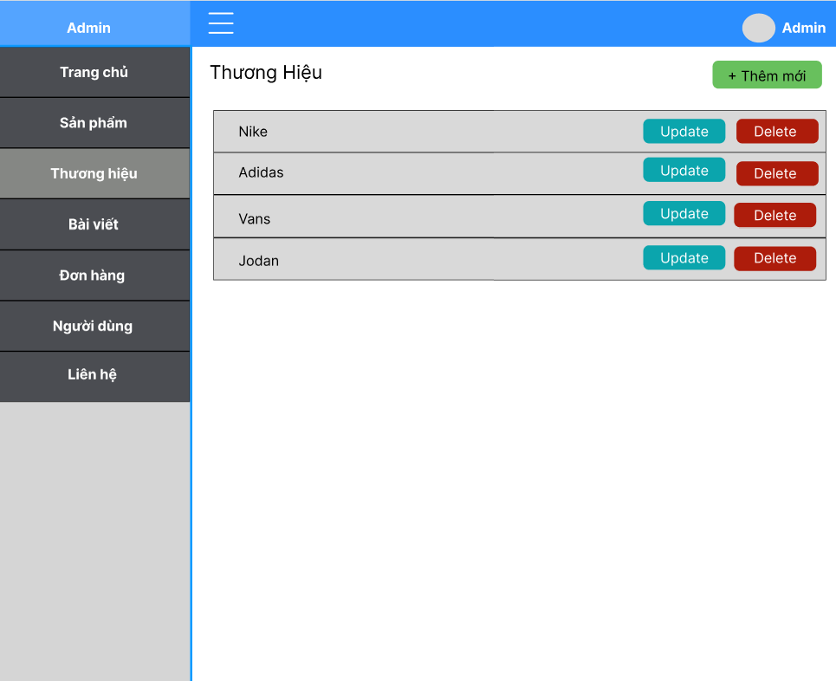

|  |  |  |  |  |  |
| --- | --- | --- | --- | --- | --- |
| **UC11: Management Brands** | | | | | |
| Goal in Context | | | This use case allows the admin to view the list of all brands. The admin can add a new brand, update an existing brand, or delete a brand. | | |
| Pre-Condition | | | The admin must be successfully logged into the system. | | |
| Post-Condition | | | The system responds with data that matches the admin's requests. | | |
|  | | | | | |
| **Step** | **Subject** (Actor) | **Verb** (Event) | | **Object** (Entity) | **Response** |
| **Main Success Scenario** | | | | | |
| Pre-Condition | | The admin has successfully logged into the system. | | | |
| 1. | User | Select | | "Add New" Button on the Screen | The system displays the "Add New Brand" screen. The admin enters the information and clicks the "Add Brand" button to add a new brand. |
| 2. | User | Click | | "Delete" Button | The brand is removed from the website, and the brand list is updated. |
| 3 | User | Select | | "Update" Button | The system displays the brand update screen. The admin edits the information and clicks the "Update" button to save the changes. |

**3.1.12 UC12: Management Orders**

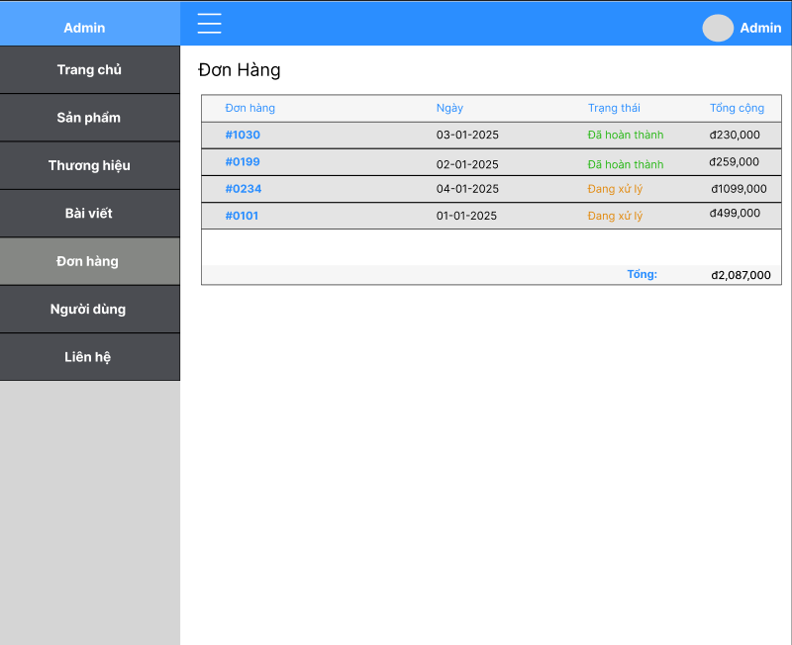

|  |  |  |  |  |  |
| --- | --- | --- | --- | --- | --- |
| **UC12: Management Orders** | | | | | |
| Goal in Context | | | This use case allows the admin to view the list of all orders. The admin can view the details of each order. | | |
| Pre-Condition | | | The admin must be successfully logged into the system. | | |
| Post-Condition | | | The system responds with data that matches the admin's requests. | | |
|  | | | | | |
| **Step** | **Subject** (Actor) | **Verb** (Event) | | **Object** (Entity) | **Response** |
| **Main Success Scenario** | | | | | |
| Pre-Condition | | The admin has successfully logged into the system. | | | |
| 1. | User | Click | | Any Order | The system displays the detailed information of that order. |
| 2. | User | Select | | “Status” combobox | The system updates status into database and displays status after update. |

**3.1.13 UC13: Management Blogs**

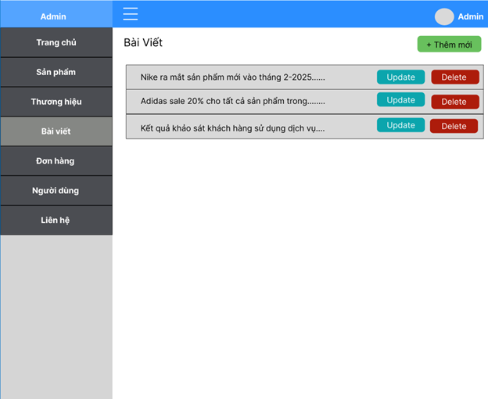

|  |  |  |  |  |  |
| --- | --- | --- | --- | --- | --- |
| **UC13: Management Blogs** | | | | | |
| Goal in Context | | | This use case allows the admin to view the list of all articles. The admin can add a new article, update an existing article, or delete an article. | | |
| Pre-Condition | | | The admin must be successfully logged into the system. | | |
| Post-Condition | | | The system responds with data that matches the admin's requests. | | |
|  | | | | | |
| **Step** | **Subject** (Actor) | **Verb** (Event) | | **Object** (Entity) | **Response** |
| **Main Success Scenario** | | | | | |
| Pre-Condition | | The admin has successfully logged into the system. | | | |
| 1. | User | Select | | "Add New" Button on the Screen | The system displays the "Add New Article" screen. The admin enters the information and clicks the "Add Article" button to add a new article. |
| 2. | User | Click | | "Delete" Button | The system displays the "Add New Article" screen. The admin enters the information and clicks the "Add Article" button to add a new article. |
| 3 | User | Select | | "Update" Button | The system displays the article update screen. The admin edits the information and clicks the "Update" button to save the changes. |

**3.1.14 UC14: Management Users**

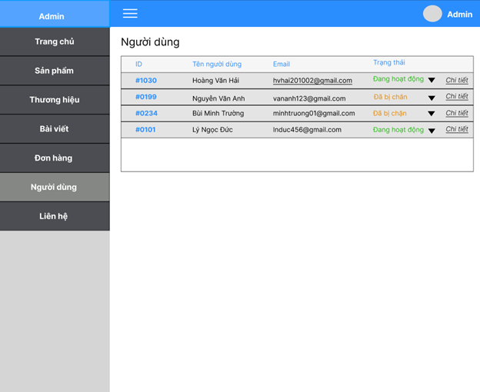

|  |  |  |  |  |  |
| --- | --- | --- | --- | --- | --- |
| **UC14: Management Users** | | | | | |
| Goal in Context | | | This use case allows the admin to view the list of all users. The admin can update the status of users and view detailed user information. | | |
| Pre-Condition | | | The admin must be successfully logged into the system. | | |
| Post-Condition | | | The system responds with data that matches the admin's requests. | | |
|  | | | | | |
| **Step** | **Subject** (Actor) | **Verb** (Event) | | **Object** (Entity) | **Response** |
| **Main Success Scenario** | | | | | |
| Pre-Condition | | The admin has successfully logged into the system. | | | |
| 1. | User | Select | | Triangle Button on the Desired User | The system displays the status for the admin to select. |
| 2. | User | Click | | "Details" Button | The system displays the detailed information of the selected user. |

**3.1.15 UC15: Authenticate User**

As the first task of running ShoesStore Website Application, system checks for the existing of user account, which is used to log in to operation system, in Active Directory.

System displays a message box “You do not have permission to use this application.” in any case of following:

* Account does not exist in Active Directory
* Account does exist but it has not assigned to any role belonging to ShoesStore Website Application. Otherwise, system displays main form with menu items based on the role assigned to user account.

## Data field valid conditions

|  |  |  |  |  |  |
| --- | --- | --- | --- | --- | --- |
| # | Field Name | Mandatory | Type | Condition | Error message |
| 1 | Full name | Y | Text | Max length is 128 |  |
| Value should not be empty | “Full name should not be empty.” |
| 2 | Avatar image | Y | File | Max size is 128KB |  |
| 3 | Phone number | Y | Text | Max length is 10 | “The phone number must not exceed 10 characters.” |
| Value should not be empty | “Phone number should not be empty.” |
| 4 | Address | Y | Text | Max length is 500 |  |
| Value should not be empty | “Address should not be empty.” |
| 5 | Quantity | Y | Number | Value > 0 | “Quantity can not be negative” |
| Value should not be empty | “Quantity should not be empty.” |
| 6 | Size | Y | Checkbox | Checkbox not empty | “Checkbox not empty” |
| 7 | Star Icon | Y | Checkbox | Checkbox not empty | “Checkbox not empty” |
| 8 | Your feedback | Y | Text | Max length is 500 |  |
| Value should not be empty | “Your feedback should not be empty.” |
| 9 | Fullname | Y | Text | Max length is 128 |  |
| Value should not be empty | “Fullname should not be empty.” |
| 10 | Phone number | Y | Text | Max length is 10 | “Phone not exceed 10 characters” |
| Value should not be empty | “Phone number should not be empty.” |
| 11 | Email | Y | Text | Include “@” and “.com” | “Email must include “@” and “.com”. Please input again!“ |
| Value should not be empty | “Email should not be empty.” |
| 12 | Address ship | Y | Text | Max length is 500 |  |
| Value should not be empty | “Address ship should not be empty.” |
| 13 | Place order note | N | Text | Max length is 500 |  |
| 14 | Payment method | Y | Checkbox | Checkbox not empty | “Checkbox not empty” |

# Non Functional Specification

## Usability

#### Look and feel

The user interface (UI) design will follow a prototype layout that includes the following guidelines:

* The system must conform to the standard look and feel of modern e-commerce websites, ensuring a clean, visually appealing, and user-friendly interface.
* Consistency in design elements, such as color schemes, fonts, and button styles, must be maintained throughout the site to enhance the user experience.

#### Screen Styles

Screen styles refer to the layout and structure of the user interface across different pages of the website. The following requirements apply:

* The style should be consistent across all pages (product pages, checkout, shopping cart, etc.).
* The design must be responsive, adapting to various screen sizes, from mobile phones to desktop computers.

## Reliability

End-user's screens must display suitable user-friendly error message (stack dump should not be displayed)

## Error handling

The website should display clear, user-friendly error messages in case of issues (e.g., invalid input, out-of-stock items). Technical errors (e.g., stack dumps) should never be shown to end users. Examples include:

* “Please check your payment details and try again.”
* “This item is currently out of stock.”

## Availability

• **Uptime:** The website should maintain a minimum uptime of 99.9% monthly, ensuring that it is almost always accessible to users.

• **Disaster Recovery:** The system must have backup and recovery procedures in place, aiming to restore functionality within 30 minutes in case of critical failures.

## System Dependencies

**Database Back-end:** The website will use **MS SQL Server 2022** for storing product details, customer data, and order information.

## **Bugs** and Defect **Rates**

No specific requirements have been stated. The defect rate objectives can be derived from standards and norms of HVN SDC quality management system.

The severity levels for bugs will be defined as follows:

|  |  |  |  |
| --- | --- | --- | --- |
| No | Bug severity | Weighted value | Description |
| 1 | Critical | 10 | Major functionality or a core system component is completely broken. No workaround is available, and testing cannot proceed. |
| 2 | High | 5 | Key functionality or system component does not work, is broken, or is incorrectly documented. |
| 3 | Medium | 3 | Minor functionality issues, such as misbehaving or incorrectly documented features. |
| 4 | Cosmetic | 1 | Cosmetic issues, like visual imperfections, that do not affect the core functionality. |

Defect rate is measured per Weighted defect / Use case point (in short form: Wdef / UCP). One use case point is 20 person-days.

SDC norm of defect rate is 5.5 wdef / UCP.

## Performance

### Response time

• **Page Load Time:** The website must load the main pages (e.g., homepage, product pages, checkout) within **3 seconds**.

• **User Actions:** Actions such as adding products to the cart or updating quantities should respond in less than **1 second**.

### Throughput

**Concurrent Users:** The website should be able to handle a minimum of **500 concurrent users** browsing and making purchases without noticeable slowdowns or downtime.

### Volume

**Data Handling:** The website should be capable of managing at least **5 years of product data**, including images, prices, and stock levels. It should also handle **10,000+ products** and **up to 100,000 customer records**.

**Users:** The website should be designed to support **5 to 10 active administrators** and **thousands of potential customers** at any given time.

## Supportability

#### 4.4.1 Maintainability

* **Ease of Updates:** All predefined values, such as product categories, sizes, and dropdown values, must be easy to maintain. Admins should be able to add, update, or remove products and values quickly through the content management system (CMS).
* **Content Management System:** The backend CMS should be user-friendly, enabling staff to update product listings, promotions, and inventory without technical expertise.

#### 4.4.2 Error Log

* **Logging:** All error logs and system events must include a standard timestamp format (e.g., **YYYY-MM-DD HH:MM:SS**) for easy tracking and debugging.
* **Security Logs:** Security events, such as login attempts and payment errors, must also be logged with appropriate severity and timestamp information.