

**TTTK 1143 REKABENTUK ATURCARA & PENYELESAIAN MASALAH**

Year 1 Semester 2 Session 2019/2020

**ASSIGNMENT 02:**

 DATA STRUCTURE: “*dits-dahs*”

|  |  |
| --- | --- |
| **STUDENT NAME:** | MELANIE NG JIUN MAY |
| **MATRIC NUMBER:** | A176426 |
| **LAB GROUP:** | LAB GROUP 1 / WEDNESDAY / 8AM – 10AM |
| **LECTURER:** | DR. SYAHANIM BT. MOHD SALLEH |

**TABLE OF CONTENTS**

|  |  |  |
| --- | --- | --- |
| **INDEX** | **CONTENTS** | **PAGE** |
| **1.** | Front Cover | 1 |
| **2.** | Table of Contents | 2 |
| **3.** | Introduction | 3 |
| **4.** | Data Structures | 4 |
| **5.** | Structure of Morse Code | 5 |
| **6.** | Classes | 6 |
| **7.** | Algorithm | 7 – 8 |
| 1. Main Method | 7 |
| 1. Encode Method | 7 |
| 1. Decode Method | 8 |
| 1. Display All Letters and Morse Codes | 8 |
| **8.** | Assumptions | 9 |
| **9.** | Input – Output | 10 – 12 |
| **10.** | Conclusion | 13 |

**INTRODUCTION**

In this assignment, we are required to code a program that will print out a menu which will be the option for 3 processes which ascending, receiving and display all letters and Morse code. We are required to code the program by making use of the knowledge on data structures. For menu options 1 and 2, users are required to input a string of message or lines so that the program will be able to translate the code from English or words, to morse code.

The message input must start with “VV” or “…- …-“ and it must end with “EOM” or “. --- --“. After this input, the program will encode or decode the message and will make a summary of the whole input. The summary consists of the total number of lines in the message including “VV” and “EOM”, the number of words, the number of alphabets, the number of symbols, the number of numbers which are Arabic numbers which will all include “VV” or “…- …-“ and “EOM” or “. --- --“. The data for the summary will also be converted into morse code for menu option 1. After the summary, a marker which is “EOT” must be printed to indicate the end of the summary part.

The third part requires the program to print all letters and their relevant morse code. It is in the inorder form. The printed data will be required to have only 5 in a row. While conducting this assignment, I have made assumptions of the program as well in order to enhance my program.

**DATA STRUCTURES**

In this assignment, we are required to code the program using the data structures knowledge. There are a few data structures that I had used while coding this program. The data structures that I had used in my code are Binary Search Tree, and List.

I had used **Binary Search Tree**, as it utilises the left child and right child which are dits and dahs respectively and the current node or root which is blank. The binary search tree method is used in the decode method for option 2, encode method for option 1 and also the inorder traversal method for option 3. If the morse code of a letter or character starts with “.” or dits, it will travel to the left of the tree, and if it starts with “-“ or dahs it will travel to the right of the tree. Following from there, if it is again dits, “.” it will traverse down left of the tree and dahs, “-“ will traverse down right of the tree. This is how I programmed it to read the morse code.

Next, in this assignment, I had also used **List**. List is like a collection of elements which are stored in insertion order. It is the base interface for list types like ArrayList and LinkedList. In this assignment, I used the base interface which is List. For the 1st option which is encoding, when a user inputs a message, the program will encode their input then store it in the List. I used iterator in order to print out the elements in the List. This is also similar for menu option 2, when a user inputs morse codes into the program, the program will decode the message then store it in the List. To print out the messages which had been decoded, an iterator is used to print out all element in the List.

**STRUCTURE OF MORSE CODE**

Each of the left child will be *dits*, “.” and each of the right child will be *dahs*, “-“. For example, the letter A in morse code is “.-“ which means it goes to the left first before going right, hence the code is “.-“. The structure of the morse code after executing the code is shown below in Figure 1. The root is left blank so when it is a space, “ “ there is no code. The other remaining nodes in the tree shown in Figure 1 is left blank as it is preoccupied by different and various characters which is not used in this assignment which are **Ü (..--),** and **Ɖ (..--.)** .

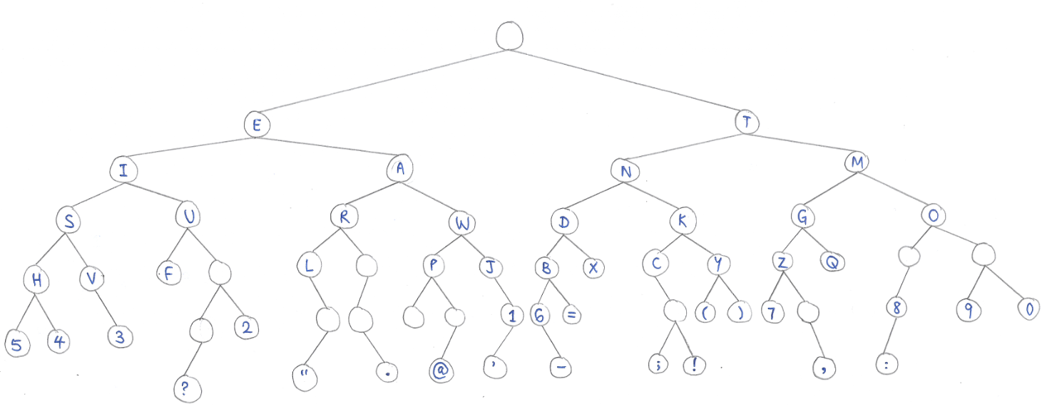

**Figure 1:** The structure of the morse code in a Binary Tree diagram.

**CLASSES**

In this assignment, I have created 3 classes altogether for my code. The first class is A176426_DitsDahs1. In this class, there are methods included example for reading an input file which contains the characters or letters and their respective morse codes (readMorseCode()), the method to decode a morse code message (decode()), method to print inorder traversal of the characters and morse codes(inorder()), and method for user to input string which is either morse codes or messages(inputString()). There is also a method to insert the characters and morse codes into the tree that was read from the input file. The method is insertInto().

The next class is A176426_DitsDahs2. It contains the class for the node which will be used to in relation to DitsDahs1 methods like decode and encode method. The attributes are char chr, and left and right to represent the left child or left side of tree and the right child or right side of tree. It is to contain data of each node like the root or current node, left child node and the right child node. The exact values are not stated in this class DitsDahs2 but the method is stated such as getLeftnode(), setLetfnode(), getRightnode(), and setRightnode().

The next class is the main class for the program which is A176426_DitsDahsMain. In this class, contains the method Menu(), to call the menu options whenever a option from the menu is selected. In this main class, users will be prompted input for number after running the code. If the user input 1, the user will have to input their message into the console to encode it to morse code. If the user input 2, they have to input their morse code message into the console to decode it to letters. If 3 is selected, then the program will print out the inorder traversal of the morse code tree. Option 4 is to exit the program. For options 1, 2, and 3, once the outputs are generated, the program will continue and prompt users to choose an option either 4 or 1-3 again. However, in option 4, once this is selected, the program is terminated and the user will have to run it again.

**ALGORITHM**

1. **MAIN METHOD**

In this main method the algorithm is as follows:-

1. When an integer is seen, the program reads the input.
2. If the program prompts for an integer, but the input is not an integer, the program will display a message “Wrong Input Format. Only numbers, please run the program again.”
3. If a number that is not between the range 1-4 has been input, the console will display message “Choose 1-4 only. Please run the program again.”
4. If 1 is selected, program prompts user to input message which calls the inputString() method. Encoded messages are added into the List. Then, when “EOM” is detected by the program, it stops and prints out the List. The program shows the menu and prompts user for input.
5. If 2 is selected, program prompts user to input message. The program does nothing if users input letters instead of morse code. While users input messages, the decode() method is called and is added to the List. An iterator is used to print the elements in the List after “. --- -“ (EOT) is detected. The program shows the menu and prompts user for input.
6. If 3 is selected, the inorder() method is called. The program shows the menu and prompts user for input.
7. If 4 is called, the program prints “Bye dits-dahs..” and the program is terminated.
8. **ENCODE METHOD**

In this main method the algorithm is as follows:-

1. When a String of message is detected, it is converted to Char.
2. The program compares the letter in charac1 to the array charac, if it is the same, the program adds the encoded message into the List.
3. When the String “EOM” or “eom” is detected, the program prints the elements in the List which are encoded messages using iterator.
4. **DECODE METHOD**

In this main method the algorithm is as follows:-

1. When String of morse code is detected, the decode() method is called.
2. The decoder checks if the operand is “.” or “-“ or “ “.
3. If “ “, that is the root and it is returned.
4. If “.”, it traverses the left side of tree. If it is not null, then the left child node is returned. If it is null, it will set the node as the left child node and returns it.
5. If “-“, it traverses the right side of tree. If it is not null, then the right child node is returned. If it is null, it will set the node as the right child node and returns it.
6. The result is returned.
7. The input are translated into letters and the result is added into the List.
8. When the input “. --- -“ (EOT) is detected, the program prints the List using the iterator.
9. The iterator checks if there still an element with the method hasNext() then assigns String mo to the next element by using method it.next() and then prints it.
10. **DISPLAY ALL LETTERS AND MORSE CODE**

In this main method the algorithm is as follows:-

1. The program reads the file from the method readMorseCode().
2. The characters and the morse codes are inserted into the tree.
3. If the node is null, then it is returned. The node is current node.
4. The inorderMethod() is called to traverse or visit the left subtree.
5. The program prints the value of the node visited.
6. The inorderMethod() is called to traverse or visit the right subtree.

**ASSUMPTIONS**

In this assignment, there are several assumptions made when designing the program code. First of all, I assumed that the file which contains the characters to morse code translation is named “A176426_File2.dat”. If a user uses a different file, then that user will have to change the name of the file. If a user tries to run the code using a different file that what was stated in the ReadFile method, the system will pop up this message, "The file is not found. Make sure it is A176426_File2.dat, not any other files." in the console.

The second assumption made by me when carrying out this assignment is, the user is immediately prompted to input a number after running the code. Since in the given example output there is no menu stated in the first part of the code, I assumed that users might not know what to do after executing the code. If the user does not know that input in the form of a number is required, then the message, ”Wrong Input Format. Only numbers, please run the program again.” will appear in the console and the users will have to run the code again. So, users will know what to input.

The next assumption made is, the user know that they must input a number, however they do not know the range of acceptable number. The menu is has only 1 to 4 as available options. So, if a user inputs a number out of the 1 to 4 range, then the message, "Choose 1-4 only. Please run the program again." will appear on the console, and the program will be terminated. Users will have to run the program again to proceed further.

Other than that, another assumption that I have made is, when a user chooses the option number 4, which is to exit, the message, "Bye dits-dahs.." will appear on the console. The program will then be terminated. The user will have to run the program again to translate a new batch of message, sentences or morse codes.

**INPUT-OUTPUT**

**Part 1 of the input-output.**

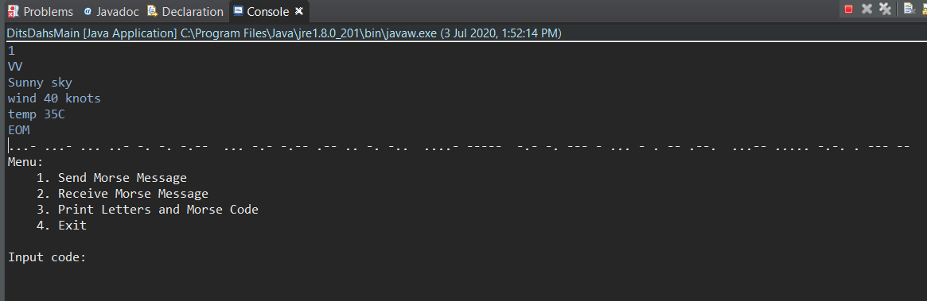

**Figure 2:** Output when user choose the 1st option.

**Part 2 of the input-output.**

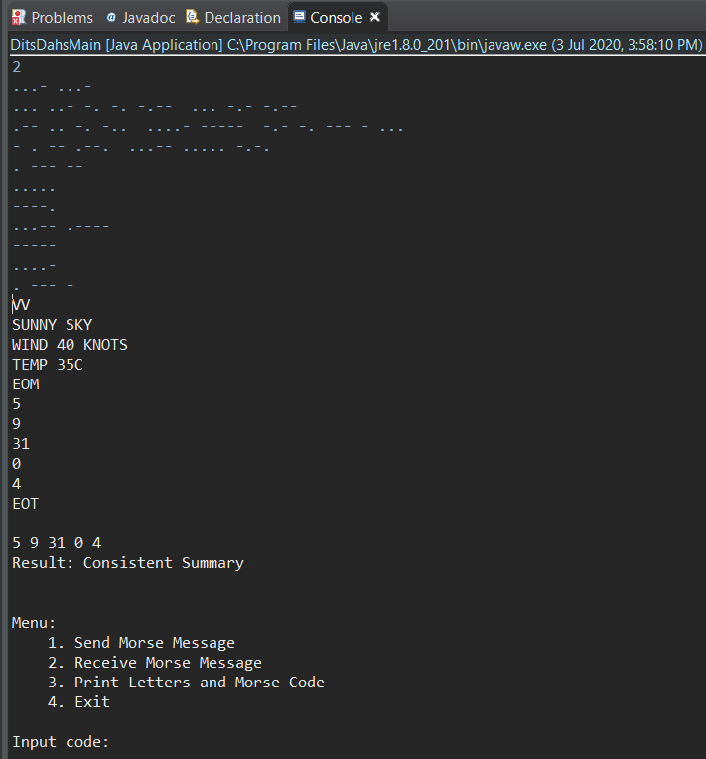

**Figure 3:** Output when user choose the 2nd option.

**Part 3 of the input-output.**

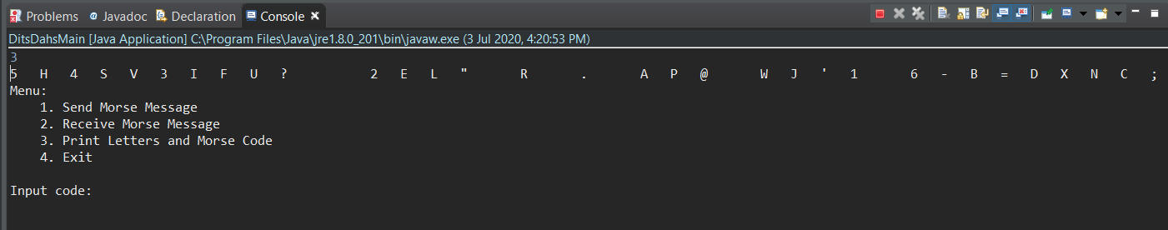

**Figure 4:** Output when user choose the 3rd option.

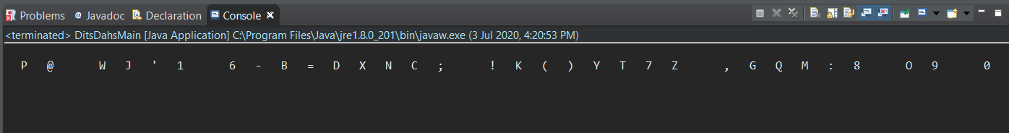

**Figure 5:** Continuous from Figure 4 the output when user choose the 3rd option.

**Part 4 of the input-output.**

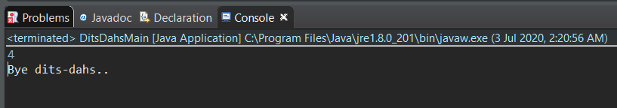

**Figure 6:** Output when user choose the 4th option.

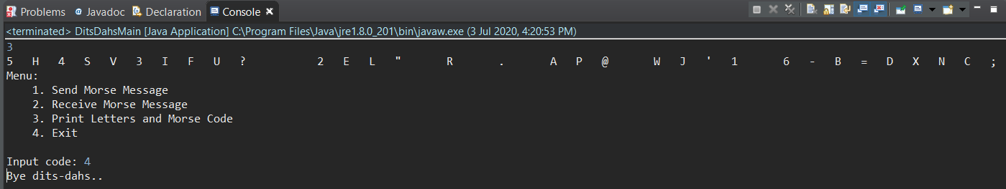

**Figure 7:** Output when user chose the 3rd option then chose the 4th option.

**Part 5 of the input-output.**

Input and output when a user input alphabets instead of the Menu number.

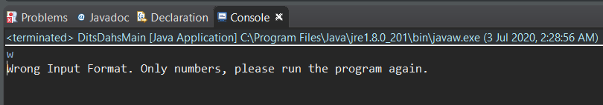

**Figure 8:** Output when user input a letter instead of a number in the first part of the program.

Input and output when a user inputs a number that is not within the 1 to 4 Menu range.

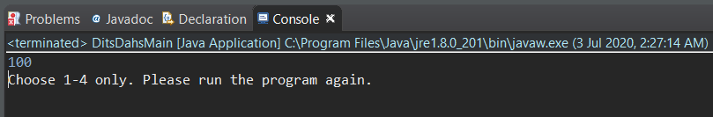

**Figure 9:** Output when user input a number which is out of range.

Input and output when the file is not the accurate file stated in the method.

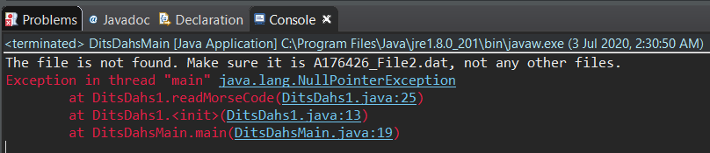

**Figure 10:** Output when the user’s file is not aligned with the one stated in the method.

**CONCLUSION**

In conclusion, I had learnt how to make use of data structures in Java programming and utilise them to enhance my code instead of using basic operations. In this assignment, although there are outputs for my program and it shows the correct morse code for each letters and characters, the output is not the exact same as the sample output given. The same goes for the menu option 3, which we are required to print out an inorder of the whole morse code data and letters. My program is able to give the correct output however, it does not follow the same output format as given in the sample output.

I had learned that even if there is shortcomings and a not accurate presentation of the outputs, I had managed to utilise my knowledge on data structures which helped me to be able to complete my assignment and task on time. Also, there are many other different data structures which we can use like Stack, Queue and Graph. For my assignment, I chose to use List and Binary Search Tree.