DEMO Script

Concentration on Communication, Synchronization, and Cryptography.

# Demo of Reliable Communication Provement.

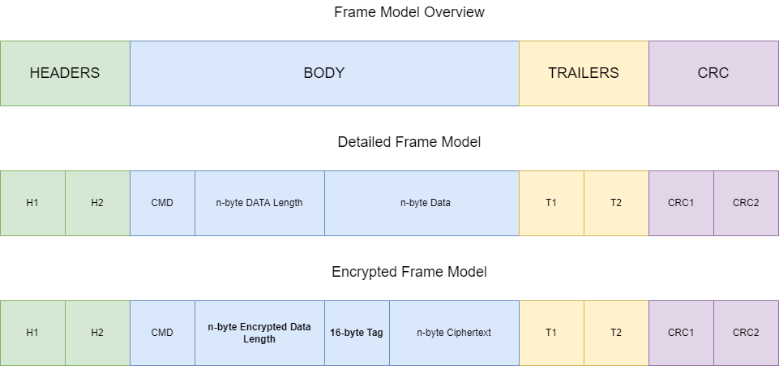

## Frame Parsing (150 ms Gateway / 15 ms Server)

* Header Parsing.
* Trailer Parsing.
* Cyclic Redundancy Check (CRC).

## Process of Poly1305 Algorithm (200 us Gateway / 11 ms Server)

* Tag Comparision.

# DEMO of ERROR DETECTION.

# Notes

## 28-07-2023: error detections in Data Link Layer

* Single parity bit
* Internet Checksum
* CRC