Given the root of a binary tree, *check whether it is a mirror of itself* (i.e., symmetric around its center).

**Example 1:**

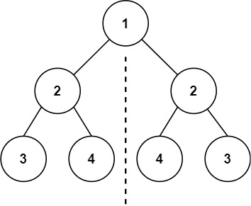

Input: root = [1,2,2,3,4,4,3]  
Output: true

**Example 2:**

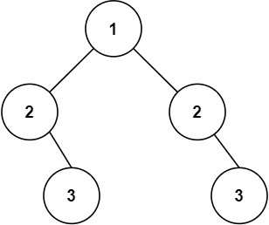

Input: root = [1,2,2,null,3,null,3]  
Output: false

**Constraints:**

* The number of nodes in the tree is in the range [1, 1000].
* -100 <= Node.val <= 100

**Follow up:** Could you solve it both recursively and iteratively?