You are given an m x n binary matrix grid, where 0 represents a sea cell and 1 represents a land cell.

A **move** consists of walking from one land cell to another adjacent (**4-directionally**) land cell or walking off the boundary of the grid.

Return *the number of land cells in* grid *for which we cannot walk off the boundary of the grid in any number of* ***moves***.

**Example 1:**

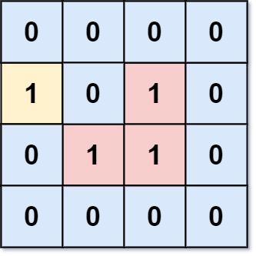

Input: grid = [[0,0,0,0],[1,0,1,0],[0,1,1,0],[0,0,0,0]]  
Output: 3  
Explanation: There are three 1s that are enclosed by 0s, and one 1 that is not enclosed because its on the boundary.

**Example 2:**

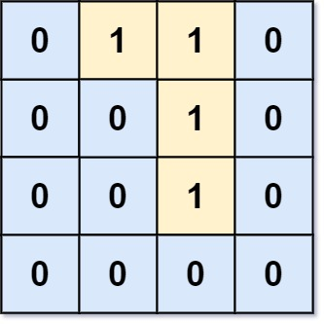

Input: grid = [[0,1,1,0],[0,0,1,0],[0,0,1,0],[0,0,0,0]]  
Output: 0  
Explanation: All 1s are either on the boundary or can reach the boundary.

**Constraints:**

* m == grid.length
* n == grid[i].length
* 1 <= m, n <= 500
* grid[i][j] is either 0 or 1.