Given the head of a singly linked list where elements are sorted in **ascending order**, convert *it to a*

***height-balanced***

*binary search tree*.

**Example 1:**

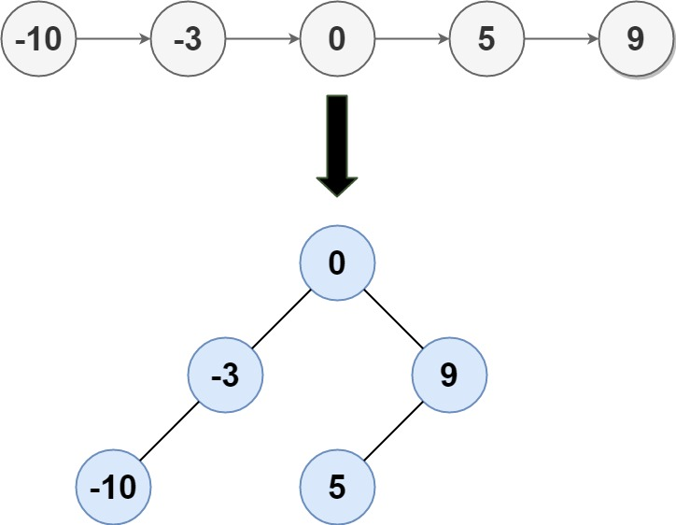

Input: head = [-10,-3,0,5,9]  
Output: [0,-3,9,-10,null,5]  
Explanation: One possible answer is [0,-3,9,-10,null,5], which represents the shown height balanced BST.

**Example 2:**

Input: head = []  
Output: []

**Constraints:**

* The number of nodes in head is in the range [0, 2 * 104].
* -105 <= Node.val <= 105