Given the root of a binary tree and an integer targetSum, return *all* ***root-to-leaf*** *paths where the sum of the node values in the path equals* targetSum*. Each path should be returned as a list of the node* ***values****, not node references*.

A **root-to-leaf** path is a path starting from the root and ending at any leaf node. A **leaf** is a node with no children.

**Example 1:**

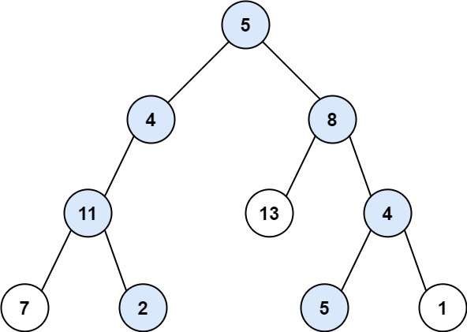

Input: root = [5,4,8,11,null,13,4,7,2,null,null,5,1], targetSum = 22  
Output: [[5,4,11,2],[5,8,4,5]]  
Explanation: There are two paths whose sum equals targetSum:  
5 + 4 + 11 + 2 = 22  
5 + 8 + 4 + 5 = 22

**Example 2:**

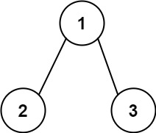

Input: root = [1,2,3], targetSum = 5  
Output: []

**Example 3:**

Input: root = [1,2], targetSum = 0  
Output: []

**Constraints:**

* The number of nodes in the tree is in the range [0, 5000].
* -1000 <= Node.val <= 1000
* -1000 <= targetSum <= 1000