Given the root of a binary tree, flatten the tree into a "linked list":

* The "linked list" should use the same TreeNode class where the right child pointer points to the next node in the list and the left child pointer is always null.
* The "linked list" should be in the same order as a [**pre-order** **traversal**](https://en.wikipedia.org/wiki/Tree_traversal#Pre-order,_NLR) of the binary tree.

**Example 1:**

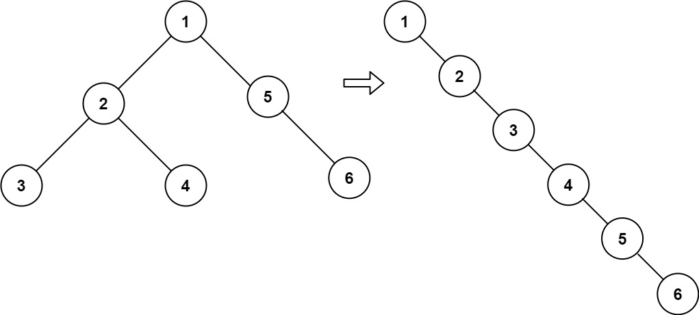

Input: root = [1,2,5,3,4,null,6]  
Output: [1,null,2,null,3,null,4,null,5,null,6]

**Example 2:**

Input: root = []  
Output: []

**Example 3:**

Input: root = [0]  
Output: [0]

**Constraints:**

* The number of nodes in the tree is in the range [0, 2000].
* -100 <= Node.val <= 100

**Follow up:** Can you flatten the tree in-place (with O(1) extra space)?