In an **infinite** chess board with coordinates from -infinity to +infinity, you have a **knight** at square [0, 0].

A knight has 8 possible moves it can make, as illustrated below. Each move is two squares in a cardinal direction, then one square in an orthogonal direction.

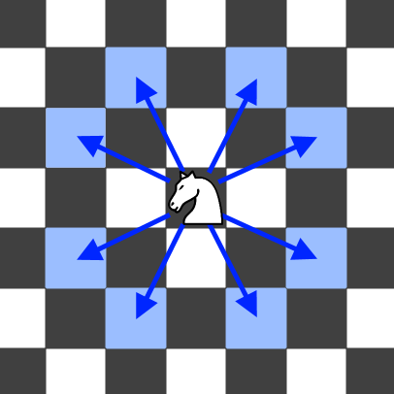

Return *the minimum number of steps needed to move the knight to the square* [x, y]. It is guaranteed the answer exists.

**Example 1:**

Input: x = 2, y = 1  
Output: 1  
Explanation: [0, 0] → [2, 1]

**Example 2:**

Input: x = 5, y = 5  
Output: 4  
Explanation: [0, 0] → [2, 1] → [4, 2] → [3, 4] → [5, 5]

**Constraints:**

* -300 <= x, y <= 300
* 0 <= |x| + |y| <= 300