A **path** in a binary tree is a sequence of nodes where each pair of adjacent nodes in the sequence has an edge connecting them. A node can only appear in the sequence **at most once**. Note that the path does not need to pass through the root.

The **path sum** of a path is the sum of the node's values in the path.

Given the root of a binary tree, return *the maximum* ***path sum*** *of any* ***non-empty*** *path*.

**Example 1:**

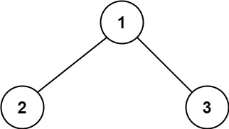

Input: root = [1,2,3]  
Output: 6  
Explanation: The optimal path is 2 -> 1 -> 3 with a path sum of 2 + 1 + 3 = 6.

**Example 2:**

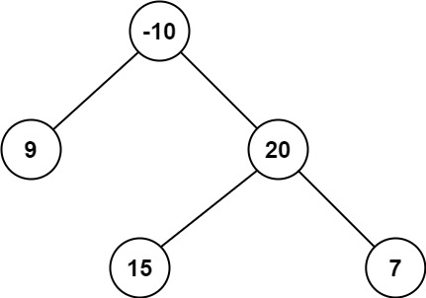

Input: root = [-10,9,20,null,null,15,7]  
Output: 42  
Explanation: The optimal path is 15 -> 20 -> 7 with a path sum of 15 + 20 + 7 = 42.

**Constraints:**

* The number of nodes in the tree is in the range [1, 3 * 104].
* -1000 <= Node.val <= 1000