**Tic-tac-toe** is played by two players A and B on a 3 x 3 grid. The rules of Tic-Tac-Toe are:

* Players take turns placing characters into empty squares ' '.
* The first player A always places 'X' characters, while the second player B always places 'O' characters.
* 'X' and 'O' characters are always placed into empty squares, never on filled ones.
* The game ends when there are **three** of the same (non-empty) character filling any row, column, or diagonal.
* The game also ends if all squares are non-empty.
* No more moves can be played if the game is over.

Given a 2D integer array moves where moves[i] = [rowi, coli] indicates that the ith move will be played on grid[rowi][coli]. return *the winner of the game if it exists* (A or B). In case the game ends in a draw return "Draw". If there are still movements to play return "Pending".

You can assume that moves is valid (i.e., it follows the rules of **Tic-Tac-Toe**), the grid is initially empty, and A will play first.

**Example 1:**

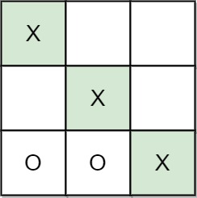

Input: moves = [[0,0],[2,0],[1,1],[2,1],[2,2]]  
Output: "A"  
Explanation: A wins, they always play first.

**Example 2:**

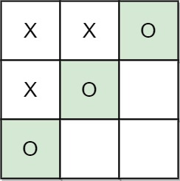

Input: moves = [[0,0],[1,1],[0,1],[0,2],[1,0],[2,0]]  
Output: "B"  
Explanation: B wins.

**Example 3:**

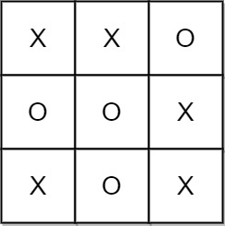

Input: moves = [[0,0],[1,1],[2,0],[1,0],[1,2],[2,1],[0,1],[0,2],[2,2]]  
Output: "Draw"  
Explanation: The game ends in a draw since there are no moves to make.

**Constraints:**

* 1 <= moves.length <= 9
* moves[i].length == 2
* 0 <= rowi, coli <= 2
* There are no repeated elements on moves.
* moves follow the rules of tic tac toe.