You are given an m x n integer matrix grid where each cell is either 0 (empty) or 1 (obstacle). You can move up, down, left, or right from and to an empty cell in **one step**.

Return *the minimum number of* ***steps*** *to walk from the upper left corner* (0, 0) *to the lower right corner* (m - 1, n - 1) *given that you can eliminate* ***at most*** k *obstacles*. If it is not possible to find such walk return -1.

**Example 1:**

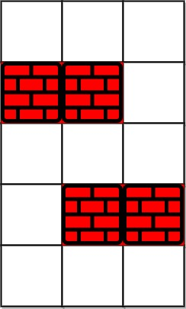

Input: grid = [[0,0,0],[1,1,0],[0,0,0],[0,1,1],[0,0,0]], k = 1  
Output: 6  
Explanation:   
The shortest path without eliminating any obstacle is 10.  
The shortest path with one obstacle elimination at position (3,2) is 6. Such path is (0,0) -> (0,1) -> (0,2) -> (1,2) -> (2,2) -> (3,2) -> (4,2).

**Example 2:**

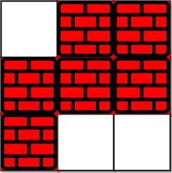

Input: grid = [[0,1,1],[1,1,1],[1,0,0]], k = 1  
Output: -1  
Explanation: We need to eliminate at least two obstacles to find such a walk.

**Constraints:**

* m == grid.length
* n == grid[i].length
* 1 <= m, n <= 40
* 1 <= k <= m * n
* grid[i][j] is either 0 **or** 1.
* grid[0][0] == grid[m - 1][n - 1] == 0