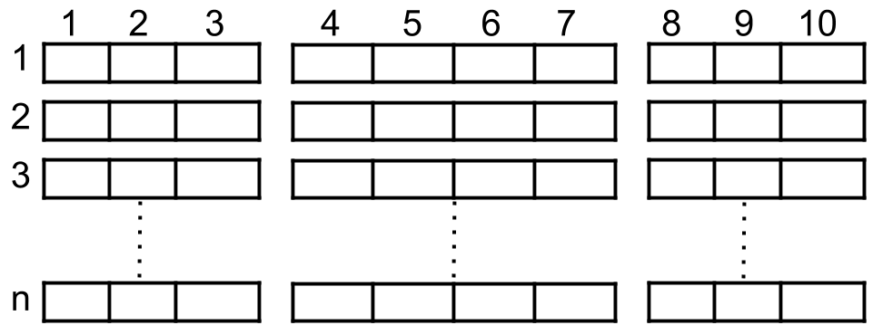

A cinema has n rows of seats, numbered from 1 to n and there are ten seats in each row, labelled from 1 to 10 as shown in the figure above.

Given the array reservedSeats containing the numbers of seats already reserved, for example, reservedSeats[i] = [3,8] means the seat located in row **3** and labelled with **8** is already reserved.

*Return the maximum number of four-person groups you can assign on the cinema seats.* A four-person group occupies four adjacent seats **in one single row**. Seats across an aisle (such as [3,3] and [3,4]) are not considered to be adjacent, but there is an exceptional case on which an aisle split a four-person group, in that case, the aisle split a four-person group in the middle, which means to have two people on each side.

**Example 1:**

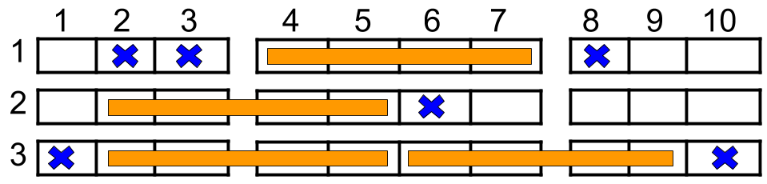

Input: n = 3, reservedSeats = [[1,2],[1,3],[1,8],[2,6],[3,1],[3,10]]  
Output: 4  
Explanation: The figure above shows the optimal allocation for four groups, where seats mark with blue are already reserved and contiguous seats mark with orange are for one group.

**Example 2:**

Input: n = 2, reservedSeats = [[2,1],[1,8],[2,6]]  
Output: 2

**Example 3:**

Input: n = 4, reservedSeats = [[4,3],[1,4],[4,6],[1,7]]  
Output: 4

**Constraints:**

* 1 <= n <= 10^9
* 1 <= reservedSeats.length <= min(10*n, 10^4)
* reservedSeats[i].length == 2
* 1 <= reservedSeats[i][0] <= n
* 1 <= reservedSeats[i][1] <= 10
* All reservedSeats[i] are distinct.