You are given three integers n, m and k. Consider the following algorithm to find the maximum element of an array of positive integers:

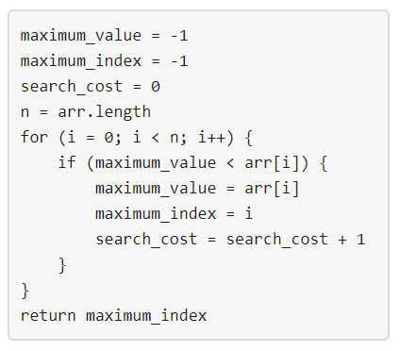

You should build the array arr which has the following properties:

* arr has exactly n integers.
* 1 <= arr[i] <= m where (0 <= i < n).
* After applying the mentioned algorithm to arr, the value search_cost is equal to k.

Return *the number of ways* to build the array arr under the mentioned conditions. As the answer may grow large, the answer **must be** computed modulo 109 + 7.

**Example 1:**

Input: n = 2, m = 3, k = 1  
Output: 6  
Explanation: The possible arrays are [1, 1], [2, 1], [2, 2], [3, 1], [3, 2] [3, 3]

**Example 2:**

Input: n = 5, m = 2, k = 3  
Output: 0  
Explanation: There are no possible arrays that satisfy the mentioned conditions.

**Example 3:**

Input: n = 9, m = 1, k = 1  
Output: 1  
Explanation: The only possible array is [1, 1, 1, 1, 1, 1, 1, 1, 1]

**Constraints:**

* 1 <= n <= 50
* 1 <= m <= 100
* 0 <= k <= n