You are given the head of a singly linked-list. The list can be represented as:

L0 → L1 → … → Ln - 1 → Ln

*Reorder the list to be on the following form:*

L0 → Ln → L1 → Ln - 1 → L2 → Ln - 2 → …

You may not modify the values in the list's nodes. Only nodes themselves may be changed.

**Example 1:**

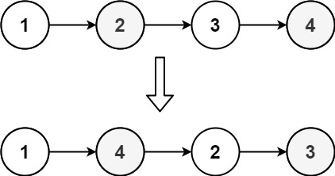

Input: head = [1,2,3,4]  
Output: [1,4,2,3]

**Example 2:**

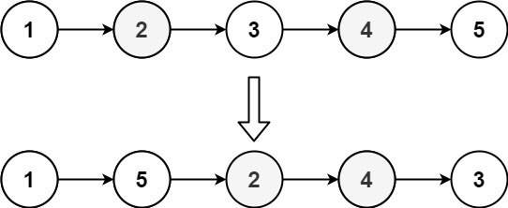

Input: head = [1,2,3,4,5]  
Output: [1,5,2,4,3]

**Constraints:**

* The number of nodes in the list is in the range [1, 5 * 104].
* 1 <= Node.val <= 1000