Given a string path, where path[i] = 'N', 'S', 'E' or 'W', each representing moving one unit north, south, east, or west, respectively. You start at the origin (0, 0) on a 2D plane and walk on the path specified by path.

Return true *if the path crosses itself at any point, that is, if at any time you are on a location you have previously visited*. Return false otherwise.

**Example 1:**

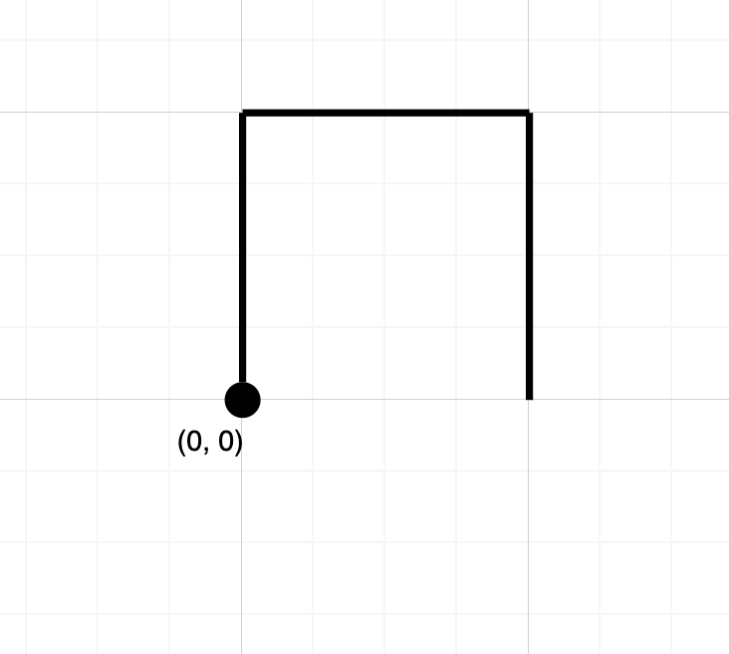

Input: path = "NES"  
Output: false   
Explanation: Notice that the path doesn't cross any point more than once.

**Example 2:**

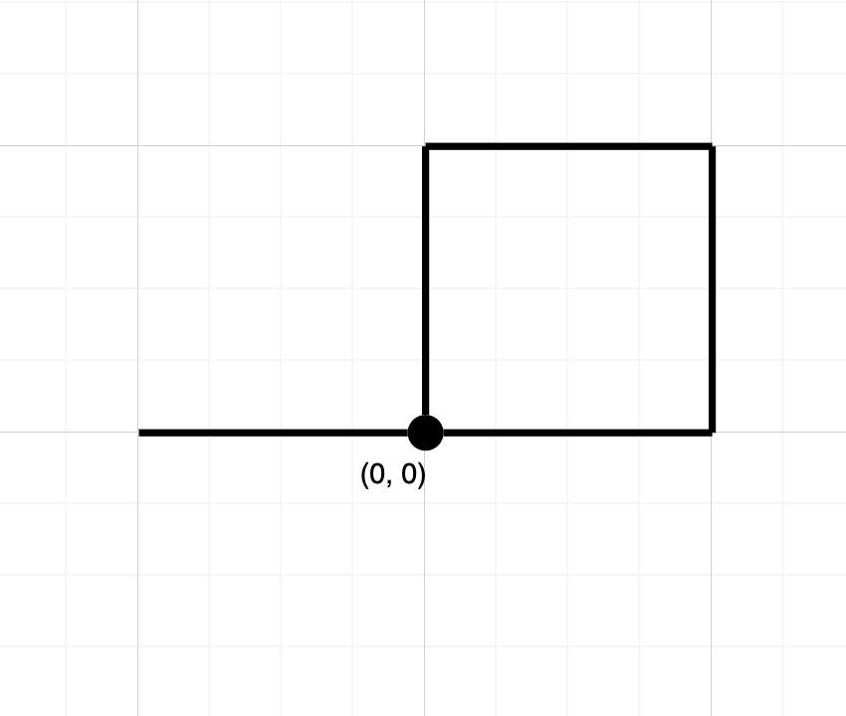

Input: path = "NESWW"  
Output: true  
Explanation: Notice that the path visits the origin twice.

**Constraints:**

* 1 <= path.length <= 104
* path[i] is either 'N', 'S', 'E', or 'W'.