You are given the root of a binary tree and an integer distance. A pair of two different **leaf** nodes of a binary tree is said to be good if the length of **the shortest path** between them is less than or equal to distance.

Return *the number of good leaf node pairs* in the tree.

**Example 1:**

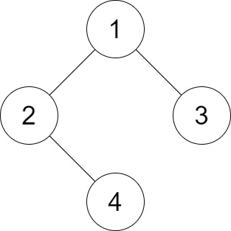

Input: root = [1,2,3,null,4], distance = 3  
Output: 1  
Explanation: The leaf nodes of the tree are 3 and 4 and the length of the shortest path between them is 3. This is the only good pair.

**Example 2:**

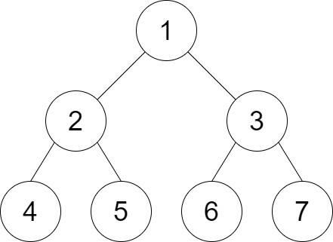

Input: root = [1,2,3,4,5,6,7], distance = 3  
Output: 2  
Explanation: The good pairs are [4,5] and [6,7] with shortest path = 2. The pair [4,6] is not good because the length of ther shortest path between them is 4.

**Example 3:**

Input: root = [7,1,4,6,null,5,3,null,null,null,null,null,2], distance = 3  
Output: 1  
Explanation: The only good pair is [2,5].

**Constraints:**

* The number of nodes in the tree is in the range [1, 210].
* 1 <= Node.val <= 100
* 1 <= distance <= 10