Alice has n balloons arranged on a rope. You are given a **0-indexed** string colors where colors[i] is the color of the ith balloon.

Alice wants the rope to be **colorful**. She does not want **two consecutive balloons** to be of the same color, so she asks Bob for help. Bob can remove some balloons from the rope to make it **colorful**. You are given a **0-indexed** integer array neededTime where neededTime[i] is the time (in seconds) that Bob needs to remove the ith balloon from the rope.

Return *the* ***minimum time*** *Bob needs to make the rope* ***colorful***.

**Example 1:**

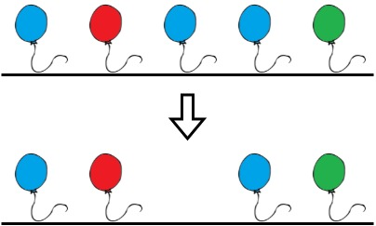

Input: colors = "abaac", neededTime = [1,2,3,4,5]  
Output: 3  
Explanation: In the above image, 'a' is blue, 'b' is red, and 'c' is green.  
Bob can remove the blue balloon at index 2. This takes 3 seconds.  
There are no longer two consecutive balloons of the same color. Total time = 3.

**Example 2:**

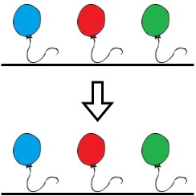

Input: colors = "abc", neededTime = [1,2,3]  
Output: 0  
Explanation: The rope is already colorful. Bob does not need to remove any balloons from the rope.

**Example 3:**

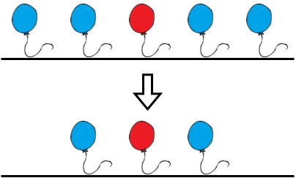

Input: colors = "aabaa", neededTime = [1,2,3,4,1]  
Output: 2  
Explanation: Bob will remove the balloons at indices 0 and 4. Each balloons takes 1 second to remove.  
There are no longer two consecutive balloons of the same color. Total time = 1 + 1 = 2.

**Constraints:**

* n == colors.length == neededTime.length
* 1 <= n <= 105
* 1 <= neededTime[i] <= 104
* colors contains only lowercase English letters.