Given an m x n binary matrix mat, return *the number of special positions in* mat*.*

A position (i, j) is called **special** if mat[i][j] == 1 and all other elements in row i and column j are 0 (rows and columns are **0-indexed**).

**Example 1:**

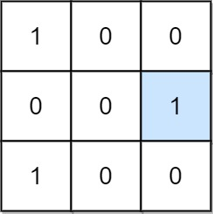

Input: mat = [[1,0,0],[0,0,1],[1,0,0]]  
Output: 1  
Explanation: (1, 2) is a special position because mat[1][2] == 1 and all other elements in row 1 and column 2 are 0.

**Example 2:**

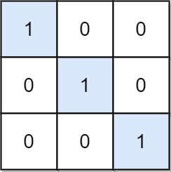

Input: mat = [[1,0,0],[0,1,0],[0,0,1]]  
Output: 3  
Explanation: (0, 0), (1, 1) and (2, 2) are special positions.

**Constraints:**

* m == mat.length
* n == mat[i].length
* 1 <= m, n <= 100
* mat[i][j] is either 0 or 1.