You are given a binary matrix matrix of size m x n, and you are allowed to rearrange the **columns** of the matrix in any order.

Return *the area of the largest submatrix within* matrix *where* ***every*** *element of the submatrix is* 1 *after reordering the columns optimally.*

**Example 1:**

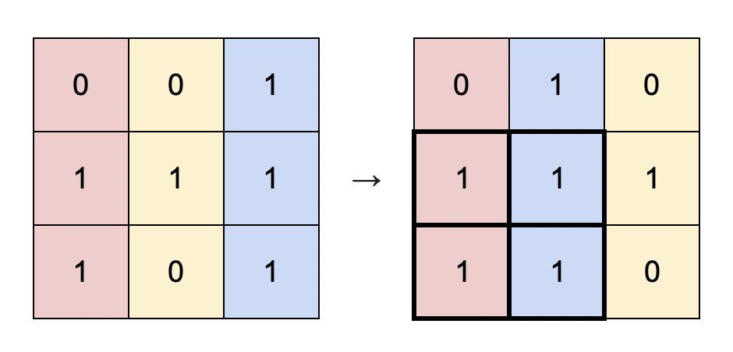

Input: matrix = [[0,0,1],[1,1,1],[1,0,1]]  
Output: 4  
Explanation: You can rearrange the columns as shown above.  
The largest submatrix of 1s, in bold, has an area of 4.

**Example 2:**

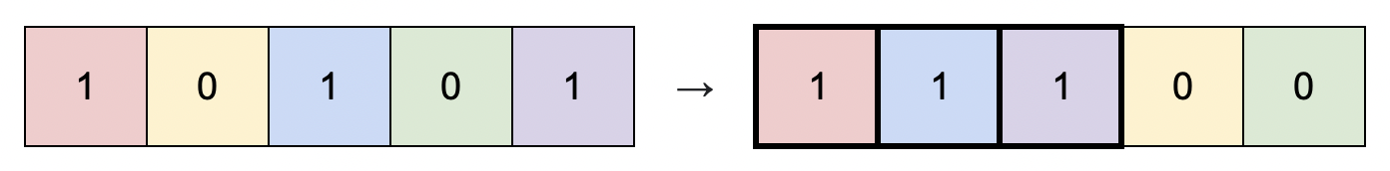

Input: matrix = [[1,0,1,0,1]]  
Output: 3  
Explanation: You can rearrange the columns as shown above.  
The largest submatrix of 1s, in bold, has an area of 3.

**Example 3:**

Input: matrix = [[1,1,0],[1,0,1]]  
Output: 2  
Explanation: Notice that you must rearrange entire columns, and there is no way to make a submatrix of 1s larger than an area of 2.

**Constraints:**

* m == matrix.length
* n == matrix[i].length
* 1 <= m * n <= 105
* matrix[i][j] is either 0 or 1.