You are given an array of events where events[i] = [startDayi, endDayi, valuei]. The ith event starts at startDayi and ends at endDayi, and if you attend this event, you will receive a value of valuei. You are also given an integer k which represents the maximum number of events you can attend.

You can only attend one event at a time. If you choose to attend an event, you must attend the **entire** event. Note that the end day is **inclusive**: that is, you cannot attend two events where one of them starts and the other ends on the same day.

Return *the* ***maximum sum*** *of values that you can receive by attending events.*

**Example 1:**

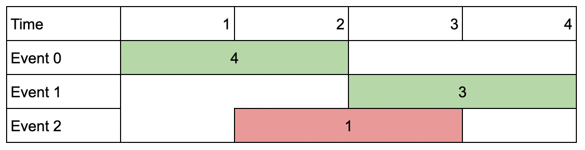

Input: events = [[1,2,4],[3,4,3],[2,3,1]], k = 2  
Output: 7  
Explanation: Choose the green events, 0 and 1 (0-indexed) for a total value of 4 + 3 = 7.

**Example 2:**

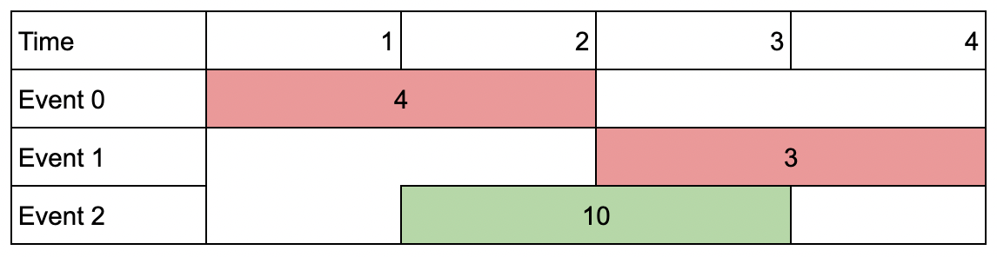

Input: events = [[1,2,4],[3,4,3],[2,3,10]], k = 2  
Output: 10  
Explanation: Choose event 2 for a total value of 10.  
Notice that you cannot attend any other event as they overlap, and that you do not have to attend k events.

**Example 3:**

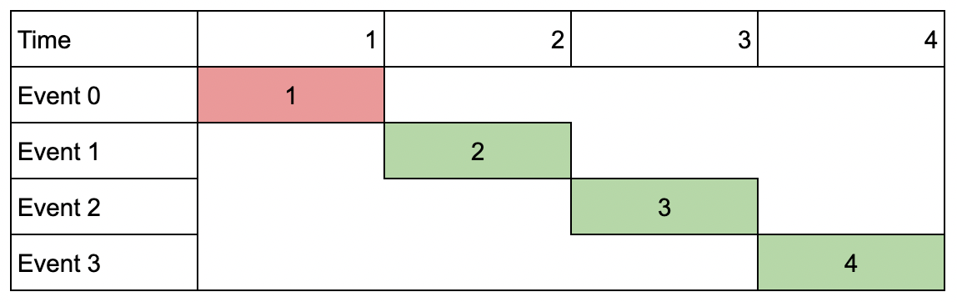

Input: events = [[1,1,1],[2,2,2],[3,3,3],[4,4,4]], k = 3  
Output: 9  
Explanation: Although the events do not overlap, you can only attend 3 events. Pick the highest valued three.

**Constraints:**

* 1 <= k <= events.length
* 1 <= k * events.length <= 106
* 1 <= startDayi <= endDayi <= 109
* 1 <= valuei <= 106