A **peak** element in a 2D grid is an element that is **strictly greater** than all of its **adjacent** neighbors to the left, right, top, and bottom.

Given a **0-indexed** m x n matrix mat where **no two adjacent cells are equal**, find **any** peak element mat[i][j] and return *the length 2 array* [i,j].

You may assume that the entire matrix is surrounded by an **outer perimeter** with the value -1 in each cell.

You must write an algorithm that runs in O(m log(n)) or O(n log(m)) time.

**Example 1:**

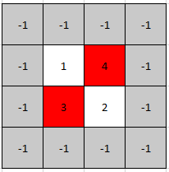

Input: mat = [[1,4],[3,2]]  
Output: [0,1]  
Explanation: Both 3 and 4 are peak elements so [1,0] and [0,1] are both acceptable answers.

**Example 2:**

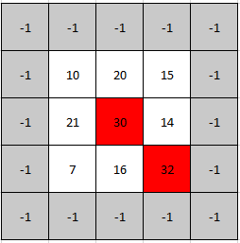

Input: mat = [[10,20,15],[21,30,14],[7,16,32]]  
Output: [1,1]  
Explanation: Both 30 and 32 are peak elements so [1,1] and [2,2] are both acceptable answers.

**Constraints:**

* m == mat.length
* n == mat[i].length
* 1 <= m, n <= 500
* 1 <= mat[i][j] <= 105
* No two adjacent cells are equal.