You are given an m x n matrix maze (**0-indexed**) with empty cells (represented as '.') and walls (represented as '+'). You are also given the entrance of the maze, where entrance = [entrancerow, entrancecol] denotes the row and column of the cell you are initially standing at.

In one step, you can move one cell **up**, **down**, **left**, or **right**. You cannot step into a cell with a wall, and you cannot step outside the maze. Your goal is to find the **nearest exit** from the entrance. An **exit** is defined as an **empty cell** that is at the **border** of the maze. The entrance **does not count** as an exit.

Return *the* ***number of steps*** *in the shortest path from the* entrance *to the nearest exit, or* -1 *if no such path exists*.

**Example 1:**

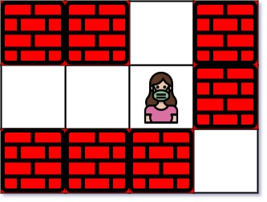

Input: maze = [["+","+",".","+"],[".",".",".","+"],["+","+","+","."]], entrance = [1,2]  
Output: 1  
Explanation: There are 3 exits in this maze at [1,0], [0,2], and [2,3].  
Initially, you are at the entrance cell [1,2].  
- You can reach [1,0] by moving 2 steps left.  
- You can reach [0,2] by moving 1 step up.  
It is impossible to reach [2,3] from the entrance.  
Thus, the nearest exit is [0,2], which is 1 step away.

**Example 2:**

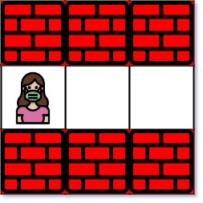

Input: maze = [["+","+","+"],[".",".","."],["+","+","+"]], entrance = [1,0]  
Output: 2  
Explanation: There is 1 exit in this maze at [1,2].  
[1,0] does not count as an exit since it is the entrance cell.  
Initially, you are at the entrance cell [1,0].  
- You can reach [1,2] by moving 2 steps right.  
Thus, the nearest exit is [1,2], which is 2 steps away.

**Example 3:**



Input: maze = [[".","+"]], entrance = [0,0]  
Output: -1  
Explanation: There are no exits in this maze.

**Constraints:**

* maze.length == m
* maze[i].length == n
* 1 <= m, n <= 100
* maze[i][j] is either '.' or '+'.
* entrance.length == 2
* 0 <= entrancerow < m
* 0 <= entrancecol < n
* entrance will always be an empty cell.