There is a special typewriter with lowercase English letters 'a' to 'z' arranged in a **circle** with a **pointer**. A character can **only** be typed if the pointer is pointing to that character. The pointer is **initially** pointing to the character 'a'.

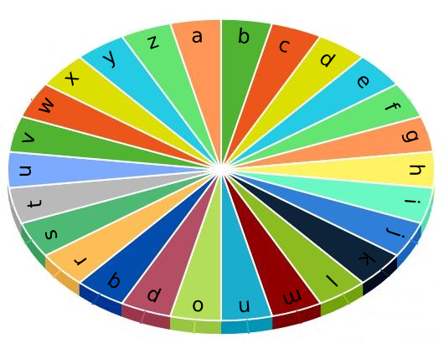

Each second, you may perform one of the following operations:

* Move the pointer one character **counterclockwise** or **clockwise**.
* Type the character the pointer is **currently** on.

Given a string word, return the **minimum** number of seconds to type out the characters in word.

**Example 1:**

Input: word = "abc"  
Output: 5  
Explanation:   
The characters are printed as follows:  
- Type the character 'a' in 1 second since the pointer is initially on 'a'.  
- Move the pointer clockwise to 'b' in 1 second.  
- Type the character 'b' in 1 second.  
- Move the pointer clockwise to 'c' in 1 second.  
- Type the character 'c' in 1 second.

**Example 2:**

Input: word = "bza"  
Output: 7  
Explanation:  
The characters are printed as follows:  
- Move the pointer clockwise to 'b' in 1 second.  
- Type the character 'b' in 1 second.  
- Move the pointer counterclockwise to 'z' in 2 seconds.  
- Type the character 'z' in 1 second.  
- Move the pointer clockwise to 'a' in 1 second.  
- Type the character 'a' in 1 second.

**Example 3:**

Input: word = "zjpc"  
Output: 34  
Explanation:  
The characters are printed as follows:  
- Move the pointer counterclockwise to 'z' in 1 second.  
- Type the character 'z' in 1 second.  
- Move the pointer clockwise to 'j' in 10 seconds.  
- Type the character 'j' in 1 second.  
- Move the pointer clockwise to 'p' in 6 seconds.  
- Type the character 'p' in 1 second.  
- Move the pointer counterclockwise to 'c' in 13 seconds.  
- Type the character 'c' in 1 second.

**Constraints:**

* 1 <= word.length <= 100
* word consists of lowercase English letters.