You are given two **non-empty** linked lists representing two non-negative integers. The digits are stored in **reverse order**, and each of their nodes contains a single digit. Add the two numbers and return the sum as a linked list.

You may assume the two numbers do not contain any leading zero, except the number 0 itself.

**Example 1:**

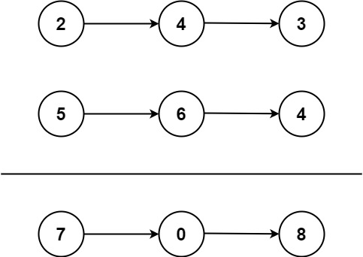

Input: l1 = [2,4,3], l2 = [5,6,4]  
Output: [7,0,8]  
Explanation: 342 + 465 = 807.

**Example 2:**

Input: l1 = [0], l2 = [0]  
Output: [0]

**Example 3:**

Input: l1 = [9,9,9,9,9,9,9], l2 = [9,9,9,9]  
Output: [8,9,9,9,0,0,0,1]

**Constraints:**

* The number of nodes in each linked list is in the range [1, 100].
* 0 <= Node.val <= 9
* It is guaranteed that the list represents a number that does not have leading zeros.